SUPPLEMENTARY FIGURE 1. Qualitative content analysis of perceived causes of constipation.*
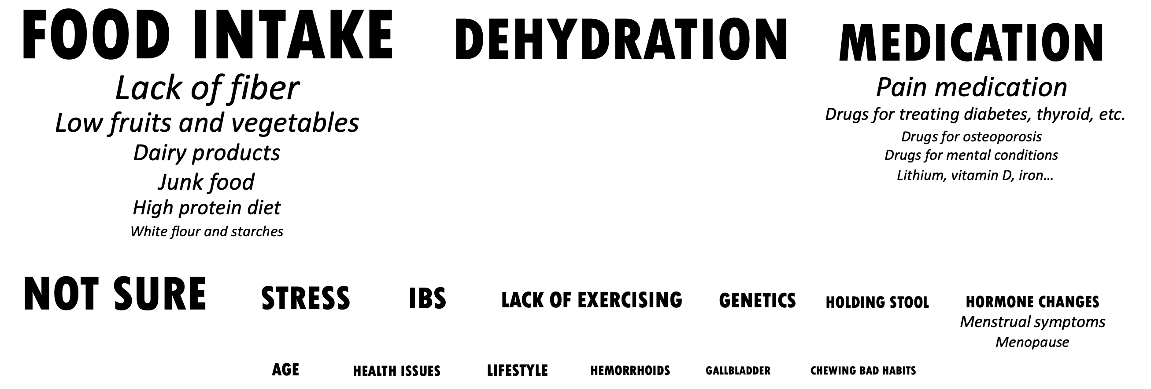

*Categories are in all capitals while subcategories are italicized. The font sizes correspond to the prevalence.
IBS, irritable bowel syndrome.

