Supplementary Appendix

Methods of electron microscopy
The biopsies were fixed in neutral formalin for over 24 hours, and then routinely processed under standard biosafety measures. Haematoxylin and eosin-stained sections were prepared and slides were examined by two pathologists (IN, RSvdP). Electron microscopy was performed (RR, BW). Formalin-fixed paraffin-embedded material was processed for electron microscopy. Tissue was punched out of the paraffin block and deparaffinized with xylene. Samples were processed for electron microscopy and embedded in Epon 812 (Merck, Darmstadt, Germany). Ultrathin sections were cut on an ultramicrotome (EM UC6, Leica microsystems, Wien, Austria), and contrasted with 1% uranyl acetate for 45 min and subsequently with lead citrate for 7 min at room temperature with an automatic contrasting system (EM AC20, Leica microsystems, Wien, Austria). Sections were examined in a Jeol 1400 electron microscope (JEOL, Tokyo, Japan).

Supplemental Figure 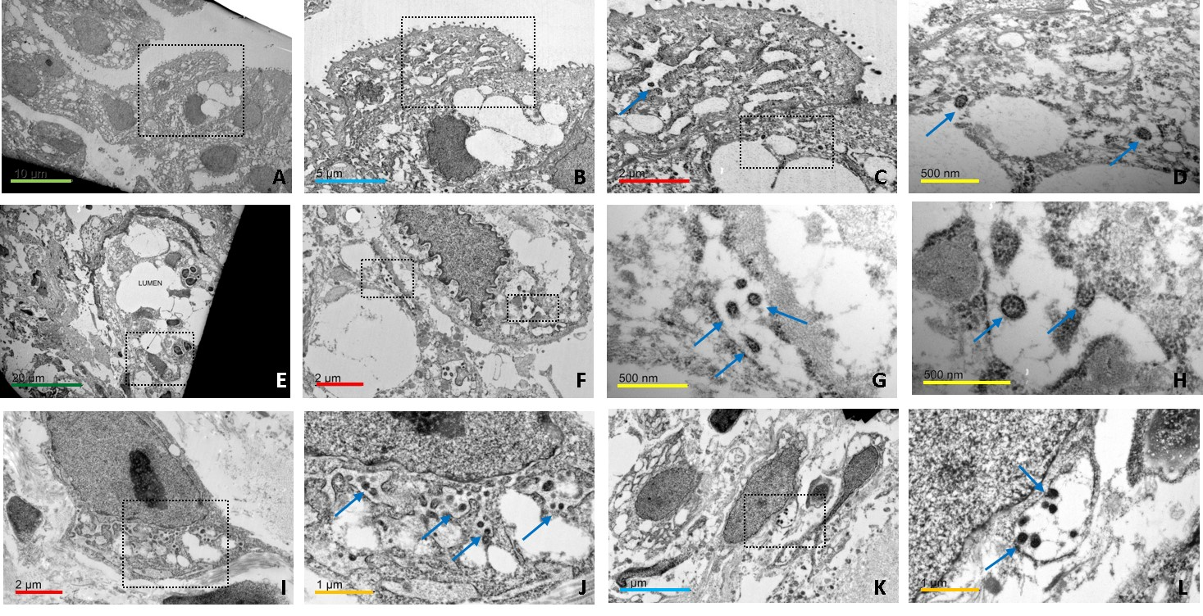
Electron microscopy revealed aggregates of intracellular virions in rough endoplasmic reticulum (rER) in the oesophagus; upper row: glandular epithelial cells (A-D), middle row: small vessel with viral particles in rER of endothelial cells (E and F overview images, G and H are higher magnifications of F), lower row: fibroblasts with viral particles in rER (I-J) and a vesicle (K-L). The virions showed club-shaped surface particles at the periphery and their size range was between 80-190 nm. The virions resemble typical Corona viral inclusions described before.^{1, 2} Magnification bars: dark green 20um, green 10um, blue 5um, red 2um, orange 1 um, yellow 500nm.

1. Kim JM, Chung YS, Jo HJ, et al. Identification of Coronavirus Isolated from a Patient in Korea with COVID-19. Osong Public Health Res Perspect 2020;11:3-7.
2. Lamers MM, Beumer J, van der Vaart J, et al. SARS-CoV-2 productively infects human gut enterocytes. Science 2020.

