Supplementary material
DNA isolation
At the time of first visit, patients were taken a sample of blood, processed within four hours and stored at -20ºC. Once anonymized, all samples, were treated as potentially infectious. EDTA-anticoagulated blood was used for DNA isolation following the procedures specified in the MagNA Pure DNA Isolation Kit protocol (Roche, Basel, Switzerland) and stored at -20ºC until assayed. DNA concentration was measured using a NanoDrop spectrophotometer (ThermoFisher, MA, USA) taking into account DNA purity as a reflection of the absorbance ratio at 260/280 nm.
Genes and SNPs assayed
Gene names and symbols are based in the latest update of Hugo Gene Nomenclature Committee (HGNC) database (1). The description of sequence variants as presented in this work are based on the current Human Genome Variation Society (HGVS) recommendations, in their version 15.11 (2), checking them by using the Mutalyzer suite v.2.0.26 (available from www.mutalyzer.nl) and with reference to sequences in the genome build GRCh38.p7 and/or the Locus Reference Genomic sequence (LRG) (3).
Proteins are named with reference to the Universal Protein Resource (www.uniprot.org) recommendations and the enzymes by following the ENZYME coding from ExPASY (https://enzyme.expasy.org). Biological and molecular functions are expressed according to the annotations of the Gene Ontology Consortium (www.geneontology.org).
Suitable candidate genes were selected based on previously known biological, physiological or functional relevance to HE. This was achieved in first place by literature mining through database (MEDLINE, Embase and Google Scholar) systematic search making use of MeSH terms. Afterwards, several gene lists were generated by taking advantage of 1) the platform SNPs3D (www.spns3d.com) (4) where the same MeSH terms were used, and 2) scrutinizing relevant pathways using PANTHER v9.0 (http://pantherdb.org) generating various lists of genes with a given ontology association. Afterwards, the lists were subjected to prioritization by means of the web server Endeavour (https://endeavour.esat.kuleuven.be). Genes were selected based on its significance and finally, the number of genes in each list was manually curated according to the grade of evidence in the literature for each pathway within the pathophysiology of the disease.
We included only common SNPs, defined as those having a minor allele frequency (MAF) greater than 1% in CEU (Utah Residents with Northern and Western European Ancestry) with reference to the dbSNP/HapMap database (HapMap release 23a/phase II March 2008 on NCBI B36 assembly, dbSNP b126), as well as in European population following ExAC Release 1 and/or 1000 Genomes Release phase3. We looked for TagSNPs in each gene including up to 5 kb in the 5’ and 3’ flanking region of the DNA by using Tagger and the Linkage Disequilibrium Calculator (http://ensemble.org). The SNPs were also selected by predicted functionality via Variant Effect Predictor, as well as its clinical significance as reported in ClinVar. Prediction of polymorphisms in miRNA binding sites was performed by means of the tools MirSNP and TargetScan 7.1 (http://bioinfo.bjmu.edu.cn/mirsnp/search/, www.targetscan.org) (5). In the same manner, we also looked for expression Quantitative Trait Loci (eQTLs) and LD-eQTLs through ExSNP database (6). Furthermore, single-tissue eQTLs were interrogated in the GTEx data (available at www.gtexportal.org). The workflow is summarized in the Figure S1.
After this analysis, 42 genes involved somehow in different pathways such as glutamine/ammonia metabolism, neurotransmission, inflammatory and immune response, oxidative stress, manganese transport and bile acid signaling were selected. Besides, the variants in GLS that showed an association in the previous study were also included and assessed as previously described (7). Briefly, the TACC haplotype formed by four SNPs within the region under influence of the gene GLS [NC_000002.12:g.190908462A>G (rs3771310), NC_000002.12:g.190912589A>G (rs6743496), NC_000002.12:g.190923691G>A (rs2883713) and NC_000002.12:g.190964686C>G (rs3088307)] were associated with the absence of HE.
The 60 SNPs analyzed, along with their MAF, their predicted genome consequence and the protein encoded in the region under their influence are shown in Table S1.
Genotyping
Genotyping was performed in an OpenArray platform by means of customized TaqMan OpenArray plates (ThermoFisher, MA, USA) using a QuantStudio 12k Flex System for cycling and Real-Time imaging. Genotype calling was performed by using the app Genotyping v. 3.5 (ThermoFisher, MA, USA) which is available in the ThermoFisher Cloud. Allele distribution was obtained by using reference panels for autocalling, with a real-time baseline ranging from 5 to 15 cycles, and allowing for cluster normalization when possible. Quality Control criteria included: exclusion of assays and/or samples with call rates <90% (Table S2). Besides, markers with allele distribution deviating from Hardy-Weinberg equilibrium in controls were also excluded. Herozigosity was checked for the variant in the X chromosome. Discordance was also avoided through performing replicates in control samples and by taking into account reference samples. Furthermore, genotype calling was considered suboptimal when the estimated quality value made by the autocaller algorithm was below the threshold of 0.95. According to these criteria, only 3 samples were excluded from the analysis.
Genotype frequencies were tested in the study groups for deviation from Hardy-Weinberg equilibrium using a chi-squared test. For genotype-phenotype association analysis, we performed multiple logistic regression models (dominant, recessive, additive, codominant and overdominant) as defined by the equation: $\log\left[\frac{p}{1-p}\right]=α+βG+γZ$, where “p” is the probability of HE, “G” is the genotype and “Z” the variables by which the model is adjusted (age and sex). Genetic models were interrogated by calculating the Akaike’s information criterion (AIC) values, being the lowest value indicative of the best fit, using the online tool SNPStats (www.snpstats.net). The strength of association between any variation and the development of HE under each model was expressed by ORs with 95% CIs.
Microsatellite analysis
In our previous study, the long-long form of the microsatellite was associated to a higher incidence of HE (7). For the analysis of the microsatellite variations, 0.5 µL of the fluorescently labeled PCR products were mixed with 5 µL of Hi-DI formamide and 0.5 µL of the size standard GeneScan600LIZ (ThermoFisher, CA, USA). Samples were then denaturized by incubation at 98ºC for 3 min, chilled on ice for 5 min, and separated by capillary electrophoresis on a genetic analyzer ABI3500. Results were visualized with PeakScanner v.3.4.1 available in the ThermoFisher Cloud (ThermoFisher, CA, USA).
Amplification of DNA fragments containing the microsatellite region was carried out by PCR in a 20 µL mixture of DreamTaq PCR Master Mix (ThermoFisher, CA, USA), deionized water, 0.5 μM of each primer and up to 50 ng of DNA sample. The primers used included: forward primer 5′–TAG CCC TCC CCT GCG CTT TA–3′ and reverse primer 5′– 6FAM-TGG GGC GGT GAG ATG ACA GAA –3′ (Tib Molbiol, Berlin, Germany). The amplification conditions were: initial denaturation step at 95ºC for 2 min followed by 35 cycles of denaturation step at 95ºC for 30 s, annealing step at 57ºC for 30 s, extension step at 72ºC for 1 min, ending with a final extension step at 72ºC for 10 min.
Primers were designed using the tool Primer-Blast (available at https://www.ncbi.nlm.nih.gov/tools/primer-blast/); Tm were calculated by means of Primer3 software v.4.1.0 (available at http://bioinfo.ut.ee/primer3/). The oligos were confirmed by in silico PCR (https://genome.ucsc.edu/cgi-bin/hgPcr) according to the assembly GRCch38/hg38:
>chr2:190880796+190880999 204bp TAGCCCTCCCCTGCGCTTTAgcctcagtgcggagccttaggcggagcgaa gagaaccggtcgcggcaatcctagcgcgcagcagcagcagcagcagcagc agcagcagcagcagcagcagcagcacccgcatccgctgcgggagtccgag ccggaaccacacccaagtagctgccctttcctcTTCTGTCATCTCACCGC
CCCA
The length of the PCR product was defined as 156 bases plus a variable number of repeats of a GCA triplet. The quality of the measurement was ensured by excluding samples with <0.75 Sizing Quality parameter, and by passing the Quality Check software (ThermoFisher, CA, USA). In order to warrant the measurement methodology, we further performed gel electrophoresis of random samples and sequencing of DNA from patients with suspicion of being homozygote for the microsatellite (Figure S2). The sequencing was performed by using the genetic analyzer ABI 3500 (ThermoFisher, CA, USA), analyzing the results in Geneious v.11.1.5 (Biomatters, Auckland, New Zealand).
Polymorphisms associated with HE development
After adjusting by age and sex, genotype-phenotype showed an association between seven SNPs and HE: rs2562582 (SLC1A3) [CT-CC vs. TT; OR 2.02 (1.20-3.40); p=0.005], rs313853 (SLC1A5) [CT-CC vs.TT; OR 1.74 (1.22-2.72); p=0.041], rs5743836 (TRL9) [AG-GG vs. AA, OR 1.94 (1.17-3.20); p=0.010], rs601338 (FUT2) [AG vs. AA-GG; OR 2.35 (1.43-3.86); p<0.001], rs4880 (SOD2) [GG-AG vs. AA; OR 2.08 (1.18-3.60); p=0.005], rs3088307 (GLS) [CC-GG vs. CG; OR 0.52 (0.31-0.86); p=0.009], rs13395505 (GLS-STAT1) [AA vs AG-GG; OR 2.03 (1.08-3.80); p=0.015].
Once the best genetic inheritance model for each variant was established, we assessed the cumulative survival free of HE during the follow-up period and found an association between four of these variants: rs601338 (AG vs. AA-GG; log-Rank 11.2; p<0.001), rs2562582 (CT-CC vs. TT; log-Rank 11.2; p<0.001), rs313853 (CT-CC vs. TT; log-Rank 6.2; p=0.034), rs5743836 (AG-GG vs. AA, log-Rank 12.3; p<0.001).
The cumulative incidence of HE at five years of each risk group of the genetic score regarding previously known risk factors such as: a) MELD score [cut-off=10 by ROC curve analysis, AUROC=0.71 (CI 95% 0.64-0.78), p<0.001; 60.4% of sensitivity and 71.3% of specificity], MELD≤10: 4.3%, 13.3%, 48.0% for 0-1, 2-3 and 4-5 risk variants groups, respectively, log-Rank 42.078; p<0.001, MELD>10: 0.0%, 42.1%, 70.8%, log-Rank 24.767; p<0.001, b) previous bouts of HE, “No”: 1.9%, 20.3%, 53.8% , log-Rank 42.176; p<0.001, “Yes”: 9.1%, 48.8%, 80.0%, log-Rank 18.965; p<0.001, c) CFF≥39 Hz: 3.0%, 23.2%, 45.8%, log-Rank 13.834; p=0.001, <39 Hz: 0%, 24.6%, 71.4%, log-Rank 23.913; p<0.001, d) PHES≥-4: 2.9%, 24.8%, 44.4%, log-Rank 15.357; p<0.001, <-4: 0.0%, 25.0%, 83.3%, log-Rank 25.574; p<0.001.

TABLES
Table S1. Polymorphisms selected, along with the MAF, the gene and encoded protein under their region of influence, and GO annotations for molecular and biological functions.
ID SNP | Variant | MAF | Conse-quence | Gene | Protein | GO - Molecular function | GO - Biological function
rs3771310 | NC_000002.12:g.190908462A>G | G=0.240 | Intronic | GLS | Glutaminase kidney isoform, mitochondrial | GO:0004359 glutaminase activity | GO:0006541 glutamine metabolic process
rs6743496 | NC_000002.12:g.190912589A>G | A=0.358 | Intronic | GLS | Glutaminase kidney isoform, mitochondrial | GO:0004359 glutaminase activity | GO:0006541 glutamine metabolic process
rs2883713 | NC_000002.12:g.190923691G>A | G=0.377 | Intronic | GLS | Glutaminase kidney isoform, mitochondrial | GO:0004359 glutaminase activity | GO:0006541 glutamine metabolic process
rs3088307 | NC_000002.12:g.190964686C>G | G=0.499 | 3’ UTR | GLS | Glutaminase kidney isoform, mitochondrial | GO:0004359 glutaminase activity | GO:0006541 glutamine metabolic process
rs13395505 | NC_000002.12:g.190973788G>A | A=0.382 | 5’ UTR | GLS | Glutaminase kidney isoform, mitochondrial | GO:0004359 glutaminase activity | GO:0006541 glutamine metabolic process
rs10911021 | NC_000001.11:g.182112825C>T | T=0.317 | 5’ UTR | GLUL | Glutamine synthetase | GO:0004356 glutamate-ammonia ligase activity | GO:0006541 glutamine metabolic process
rs7549329 | NC_000001.11:g.182394284G>A | G=0.406 | 3’ UTR | GLUL | Glutamine synthetase | GO:0004356 glutamate-ammonia ligase activity | GO:0006541 glutamine metabolic process
rs715 | NC_000002.12:g.210678331T>C | C=0.316 | 3’ UTR | CPS1 | Carbamoil-phosphate synthase 1 | GO:0004087 carbamoyl-phosphate synthase (ammonia) activity | GO:0000050 urea cycle
rs1047891 | NC_000002.12:g.210675783C>A | A=0.313 | Missense | CPS1 | Carbamoil-phosphate synthase 1 | GO:0004087 carbamoyl-phosphate synthase (ammonia) activity | GO:0000050 urea cycle
rs186636 | NC_000017.11:g.44008604C>T | C=0.367 | 3’ UTR | NAGS | N-acetylglutamate synthase | GO:0004042 acetyl-CoA:L-glutamate N-acetyltransferase activity | GO:0000050 urea cycle
rs228771 | NC_000017.11:g.44006729C>G | G=0.412 | Intronic | NAGS | N-acetylglutamate synthase | GO:0004042 acetyl-CoA:L-glutamate N-acetyltransferase activity | GO:0000050 urea cycle
rs313830 | NC_000007.14:g.66086944T>C | T=0.251 | Intronic | ASL | Arginine succinate liase | GO:0004056 argininosuccinate lyase activity | GO:0000050 urea cycle
rs10814988 | NC_000009.12:g.4483912G>A | A=0.189 | 3’ UTR | SLC1A1 | Excitatory amino acid transporter 3 | GO:0015171 amino acid transmembrane transporter activity | GO:0015807 L-amino acid transport
rs301430 | NC_000009.12:g.4576680T>C | C=0.308 | Synonym | SLC1A1 | Excitatory amino acid transporter 3 | GO:0015171 amino acid transmembrane transporter activity | GO:0015807 L-amino acid transport
rs4354668 | NC_000011.10:g.35419429T>G | G=0.409 | Intronic | SLC1A2 | Excitatory amino acid transporter 2 | GO:0015171 amino acid transmembrane transporter activity | GO:0015807 L-amino acid transport
rs752949 | NC_000011.10:g.35306201C>T | T=0.258 | Intronic | SLC1A2 | Excitatory amino acid transporter 2 | GO:0015171 amino acid transmembrane transporter activity | GO:0015807 L-amino acid transport
rs2269272 | NC_000005.10:g.36687754C>T | T=0.219 | 3’ UTR | SLC1A3 | Excitatory amino acid transporter 1 | GO:0015171 amino acid transmembrane transporter activity | GO:0015807 L-amino acid transport
rs2562582 | NC_000005.10:g.36605258C>T | C=0.201 | 2Kb Upstream | SLC1A3 | Excitatory amino acid transporter 1 | GO:0015171 amino acid transmembrane transporter activity | GO:0015807 L-amino acid transport
rs8105903 | NC_000019.10:g.46784893C>G | C=0.446 | Intronic | SLC1A5 | Neutral amino acid transporter B(0) | GO:0015171 amino acid transmembrane transporter activity | GO:0015807 L-amino acid transport
rs2070246 | NC_000019.10:g.46778905G>A | A=0.204 | Synonym | SLC1A5 | Neutral amino acid transporter B(0) | GO:0015171 amino acid transmembrane transporter activity | GO:0015807 L-amino acid transport
rs313853 | NC_000019.10:g.46784682T>C | C=0.333 | Intronic | SLC1A5 | Neutral amino acid transporter B(0) | GO:0015171 amino acid transmembrane transporter activity | GO:0015807 L-amino acid transport
rs35742391 | NC_000003.12:g.50219957G>A | A=0.096 | Synonym | SLC38A3 | Sodium-coupled neutral amino acid transporter 3 | GO:0015171 amino acid transmembrane transporter activity | GO:0015807 L-amino acid transport
rs2293953 | NC_000023.11:g.48467829G>A | G=0.175 | Intronic | SLC38A5 | Sodium-coupled neutral amino acid transporter 5 | GO:0015171 amino acid transmembrane transporter activity | GO:0015807 L-amino acid transport
rs4975611 | NC_000005.10:g.1194214T>A | T=0.217 | 3’ UTR | SLC6A19 | Sodium-dependent neutral amino acid transporter B(0)AT1 | GO:0015171 amino acid transmembrane transporter activity | GO:0015807 L-amino acid transport
rs11746371 | NC_000005.10:g.1219744C>T | T=0.418 | Intronic | SLC6A19 | Sodium-dependent neutral amino acid transporter B(0)AT1 | GO:0015171 amino acid transmembrane transporter activity | GO:0015807 L-amino acid transport
rs279858 | NC_000004.12:g.46312576T>C | C=0.425 | Synonym | GABRA2 | Gamma-aminobutyric acid receptor subunit alpha-2 | GO:0004890 GABA-A receptor activity | GO:0007214 gamma-aminobutyric acid signaling pathway
rs4880213 | NC_000009.12:g.137136549C>T | T=0.424 | 2Kb Upstream | GRIN1 | Glutamate receptor ionotropic, NMDA 1 | GO:0042165 neurotransmitter binding | GO:0098976 excitatory chemical synaptic transmission
rs1805247 | NC_000012.12:g.13563041A>G | G=0.089 | Synonym | GRIN2B | Glutamate receptor ionotropic, NMDA 2B | GO:0042165 neurotransmitter binding | GO:0098976 excitatory chemical synaptic transmission
rs2288629 | NC_000002.12:g.221442590C>A | C=0.180 | Intronic | EPHA4 | Ephrin type-A receptor 4 | GO:0004672 protein kinase activity | GO:0048013 ephrin receptor signaling pathway
rs1440581 | NC_000004.12:g.88305270T>C | T=0.486 | 2Kb Upstream | PPM1K | Protein phosphatase 1K, mitochondrial | GO:0004722 protein serine/threonine phosphatase activity | GO:0009083 branched-chain amino acid catabolic process
rs5743708 | NC_000004.12:g.153705165G>A | A=0.026 | Missense | TLR2 | Toll-like receptor 2 | GO:0001530 lipopolysaccharide binding | GO:0045089 positive regulation of innate immune response
rs4986790 | NC_000009.12:g.117713024A>G | G=0.063 | Missense | TLR4 | Toll-like receptor 4 | GO:0001530 lipopolysaccharide binding | GO:0045089 positive regulation of innate immune response
rs2569190 | NC_000005.10:g.140633331A>G | A=0.451 | Intronic | CD14 | Monocyte differentiation antigen CD14 | GO:0001530 lipopolysaccharide binding | GO:0045089 positive regulation of innate immune response
rs5743836 | NC_000003.12:g.52226766A>G | G=0.126 | 2Kb Upstream | TLR9 | Toll-like receptor 9 | GO:0005149 interleukin-1 receptor binding | GO:0045089 positive regulation of innate immune response
rs5743289 | NC_000016.10:g.50722863C>T | T=0.140 | Intronic | NOD2 | Nucleotide-binding oligomerization domain-containing protein 2 | GO:0042834 peptidoglycan binding | GO:0045089 positive regulation of innate immune response
rs17221417 | NC_000016.10:g.50705671C>G | G=0.276 | Intronic | NOD2 | Nucleotide-binding oligomerization domain-containing protein 2 | GO:0042834 peptidoglycan binding | GO:0045089 positive regulation of innate immune response
rs10065172 | NC_000005.10:g.150848436C>T | T=0.076 | Synonym | IRGM | Immunity-related GTPase family M protein | GO:0019901 protein kinase binding | GO:0045089 positive regulation of innate immune response
rs1800795 | NC_000007.14:g.22727026C>G | C=0.460 | Intronic | IL6 | Interleukin 6 | GO:0005125 cytokine activity | GO:0002675 positive regulation of acute inflammatory response  GO:0071219 cellular response to molecule of bacterial origin
rs1800629 | NC_000006.12:g.31575254G>A | A=0.159 | 2Kb Upstream | TNF | Tumor necrosis factor | GO:0005125 cytokine activity | GO:1903426 regulation of reactive oxygen species biosynthetic process  GO:0002675 positive regulation of acute inflammatory response  GO:0071219 cellular response to molecule of bacterial origin
rs35829419 | NC_000001.11:g.247425556C>A | A=0.051 | Missense | NLRP3 | NACHT, LRR and PYD domains-containing protein 3 | GO:0042834 peptidoglycan binding | GO:0071219 cellular response to molecule of bacterial origin
rs689466 | NC_000001.11:g.186681619T>C | C=0.184 | 2Kb Upstream | PTGS2 | Prostaglandin G/H synthase 2 | GO:0004601 peroxidase activity | GO:1903426 regulation of reactive oxygen species biosynthetic process  GO:0002675 positive regulation of acute inflammatory response
rs1024611 | NC_000017.11:g.34252769A>G | G=0.286 | 2Kb Upstream | CCL2 | C-C motif chemokine 2 | GO:0008009 chemokine activity | GO:0071219 cellular response to molecule of bacterial origin
rs2669845 | NC_000003.12:g.39279727T>C | T=0.115 | Intronic | CX3CR1 | CX3C chemokine receptor 1 | GO:0004950 chemokine receptor activity | GO:1903426 regulation of reactive oxygen species biosynthetic process  GO:0071219 cellular response to molecule of bacterial origin
rs959106 | NC_000003.12:g.108760670A>G | G=0.169 | 2Kb Upstream | RETNLB | Resistin-like beta |  | GO:0005179 hormone activity
rs3814058 | NC_000003.12:g.119818444T>C | C=0.216 | 3’ UTR | NR1I2 | Nuclear receptor subfamily 1 group I member 2 | GO:0004879 nuclear receptor activity | GO:0006805 xenobiotic metabolic process
rs601338 | NC_000019.10:g.48703417G>A | A=0.458 | Nonsense | FUT2 | Galactoside 2-alpha-L-fucosyltransferase 2 | GO:0008417 fucosyltransferase activity | GO:0005975 carbohydrate metabolic process
rs10210302 | NC_000002.12:g.233250193C>T | T=0.486 | 2Kb Upstream | ATG16L1 | Autophagy-related protein 16-1 | GO:0019787 ubiquitin-like protein transferase activity | GO:0061912 selective autophagy
rs2241880 | NC_000002.12:g.233274722A>G | A=0.489 | Missense | ATG16L1 | Autophagy-related protein 16-1 | GO:0019787 ubiquitin-like protein transferase activity | GO:0061912 selective autophagy
rs2303015 | NC_000017.11:g.48852546T>C | C=0.043 | Missense | CALCOCO2 | Calcium-binding and coiled-coil domain-containing protein 2 | GO:0042803 protein homodimerization activity | GO:0061912 selective autophagy
rs550510 | NC_000017.11:g.48849253G>C | A=0.363 | Missense | CALCOCO2 | Calcium-binding and coiled-coil domain-containing protein 2 | GO:0042803 protein homodimerization activity | GO:0061912 selective autophagy
rs4880 | NC_000006.12:g.159692840A>G | G=0.493 | Missense | SOD2 | Superoxide dismutase [Mn], mitochondrial | GO:0030145 manganese ion binding | GO:0006979 response to oxidative stress
rs1800849 | NC_000011.10:g.74009120G>A | A=0.282 | 5’ UTR | UCP3 | Mitochondrial uncoupling protein 3 | GO:0017077 oxidative phosphorylation uncoupler activity | GO:0006979 response to oxidative stress
rs3017887 | NC_000011.10:g.89492920A>C | A=0.191 | Intronic | NOX4 | NADPH oxidase 4 | GO:0016174 NAD(P)H oxidase activity | GO:0006979 response to oxidative stress
rs761142 | NC_000006.12:g.53527310A>C | C=0.274 | Intronic | GCLC | Glutamate--cysteine ligase catalytic subunit | GO:0016595 glutamate binding | GO:0006534 cysteine metabolic process  GO:0006979 response to oxidative stress
rs17883901 | NC_000006.12:g.53545239G>A | A=0.064 | 2Kb Upstream | GCLC | Glutamate--cysteine ligase catalytic subunit | GO:0016595 glutamate binding | GO:0006534 cysteine metabolic process  GO:0006979 response to oxidative stress
rs6586282 | NC_000021.9:g.43058387C>T | T=0.142 | No coding | CBS | Cystathionine beta-synthase | GO:0004122 cystathionine beta-synthase activity | GO:0006534 cysteine metabolic process
rs6971 | NC_000022.11:g.43162920A>G | A=0.320 | Missense | TSPO | Translocator protein | GO:0008503 benzodiazepine receptor activity | GO:1905802 regulation of cellular response to manganese ion  GO:1903427 negative regulation of reactive oxygen species biosynthetic process
rs281860284 | NC_000001.11:g.219928175A>G |  | Missense | SLC30A10 | Zinc transporter 10 | GO:0005384 manganese ion transmembrane transporter activity | GO:1905802 regulation of cellular response to manganese ion  GO:1903427 negative regulation of reactive oxygen species biosynthetic process
rs56163822 | NC_000012.12:g.100493323G>T | T=0.022 | No coding | NR1H4 | Bile acid receptor | GO:0032052 bile acid binding | GO:0038183 bile acid signaling pathway
rs11110385 | NC_000012.12:g.100458927C>T | T=0.393 | 2Kb Upstream | NR1H4 | Bile acid receptor | GO:0032052 bile acid binding | GO:0038183 bile acid signaling pathway

Table S2. Quality control parameters for OpenArray platform in the analysis of variants.
Icon | Flag Name | Value | Condition | Threshold
 | Failed Control
 | Genotype Quality Low | Quality | Less than | 0,95
 | Low Passive Ref | Passive Ref | Less than | 0
 | NTC Allele 2 Intensity High | Allele 2 | Greater than | 3000
 | NTC Allele 1 Intensity High | Allele 1 | Greater than | 2000
 | Reference Sample Discordance
 | Replicate Sample Discordance
 | Experiment Low ROX™ Rate High | Percentage | Greater than | 10.0%
 | Assay Call Rate Low | Percentage | Less than | 90.0%
 | Experiment Call Rate Low | Percentage | Less than | 90.0%
 | Sample Call Rate Low | Percentage | Less than | 90.0%

Table S3. Data from variants deviating from Hardy-Weinberg equilibrium in control subjects. 3 variants were excluded after Pearson’s Chi-square test analysis, α=10⁻³.
rs2293953 exact test for Hardy-Weinberg equilibrium (n=333)
 | A/A | A/G |  | G/G |  |  | A allele |  | G allele | P-value
All subjects | 266 | 29 |  | 38 |  |  | 561 |  | 105 | <0.0001
STATUS=0-Control | 194 | 21 |  | 31 |  |  | 409 |  | 83 | <0.0001
STATUS=1-Case | 72 | 8 |  | 7 |  |  | 152 |  | 22 | <0.0001
rs2288629 exact test for Hardy-Weinberg equilibrium (n=332)
 | A/A |  | A/C |  | C/C |  | A allele |  | C allele | P-value
All subjects | 206 |  | 80 |  | 46 |  | 492 |  | 172 | <0.0001
STATUS=0-Control | 156 |  | 56 |  | 32 |  | 368 |  | 120 | <0.0001
STATUS=1-Case | 50 |  | 24 |  | 14 |  | 124 |  | 52 | 0.0017
rs689466 exact test for Hardy-Weinberg equilibrium (n=333)
 | T/T |  | T/C |  |  | C/C | T allele | C allele |  | P-value
All subjects | 207 |  | 40 |  |  | 56 | 454 | 152 |  | <0.0001
STATUS=0-Control | 147 |  | 37 |  |  | 37 | 331 | 111 |  | <0.0001
STATUS=1-Case | 60 |  | 3 |  |  | 19 | 123 | 41 |  | <0.0001

Table S4. Data from genotype-phenotype analysis. 8 variants showed significant association with HE presence as dependent variable in the different regression models, which were adjusted for age and sex.
rs13395505 association with response STATUS (n=333, adjusted by SEX+AGE)
Model | Genotype | Control | Case | OR (95% CI) | P-value | AIC | BIC
Codominant | G/G | 84 (34.1%) | 34 (39.1%) | 1.00 | 0.024 | 384 | 403
 | A/G | 130 (52.9%) | 33 (37.9%) | 0.62 (0.36-1.09)
 | A/A | 32 (13%) | 20 (23%) | 1.55 (0.78-3.11)
Dominant | G/G | 84 (34.1%) | 34 (39.1%) | 1.00 | 0.4 | 388.7 | 404
 | A/G-A/A | 162 (65.8%) | 53 (60.9%) | 0.80 (0.48-1.34)
Recessive | G/G-A/G | 214 (87%) | 67 (77%) | 1.00 | 0.015 | 383.5 | 398.7
 | A/A | 32 (13%) | 20 (23%) | 2.03 (1.08-3.80)
Overdominant | G/G-A/A | 116 (47.1%) | 54 (62.1%) | 1.00 | 0.03 | 384.7 | 400.0
 | A/G | 130 (52.9%) | 33 (37.9%) | 0.54 (0.32-0.89)
Log-additive | --- | --- | --- | 1.12 (0.78-1.60) | 0.54 | 389.1 | 404.3
rs4880 association with response STATUS (n=336, adjusted by SEX+AGE)
Model | Genotype | Control | Case | OR (95% CI) | P-value | AIC | BIC
Codominant | A/A | 78 (31.4%) | 17 (19.3%) | 1.00 | 0.0068 | 384.7 | 403.8
 | A/G | 106 (42.7%) | 55 (62.5%) | 2.05 (1.22-4.56)
 | G/G | 64 (25.8%) | 16 (18.2%) | 1.19 (0.55-2.55)
Dominant | A/A | 78 (31.4%) | 17 (19.3%) | 1.00 | 0.005 | 382.0 | 403.2
 | A/G-G/G | 170 (68.5%) | 71 (80.7%) | 2.08 (1.09-3.60)
Recessive | A/A-A/G | 184 (74.2%) | 72 (81.8%) | 1.00 | 0.15 | 391.3 | 406.6
 | G/G | 64 (25.8%) | 16 (18.2%) | 0.65 (0.35-1.20)
Overdominant | A/A-G/G | 142 (57.3%) | 33 (37.5%) | 1.00 | 0.012 | 382.9 | 403.2
 | A/G | 106 (42.7%) | 55 (62.5%) | 2.06 (1.37-3.73)
Log-additive | --- | --- | --- | 1.11 (0.79-1.56) | 0.55 | 393 | 408.3
rs3088307 association with response STATUS (n=335, adjusted by SEX+AGE)
Model | Genotype | Control | Case | OR (95% CI) | P-value | AIC | BIC
Codominant | C/C | 77 (31.2%) | 34 (38.6%) | 1.00 | 0.028 | 387.6 | 406.6
 | C/G | 127 (51.4%) | 31 (35.2%) | 0.56 (0.32-0.98)
 | G/G | 43 (17.4%) | 23 (26.1%) | 1.23 (0.64-2.37)
Dominant | C/C | 77 (31.2%) | 34 (38.6%) | 1.00 | 0.22 | 391.2 | 406.5
 | C/G-G/G | 170 (68.8%) | 54 (61.4%) | 0.73 (0.44-1.21)
Recessive | C/C-C/G | 204 (82.6%) | 65 (73.9%) | 1.00 | 0.079 | 389.6 | 404.9
 | G/G | 43 (17.4%) | 23 (26.1%) | 1.70 (0.95-3.04)
Overdominant | C/C-G/G | 120 (48.6%) | 57 (64.8%) | 1.00 | 0.0094 | 386.0 | 401.2
 | C/G | 127 (51.4%) | 31 (35.2%) | 0.52 (0.31-0.86)
Log-additive | --- | --- | --- | 1.03 (0.73-1.45) | 0.85 | 392.7 | 407.9
rs601338 association with response STATUS (n=336, adjusted by SEX+AGE)
Model | Genotype | Control | Case | OR (95% CI) | P-value | AIC | BIC
Codominant | A/A | 77 (31.1%) | 23 (26.1%) | 1.00 | 0.0013 | 382.1 | 401.2
 | A/G | 93 (37.5%) | 51 (58%) | 1.88 (1.05-3.37)
 | G/G | 78 (31.4%) | 14 (15.9%) | 0.61 (0.29-1.27)
Dominant | A/A | 77 (31.1%) | 23 (26.1%) | 1.00 | 0.35 | 392.5 | 407.8
 | A/G-G/G | 171 (69%) | 65 (73.9%) | 1.29 (0.75-2.24)
Recessive | A/A-A/G | 170 (68.5%) | 74 (84.1%) | 1.00 | 0.0034 | 384.8 | 400.1
 | G/G | 78 (31.4%) | 14 (15.9%) | 0.41 (0.22-0.77)
Overdominant | A/A-G/G | 155 (62.5%) | 37 (42%) | 1.00 | 7e-04 | 381.9 | 397.2
 | A/G | 93 (37.5%) | 51 (58%) | 2.35 (1.43-3.86)
Log-additive | --- | --- | --- | 0.83 (0.60-1.15) | 0.27 | 392.2 | 407.4
rs2562582 association with response STATUS (n=336, adjusted by SEX+AGE)
Model | Genotype | Control | Case | OR (95% CI) | P-value | AIC | BIC
Codominant | T/T | 189 (76.2%) | 54 (61.4%) | 1.00 | 0.017 | 387.2 | 406.3
 | C/T | 58 (23.4%) | 32 (36.4%) | 1.92 (1.13-3.27)
 | C/C | 1 (0.4%) | 2 (2.3%) | 7.85 (0.69-89.26)
Dominant | T/T | 189 (76.2%) | 54 (61.4%) | 1.00 | 0.0051 | 385.6 | 401.8
 | C/T-C/C | 59 (23.8%) | 34 (38.6%) | 2.02 (1.20-3.40)
Recessive | T/T-C/T | 247 (99.6%) | 86 (97.7%) | 1.00 | 0.12 | 390.9 | 406.2
 | C/C | 1 (0.4%) | 2 (2.3%) | 6.46 (0.57-73.00)
Overdominant | T/T-C/C | 190 (76.6%) | 56 (63.6%) | 1.00 | 0.022 | 388.1 | 403.4
 | C/T | 58 (23.4%) | 32 (36.4%) | 1.86 (1.10-3.15)
Log-additive | --- | --- | --- | 2.03 (1.24-3.33) | 0.0091 | 386.5 | 401.8
rs313853 association with response STATUS (n=336, adjusted by SEX+AGE)
Model | Genotype | Control | Case | OR (95% CI) | P-value | AIC | BIC
Codominant | T/T | 117 (47.2%) | 31 (35.2%) | 1.00 | 0.14 | 391.4 | 410.5
 | C/T | 112 (45.2%) | 50 (56.8%) | 1.68 (1.00-2.83)
 | C/C | 19 (7.7%) | 7 (8%) | 1.40 (0.54-3.66)
Dominant | T/T | 117 (47.2%) | 31 (35.2%) | 1.00 | 0.041 | 389.6 | 404.8
 | C/T-C/C | 131 (52.8%) | 57 (64.8%) | 1.74 (1.22-2.72)
Recessive | T/T-C/T | 229 (92.3%) | 81 (92%) | 1.00 | 0.91 | 393.4 | 408.6
 | C/C | 19 (7.7%) | 7 (8%) | 1.06 (0.43-2.62)
Overdominant | T/T-C/C | 136 (54.8%) | 38 (43.2%) | 1.00 | 0.061 | 389.9 | 405.1
 | C/T | 112 (45.2%) | 50 (56.8%) | 1.60 (0.98-2.61)
Log-additive | --- | --- | --- | 1.37 (0.93-2.03) | 0.11 | 390.8 | 406.1
rs5743836 association with response STATUS (n=336, adjusted by SEX+AGE)
Model | Genotype | Control | Case | OR (95% CI) | P-value | AIC | BIC
Codominant | A/A | 169 (68.2%) | 47 (53.4%) | 1.00 | 0.035 | 388.7 | 407.7
 | A/G | 71 (28.6%) | 36 (40.9%) | 1.90 (1.13-3.20)
 | G/G | 8 (3.2%) | 5 (5.7%) | 2.25 (0.70-7.22)
Dominant | A/A | 169 (68.2%) | 47 (53.4%) | 1.00 | 0.01 | 386.7 | 402
 | A/G-G/G | 79 (31.9%) | 41 (46.6%) | 1.94 (1.17-3.20)
Recessive | A/A-A/G | 240 (96.8%) | 83 (94.3%) | 1.00 | 0.33 | 392.4 | 407.7
 | G/G | 8 (3.2%) | 5 (5.7%) | 1.79 (0.57-5.65
Overdominant | A/A-G/G | 177 (71.4%) | 52 (59.1%) | 1.00 | 0.025 | 388.4 | 403.7
 | A/G | 71 (28.6%) | 36 (40.9%) | 1.80 (1.08-3.01)
Log-additive | --- | --- | --- | 1.71 (1.13-2.60) | 0.012 | 387.1 | 402.4
OR: odds ratio, CI 95%: 95% confidence intervals, AIC: Akaike’s Information Criterion, BIC: Bayesian Information Criterion. In red, statistically significant model conferring risk of HE. In green, statistically significant model conferring protection of HE. p<0.05 was considered as statistically significant. In bold, lower AIC (selected inheritance model).

Table S5.
Variable | Univariate |  | Multivariate
 | HR (CI 95%) | p-value | sHR (95% CI) | p-value
Age ± SD, years | 0.941 (0.540-1.638) | 0.829 | 1.019 (0.989-1.049) | 0.207
Gender, male | 1.017 (0.991-1.044) | 0.192 | 1.171 (0.628-2.184) | 0.619
Etiology  Alcohol  Virus  Other | Ref  1.155 (0.663-2.010)  1.540 (0.718-3.299) | 0.612  0.267
MELD ± SD | 1.188 (1.124-1.257) | <0.001
Albumin ± SD (g/L) | 0.865 (0.829-0.902) | <0.001 | 0.872 (0.836-0.910) | <0.001
Bilirubin ± SD (mg/dL) | 1.264 (1.127-1.419) | <0.001 | 1.192 (1.036-1.372) | 0.014
Platelets ± SD (x 10⁹/L) | 0.995 (0.990-1.000) | 0.038 | 0.998 (0.993-1.003) | 0.435
AST ± SD (IU/L) | 1.009 (1.004-1.014) | <0.001 | 1.002 (0.996-1.008) | 0.408
ALT ± SD (IU/L) | 1.003 (0.997-1.009) | 0.285
INR ± SD | 2.664 (1.575-4.508) | <0.002 | 1.620 (0.758-3.462) | 0.213
Creatinine ± SD (mg/dL) | 1.115 (0.364-3.414) | 0.849
Leukocytes ± SD (cells/x 10⁹/L) | 1.000 (1.000-1.000) | 0.563
rs2562582 (CT-CC vs. TT) | 1.909 (1.125-3.239) | 0.017 | 1.836 (1.106-2.995) | 0.038
rs313853 (CT-CC vs. TT) | 1.883 (1.132-3.081) | 0.038 | 1.774 (0.986-2.842) | 0.062
rs5743836 (AG-GG vs. AA) | 2.038 (1.223-3.396) | 0.006 | 2.247 (1.321-3.822) | 0.003
rs601338 (AG vs. AA-GG) | 2.634 (1.545-4.491) | <0.001 | 2.770 (1.603-4.784) | <0.001
GLS microsatellite | 1.773 (1.057-2.978) | 0.030 | 1.956 (1.145-3.343) | 0.014

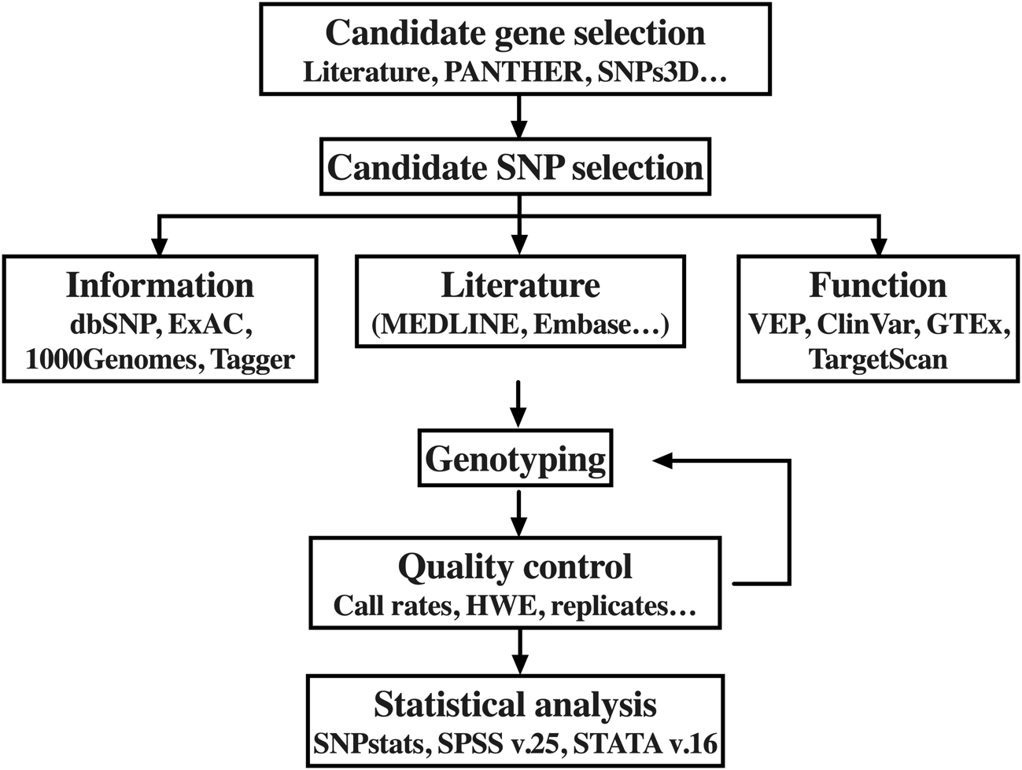
Figure S1. Chart representing the workflow in the candidate gene and polymorphisms selection.
ExAC: Exome Aggregation Consortium, VEP: Variant Effect Predictor, GTEx: Genotype-Tissue Expression, HWE: Hardy-Weinberg Equilibrium

Figure S2. Microsatellite analysis by: a) capillary electrophoresis, image from PeakScanner v.3.4.1 (ThermoFisher, CA, USA), b) sequencing homozygotes, c) gel electrophoresis of random samples (numbers show fragments length), d) histogram showing the distribution of the number of repeats (derivation cohort), e) dot-plot illustrating the frequency distribution of the short and long forms of the polymorphisms (derivation cohort).
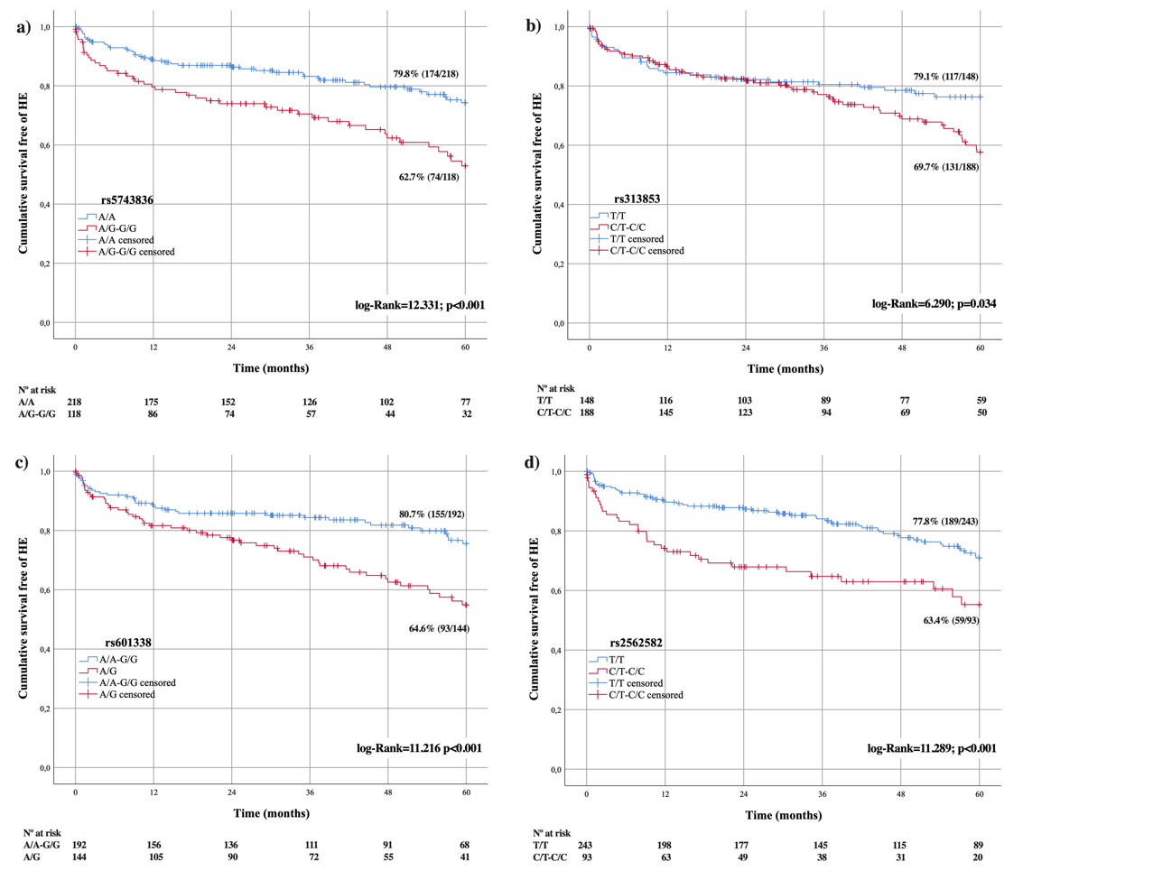
Figure S3. Kaplan-Meier graphs of the variants showing differences in the cumulative incidence of HE by the log-Rank test: a) rs5743836, b) rs313853, c) rs601338 and d) rs2562582.
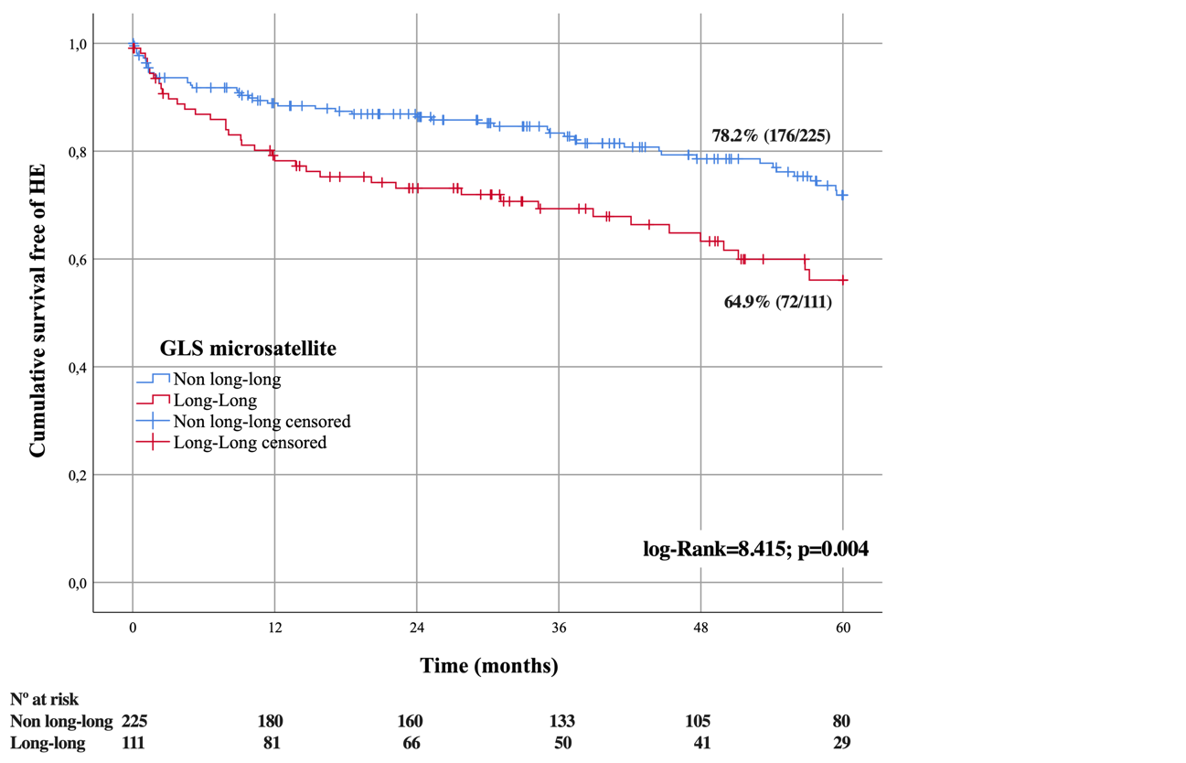
Figure S4. Kaplan-Meier graph showing differences in the cumulative incidence of HE by the number of repeats of the microsatellite in the promoter region of GLS.

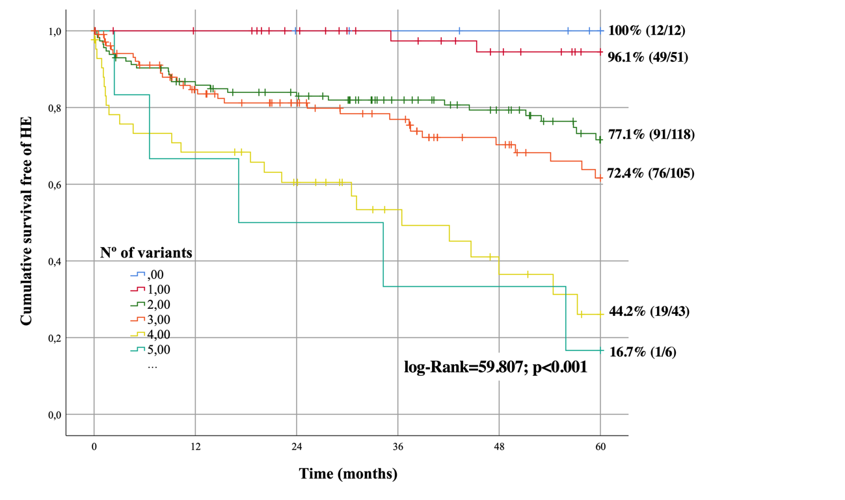
Figure S5. Cumulative survival free of HE at 5 years depending on the number of risk variants: “Genetic Score”.
Survival functions were calculated at 5 years by means of the Kaplan-Meier estimator. Comparisons between curves were made by using the log-Rank test.

Figure S6. Heatmap illustrating the frequency of patients who developed HE in each group defined by the Genetic Score distributed by the severity of the episodes. *p-value<0.05 after chi-square or Fisher’s exact tests.

REFERENCES
1. Yates B, Braschi B, Gray KA, Seal RL, Tweedie S, Bruford EA. Genenames.org: the HGNC and VGNC resources in 2017. Nucleic Acids Res. 2017;45(D1):D619-D25.
2. den Dunnen JT, Dalgleish R, Maglott DR, Hart RK, Greenblatt MS, McGowan-Jordan J, et al. HGVS Recommendations for the Description of Sequence Variants: 2016 Update. Hum Mutat. 2016;37(6):564-9.
3. Dalgleish R, Flicek P, Cunningham F, Astashyn A, Tully RE, Proctor G, et al. Locus Reference Genomic sequences: an improved basis for describing human DNA variants. Genome Med. 2010;2(4):24-.
4. Yue P, Melamud E, Moult J. SNPs3D: candidate gene and SNP selection for association studies. BMC bioinformatics. 2006;7:166.
5. Liu C, Zhang F, Li T, Lu M, Wang L, Yue W, et al. MirSNP, a database of polymorphisms altering miRNA target sites, identifies miRNA-related SNPs in GWAS SNPs and eQTLs. BMC Genomics. 2012;13(1):661-.
6. Yu C-H, Pal LR, Moult J. Consensus Genome-Wide Expression Quantitative Trait Loci and Their Relationship with Human Complex Trait Disease. Omics. 2016;20(7):400-14.
7. Romero-Gómez M, Jover M, Del Campo JA, Royo JL, Hoyas E, Galán JJ, et al. Variations in the promoter region of the glutaminase gene and the development of hepatic encephalopathy in patients with cirrhosis: a cohort study. Ann Intern Med. 2010;153(5):281-8.

