ONLINE SUPPLEMENTARY MATERIAL

Supplementary file 1. Contribution log
Inmaculada Santaella Agencia Sanitaria Costa del Sol Marbella SPAIN Acquired data, critically reviewed the manuscript draft, and approved the submitted manuscript.
Nuria Fernandez Moreno Agencia Sanitaria Costa del Sol Marbella SPAIN Acquired data, critically reviewed the manuscript draft, and approved the submitted manuscript.
Horacio Alonso Galán Hospital de Donosti San Sebastian SPAIN Acquired data, critically reviewed the manuscript draft, and approved the submitted manuscript.
Ana Garre Hospital Univeraitario La Princesa Madrid SPAIN Acquired data, critically reviewed the manuscript draft, and approved the submitted manuscript.
Pilar Canelles Hospital General Universitario de Valencia Valencia SPAIN Acquired data, critically reviewed the manuscript draft, and approved the submitted manuscript.
Luis Ferrer Hospital General Universitario de Valencia Valencia SPAIN Acquired data, critically reviewed the manuscript draft, and approved the submitted manuscript.
Enrique Medina-Chulia Hospital General Universitario de Valencia Valencia SPAIN Acquired data, critically reviewed the manuscript draft, and approved the submitted manuscript.
Miroslav Vujasinovic Slovenj Gradec General Hospital Slovenj Gradec SLOVENIA Acquired data, critically reviewed the manuscript draft, and approved the submitted manuscript.
Luís Elvas Portuguese Oncology Institute Coimbra PORTUGAL Acquired data, critically reviewed the manuscript draft, and approved the submitted manuscript.
Susana Isabel Alves Portuguese Oncology Institute Coimbra PORTUGAL Acquired data, critically reviewed the manuscript draft, and approved the submitted manuscript.
Luís Elvas Portuguese Oncology Institute Coimbra PORTUGAL Acquired data, critically reviewed the manuscript draft, and approved the submitted manuscript.
Sandra Saraiva Portuguese Oncology Institute Coimbra PORTUGAL Acquired data, critically reviewed the manuscript draft, and approved the submitted manuscript.
Luís Elvas Portuguese Oncology Institute Coimbra PORTUGAL Acquired data, critically reviewed the manuscript draft, and approved the submitted manuscript.
Daniel Brito Portuguese Oncology Institute Coimbra PORTUGAL Acquired data, critically reviewed the manuscript draft, and approved the submitted manuscript.
Luís Elvas Portuguese Oncology Institute Coimbra PORTUGAL Acquired data, critically reviewed the manuscript draft, and approved the submitted manuscript.
Ana Teresa Cadime Portuguese Oncology Institute Coimbra PORTUGAL Acquired data, critically reviewed the manuscript draft, and approved the submitted manuscript.
Noelia Alcaide Hospital Clínico Universitario Valladolid SPAIN Acquired the data, critically reviewed the manuscript draft, and approved the submitted manuscript.
Benito Velayos Hospital Clínico Universitario Valladolid SPAIN Acquired the data, critically reviewed the manuscript draft, and approved the submitted manuscript.
Javier Santos-Fernández Hospital Clínico Universitario Valladolid SPAIN Acquired the data, critically reviewed the manuscript draft, and approved the submitted manuscript.
Tommaso Di Maira University Hospital La Fe Valencia SPAIN Acquired data, critically reviewed the manuscript draft, and approved the submitted manuscript.
Xavier Molina-Infante Hospital San Pedro Alcántara Cáceres SPAIN Acquired data, critically reviewed the manuscript draft, and approved the submitted manuscript.
Angel Lanas Hospital Clinico Lozano Blesa Zaragoza SPAIN Acquired data, critically reviewed the manuscript draft, and approved the submitted manuscript.
Elida Oblitas Susanibar Consorci Sanitari Terrassa Terrassa SPAIN Acquired data, critically reviewed the manuscript draft, and approved the submitted manuscript.
Pedro Almela Hospital General Universitario de Castellon Castellon SPAIN Acquired data, critically reviewed the manuscript draft, and approved the submitted manuscript.
Manuel Jimenez-Moreno Hospital Universitario de Burgos Burgos SPAIN Acquired data, critically reviewed the manuscript draft, and approved the submitted manuscript.
Rafael Ruiz -Zorrilla Lopez Hospital de Sierrallana Torrelavega SPAIN Acquired data, critically reviewed the manuscript draft, and approved the submitted manuscript.
Maria Anatolyevna Livzan Omsk state medical academy Omsk RUSSIA Acquired data, critically reviewed the manuscript draft, and approved the submitted manuscript.
Liliana Silvia Pozzati Mérida Hospital Mérida SPAIN Acquired data, critically reviewed the manuscript draft, and approved the submitted manuscript.
Josep Maria Botargues Hospital Universitari de Bellvitge L'Hospitalet de Llobregat SPAIN Acquired data, critically reviewed the manuscript draft, and approved the submitted manuscript.
Alain Huerta-Madrigal Hospital de Galdakao Bizkaia SPAIN Acquired the data, critically reviewed the manuscript draft, and approved the submitted manuscript.
Eduardo Iyo Hospital Comarcal de Inca Mallorca SPAIN Acquired data, critically reviewed the manuscript draft, and approved the submitted manuscript.
Cristobal de la Coba Hospital de Cabueñes Gijon SPAIN Acquired data, critically reviewed the manuscripts draft, and approved the submitted manuscript.
Dag Arne Lihaug Hoff Hospital of Alesund Alesund NORWAY Acquired data, critically reviewed the manuscripts draft, and approved the submitted manuscript.
Ingrid Prytz Berset Hospital of Alesund Alesund NORWAY Acquired data, critically reviewed the manuscripts draft, and approved the submitted manuscript.
Dan Dumitrascu Medical Department 2, University of Medicine and Pharmacy Iuliu Hatieganu Cluj Napoca ROMANIA Acquired data, critically reviewed the manuscript draft, and approved the submitted manuscript.
Sergey Gennadievich Burkov Outpatient clinic Moscow RUSSIA Acquired data, critically reviewed the manuscript draft, and approved the submitted manuscript.
Mercè Barenys Hospital de Viladecans Viladecans SPAIN Acquired data, critically reviewed the manuscript draft, and approved the submitted manuscript.
Charo Antón Hospital Clínico de Valencia SPAIN Acquired data, critically reviewed the manuscript draft, and approved the submitted manuscript.
Ian Beales Norfolk and Norwich University Hospital Norwich U.K. Acquired data, critically reviewed the manuscript draft, and approved the submitted manuscript.
Vendel Kristensen Lovisenberg Diakonale Hospital Oslo NORWAY Acquired data, critically reviewed the manuscript draft, and approved the submitted manuscript.
Stephan Brackmann Lovisenberg Diakonale Hospital Oslo NORWAY Acquired data, critically reviewed the manuscript draft, and approved the submitted manuscript.
Rustam Abdulkhakov Kazan State Medical University Kazan RUSSIA Acquired data, critically reviewed the manuscript draft, and approved the submitted manuscript.
Doron Boltin Rabin Medical Center, Beilinson Campus and the Sackler School of Medicine Tel Aviv University ISRAEL Acquired data, critically reviewed the manuscript draft, and approved the submitted manuscript.
Marina Fedorovna Osipenko Novosibirsk State Medical University Novosibirsk RUSSIA Acquired data, critically reviewed the manuscript draft, and approved the submitted manuscript.
Igor Bakulin North-western State Medical University St Petersburg RUSSIA Acquired data, critically reviewed the manuscript draft, and approved the submitted manuscript.
Natalia Valerievna Bakulina North-western State Medical University St Petersburg RUSSIA Acquired data, critically reviewed the manuscript draft, and approved the submitted manuscript
Miguel Fernandez-Bermejo Clinica San Francisco Caceres SPAIN Acquired data, critically reviewed the manuscript draft, and approved the submitted manuscript
Teresa Angueira Hospital General de Tomelloso Ciudad Real SPAIN Acquired data, critically reviewed the manuscript draft, and approved the submitted manuscript.
Denise Elizabeth Brennan Trinity College Dublin Dublin IRELAND Acquired data, critically reviewed the manuscript draft, and approved the submitted manuscript.
Sinead Smith Trinity College Dublin Dublin IRELAND Acquired data, critically reviewed the manuscript draft, and approved the submitted manuscript.
Rosa Rosania Otto-von-Guericke University Hospital Magdeburg GERMANY Acquired data, critically reviewed the manuscript draft, and approved the submitted manuscript.
Peter Malfertheiner Otto-von-Guericke University Hospital Magdeburg GERMANY Acquired data, critically reviewed the manuscript draft, and approved the submitted manuscript.
Ana Campillo Hospital Reina Sofia Tudela SPAIN Acquired data, critically reviewed the manuscript draft, and approved the submitted manuscript.
Oscar Núñez Hospital Universitario Sanitas La Moraleja Madrid SPAIN Acquired data, critically reviewed the manuscript draft, and approved the submitted manuscript.
Aiman Silkanovna Sarsenbaeva Gastroenterological center Chelyabinsk RUSSIA Acquired data, critically reviewed the manuscript draft, and approved the submitted manuscript.
Zaza Beniashvili Rabin Medical Center, Hospital Ha Sharon Petah Tikva ISRAEL Acquired data, critically reviewed the manuscript draft, and approved the submitted manuscript.
Ramon Pajares Hospital Universitario Infanta Sofía San Sebastian de los Reyes SPAIN Acquired data, critically reviewed the manuscript draft, and approved the submitted manuscript.
Victor Asparuhov Kamburov BalkanMed Medical Center Sofia BULGARIA Acquired data, critically reviewed the manuscript draft, and approved the submitted manuscript.
Alicia Algaba Hospital Universitario de Fuenlabrada Madrid SPAIN Acquired data, critically reviewed the manuscript draft, and approved the submitted manuscript.
Fernando Bermejo Hospital Universitario de Fuenlabrada Madrid SPAIN Acquired data, critically reviewed the manuscript draft, and approved the submitted manuscript.
Adi Lahat-zok Chaim Sheba medical center and Sackler School of Medicine, Tel Aviv University ISRAEL Acquired data, critically reviewed the manuscript draft, and approved the submitted manuscript.
Jose Luis Dominguez Jimenez Hospital Alto Guadalquivir Andujar SPAIN Acquired data, critically reviewed the manuscript draft, and approved the submitted manuscript.
Barbara Gómez Hospital de Mataró Barcelona SPAIN Acquired data, critically reviewed the manuscript draft, and approved the submitted manuscript.
Llucia Tito Hospital de Mataró Barcelona SPAIN Acquired data, critically reviewed the manuscript draft, and approved the submitted manuscript.
Dragan Jurcic University Hospital Sveti Duh Zagreb CROATIA Acquired data, critically reviewed the manuscript draft, and approved the submitted manuscript.
Marinko Marusic University Hospital Sveti Duh Zagreb CROATIA Acquired data, critically reviewed the manuscript draft, and approved the submitted manuscript.
Xavier Calvet Corporació Sanitària Universitària Parc Taulí. CIBERehd, Instituto de Salud Carlos III Departament de Medicina. Universitat Autònoma de Barcelona Sabadell SPAIN Acquired data, critically reviewed the manuscript draft, and approved the submitted manuscript.
Ariadna Figuerola Corporació Sanitària Universitària Parc Taulí. CIBERehd, Instituto de Salud Carlos III Departament de Medicina. Universitat Autònoma de Barcelona Sabadell SPAIN Acquired data, critically reviewed the manuscript draft, and approved the submitted manuscript.
Gerardo Nardone University Federico II Naples ITALY Acquired data, critically reviewed the manuscript draft, and approved the submitted manuscript.
Alba Rocco University Federico II Naples ITALY Acquired data, critically reviewed the manuscript draft, and approved the submitted manuscript.
Edurne Amorena Complejo Hospitalario de Navarra Pamplona SPAIN Acquired data, critically reviewed the manuscript draft, and approved the submitted manuscript.
Fermin Estremera Complejo Hospitalario de Navarra Pamplona SPAIN Acquired data, critically reviewed the manuscript draft, and approved the submitted manuscript.
Pilar Sánchez-Pobre Hospital Clinico San Carlos Madrid SPAIN Acquired data, critically reviewed the manuscript draft, and approved the submitted manuscript.
Albert Tomàs Consorci Sanitari del Garraf Sant Pere de Ribes SPAIN Acquired data, critically reviewed the manuscript draft, and approved the submitted manuscript.
Ekaterina Yuryevna Plotnikova Kemerovo State Medical Academy Kuzbass Regional Hepatology Center Kemerovo RUSSIA Acquired data, critically reviewed the manuscript draft, and approved the submitted manuscript.
Francisco Jose Martinez Cerezo Hospital Sant Joan Reus SPAIN Acquired data, critically reviewed the manuscript draft, and approved the submitted manuscript.
Laszlo Czako First Medical Clinic Szeged HUNGARY Acquired data, critically reviewed the manuscript draft, and approved the submitted manuscript.
Marco Romano Università degli Studi della Campania "Luigi Vanvitelli" Napoli ITALY Acquired data, critically reviewed the manuscript draft, and approved the submitted manuscript.
Antonietta Gerarda Gravina Università degli Studi della Campania "Luigi Vanvitelli" Napoli ITALY Acquired data, critically reviewed the manuscript draft, and approved the submitted manuscript.
Fazia Mana UZ Brussel Jette BELGIUM Acquired data, critically reviewed the manuscript draft, and approved the submitted manuscript.
Christella Ukunda UZ Brussel Jette BELGIUM Acquired data, critically reviewed the manuscript draft, and approved the submitted manuscript.
Javier Alcedo Hospital de Barbastro Huesca SPAIN Acquired data, critically reviewed the manuscript draft, and approved the submitted manuscript.
Tatyana Vasilyevna Zhestkova Ryazan State Medical University Ryazan RUSSIA Acquired data, critically reviewed the manuscript draft, and approved the submitted manuscript.
Liya Nikolaevna Belousova North-Western State Medical University n.a. I.I.Mechnicov Saint-Petersburg RUSSIA Acquired data, critically reviewed the manuscript draft, and approved the submitted manuscript.
Larissa Tarasova Chuvash State University named after I.N. Ulyanov, the chair of faculty therapy Cheboksary RUSSIA Acquired data, critically reviewed the manuscript draft, and approved the submitted manuscript.
Ludmila Grigorieva Chuvash State University named after I.N. Ulyanov, the chair of faculty therapy Cheboksary RUSSIA Acquired data, critically reviewed the manuscript draft, and approved the submitted manuscript.
Diego Burgos Santamaría Hospital Universitario Ramón y Cajal, Instituto Ramón y Cajal De Investigación Sanitaria (IRYCIS), Universidad de Alcalá, Madrid SPAIN Acquired data, critically reviewed the manuscript draft, and approved the submitted manuscript.
Natalia Baryshnikova Fisrt St-Petersburg Pavlov State Medical University St-Petersburg RUSSIA Acquired data, critically reviewed the manuscript draft, and approved the submitted manuscript.
Jesús M González-Santiago Hospital Clínico Salamanca SPAIN Acquired data, critically reviewed the manuscript draft, and approved the submitted manuscript.
Roald Torp Sykehuset Innlandet, Hamar Hamar NORWAY Acquired data, critically reviewed the manuscript draft, and approved the submitted manuscript.
Yury Aleksandrovich Kucheryavyy Moscow State University of Medicine and Dentistry named after A.I. Evdokimov Moscow RUSSIA Acquired data, critically reviewed the manuscript draft, and approved the submitted manuscript.
Judith Millastre Hospital de Barbastro Barbastro SPAIN Acquired data, critically reviewed the manuscript draft, and approved the submitted manuscript.
Alla Kononova Department of General Practice Tver RUSSIA Acquired data, critically reviewed the manuscript draft, and approved the submitted manuscript.
Sergey Kolbasnikov The Head of Department of General Practice Tver RUSSIA Acquired data, critically reviewed the manuscript draft, and approved the submitted manuscript.
Anna Pakhomova Saratov State Clinical Hospital N5 RUSSIA Acquired data, critically reviewed the manuscript draft, and approved the submitted manuscript.
Oleksiy Gridnyev L.T.Malaya Therapy National Institute of the National Academy of Medical Sciences, Kharkiv UKRAINE Acquired data, critically reviewed the manuscript draft, and approved the submitted manuscript.
Antonio Cuadrado Lavin Hospital Universitario Marqués de Valdecilla Santander SPAIN Acquired data, critically reviewed the manuscript draft, and approved the submitted manuscript.
Marta Lozano Lanagran Hospital Quuiron Malaga SPAIN Acquired data, critically reviewed the manuscript draft, and approved the submitted manuscript.
Anne Courillon-Mallet Centre Hospitalier Intercommunal (CIHV) Villeneuve St Georges FRANCE Acquired data, critically reviewed the manuscript draft, and approved the submitted manuscript.
Marianela Mego Hospital General de Cataluña SPAIN Acquired data, critically reviewed the manuscript draft, and approved the submitted manuscript.
Antonio Cerezo-Ruiz Hospital Sierra de Segura Jaen SPAIN Acquired data, critically reviewed the manuscript draft, and approved the submitted manuscript.
Giulia Fiorini University of Bologna, Bologna. ITALY Acquired data, critically reviewed the manuscript draft, and approved the submitted manuscript.
Ilaria Maria Saracino University of Bologna, Bologna. ITALY Acquired data, critically reviewed the manuscript draft, and approved the submitted manuscript.
Dino Vaira University of Bologna, Bologna. ITALY Acquired data, critically reviewed the manuscript draft, and approved the submitted manuscript.
Michael Selgrad Otto-von Guericke University Magdeburg GERMANY Acquired data, critically reviewed the manuscript draft, and approved the submitted manuscript.
Santiago Frago Larramona Hospital Santa Barbara Soria SPAIN Acquired data, critically reviewed the manuscript draft, and approved the submitted manuscript.
Marko Duvnjak University Centre Sestre Milosrdnice Zagreb CROATIA Acquired data, critically reviewed the manuscript draft, and approved the submitted manuscript.
Marko Nikolic University Centre Sestre Milosrdnice Zagreb CROATIA Acquired data, critically reviewed the manuscript draft, and approved the submitted manuscript.
Neven Ljubicic University Centre Sestre Milosrdnice Zagreb CROATIA Acquired data, critically reviewed the manuscript draft, and approved the submitted manuscript.
Rolando Pinho Centro Hospitalar de Vila Nova de Gaia PORTUGAL Acquired data, critically reviewed the manuscript draft, and approved the submitted manuscript.
Igor Bakulin University Hospital n.a. Peter The Great Saint-Petersburg RUSSIA Acquired data, critically reviewed the manuscript draft, and approved the submitted manuscript.
Valeriy Kryvy Crimean State Medical University named after S.I.Georgievskyi Simferopol UKRANIA Acquired data, critically reviewed the manuscript draft, and approved the submitted manuscript.
Peter Bytzer Koge University Hospital Koge DENMARK Acquired data, critically reviewed the manuscript draft, and approved the submitted manuscript.
Jane Moller Hansen Odense University Hospital DENMARK Acquired data, critically reviewed the manuscript draft, and approved the submitted manuscript.
Maria Pina Dore Clinica Medica, Dipartimento di Scienze Mediche, Chirurgiche e Sperimentali, Università di Sassari Sassari ITALY Acquired data, critically reviewed the manuscript draft, and approved the submitted manuscript.
Mirjana Kalauz Clinical Hospital Centre Zagreb CROATIA Acquired data, critically reviewed the manuscript draft, and approved the submitted manuscript.
Francesco Franceschi Catholic University of Rome Rome ITALY Acquired data, critically reviewed the manuscript draft, and approved the submitted manuscript.
Jonathan Hirsch Meir Medical Center Kfar Saba ISRAEL Acquired data, critically reviewed the manuscript draft, and approved the submitted manuscript.
Lorena Sancho Del val Hospital Rey Juan Carlos Madrid SPAIN Acquired data, critically reviewed the manuscript draft, and approved the submitted manuscript.
Sandra Agudo Fernandez Hospital Rey Juan Carlos Madrid SPAIN Acquired data, critically reviewed the manuscript draft, and approved the submitted manuscript.
Angel Cedeño Hospital Comarcal Sant Jaume de Calella Barcelona SPAIN SPAIN Acquired data, critically reviewed the manuscript draft, and approved the submitted manuscript.
Leyanira Torrealba Medina Hospital Universitario Dr. Josep Trueta Girona SPAIN Acquired data, critically reviewed the manuscript draft, and approved the submitted manuscript.

Supplementary file 2. Adverse events by treatment scheme

Triple therapies

In total, 8,014 patients treated with a triple regimen provided information on safety: PPI+C+A (6,741 cases), PPI+C+M (907 cases) and PPI+A+M (366 cases) reported an incidence of AEs of 15%, 20% and 22%, respectively.
The most frequent AEs with PPI+C+A were metallic taste and nausea (both in 4% of the cases) with a mean duration of 7.2 (±3.7) and 5.2 (±3.7) days, respectively. Metallic taste was severe in 12% of the patients.
All patients were given standard triple therapy as a PPI in combination with 1000 mg of amoxicillin and 500 mg of metronidazole, both twice daily, and therefore no sub-analysis could be performed by antibiotic dosage. However, the appearance of AEs with PPI+C+A occurred in approximately 14% of the cases when the treatment was administered for 7-10 days, and in 19% of the cases with 14-day treatment durations, with significant statistical differences (p<0.001) between treatment durations.
The most frequent AEs with PPI+C+M were metallic taste and dyspepsia, in 7% and 5% of the cases respectively, with a mean duration of 6.5 (±1.8) and 6.5 (±2.5) days, respectively. Metallic taste was severe in 11% of the patients.
The appearance of AEs with PPI+C+M occurred in 21% of the cases when given for 7 days, in 16% of the cases with 10 day-treatment and in 25% of the cases with 14-day regimens (Table 5), with no statistically significant differences between treatment durations. Also, patients were given different clarithromycin and metronidazole doses: when clarithromycin 250 or 500 mg b.i.d. was prescribed, AEs occurred in 19% and 23% of the cases respectively, but differences were not statistically significant. Likewise, when metronidazole 400 or 500 mg b.i.d. was administered, AEs occurred in 20% and 24% of the cases respectively, with no statistical differences between them.
The most frequent AEs with PPI+A+M were metallic taste, diarrhoea and nausea, all three occurring in 7% of the cases, with a mean duration of 7.6 (3.3) days for metallic taste and 7.4 (3.9) days both for diarrhoea and nausea. These two latter were severe in 11% of the cases each. No subgroup analysis detected statistically significant differences.
The remaining AEs occurred in less than 2% of the cases in all three triple regimens.

Non-bismuth quadruple therapies

In total, 4,185 patients treated with non-bismuth quadruple therapies provided information on safety: concomitant (PPI+C+A+nitroimidazole; 3,844 cases) and sequential (PPI+C+A+nitroimidazole; 341 cases) regimens reported an incidence of AEs of 17 and 25% and 7 and 19%, respectively when using tinidazole or metronidazole.
Metallic taste was the most frequent AE, being reported by 10% and 8% of the patients who were prescribed concomitant and sequential therapies, respectively; and was severe in 4% of the cases, with a mean duration of 8.4 (±3.2) days in both regimens.
All patients received the same antibiotic doses, but were treated with different treatment lengths (Table 5). Statistically significant differences were found in the incidence of AEs between treatment durations with PPI+C+A+M (p<0.05); AE incidences ranged from 19% with 7-day to 27% with 14-day regimens.

Bismuth quadruple therapies

In total, 2,720 patients treated with bismuth quadruple therapies reported information on safety: three-in-one single capsule Pylera® (2,304 cases), PPI+bismuth+tetracycline+M (230 cases) and PPI+bismuth+doxycycline+M (186 cases), reporting an AE incidence of 28%, 37% and 33% respectively.
Nausea was the most frequent AE reported with PPI+bismuth+tetracycline+M (20%) and its variant with doxycycline (17%), and was severe in 11% and 12% of the cases, respectively. Diarrhoea and nausea were the most frequent AEs with the three-in-one single capsule (both in 8% of cases), both mostly of mild to moderate intensity.
Classic bismuth quadruple therapy used metronidazole 500 mg/8h in all cases but was prescribed for 7, 10 or 14 days, with statistically significant differences (p<0.001) in the incidence of AEs between treatment durations: ranging from 21% with 7-day to 56% with 14-day regimens. Its variant with doxycycline was mainly administered for 10 and 14 days, reporting 17% and 45% of AEs, with statistically significant differences (p<0.001) between groups.

Levofloxacin-based triple and quadruple therapies

In total, 2,162 patients treated with levofloxacin-based therapies reported information on safety: PPI+A+levofloxacin (1,603 cases) and PPI+A+levofloxacin+bismuth (559 cases), reporting an AE incidence of 21% and 32%, respectively.
Diarrhoea and nausea were the most frequent AEs, occurring in triple therapies in 8% and 6% of the cases respectively, and in quadruple therapies in 15% and 8.5% respectively; they were mostly mild.
Most of the patients were prescribed levofloxacin 500 mg/12h and therefore no sub-analysis could be performed by antibiotic dosage. Likewise, most of the patients were treated with 14-day PPI+A+levofloxacin+bismuth, and no statistical differences were observed with respect to 10-day regimens, showing approximately 31% of AEs in both schedules. The incidence of AEs ranged from 21% to 39% with 7-day and 14-day regimens, respectively, showing statistically significant differences (p<0.001) between groups.

Supplementary table 1. Case report form used for collection of information on adverse events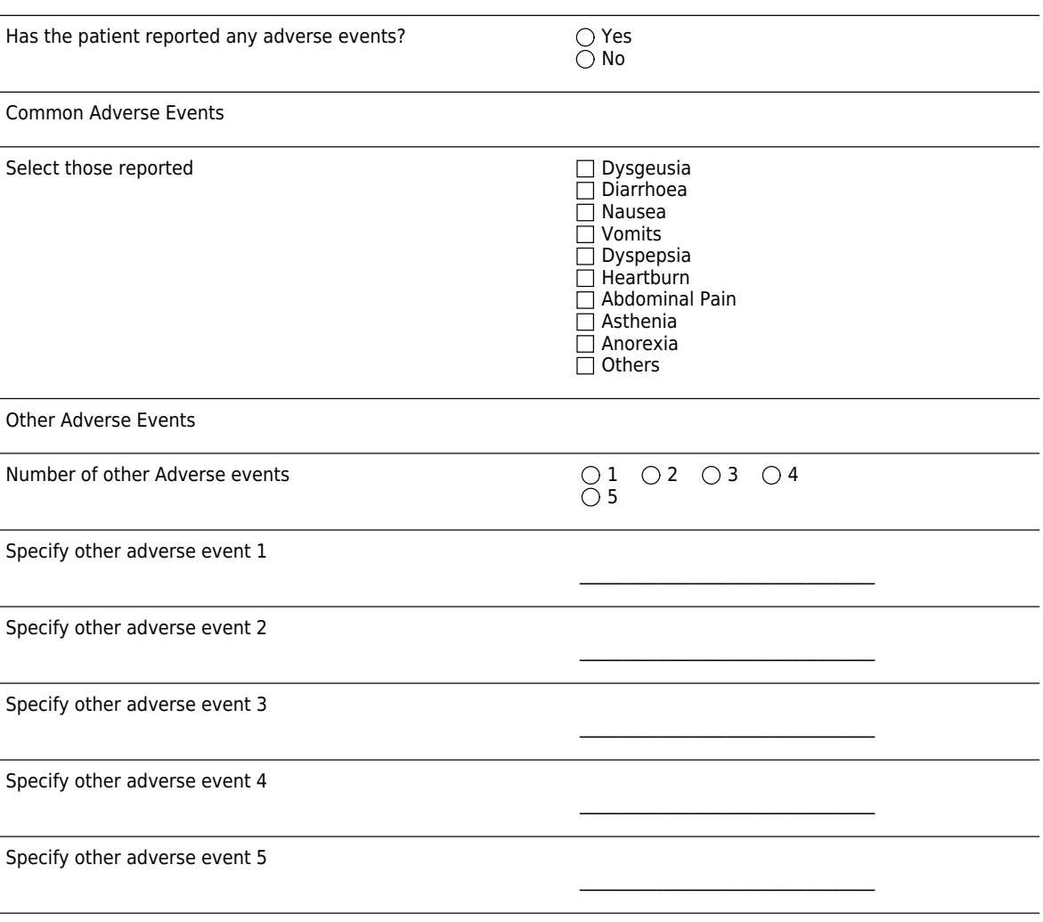
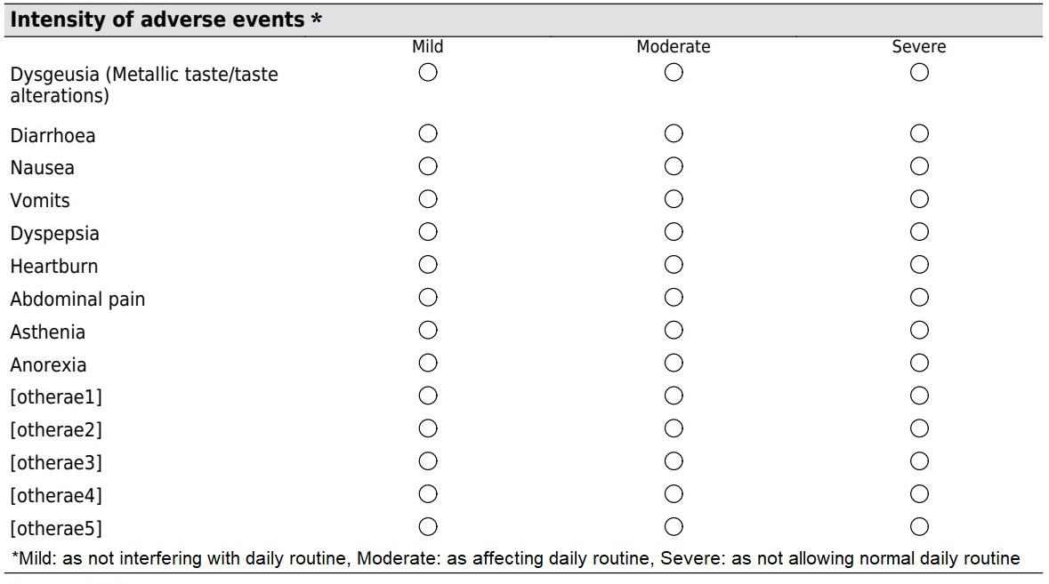
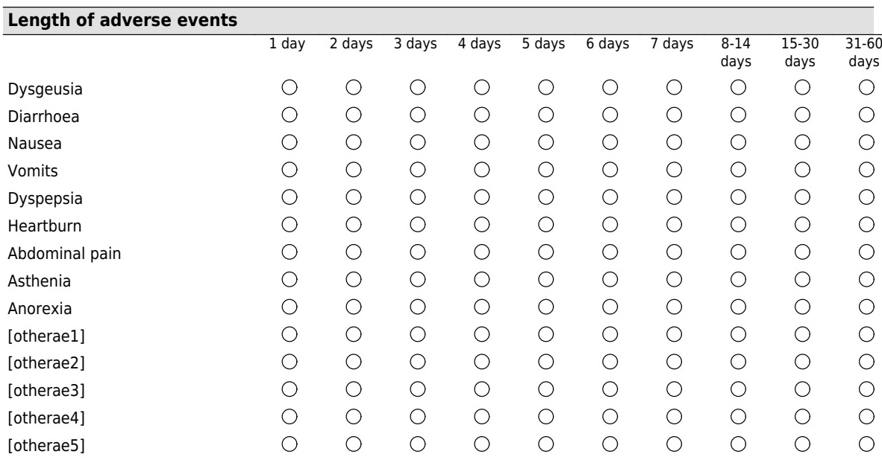
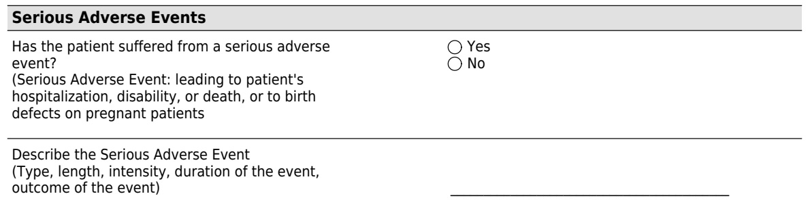

Supplementary table 2. Inclusion of patients reporting any adverse event per country

COUNTRY | Frequency (N) | Percentage (%)
Spain | 11,987 | 53.3
Slovenia | 3,032 | 13.5
Russia | 2,446 | 10.9
Lithuania | 1,082 | 4.8
Ukraine | 489 | 2.2
Greece | 425 | 1.9
Latvia | 418 | 1.9
Portugal | 403 | 1.8
Italy | 309 | 1.4
UK | 261 | 1.2
Norway | 260 | 1.2
Hungary | 248 | 1.1
Ireland | 240 | 1.1
Israel | 227 | 1
Turkey | 197 | 0.9
Romania | 115 | 0.5
Germany | 93 | 0.4
France | 88 | 0.4
Bulgaria | 63 | 0.3
Croatia | 58 | 0.3
Belgium | 25 | 0.1
Switzerland | 20 | 0.1
Denmark | 6 | 0
Total | 22,492 | 100

Supplementary table 3. Intensity of each adverse event by treatment scheme

- Metallic taste
 | Mild, N | % | 95% CI | Moderate, N | % | 95% CI | Severe, N | % | 95% CI
PPI+C+A | 124 | 36 | (31-42) | 173 | 51 | (46-57) | 41 | 12 | (8.5-16)
Concomitant (PPI+C+A+M) | 250 | 66 | (61-71) | 114 | 30 | (25-35) | 16 | 4.2 | (2.1-6.4)
PPI+three-in-one | 90 | 72 | (64-80) | 34 | 27 | (19-35) | 1 | 0.8 | (0.02-4.4)
PPI+C+A+B | 264 | 86 | (82-90) | 40 | 13 | (9.1-17) | 4 | 1.3 | (0.36-3.3)
PPI+A+L | 12 | 44 | (24-65) | 14 | 52 | (31-73) | 1 | 3.7 | (0.09-19)
PPI+C+M | 34 | 45 | (33-57) | 33 | 44 | (32-56) | 8 | 11 | (3.0-18)
PPI+A+L+B | 34 | 79 | (66-92) | 9 | 21 | (7.6-34) | 0 | 0.00 | (0.00-8.2)
Triple-A+M | 19 | 68 | (49-87) | 7 | 25 | (7.2-43) | 2 | 7.1 | (0.88-24)
Sequential (PPI+C+A+M) | 13 | 57 | (34-79) | 9 | 39 | (17-61) | 1 | 4.3 | (0.11-22)
PPI+B+Tc+M | 24 | 63 | (47-80) | 12 | 32 | (15-48) | 2 | 5.3 | (0.64-18)
PPI+B+A+J | 5 | 39 | (14-68) | 6 | 46 | (19-75) | 2 | 15 | (1.9-45)
PPI+B+D+M | 17 | 90 | (67-99) | 2 | 11 | (1.3-33) | 0 | 0.00 | (0.00-18)
Sequential (PPI+C+A+T) | NA | NA | NA | NA | NA | NA | NA | NA | NA
Concomitant (PPI+C+A+T) | 1 | 50 | (1.3-99) | 1 | 50 | (1.3-99) | 0 | 0.00 | (0.00-84)

N: number of patients; PPI: proton-pomp-inhibitor; CI: confidence interval; NA: not available; A: amoxicillin C: clarithromycin; M: metronidazole; T: tinidazole; D: doxycycline; L: levofloxacin; B: bismuth; Tc: tetracycline; J: josamycin; three-in-one: three-in-one single capsule bismuth quadruple therapy.

- Diarrhoea

 | Mild, N | % | 95% CI | Moderate, N | % | 95% CI | Severe, N | % | 95% CI
PPI+C+A | 132 | 56 | (50-63) | 78 | 33 | (27-40) | 24 | 10 | (6.2-14)
Concomitant (PPI+C+A+M) | 291 | 73 | (68-77) | 94 | 24 | (19-28) | 15 | 3.8 | (1.8-5,7)
PPI+three-in-one | 85 | 42 | (35-49) | 114 | 56 | (49-63) | 5 | 2.5 | (0.80-5.6)
PPI+C+A+B | 145 | 69 | (63-76) | 60 | 29 | (22-35) | 5 | 2.4 | (0.78-5.5)
PPI+A+L | 54 | 38 | (29-46) | 88 | 61 | (53-69) | 2 | 1.4 | (0.17-4.9)
PPI+C+M | 15 | 54 | (33-74) | 16 | 46 | (37-77) | 0 | 0.00 | (0.00-12)
PPI+A+L+B | 60 | 66 | (56-76) | 27 | 30 | (20-40) | 4 | 4.4 | (1.2-11)
Triple-A+M | 12 | 43 | (23-63) | 13 | 46 | (26-67) | 3 | 11 | (2.3-28)
Sequential (PPI+C+A+M) | 2 | 50 | (6.8-93) | 2 | 50 | (6.8-93) | 0 | 0.00 | (0.00-60)
PPI+B+Tc+M | 10 | 35 | (15-54) | 17 | 59 | (39-78) | 2 | 6.9 | (0.85-23)
PPI+B+A+J | 12 | 50 | (28-72) | 11 | 46 | (24-68) | 1 | 4.2 | (0.11-21)
PPI+B+D+M | 4 | 40 | (12-74) | 5 | 50 | (19-81) | 1 | 10 | (0.25-45)
Sequential (PPI+C+A+T) | NA | NA | NA | NA | NA | NA | NA | NA | NA
Concomitant (PPI+C+A+T) | 1 | 17 | (0.42-64) | 4 | 67 | (22-96) | 1 | 17 | (0.42-64)

N: number of patients; PPI: proton-pomp-inhibitor; CI: confidence interval; NA: not available; A: amoxicillin C: clarithromycin; M: metronidazole; T: tinidazole; D: doxycycline; L: levofloxacin; B: bismuth; Tc: tetracycline; J: josamycin; three-in-one: three-in-one single capsule bismuth quadruple therapy (Pylera®).

- Nausea

 | Mild, N | % | 95% CI | Moderate, N | % | 95% CI | Severe, N | % | 95% CI
PPI+C+A | 192 | 58 | (53-64) | 114 | 35 | (29-40) | 27 | 7.3 | (5.1-11)
Concomitant (PPI+C+A+M) | 169 | 66 | (60-72) | 75 | 29 | (24-35) | 12 | 4.7 | (1.9-7.5)
PPI+three-in-one | 109 | 55 | (47-62) | 84 | 42 | (35-49) | 7 | 3.5 | (0.70-6.3)
PPI+C+A+B | 102 | 66 | (58-74) | 46 | 30 | (22-37) | 6 | 3.9 | (0.52-7.3)
PPI+A+L | 38 | 36 | (26-45) | 68 | 64 | (54-74) | 0 | 0.00 | (0.00-3.4)
PPI+C+M | 17 | 42 | (25-58) | 19 | 46 | (30-63) | 5 | 12 | (4.1-26)
PPI+A+L+B | 38 | 75 | (62-87) | 11 | 22 | (9.3-34) | 2 | 3.9 | (0.48-13)
Triple-A+M | 10 | 37 | (17-54) | 14 | 52 | (31-73) | 3 | 11 | (2.4-29)
Sequential (PPI+C+A+M) | 10 | 77 | (46-95) | 3 | 23 | (5.0-54) | 0 | 0.00 | (0.00-25)
PPI+B+Tc+M | 25 | 53 | (38-69) | 17 | 36 | (21-51) | 5 | 11 | (3.5-23)
PPI+B+A+J | 3 | 23 | (5.0-54) | 6 | 46 | (19-75) | 4 | 31 | (9.1-61)
PPI+B+D+M | 19 | 58 | (39-76) | 10 | 30 | (13-47) | 4 | 12 | (3.4-28)
Sequential (PPI+C+A+T) | 1 | 100 | NA | 0 | 0.00 | NA | 0 | 0.00 | NA
Concomitant (PPI+C+A+T) | 2 | 33 | (4.3-78) | 1 | 17 | (.42-64) | 3 | 50 | (12-88)

N: number of patients; PPI: proton-pomp-inhibitor; CI: confidence interval; NA: not available; A: amoxicillin C: clarithromycin; M: metronidazole; T: tinidazole; D: doxycycline; L: levofloxacin; B: bismuth; Tc: tetracycline; J: josamycin; three-in-one: three-in-one single capsule bismuth quadruple therapy (Pylera®).

- Vomiting

 | Mild, N | % | 95% CI | Moderate, N | % | 95% CI | Severe, N | % | 95% CI
PPI+C+A | 49 | 54 | (44-65) | 35 | 39 | (28-50) | 6 | 6.7 | (0.96-12)
Concomitant (PPI+C+A+M) | 51 | 60 | (49-71) | 27 | 32 | (21-42) | 7 | 8.2 | (1.8-15)
PPI+three-in-one | 68 | 62 | (52-71) | 38 | 35 | (25-44) | 4 | 3.6 | (1.0-9.0)
PPI+C+A+B | 57 | 71 | (61-82) | 21 | 26 | (16-37) | 2 | 2.5 | (0.30-8.7)
PPI+A+L | 43 | 58 | (46-70) | 30 | 41 | (29-52) | 1 | 1.4 | (0.03-7.3)
PPI+C+M | 1 | 9.1 | (0.23-41) | 6 | 55 | (23-83) | 4 | 36 | (11-69)
PPI+A+L+B | 11 | 55 | (32-77) | 8 | 40 | (19-64) | 1 | 5.0 | (0.13-25)
Triple-A+M | 5 | 39 | (14-68) | 5 | 39 | (14-68) | 3 | 23 | (5.0-54)
Sequential (PPI+C+A+M) | 2 | 67 | (9.4-99) | 1 | 33 | (0.84-91) | 0 | 0.00 | (0.00-71)
PPI+B+Tc+M | 9 | 53 | (28-77) | 7 | 41 | (18-67) | 1 | 5.9 | (0.15-29)
PPI+B+A+J | 0 | NA | NA | 1 | 100 | NA | 0 | 0.00 | NA
PPI+B+D+M | 5 | 63 | (24-91) | 2 | 25 | (3.2-65) | 1 | 13 | (0.32-53)
Sequential (PPI+C+A+T) | 0 | 0.00 | NA | 1 | 100 | NA | 0 | 0.00 | NA
Concomitant (PPI+C+A+T) | 1 | 50 | (1.3-99) | 0 | 0.00 | (0.00-84) | 1 | 50 | (1.3-99)

N: number of patients; PPI: proton-pomp-inhibitor; CI: confidence interval; NA: not available; A: amoxicillin C: clarithromycin; M: metronidazole; T: tinidazole; D: doxycycline; L: levofloxacin; B: bismuth; Tc: tetracycline; J: josamycin; three-in-one: three-in-one single capsule bismuth quadruple therapy (Pylera®).

- Dyspepsia

 | Mild, N | % | 95% CI | Moderate, N | % | 95%CI | Severe, N | % | 95%CI
PPI+C+A | 67 | 48 | (39-56) | 67 | 48 | (39-56) | 7 | 5.0 | (1.0-8.9)
Concomitant (PPI+C+A+M) | 57 | 59 | (48-69) | 29 | 30 | (20-40) | 11 | 11 | (4.5-18)
PPI+three-in-one | 41 | 44 | (33-55) | 48 | 52 | (41-62) | 4 | 4.3 | (1.2-11)
PPI+C+A+B | 23 | 59 | (42-76) | 15 | 39 | (22-55) | 1 | 2.6 | (0.07-13)
PPI+A+L | 18 | 33 | (19-46) | 36 | 66 | (52-79) | 1 | 1.8 | (0.05-7.9)
PPI+C+M | 24 | 49 | (34-64) | 23 | 47 | (32-62) | 2 | 4.1 | (0.50-14)
PPI+A+L+B | 6 | 40 | (16-68) | 9 | 60 | (32-84) | 0 | 0.00 | (0.00-22)
Triple-A+M | 6 | 38 | (15-65) | 6 | 38 | (39-56) | 4 | 25 | (7.3-52)
Sequential (PPI+C+A+M) | 3 | 50 | (12-88) | 3 | 50 | (12-88) | 0 | 0.00 | (0.00-46)
PPI+B+Tc+M | 9 | 69 | (39-91) | 4 | 31 | (9.1-61) | 0 | 0.00 | (0.00-25)
PPI+B+A+J | 2 | 29 | (3.7-71) | 4 | 57 | (18-90) | 1 | 14 | (0.36-58)
PPI+B+D+M | 10 | 66 | (35-85) | 5 | 31 | (11-59) | 1 | 6.3 | (0.16-30)
Sequential (PPI+C+A+T) | NA | NA | NA | NA | NA | NA | NA | NA | NA
Concomitant (PPI+C+A+T) | NA | NA | NA | NA | NA | NA | NA | NA | NA

N: number of patients; PPI: proton-pomp-inhibitor; CI: confidence interval; NA: not available; A: amoxicillin C: clarithromycin; M: metronidazole; T: tinidazole; D: doxycycline; L: levofloxacin; B: bismuth; Tc: tetracycline; J: josamycin; three-in-one: three-in-one single capsule bismuth quadruple therapy (Pylera®).

- Heartburn

 | Mild, N | % | 95%CI | Moderate, N |  | % | 95%CI | Severe, N | % | 95%CI
PPI+C+A | 48 | 61 | (49-72) | 24 | 30 |  | (20-41) | 7 | 8.9 | (2.0-16)
Concomitant (PPI+C+A+M) | 14 | 58 | (37-80) | 8 | 33 |  | (12-54) | 2 | 8.3 | (1.0-27)
PPI+three-in-one | 10 | 46 | (22-69) | 11 | 50 |  | (27-73) | 1 | 4.5 | (0.12-23)
PPI+C+A+B | 7 | 78 | (40-97) | 2 | 22 |  | (2.8-60) | 0 | 0.00 | (0.00-34)
PPI+A+L | 8 | 31 | (11-50) | 18 | 69 |  | (50-89) | 0 | 0.00 | (0.00-13)
PPI+C+M | 0 | 0.00 | (0.00-52) | 4 | 80 |  | (28-99) | 1 | 20 | (0.51-72)
PPI+A+L+B | 0 | 0.00 | (0.00-84) | 2 | 100 |  | (16-100) | 0 | 0.00 | (0.00-84)
Triple-A+M | 7 | 47 | (21-73) | 3 | 20 |  | (4.3-48) | 5 | 33 | (12-62)
Sequential (PPI+C+A+M) | NA | NA | NA | NA | NA |  | NA | NA | NA | NA
PPI+B+Tc+M | 2 | 67 | (9.4-99) | 1 | 33 |  | (0.84-91) | 0 | 0.00 | (0.00-71)
PPI+B+A+J | 2 | 100 | (16-100) | 0 | 0.00 |  | (0.00-84) | 0 | 0.00 | (0.00-84)
PPI+B+D+M | 0 | 0.00 | (0.00-84) | 1 | 50 |  | (1.3-99) | 1 | 50 | (1.3-99)
Sequential (PPI+C+A+T) | NA | NA | NA | NA | NA |  | NA | NA | NA | NA
Concomitant (PPI+C+A+T) | NA | NA | NA | NA | NA |  | NA | NA | NA | NA

N: number of patients; PPI: proton-pomp-inhibitor; CI: confidence interval; NA: not available; A: amoxicillin C: clarithromycin; M: metronidazole; T: tinidazole; D: doxycycline; L: levofloxacin; B: bismuth; Tc: tetracycline; J: josamycin; three-in-one: three-in-one single capsule bismuth quadruple therapy (Pylera®).

- Abdominal pain

 | Mild, N | % | 95%CI | Moderate, N | % | 95%CI | Severe, N | % | 95%CI
PPI+C+A | 59 | 53 | (43-62) | 38 | 34 | (25-43) | 15 | 13 | (6.6-20)
Concomitant (PPI+C+A+M) | 109 | 67 | (60-75) | 42 | 26 | (19-33) | 11 | 6.8 | (2.6-11)
PPI+three-in-one | 70 | 56 | (47-65) | 47 | 38 | (29-46) | 8 | 6.4 | (1.7-11)
PPI+C+A+B | 107 | 82 | (70-85) | 18 | 14 | (7.5-20) | 6 | 4.6 | (0.62-8.5)
PPI+A+L | 14 | 54 | (33-75) | 11 | 42 | (21-63) | 1 | 3.8 | (0.10-20)
PPI+C+M | 4 | 33 | (9.9-65) | 3 | 25 | (5.5-57) | 5 | 42 | (15-72)
PPI+A+L+B | 16 | 64 | (43-85) | 8 | 32 | (12-52) | 1 | 4.0 | (0.10-20)
Triple-A+M | 9 | 43 | (19-66) | 7 | 33 | (15-57) | 5 | 24 | (8.2-47)
Sequential (PPI+C+A+M) | 3 | 75 | (19-99) | 1 | 25 | (0.63-81) | 0 | 0.00 | (0.00-60)
PPI+B+Tc+M | 5 | 36 | (13-65) | 5 | 36 | (13-65) | 4 | 28 | (8.4-58)
PPI+B+A+J | 1 | 17 | (0.42-64) | 4 | 67 | (22-96) | 1 | 17 | (23-68)
PPI+B+D+M | 9 | 45 | (23-68) | 9 | 45 | (23-68) | 2 | 10 | (1.2-32)
Sequential (PPI+C+A+T) | NA | NA | NA | NA | NA | NA | NA | NA | NA
Concomitant (PPI+C+A+T) | 3 | 75 | (19-99) | 0 | 0.00 | (0.00-60) | 1 | 25 | (0.63-81)

N: number of patients; PPI: proton-pomp-inhibitor; CI: confidence interval; NA: not available; A: amoxicillin C: clarithromycin; M: metronidazole; T: tinidazole; D: doxycycline; L: levofloxacin; B: bismuth; Tc: tetracycline; J: josamycin; three-in-one: three-in-one single capsule bismuth quadruple therapy (Pylera®).

- Fatigue

 | Mild, N | % | 95%CI | Moderate, N | % | 95%CI | Severe, N | % | 95%CI
PPI+C+A | 51 | 40 | (31-49) | 62 | 49 | (30-47) | 14 | 11 | (5.2-17)
Concomitant (PPI+C+A+M) | 69 | 63 | (53-72) | 33 | 30 | (21-39) | 8 | 7.0 | (2.0-13)
PPI+three-in-one | 58 | 40 | (32-48) | 71 | 49 | (40-57) | 16 | 11 | (5.6-16)
PPI+C+A+B | 25 | 76 | (60-92) | 7 | 21 | (5.7-37) | 1 | 3.0 | (0.08-16)
PPI+A+L | 8 | 23 | (7.5-38) | 24 | 69 | (52-85) | 3 | 8.6 | (1.8-23)
PPI+C+M | 5 | 42 | (15-72) | 5 | 42 | (15-72) | 2 | 17 | (2.1-48)
PPI+A+L+B | 1 | 9.1 | (0.23-41) | 10 | 91 | (59-100) | 0 | 0.00 | (0.00-28)
Triple-A+M | 2 | 50 | (6.8-93) | 1 | 25 | (0.63-81) | 1 | 25 | (0.63-81)
Sequential (PPI+C+A+M) | 0 | 0.00 | (0.00-52) | 5 | 100 | (48-100) | 0 | 0.00 | (0.63-81)
PPI+B+Tc+M | 3 | 27 | (6.0-61) | 6 | 55 | (23-83) | 2 | 18 | (2.3-52)
PPI+B+A+J | 2 | 40 | (5.3-85) | 2 | 40 | (5.3-85) | 1 | 20 | (0.51-72)
PPI+B+D+M | 5 | 56 | (21-86) | 4 | 44 | (14-79) | 0 | 0.00 | (0.00-34)
Sequential (PPI+C+A+T) | 1 | 50 | (1.3-99) | 1 | 50 | (0.63-81) | 0 | 0.00 | (0.00-84)
Concomitant (PPI+C+A+T) | NA | NA | NA | NA | NA | NA | NA | NA | NA

N: number of patients; PPI: proton-pomp-inhibitor; CI: confidence interval; NA: not available; A: amoxicillin C: clarithromycin; M: metronidazole; T: tinidazole; D: doxycycline; L: levofloxacin; B: bismuth; Tc: tetracycline; J: josamycin; three-in-one: three-in-one single capsule bismuth quadruple therapy (Pylera®).

- Anorexia

 | Mild, N | % | 95%CI | Moderate, N | % | 95%CI | Severe, N | % | 95%CI
PPI+C+A | 26 | 36 | (24-47) | 39 | 53 | (41-66) | 8 | 11 | (3.1-19)
Concomitant (PPI+C+A+M) | 18 | 47 | (33-65) | 18 | 47 | (33-65) | 2 | 5.3 | (0.64-18)
PPI+three-in-one | 14 | 24 | (12-35) | 42 | 71 | (59-84) | 3 | 5.1 | (1.1-14)
PPI+C+A+B | 5 | 50 | (19-81) | 5 | 50 | (33-65) | 0 | 0.00 | (0.00-31)
PPI+A+L | 8 | 14 | (4.2-24) | 44 | 79 | (67-90) | 4 | 7.1 | (2.0-17)
PPI+C+M | 2 | 25 | (3.2-65) | 3 | 38 | (8.5-76) | 3 | 38 | (8.5-76)
PPI+A+L+B | 1 | 25 | (0.63-81) | 3 | 75 | (19-99) | 0 | 0.00 | (0.00-60)
Triple-A+M | 7 | 44 | (20-70) | 7 | 44 | (8.5-76) | 2 | 13 | (1.6-38)
Sequential (PPI+C+A+M) | 2 | 67 | (9.4-99) | 1 | 33 | (0.84-91) | 0 | 0.00 | (0.00-71)
PPI+B+Tc+M | 3 | 30 | (6.7-65) | 6 | 60 | (26-88) | 1 | 10 | (0.25-45)
PPI+B+A+J | 1 | 50 | (1.3-99) | 1 | 50 | (1.3-99) | NA | NA | NA
PPI+B+D+M | NA | NA | NA | NA | NA | NA | NA | NA | NA
Sequential (PPI+C+A+T) | NA | NA | NA | NA | NA | NA | NA | NA | NA
Concomitant (PPI+C+A+T) | NA | NA | NA | NA | NA | NA | NA | NA | NA

N: number of patients; PPI: proton-pomp-inhibitor; CI: confidence interval; NA: not available; A: amoxicillin C: clarithromycin; M: metronidazole; T: tinidazole; D: doxycycline; L: levofloxacin; B: bismuth; Tc: tetracycline; J: josamycin; three-in-one: three-in-one single capsule bismuth quadruple therapy (Pylera®).

