Supplemental Figure
Figure S1. Flow of patients. Flow of patients for study inclusion. FLIP – functional luminal imaging probe. HRM – high-resolution manometry. TBE – timed barium esophagram.
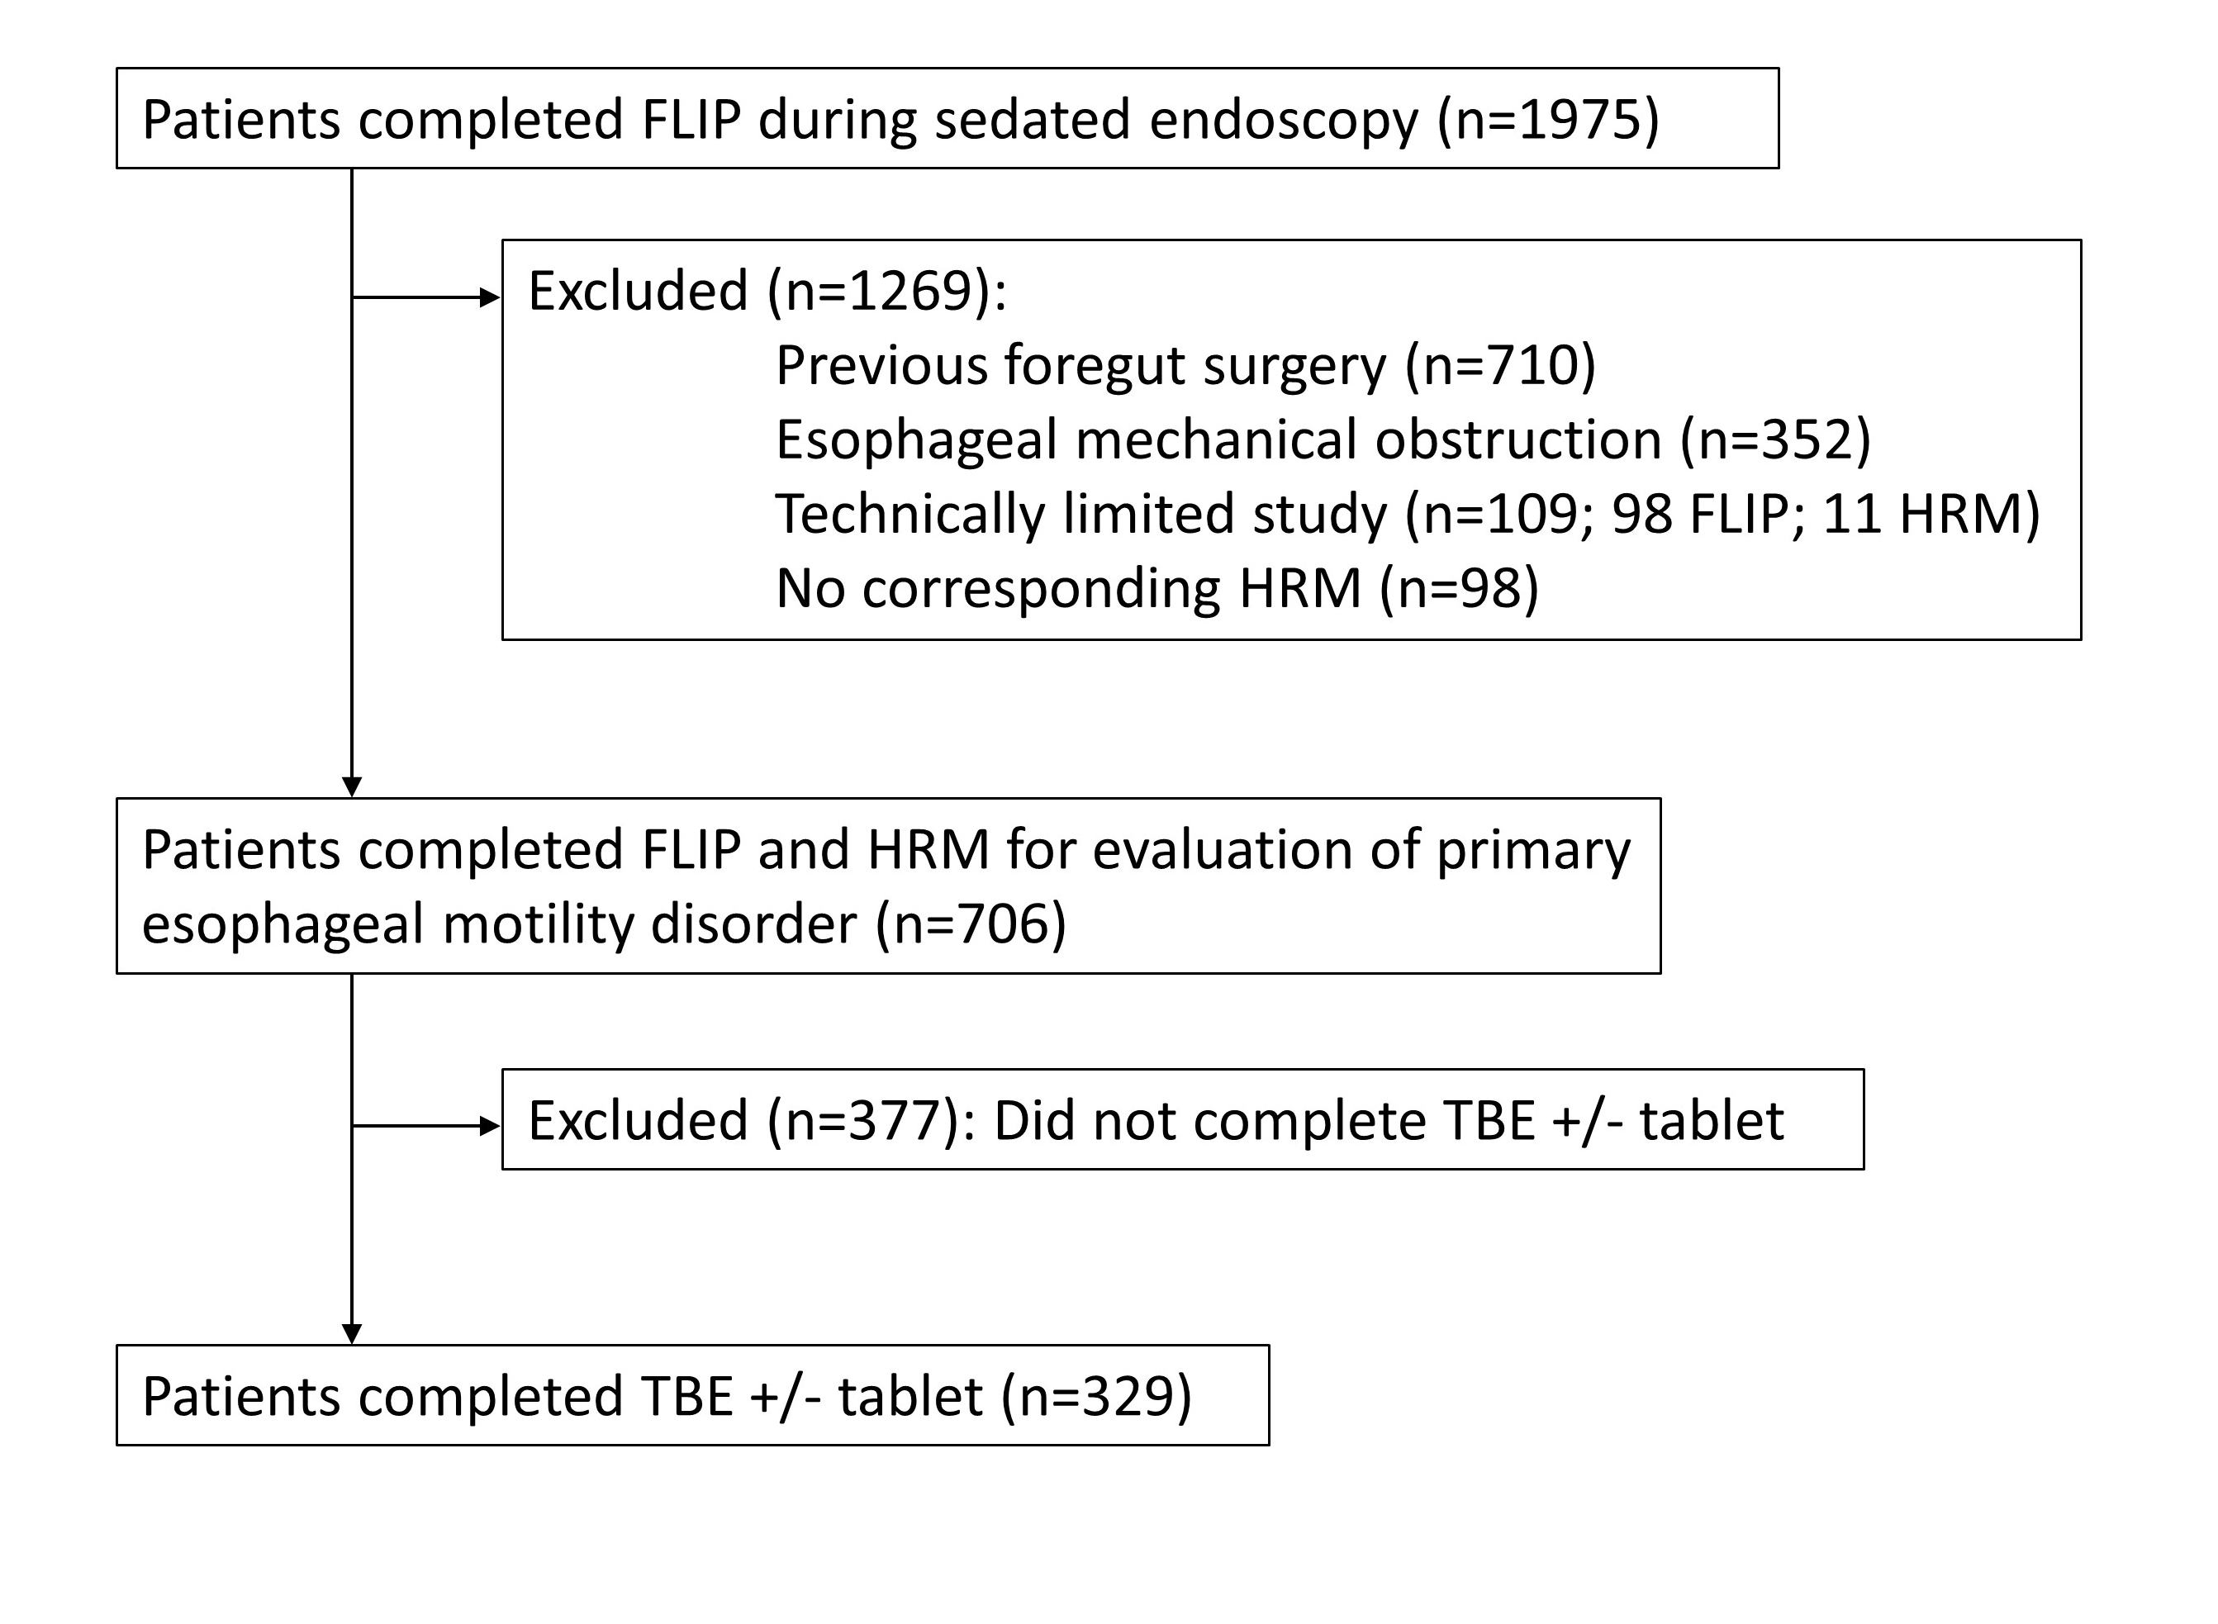

Supplemental Table
Table S1. Binary logistic regression for prediction of timed barium esophagram column height >5 cm at 5-minutes. S1A reflects the binary logistic regression model that included the entire cohort (n=329). S1B reflects the subgroup analysis that omitted patients with achalasia or absent contractility on high-resolution manometry (n=186); 24/186 (13%) met the threshold for an abnormal TBE. ªDefined by type II or type III EGJ-morphology on high-resolution manometry.⁴ SE – standard error. OR – odds ratio. IRP – integrated relaxation pressure. EGJ – esophagogastric junction
S1A – Total Cohort
 | B | SE | OR (95% CI) | P
Age | -0.16 | 0.01 | 0.99 (0.97-1.0) | 0.093
Female Gender | -0.56 | 0.30 | 0.57 (0.32-1.0) | 0.061
Hiatal hernia presentª | 1.2 | 0.44 | 3.2 (1.3-7.5) | 0.009
IRP classification (normal IRP) | -- |  |  | 0.051
Isolated IRP elevation | 0.10 | 0.52 | 1.1 (0.40-3.1) | 0.850
Consistent IRP elevation | 0.84 | 0.43 | 2.3 (0.99-5.4) | 0.051
FLIP-EGJ (Normal EGJ opening) | -- |  |  | <0.001
Borderline-normal EGJ opening | 0.83 | 0.76 | 2.3 (0.52-10.0) | 0.274
Borderline-reduced EGJ opening | 2.5 | 0.63 | 11.9 (3.5-41.0) | <0.001
Reduced EGJ opening | 3.3 | 0.57 | 28.1 (9.1-86.7) | <0.001
Constant | -3.1 | 0.89 | 0.04 | <0.001

S1B – Subgroup
 | B | SE | OR (95% CI) | P
Age | -0.01 | 0.02 | 0.99 (0.96-1.03) | 0.675
Female Gender | -1.0 | 0.56 | 0.36 (0.12-1.1) | 0.070
Hiatal hernia presentª | 1.1 | 0.73 | 2.9 (0.70-12.2) | 0.141
IRP classification (normal IRP) | -- |  |  | 0.933
Isolated IRP elevation | -0.08 | 0.89 | 0.93 (0.16-5.2) | 0.93
Consistent IRP elevation | -0.25 | 0.70 | 0.78 (0.20-3.1) | 0.782
FLIP-EGJ (Normal EGJ opening) | -- |  |  | <0.001
Borderline-normal EGJ opening | 0.69 | 1.5 | 2.0 (0.11-34.1) | 0.637
Borderline-reduced EGJ opening | 1.3 | 1.5 | 3.7 (0.21-66.1) | 0.376
Reduced EGJ opening | 4.0 | 1.1 | 56.9 (6.4-504) | <0.001
Constant | -4.1 | 1.6 | 0.02 | 0.008

