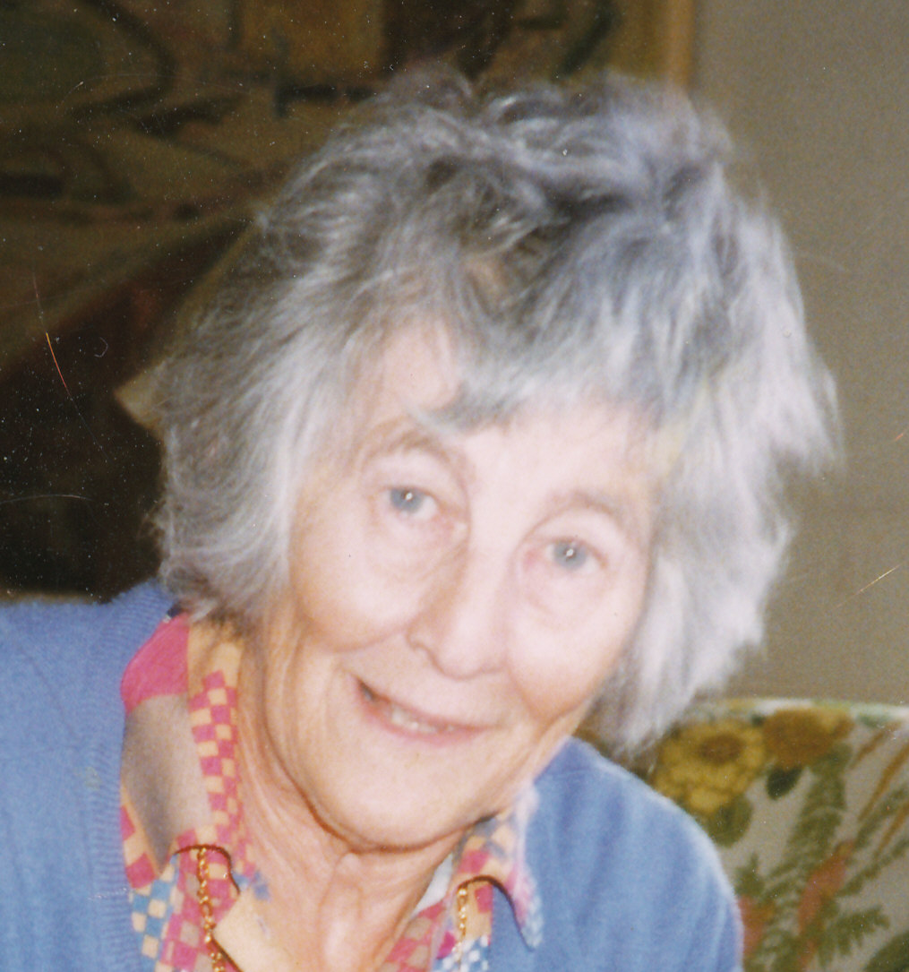

Supplemental Digital Content 2:
Ulla Gordh, M.D., first working with anesthesia, later in psychiatry, performed the first lidocaine tests in volunteers in 1944 with Torsten Gordh.
Photo taken by John W Severinghaus, M.D. Professor Emeritus of Anesthesia, University of California in San Francisco; Emeritus Senior Staff Member, Cardiovascular Research Institute.

