Supplemental Digital Content 1: Individual Forest Plots

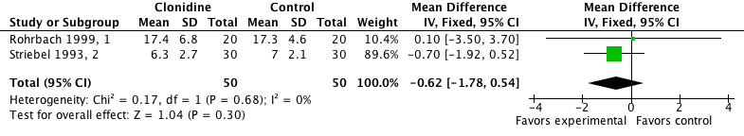

Fig. 1. 2 h morphine consumption (mg), with clonidine. A weighted mean difference less than 0 indicates less morphine consumption with active compared with control.

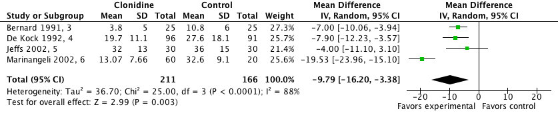

Fig. 2. 12 h morphine consumption (mg), with clonidine. A weighted mean difference less than 0 indicates less morphine consumption with active compared with control.

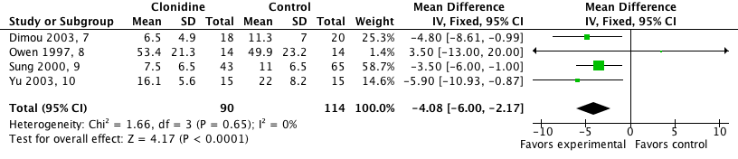

Fig. 3. 24 h morphine consumption (mg), with clonidine. A weighted mean difference less than 0 indicates less morphine consumption with active compared with control.

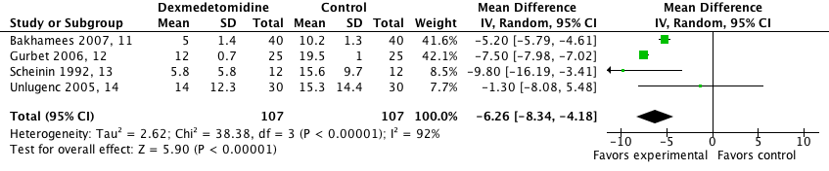

Fig. 4. 2 h morphine consumption (mg), with dexmedetomidine. A weighted mean difference less than 0 indicates less morphine consumption with active compared with control.

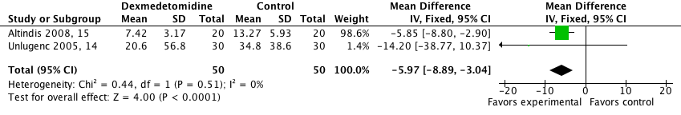

Fig. 5. 12 h morphine consumption (mg), with dexmedetomidine. A weighted mean difference less than 0 indicates less morphine consumption with active compared with control.

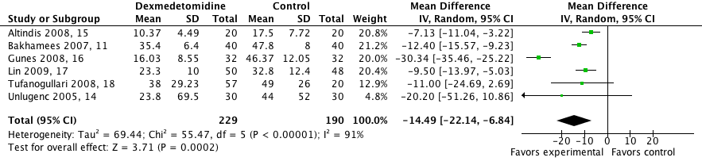

Fig. 6. 24 h morphine consumption (mg), with dexmedetomidine. A weighted mean difference less than 0 indicates less morphine consumption with active compared with control.

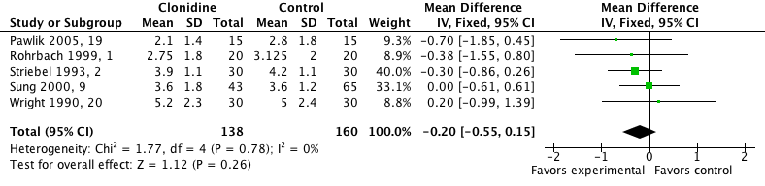

Fig. 7. 1 h visual analog pain score (cm), with clonidine. A weighted mean difference less than 0 indicates less pain with active compared with control.

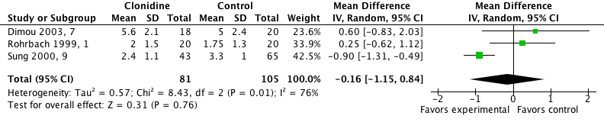

Fig. 8. 2 h visual analog pain score (cm), with clonidine. A weighted mean difference less than 0 indicates less pain with active compared with control.

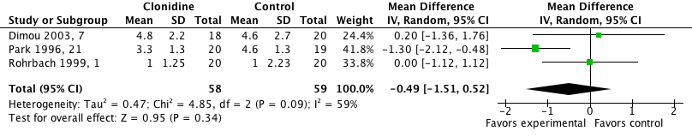

Fig. 9. 4 h visual analog pain score (cm), with clonidine. A weighted mean difference less than 0 indicates less pain with active compared with control.

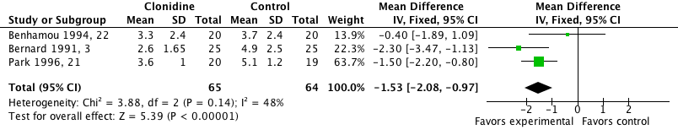

Fig. 10. 1 2h visual analog pain score (cm), with clonidine. A weighted mean difference less than 0 indicates less pain with active compared with control.

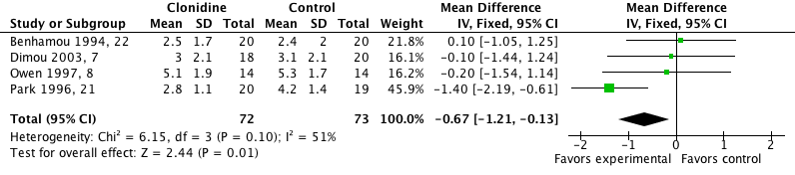

Fig. 11. 24 h visual analog pain score (cm), with clonidine. A weighted mean difference less than 0 indicates less pain with active compared with control.

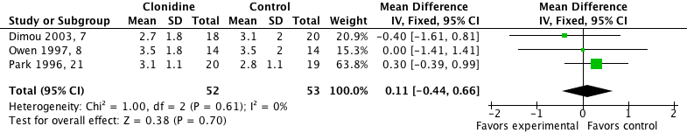

Fig. 12. 48 h visual analog pain score (cm), with clonidine. A weighted mean difference less than 0 indicates less pain with active compared with control.

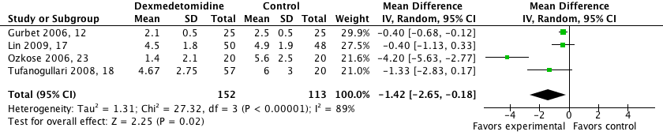

Fig. 13. 1 h visual analog pain score (cm), with dexmedetomidine. A weighted mean difference less than 0 indicates less pain with active compared with control.

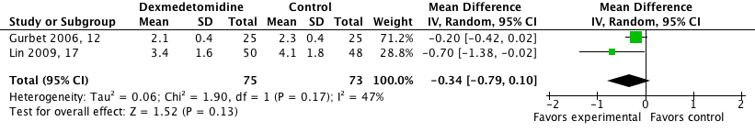

Fig. 14. 2 h visual analog pain score (cm), with dexmedetomidine. A weighted mean difference less than 0 indicates less pain with active compared with control.

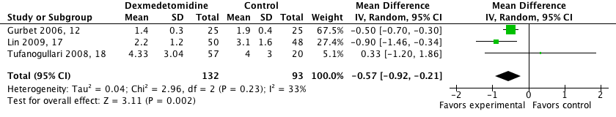

Fig. 15. 24 h visual analog pain score (cm), with dexmedetomidine. A weighted mean difference less than 0 indicates less pain with active compared with control.

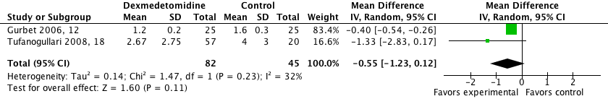

Fig. 16. 48 h visual analog pain score (cm), with dexmedetomidine. A weighted mean difference less than 0 indicates less pain with active compared with control.

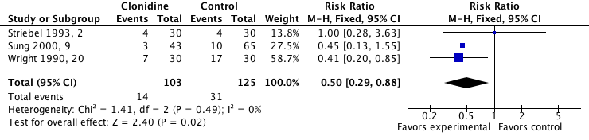

Fig. 17. Postoperative early nausea, with clonidine. A risk ratio less than 1 indicates less nausea with active compared with control.

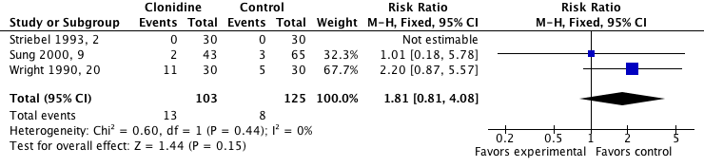

Fig. 18. Postoperative early vomiting, with clonidine. A risk ratio more than 1 indicates more vomiting with active compared with control.

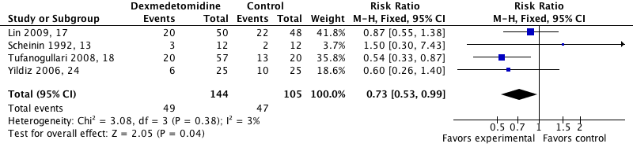

Fig. 19. Postoperative early nausea, with dexmedetomidine. A risk ratio less than 1 indicates less nausea with active compared with control.

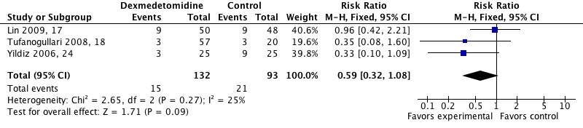

Fig. 20. Postoperative early vomiting, with dexmedetomidine. A risk ratio less than 1 indicates less vomiting with active compared with control.

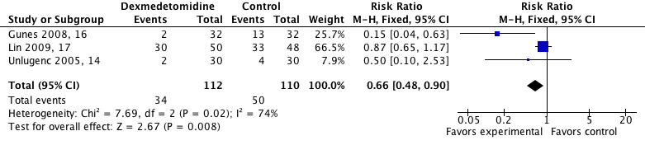

Fig. 21. Postoperative late nausea, with dexmedetomidine. A risk ratio less than 1 indicates less nausea with active compared with control.

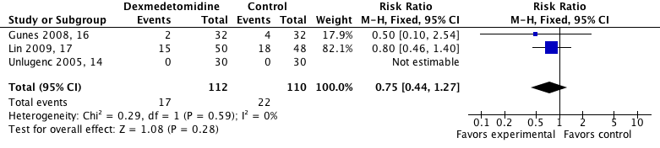

Fig. 22. Postoperative late vomiting, with dexmedetomidine. A risk ratio less than 1 indicates less vomiting with active compared with control.

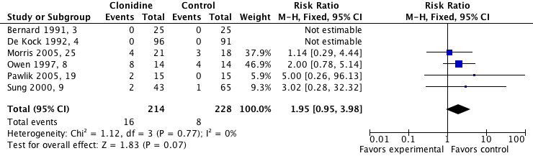

Fig. 23. Intraoperative bradycardia, with clonidine. A risk ratio more than 1 indicates more bradycardia with active compared with control.

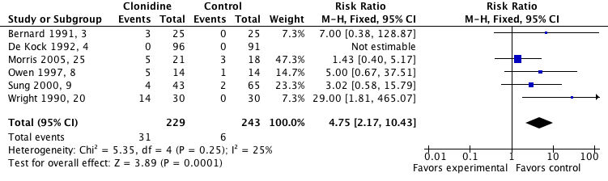

Fig. 24. Intraoperative hypotension, with clonidine. A risk ratio more than 1 indicates more hypotension with active compared with control.

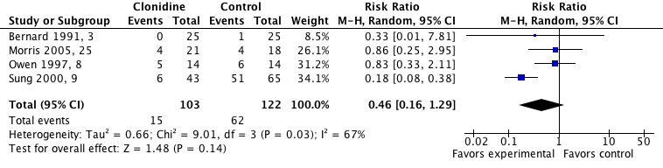

Fig. 25. Intraoperative hypertension, with clonidine. A risk ratio less than 1 indicates less hypertension with active compared with control.

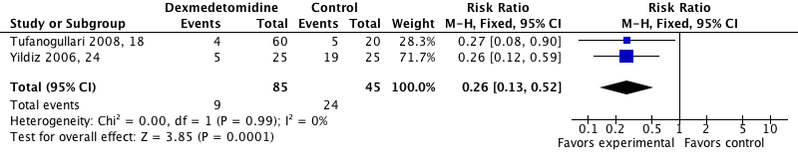

Fig. 26. Intraoperative hypertension, with dexmedetomidine. A risk ratio less than 1 indicates less hypertension with active compared with control.

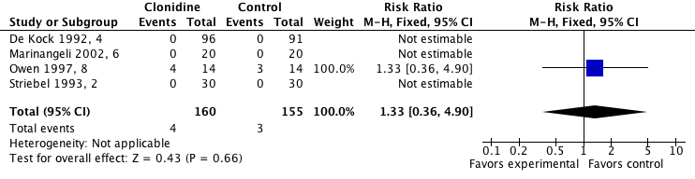

Fig. 27. Postoperative bradycardia, with clonidine. A risk ratio more than 1 indicates more bradycardia with active compared with control.

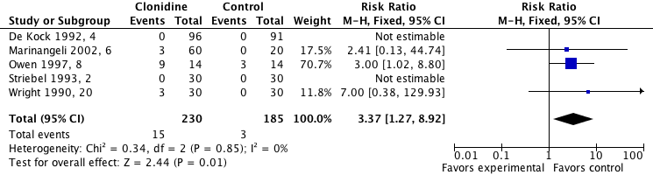

Fig. 28. Postoperative hypotension, with clonidine. A risk ratio more than 1 indicates more hypotension with active compared with control.

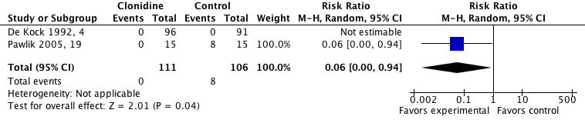

Fig. 29. Postoperative hypertension, with clonidine. A risk ratio less than 1 indicates less hypertension with active compared with control.

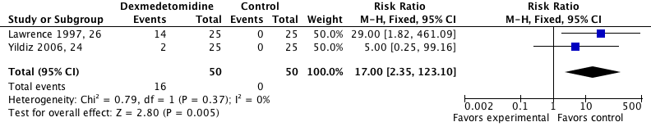

Fig. 30. Postoperative bradycardia, with dexmedetomidine. A risk ratio more than 1 indicates more bradycardia with active compared with control.

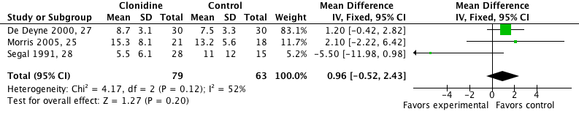

Fig. 31. Time to response to verbal command (min), with clonidine. A weighted mean difference more than 0 indicates more time with active compared with control.

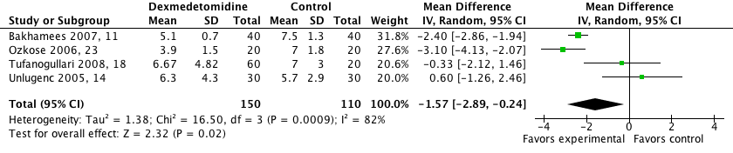

Fig. 32. Time to extubation (min), with dexmedetomidine. A weighted mean difference less than 0 indicates less time with active compared with control.

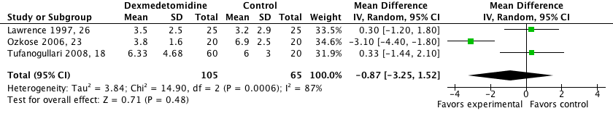

Fig. 33. Time to spontaneous eye opening (min), with dexmedetomidine. A weighted mean difference less than 0 indicates less time with active compared with control.

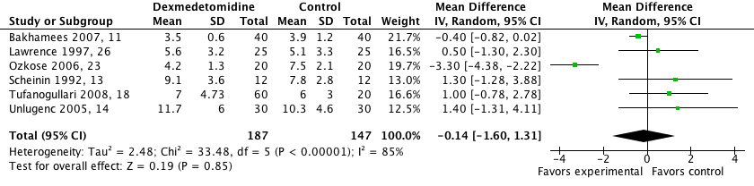

Fig. 34. Time to response to verbal command (min), with dexmedetomidine. A weighted mean difference less than 0 indicates less time with active compared with control.

References
1. Rohrbach A, Jage J, Olthoff D: Intraoperative clonidine modulates sympathetic tone in the early postoperative period after remifentanil. A double blind, placebo-controlled study. Acute Pain 1999; 2:129-38
2. Striebel WH, Koenigs DI, Krämer JA: Intravenous clonidine fails to reduce postoperative meperidine requirements. J Clin Anesth 1993; 5:221-5
3. Bernard JM, Hommeril JL, Passuti N, Pinaud M: Postoperative analgesia by intravenous clonidine. Anesthesiology 1991; 75:577-82
4. De Kock MF, Pichon G, Scholtes JL: Intraoperative clonidine enhances postoperative morphine patient-controlled analgesia. Can J Anaesth 1992; 39:537-44
5. Jeffs SA, Hall JE, Morris S: Comparison of morphine alone with morphine plus clonidine for postoperative patient-controlled analgesia. Br J Anaesth 2002; 89:424-7
6. Marinangeli F, Ciccozzi A, Donatelli F, Di Pietro A, Iovinelli G, Rawal N, Paladini A, Varrassi G: Clonidine for treatment of postoperative pain: A dose-finding study. Eur J Pain 2002; 6:35-42
7. Dimou P, Paraskeva A, Papilas K, Fassoulaki A: Transdermal clonidine: Does it affect pain after abdominal hysterectomy? Acta Anaesthesiol Belg 2003; 54:227-32
8. Owen MD, Fibuch EE, McQuillan R, Millington WR: Postoperative analgesia using a low-dose, oral-transdermal clonidine combination: Lack of clinical efficacy. J Clin Anesth 1997; 9:8-14
9. Sung CS, Lin SH, Chan KH, Chang WK, Chow LH, Lee TY: Effect of oral clonidine premedication on perioperative hemodynamic response and postoperative analgesic requirement for patients undergoing laparoscopic cholecystectomy. Acta Anaesthesiol Sin 2000; 38:23-9
10. Yu HP, Hseu SS, Yien HW, Teng YH, Chan KH: Oral clonidine premedication preserves heart rate variability for patients undergoing larparoscopic cholecystectomy. Acta Anaesthesiol Scand 2003; 47:185-90
11. Bakhamees HS, El-Halafawy YM, El-Kerdawy HM, Gouda NM, Altemyatt S: Effects of dexmedetomidine in morbidly obese patients undergoing laparoscopic gastric bypass. Middle East J Anesthesiol 2007; 19:537-51
12. Gurbet A, Basagan-Mogol E, Turker G, Ugun F, Kaya FN, Ozcan B: Intraoperative infusion of dexmedetomidine reduces perioperative analgesic requirements. Can J Anaesth 2006; 53:646-52
13. Scheinin B, Lindgren L, Randell T, Scheinin H, Scheinin M: Dexmedetomidine attenuates sympathoadrenal responses to tracheal intubation and reduces the need for thiopentone and peroperative fentanyl. Br J Anaesth 1992; 68:126-31
14. Unlugenc H, Gunduz M, Guler T, Yagmur O, Isik G: The effect of pre-anaesthetic administration of intravenous dexmedetomidine on postoperative pain in patients receiving patient-controlled morphine. Eur J Anaesthesiol 2005; 22:386-91
15. Altindis NT, Karaaslan D, Peker TT, Ozmen S, Bulbul M: Comparison of meperidine alone with meperidine plus dexmedetomidine for postoperative patient-controlled analgesia. Neurosciences (Riyadh) 2008; 13:117-21
16. Gunes Y, Ozbek TH, Gunduz HM, Gedik YE, Erman T, Ozcengiz D: Patient-controlled analgesia comparison of morphine to dexmedetomidine plus morphine in patients undergoing laminectomy. Neurosurg Q 2008; 178-81
17. Lin TF, Yeh YC, Lin FS, Wang YP, Lin CJ, Sun WZ, Fan SZ: Effect of combining dexmedetomidine and morphine for intravenous patient-controlled analgesia. Br J Anaesth 2009; 102:117-22
18. Tufanogullari B, White PF, Peixoto MP, Kianpour D, Lacour T, Griffin J, Skrivanek G, Macaluso A, Shah M, Provost DA: Dexmedetomidine infusion during laparoscopic bariatric surgery: The effect on recovery outcome variables. Anesth Analg 2008; 106:1741-8
19. Pawlik MT, Hansen E, Waldhauser D, Selig C, Kuehnel TS: Clonidine premedication in patients with sleep apnea syndrome: A randomized, double-blind, placebo-controlled study. Anesth Analg 2005; 101:1374-80
20. Wright PM, Carabine UA, McClune S, Orr DA, Moore J: Preanaesthetic medication with clonidine. Br J Anaesth 1990; 65:628-32
21. Park J, Forrest J, Kolesar R, Bhola D, Beattie S, Chu C: Oral clonidine reduces postoperative PCA morphine requirements. Can J Anaesth 1996; 43:900-6
22. Benhamou D, Narchi P, Hamza J, Marx M, Peyrol MT, Sembeil F: Addition of oral clonidine to postoperative patient-controlled analgesia with i.v. morphine. Br J Anaesth 1994; 72:537-40
23. Ozkose Z, Demir FS, Pampal K, Yardim S: Hemodynamic and anesthetic advantages of dexmedetomidine, an alpha 2-agonist, for surgery in prone position. Tohoku J Exp Med 2006; 210:153-60
24. Yildiz M, Tavlan A, Tuncer S, Reisli R, Yosunkaya A, Otelcioglu S: Effect of dexmedetomidine on haemodynamic responses to laryngoscopy and intubation: Perioperative haemodynamics and anaesthetic requirements. Drugs R D 2006; 7:43-52
25. Morris J, Acheson M, Reeves M, Myles PS: Effect of clonidine pre-medication on propofol requirements during lower extremity vascular surgery: A randomized controlled trial. Br J Anaesth 2005; 95:183-8
26. Lawrence CJ, De Lange S: Effects of a single pre-operative dexmedetomidine dose on isoflurane requirements and peri-operative haemodynamic stability. Anaesthesia 1997; 52:736-44
27. De Deyne C, Struys M, Heylen R, De Jongh R, Van der Laenen M, Buyse L, Deghislage J, Rolly G: Influence of intravenous clonidine pretreatment on anesthetic requirements during bispectral EEG-guided sevoflurane anesthesia. J Clin Anesth 2000; 12:52-7
28. Segal IS, Jarvis DJ, Duncan SR, White PF, Maze M: Clinical efficacy of oral-transdermal clonidine combinations during the perioperative period. Anesthesiology 1991; 74:220-5

