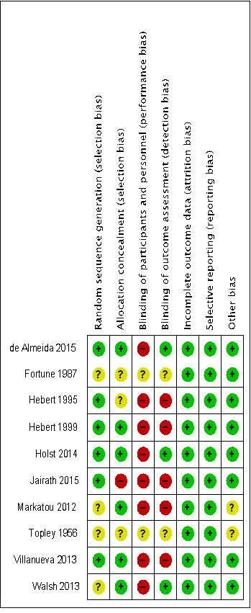
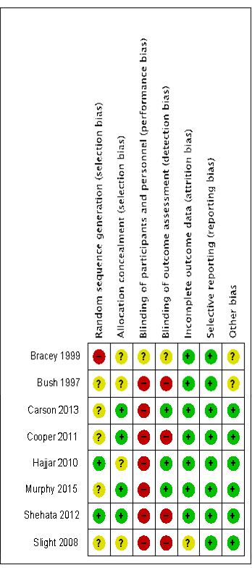
Supplemental Digital Content 9. Risk of bias summary

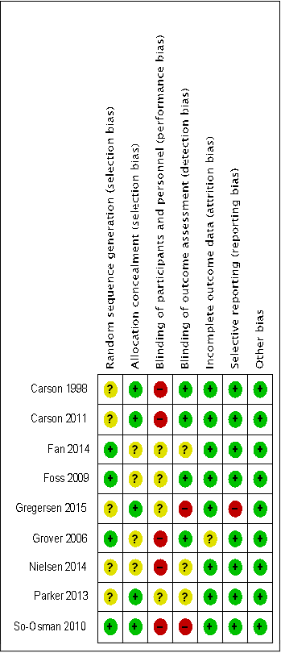
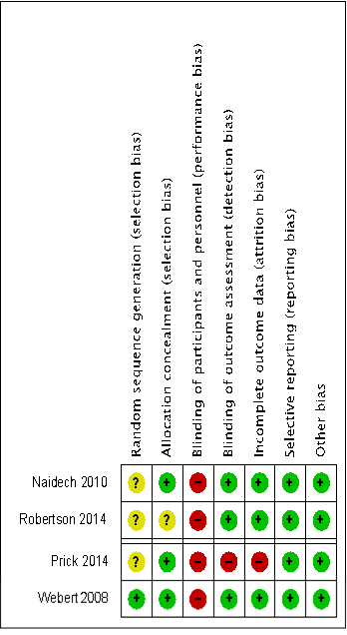

Group 1 studies
Group 3 studies

Group 4 studies
Group 5 studies
Group 2 studies

Summary of the risk of bias. Color code: red = high risk of bias; yellow = unclear risk of bias; green = low risk of bias. Group 1 studies: patients with cardiovascular disease undergoing cardiac or vascular procedures (surgery or catheterization); Group 2 studies: elderly patients undergoing orthopedic surgery; Group 3 studies: mixed surgical/medical patient population admitted to an acute care facility (emergency or intensive care unit); Group 4 studies: younger population admitted to an intensive care facility for acute traumatic brain injury or subarachnoid hemorrhage; Group 5 studies: other patients or clinical settings.

