Supplemental Digital Content 6 : ABP-700 population and individual predictions versus time and observed BIS.
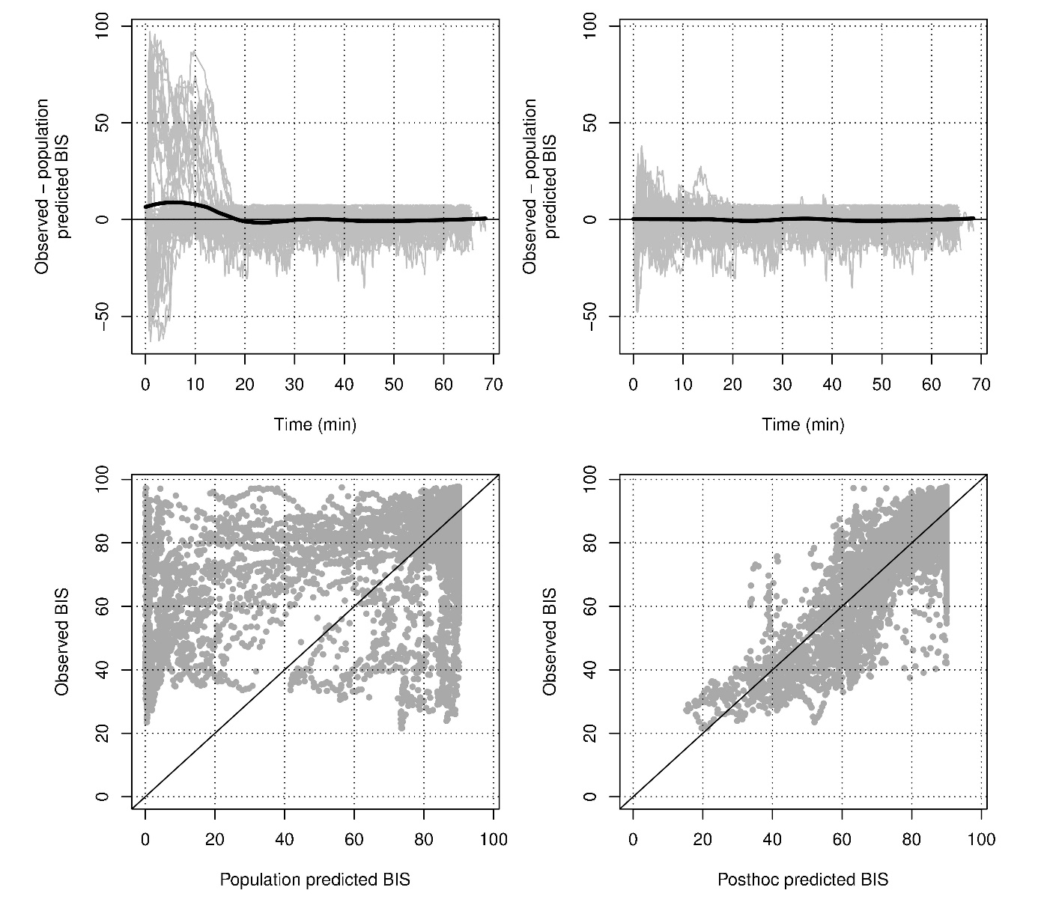
BIS is the Bispectral Index as measured by the Vista Monitor (Medtronic, Dublin, Ireland)

