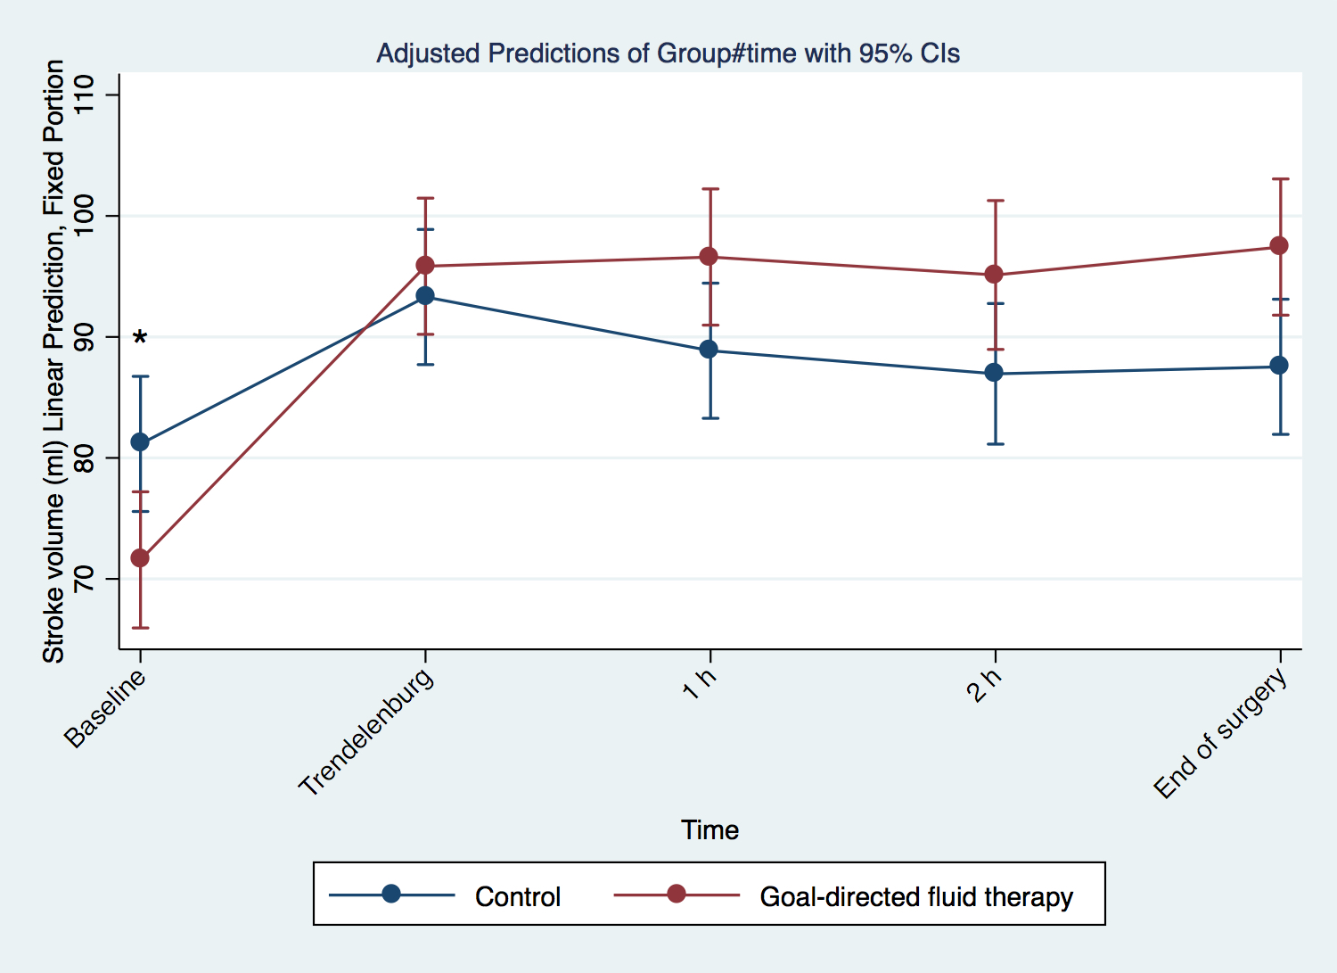

Figure B. Stroke volume between groups during surgery (slope difference, p<0.001). Baseline= ₌5 minutes after induction of anesthesia; Trendelenburg= goal-directed fluid therapy group: final stroke volume measurement in Trendelenburg which did not result in an increase in stroke volume by more than 10%; control group= stroke volume after positioning the patient in Trendelenburg; 1h= 1 hour after beginning of surgery; 2h= 2 hours after beginning of surgery); * p <0.05 between groups at Baseline.

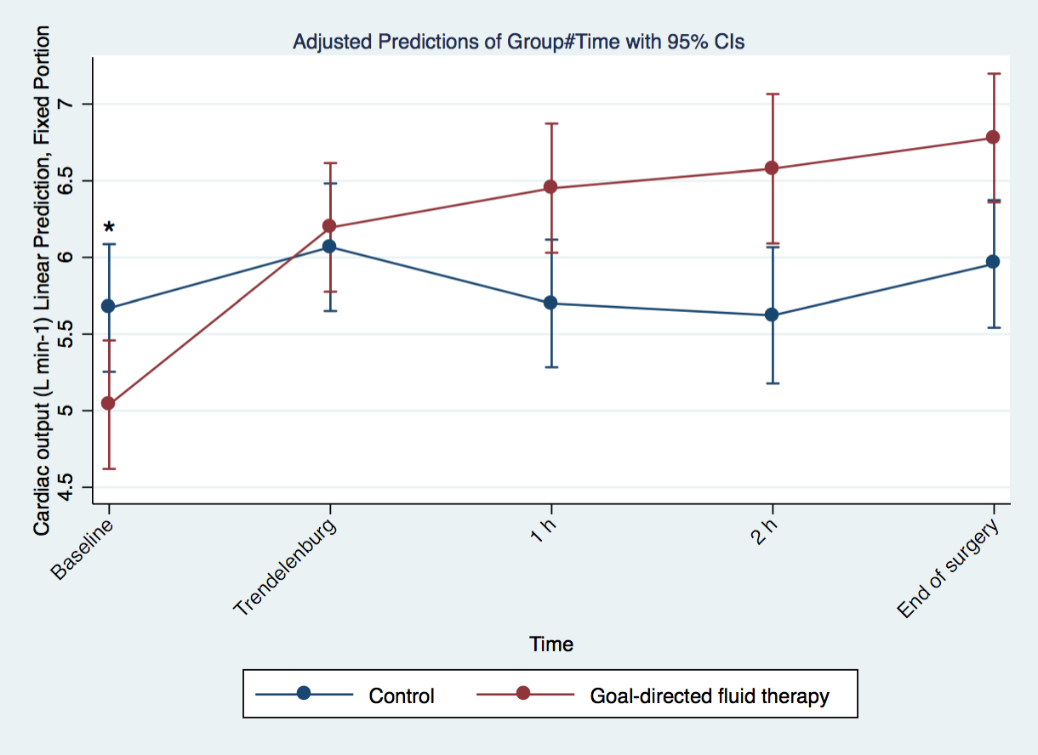

Figure C. Cardiac output between groups during surgery (slope difference, p<0.001). Baseline= ₌5 minutes after induction of anesthesia; Trendelenburg= goal-directed fluid therapy group: final cardiac output measurement in Trendelenburg which did not result in an increase in stroke volume by more than 10%; control group= cardiac output after positioning the patient in Trendelenburg; 1h= 1 hour after beginning of surgery; 2h= 2 hours after beginning of surgery); * p <0.05 between groups at Baseline.

