Supplemental Digital Content 5: ROC curves for age and Glasgow Coma Score.

ROC Curve for Age

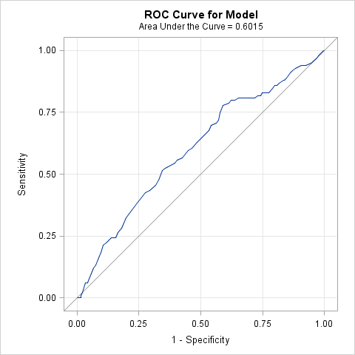

Age | Sensibility | Specificity | PPV | NPV | Youden index
15 | 0 | 0.99704 | 0 | 0.772936 | -0.00296
16 | 0 | 0.99408 | 0 | 0.772414 | -0.00592
17 | 0 | 0.98817 | 0 | 0.771363 | -0.01183
18 | 0 | 0.98521 | 0 | 0.770833 | -0.01479
19 | 0.010101 | 0.98521 | 0.166667 | 0.772622 | -0.00469
20 | 0.020202 | 0.97929 | 0.222222 | 0.773364 | -0.00051
21 | 0.050505 | 0.97041 | 0.333333 | 0.777251 | 0.02092
22 | 0.060606 | 0.96746 | 0.352941 | 0.778571 | 0.02806
23 | 0.060606 | 0.95858 | 0.300000 | 0.776978 | 0.01919
24 | 0.070707 | 0.95562 | 0.318182 | 0.778313 | 0.02633
25 | 0.121212 | 0.93491 | 0.352941 | 0.784119 | 0.05612
26 | 0.131313 | 0.92604 | 0.342105 | 0.784461 | 0.05735
27 | 0.161616 | 0.91124 | 0.347826 | 0.787724 | 0.07286
28 | 0.181818 | 0.90237 | 0.352941 | 0.790155 | 0.08419
29 | 0.212121 | 0.89349 | 0.368421 | 0.794737 | 0.10561
30 | 0.222222 | 0.88166 | 0.354839 | 0.794667 | 0.10388
31 | 0.242424 | 0.86095 | 0.338028 | 0.795082 | 0.10337
32 | 0.242424 | 0.84320 | 0.311688 | 0.791667 | 0.08562
33 | 0.262626 | 0.83432 | 0.317073 | 0.794366 | 0.09695
34 | 0.282828 | 0.81953 | 0.314607 | 0.795977 | 0.10235
35 | 0.323232 | 0.80178 | 0.323232 | 0.801775 | 0.12501
36 | 0.383838 | 0.75740 | 0.316667 | 0.807571 | 0.14123
37 | 0.424242 | 0.72485 | 0.311111 | 0.811258 | 0.14909
38 | 0.434343 | 0.70710 | 0.302817 | 0.810169 | 0.14144
39 | 0.454545 | 0.68343 | 0.296053 | 0.810526 | 0.13798
40 | 0.474747 | 0.67160 | 0.297468 | 0.813620 | 0.14635
41 | 0.515152 | 0.65680 | 0.305389 | 0.822222 | 0.17196
42 | 0.525253 | 0.64201 | 0.300578 | 0.821970 | 0.16726
43 | 0.545455 | 0.60355 | 0.287234 | 0.819277 | 0.14900
44 | 0.555556 | 0.59467 | 0.286458 | 0.820408 | 0.15023
45 | 0.565657 | 0.57396 | 0.280000 | 0.818565 | 0.13962
46 | 0.595960 | 0.55030 | 0.279621 | 0.823009 | 0.14626
47 | 0.606061 | 0.53550 | 0.276498 | 0.822727 | 0.14156
48 | 0.626263 | 0.51775 | 0.275556 | 0.825472 | 0.14401
49 | 0.656566 | 0.48817 | 0.273109 | 0.829146 | 0.14473
50 | 0.676768 | 0.46746 | 0.271255 | 0.831579 | 0.14422
51 | 0.696970 | 0.45858 | 0.273810 | 0.837838 | 0.15555
52 | 0.707071 | 0.43787 | 0.269231 | 0.836158 | 0.14494
53 | 0.717172 | 0.42899 | 0.268939 | 0.838150 | 0.14617
54 | 0.747475 | 0.42308 | 0.275093 | 0.851190 | 0.17055
55 | 0.777778 | 0.41124 | 0.278986 | 0.863354 | 0.18902
56 | 0.787879 | 0.38757 | 0.273684 | 0.861842 | 0.17545
57 | 0.797980 | 0.37574 | 0.272414 | 0.863946 | 0.17372
58 | 0.797980 | 0.36095 | 0.267797 | 0.859155 | 0.15893
59 | 0.808081 | 0.34615 | 0.265781 | 0.860294 | 0.15423
60 | 0.808081 | 0.32840 | 0.260586 | 0.853846 | 0.13648
61 | 0.808081 | 0.30473 | 0.253968 | 0.844262 | 0.11281
62 | 0.808081 | 0.28994 | 0.250000 | 0.837607 | 0.09802
63 | 0.808081 | 0.28107 | 0.247678 | 0.833333 | 0.08915
64 | 0.818182 | 0.26923 | 0.246951 | 0.834862 | 0.08741
65 | 0.818182 | 0.25740 | 0.243976 | 0.828571 | 0.07558
66 | 0.828283 | 0.25148 | 0.244776 | 0.833333 | 0.07976
67 | 0.828283 | 0.23669 | 0.241176 | 0.824742 | 0.06497
68 | 0.828283 | 0.22485 | 0.238372 | 0.817204 | 0.05313
69 | 0.848485 | 0.21006 | 0.239316 | 0.825581 | 0.05854
70 | 0.858586 | 0.20118 | 0.239437 | 0.829268 | 0.05977
71 | 0.858586 | 0.19231 | 0.237430 | 0.822785 | 0.05089
72 | 0.868687 | 0.18343 | 0.237569 | 0.826667 | 0.05212
73 | 0.878788 | 0.16568 | 0.235772 | 0.823529 | 0.04447
74 | 0.878788 | 0.16272 | 0.235135 | 0.820896 | 0.04151
75 | 0.888889 | 0.15385 | 0.235294 | 0.825397 | 0.04274

ROC Curve for Glasgow Coma Score

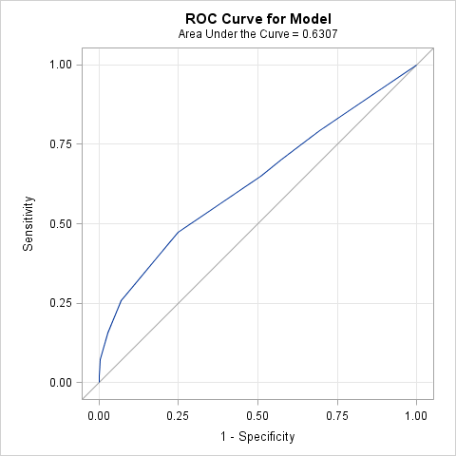

GCS | Sensibility | Specificity | PPV | NPV | Youden index
3 | 0.010309 | 1.00000 | 1.000000 | 0.773585 | 0.01031
4 | 0.020619 | 1.00000 | 1.000000 | 0.775414 | 0.02062
6 | 0.072165 | 0.99695 | 0.875000 | 0.784173 | 0.06912
7 | 0.113402 | 0.98476 | 0.687500 | 0.789731 | 0.09816
8 | 0.154639 | 0.97256 | 0.625000 | 0.795511 | 0.12720
9 | 0.257732 | 0.92988 | 0.520833 | 0.809019 | 0.18761
10 | 0.474227 | 0.75000 | 0.359375 | 0.828283 | 0.22423
11 | 0.649485 | 0.49085 | 0.273913 | 0.825641 | 0.14034
12 | 0.701031 | 0.42683 | 0.265625 | 0.828402 | 0.12786
13 | 0.793814 | 0.30488 | 0.252459 | 0.833333 | 0.09869
14 | 0.917526 | 0.11890 | 0.235450 | 0.829787 | 0.03643
15 | 1.000000 | 0.00000 | 0.228235 | . | 0.00000

