**Supplemental Digital Content 9:** Decision curve analysis of extubation in patients after brain-injury with the VISAGE score.

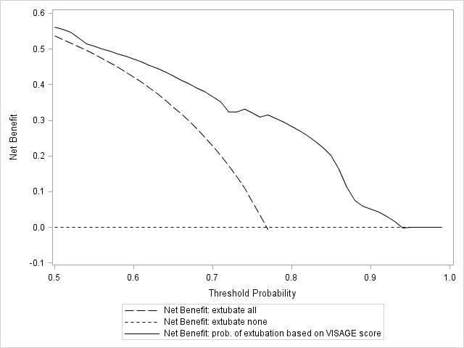

**Legend:** Decision curve analysis was performed to evaluate the net benefit of decision for extubation using the VISAGE score. Threshold probability is the probability of extubation success from which a clinician considers that it may extubate. The highest curve at any given threshold probability is the optimal decision-making strategy to maximize net benefit. Across the range of reasonable threshold probabilities (probability of extubation success greater than 50%), net benefit was maximized by the VISAGE score approach compared to alternative strategy (extubate all or extubate none).