Supplemental Information.

Anesthetic sevoflurane acts on ubiquitination-proteasome pathway

to reduce postsynaptic density 95 levels in young mice

Han Lu, M.D. Ph.D., Ning Liufu, M.D., Ph.D., Yuanlin Dong, M.D., M.S.,
Guanghong Xu, M.D. Ph.D., Yiying Zhang, M.D., M.S., Liqi Shu, Sulpicio G. Soriano, M.D.,
Hui Zheng, Ph.D., Buwei Yu, M.D., Ph.D. and Zhongcong Xie, M.D., Ph.D.

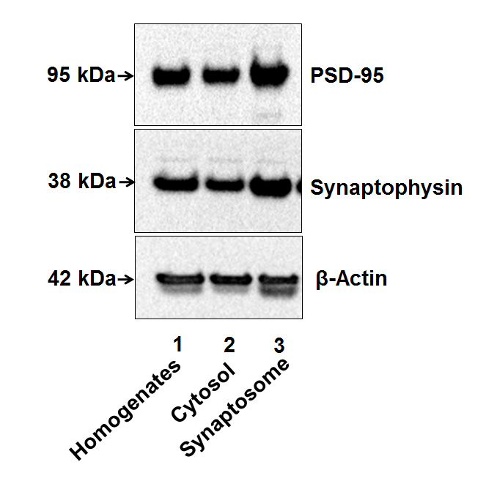
Supplementary Figure 1.
Supplementary Figure 1. Confirmation of the extraction of synaptosome. We killed the mice by using decapitation on P6 and harvested hippocampus from the mice. The tissues were weighed and dounced in a grinder using SynPER synaptic protein extraction reagent (cat# 87793, Thermo Scientific). Immediately before use, protease inhibitor cocktail from Sigma (cat# 11836170001, St. Louis, MO, USA) was added to the Syn-PER reagent. Mice tissues were dounced using Syn-PER synaptic protein extraction reagent using a 7-ml Dounce tissue grinder with 15 up and down even strokes. The mouse brain tissue homogenate was centrifuged at 2,000 g for 10 minutes to remove cell debris. The resulting supernatant was centrifuged at 15,000 g for 20 minutes. The supernatant formed the cytosolic fraction and the synaptosome pellet was gently resuspended in Syn-PER synaptic protein extraction reagent. Total protein from mouse brain tissue homogenates, cytosol fraction, and synaptosome suspension were analyzed by Western blot. The pre- and post-synaptic protein markers evaluated include synaptophysin, post-synaptic density protein-95 (PSD-95). The levels of PSD-95 and synaptophysin in synaptosome (lane 3) were higher than those in homogenates (lane 1) and cytosol (lane 2). These data suggest successful isolation of synaptosomes.

