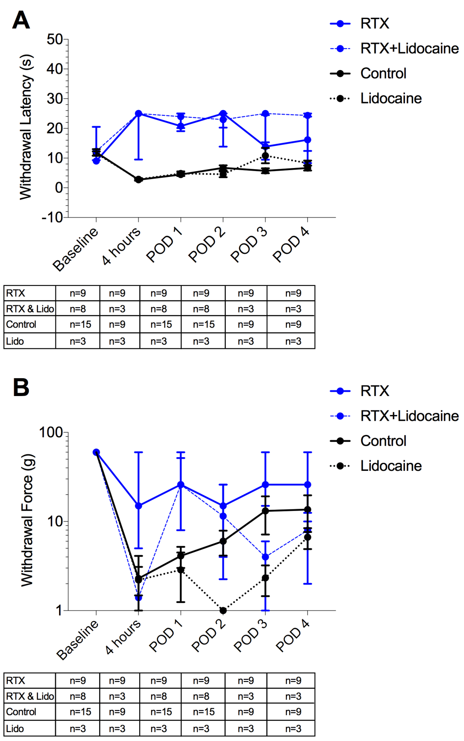
Supplemental Digital Content 1. The effect of lidocaine on thermal hyperalgesia and mechanical allodynia. A) Lidocaine did not significantly alter sensitivity to continuous thermal stimulation when added to resiniferatoxin compared to resiniferatoxin alone. Lidocaine did not significantly change post-incisional thermal hyperalgesia compared to vehicle when testing commenced at 4 hours post-incision. B) There was no significant difference in withdrawal threshold to mechanical stimuli when lidocaine was added to resiniferatoxin compared to resiniferatoxin alone. Lidocaine did not attenuate mechanical allodynia after surgical incision when compared to vehicle. p>0.05 for all comparisons, repeated Mann-Whitney tests with Holm-Sidak adjustment. Sample sizes at each time point can be found in the table below each graph.

