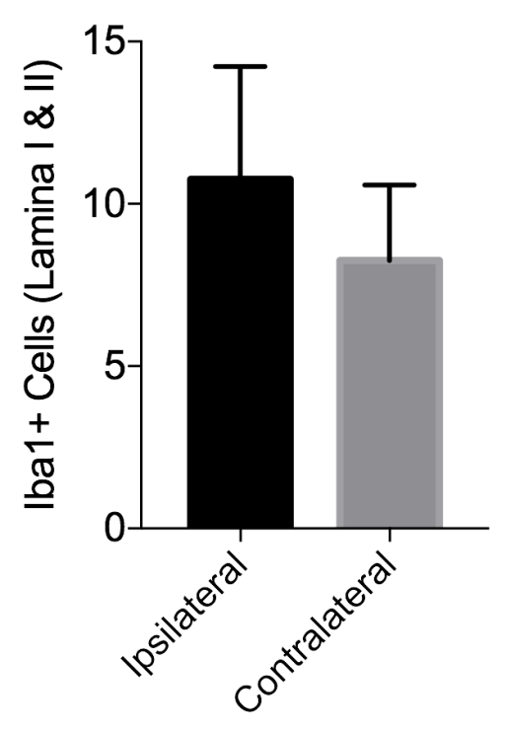
Supplemental Digital Content 12. Dorsal horn immunohistochemical staining for Iba1 after resiniferatoxin (without surgical manipulation) shows microglial activation 2 days after injection. There was a non-significant trend towards more Iba1+ cells in lamina I and II of the dorsal spinal cord ipsilateral to the injected paw compared to contralateral (p=0.17, paired t-test, n=4, data plotted as mean with SD).

