Supplemental Digital Content 7

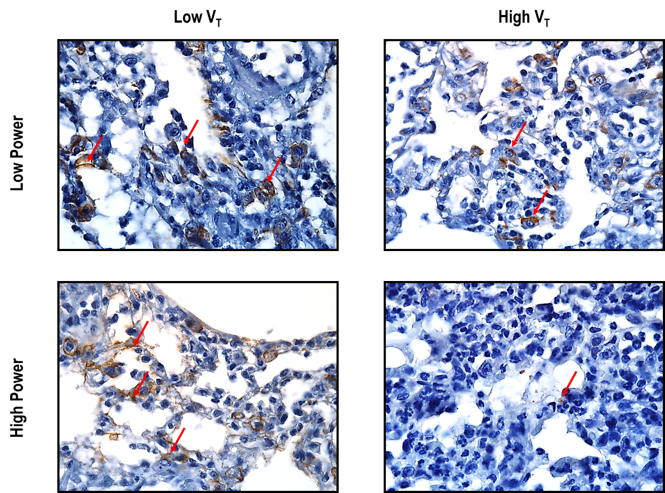

Supplemental Digital Content - figure 3. Immunohistochemical staining for E-cadherin in lung tissue. Photomicrographs are representative of data obtained from lung sections of eight animals from the following groups: 1) Low Power/Low V_{T}: V_{T} = 6 mL/kg and RR adjusted to maintain normocapnia; 2) Low Power/High V_{T}: V_{T} = 11 mL/kg and RR to maintain the same power as in the Low Power/Low V_{T} group; 3) High Power/Low V_{T}: V_{T} = 6 mL/kg and RR set to obtain a power three times that of the low-power groups; and 4) High Power/High V_{T} (11 mL/kg), with RR set to obtain a power three times that of the low-power groups. Arrows: E-cadherin. Original magnification ×400.

