Supplemental Digital Content 14
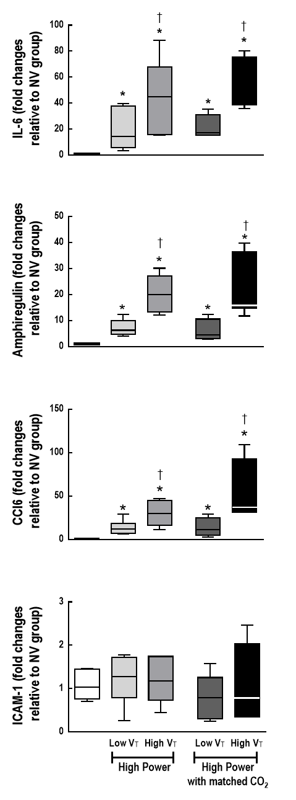

Supplemental Digital Content - figure 6. Expression of biological markers. Real-time polymerase chain reaction analysis of biological markers associated with inflammation [interleukin (IL)-6], alveolar mechanical stretch (amphiregulin), alveolar epithelial cell damage [club cell protein 16 (CC16)], and endothelial cell damage [intercellular adhesion molecule (ICAM)-1)]. Relative gene expression was calculated as a ratio of the average gene expression levels to the reference gene (36B4) and expressed as fold change relative to non-ventilated (NV) animals. Values represent medians and whiskers represent the 10-90 percentile range of 8 animals in each group. Comparisons among groups were done using the Mann–Whitney U test and Bonferroni correction for 4 comparisons (p < 0.0125). * vs. NV (p < 0.0125); † vs. Low Power/High V_{T} (p < 0.0125).

