Supplemental Digital Content 5

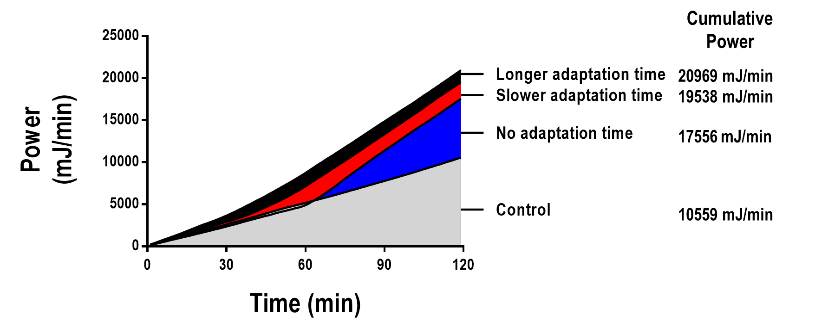

figure 1. Cumulative power over time in the four groups: mechanical ventilation with a protective strategy (V_{T}=6mL/kg) for 2 hours (Control); V_{T}=6mL/kg during hour 1 followed by an abrupt increase in V_{T}=22mL/kg during hour 2 (No adaptation time); V_{T}=6mL/kg during the first 30 minutes followed by a gradual V_{T} increase up to 22mL/kg for 30 minutes, then constant V_{T}=22mL/kg during hour 2 (Shorter adaptation time); and a more gradual V_{T} increase, from 6mL/kg to 22mL/kg during hour 1 followed by V_{T}=22mL/kg during hour 2 (Longer adaptation time).

