Supplemental Digital Content 8
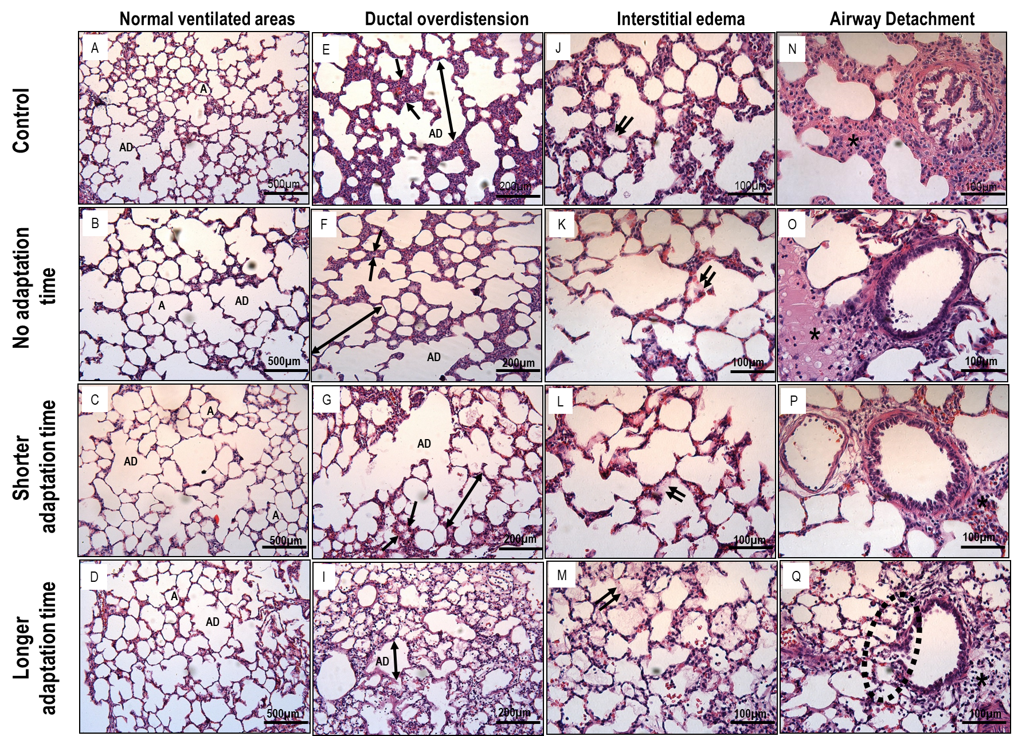

figure 4. Representative photomicrographs (light microscopy) of lung parenchyma stained with hematoxylin and eosin. Asterisks show areas of inflammation. Double arrows indicate alveolar duct (AD) overdistension. Two arrows indicate areas of interstitial edema. Note the detachment of airway epithelial cells (dotted circle) in panel Q. Photomicrographs are representative of data obtained from lung sections of eight animals. Control: mechanical ventilation with a protective strategy (V_{T}=6mL/kg) for 2 hours; No adaptation time: V_{T}=6mL/kg during hour 1, followed by an abrupt increase to V_{T}=22mL/kg throughout hour 2; Shorter adaptation time: V_{T}=6mL/kg during the first 30 minutes followed by a gradual V_{T} increase up to 22mL/kg for 30 minutes, then constant V_{T}=22mL/kg during hour 2; and Longer adaptation time: a more gradual V_{T} increase, from 6mL/kg to 22mL/kg during 1 hour, followed by V_{T}=22mL/kg during hour 2.

