Ref. No.: ALN-D-18-00280
Title: Preload dependence is associated with sublingual microcirculation alterations during major abdominal surgery

Supplemental Digital Content

1) Distribution of preload dependence episodes among the 17 studied patients.

2) Hemodynamic protocol.

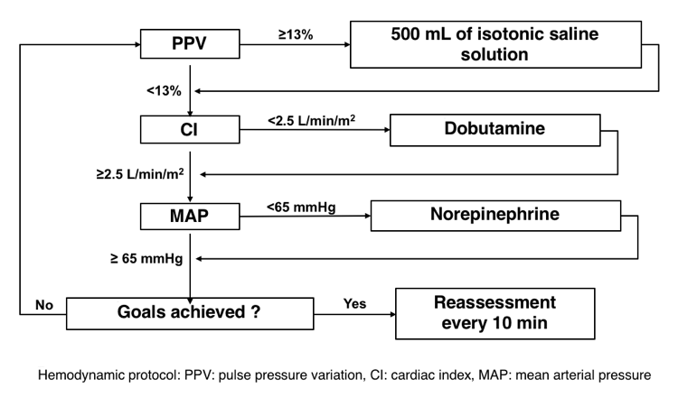
3) Flowchart: Seventeen consecutive patients were included in the study over a three-month period

4) Table1

Table 1: Demographic data for patients prior to surgery (n=16)
Age (Years) | 59 (±21)
Gender (Female/Male) | 7/9
ASA score | 2 (±1)
NYHA score | 2 (±1)
Type of surgery (number and percentage of patients)  - Colorectal surgery  - Pancreatic surgery  - Liver surgery  - Kidney surgery  - Urinary tract and prostatic surgery | 3 (19%)  2 (12%)  1 (6%)  6 (36%)  4 (25%)
Medical history (number and percentage of patients)  - Essential hypertension  - Coronary disease  - Diabetes mellitus with any complication  - Chronic respiratory failure  - Cancer | 10 (63%)  2 (13%)  3 (19%)  4 (25%)  11 (69%)
Usual medication (number and percentage of patients)  - Angiotensin converting enzyme inhibitor  - Beta-blocker  - Antiplatelet drug  - Antiarrythmic agent  - Calcium blocker  - Diuretic  - Oral antidiabetic | 7 (44%)  5 (31%)  4 (25%)  1 (6%)  3 (19%)  2 (13%)  2 (13%)
Data are presented as mean ± SD or n (%)

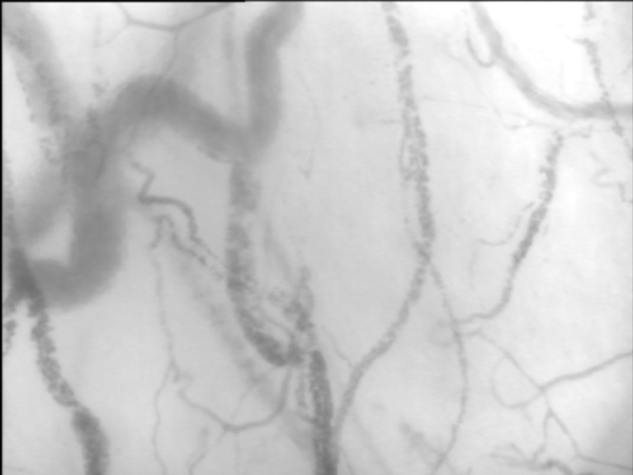
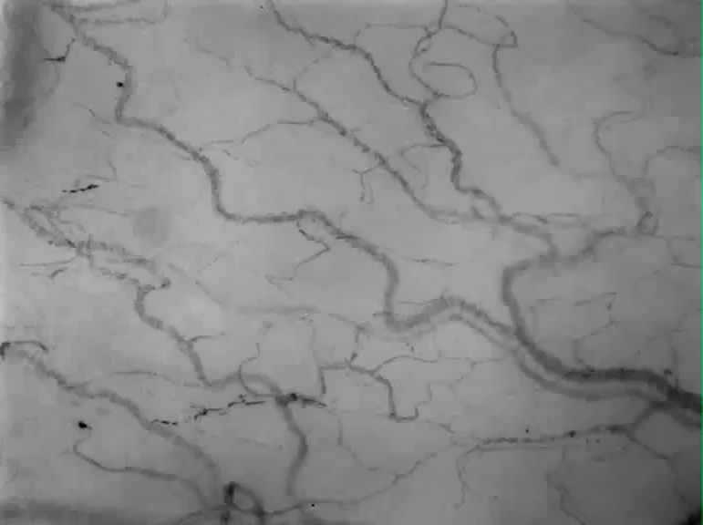
5) Illustrative examples of videos of normal and impaired microcirculatory flow in the supplemental data.
Video 1: Normal microcirculatory flow

Video 2: impaired microcirculatory flow

