Results
Pharmacokinetic model
A five-compartment linear model with zero order input of drug into the central compartment by IV administration, or a dosing compartment for nebulised administration, best described the time-course tobramycin in plasma, ELF and ISF.
The final model is structural defined as follows:

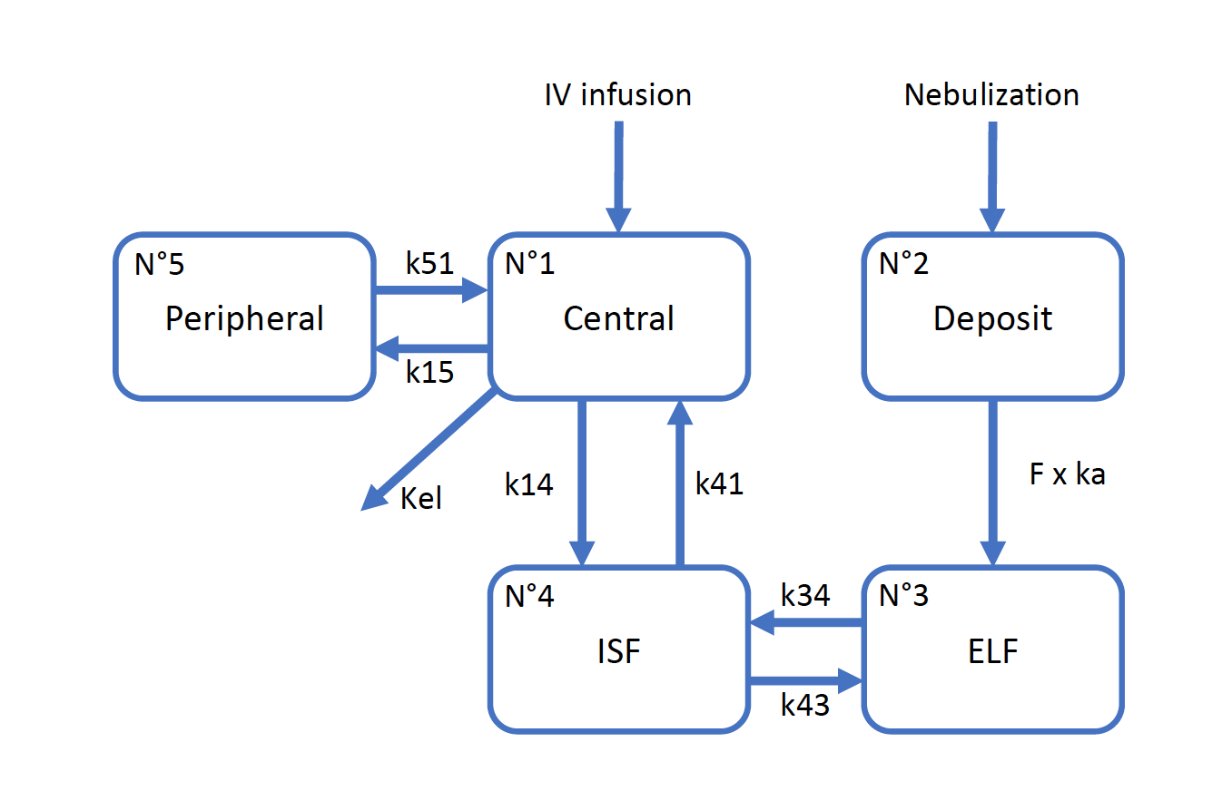
Where: Nº refers to the various compartment numbers; ISF is interstitial fluid compartment; ELF is epithelial lining fluid compartment; Deposit is the dosing compartment for administration by nebulisation; k15 is the rate constant for transfer from Central to Peripheral compartment, k51 is the rate constant for transfer from Peripheral to Central compartment; k14 is the rate constant for transfer from Central is ISF compartment; k41 is the rate constant for transfer from ISF to Central compartment; k34 is the rate constant for transfer from ELF to ISF compartment; k43 is the rate constant for transfer from ISF to ELF compartment; ka is absorption rate constant; and F is bioavailability.

The population pharmacokinetic parameter estimates from the final model are detailed in Table 1.

Table 1: Population pharmacokinetic parameter estimates from the final model
 | Mean | SD | CV% | Median
F | 0.13 | 0.15 | 123.01 | 0.04
ka (h⁻¹) | 15.22 | 5.15 | 33.86 | 16.37
kel (h⁻¹) | 1.28 | 1.31 | 102.58 | 0.84
k14 (h⁻¹) | 4.81 | 4.36 | 90.63 | 3.21
k41 (h⁻¹) | 3.99 | 3.31 | 83.02 | 1.95
k15 (h⁻¹) | 0.47 | 0.53 | 112.36 | 0.37
k51 (h⁻¹) | 9.22 | 7.08 | 76.72 | 15.00
k34 (h⁻¹) | 1.42 | 0.89 | 62.32 | 1.08
k43 (h⁻¹) | 0.11 | 0.09 | 82.02 | 0.08
V_{C} (L) | 8.57 | 6.24 | 72.87 | 6.73
V_{ISF} (L) | 9.76 | 6.53 | 66.90 | 7.90
V_{ELF} (L) | 1.78 | 2.16 | 121.74 | 0.33

Legend: F is bioavailability; ka is absorption rate constant; kel is elimination rate constant; k15 is the rate constant for transfer from Central to Peripheral compartment, k51 is the rate constant for transfer from Peripheral to Central compartment; k14 is the rate constant for transfer from Central is ISF compartment; k41 is the rate constant for transfer from ISF to Central compartment; k34 is the rate constant for transfer from ELF to ISF compartment; k43 is the rate constant for transfer from ISF to ELF compartment; and; V_{C} is volume of the central (plasma) compartment; V_{ISF} is volume of the interstitial fluid compartment; V_{ELF} is volume of the epithelial lining fluid compartment

The diagnostic plots to confirm the goodness-of-fit are shown in Supplementary Figure 2 (red markers and lines represent plasma data; black markers and lines represent microdialysis data; blue markers and lines represent epithelial lining fluid data; ID refers to individual sheep identifier).
