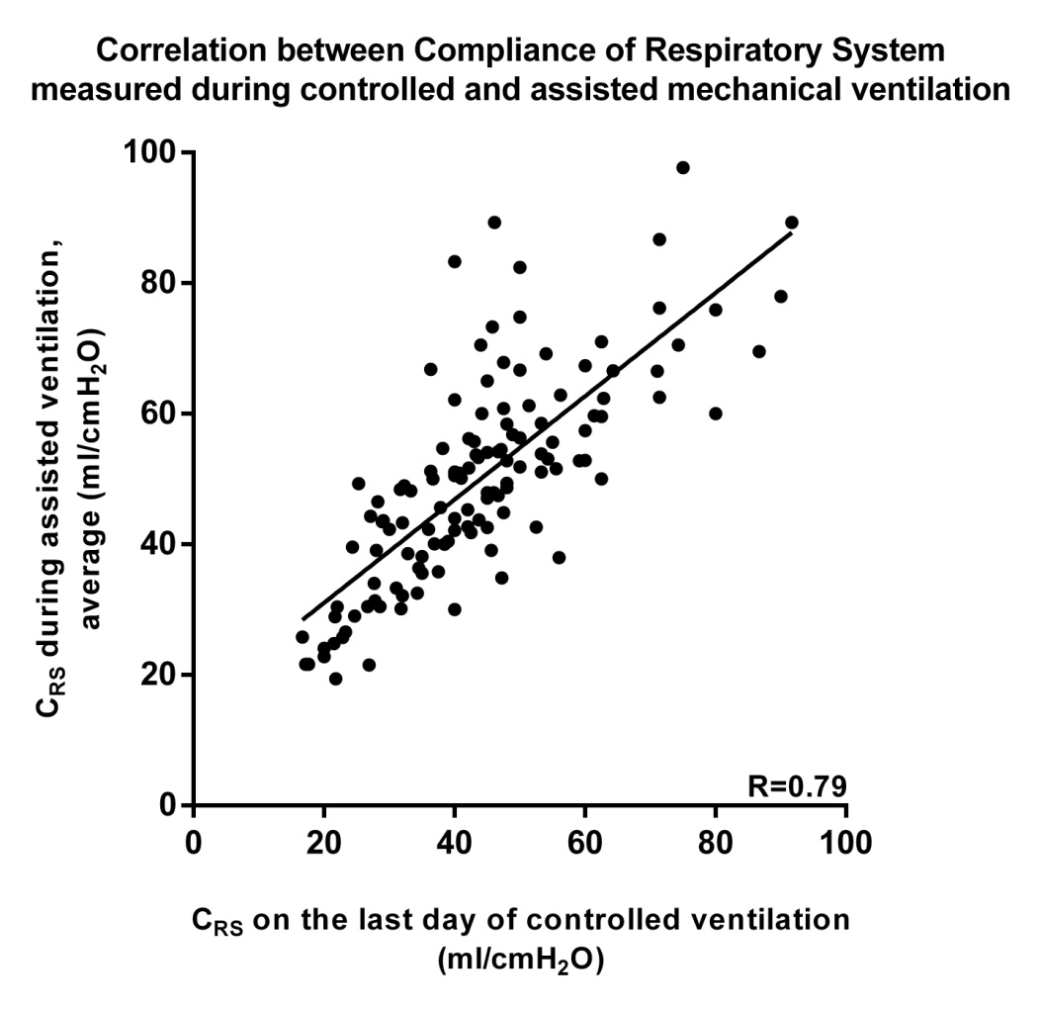
Figure E1: Respiratory System Compliance (C_{RS}) measured during the last day of Controlled Mechanical Ventilation is highly correlated with the average C_{RS} measured during the first three days of Assisted Mechanical Ventilation. R=0.79, p<0.0001.

