Practice Guidelines for Central Venous Access: Update 2020
Supplement 5: Bar Chart of Survey Results

Resource Preparation
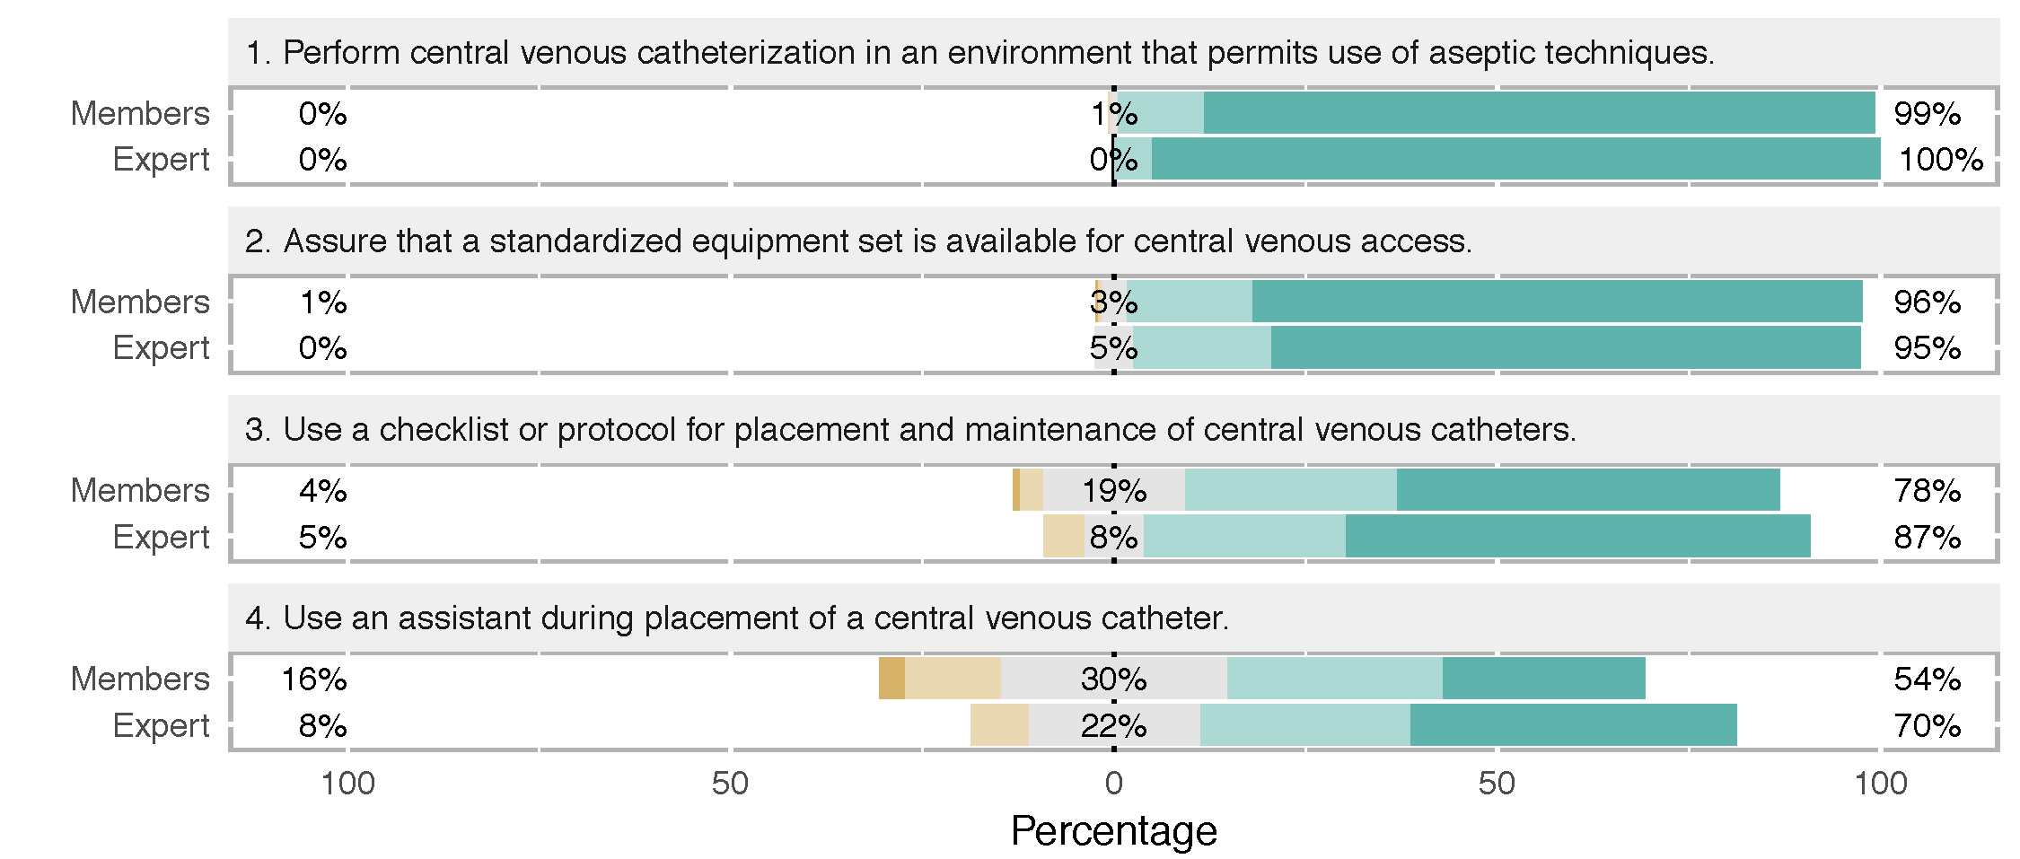

Prevention of Infections Complications
Intravenous Antibiotic Prophylaxis

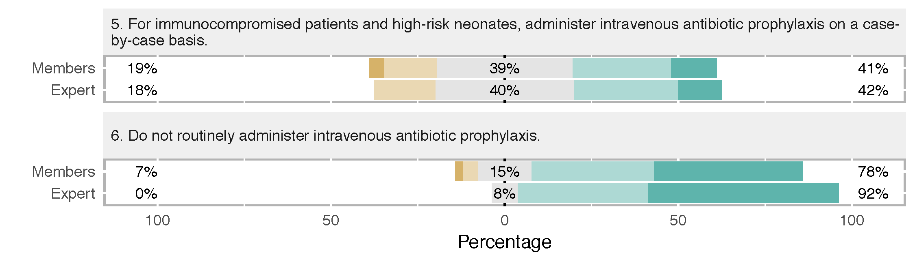

Aseptic Preparation
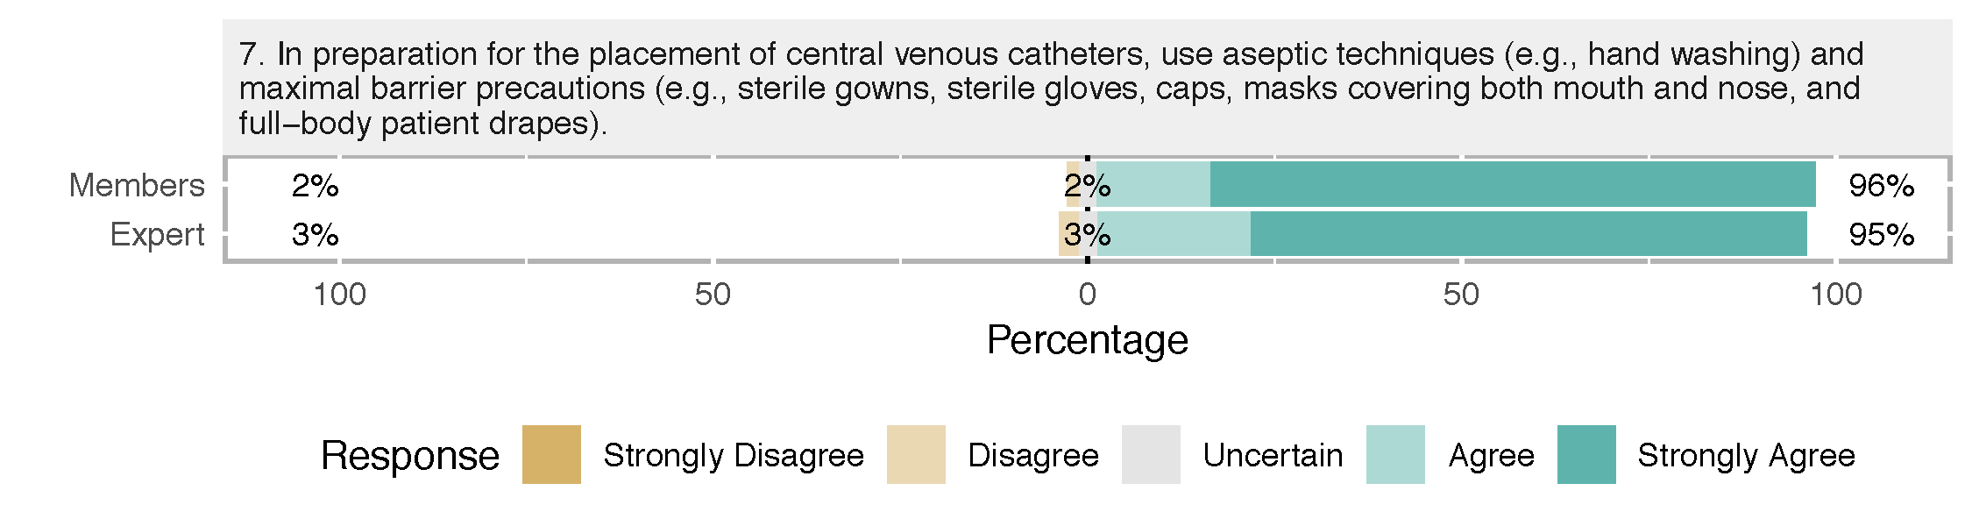

Selection of Antiseptic Solution
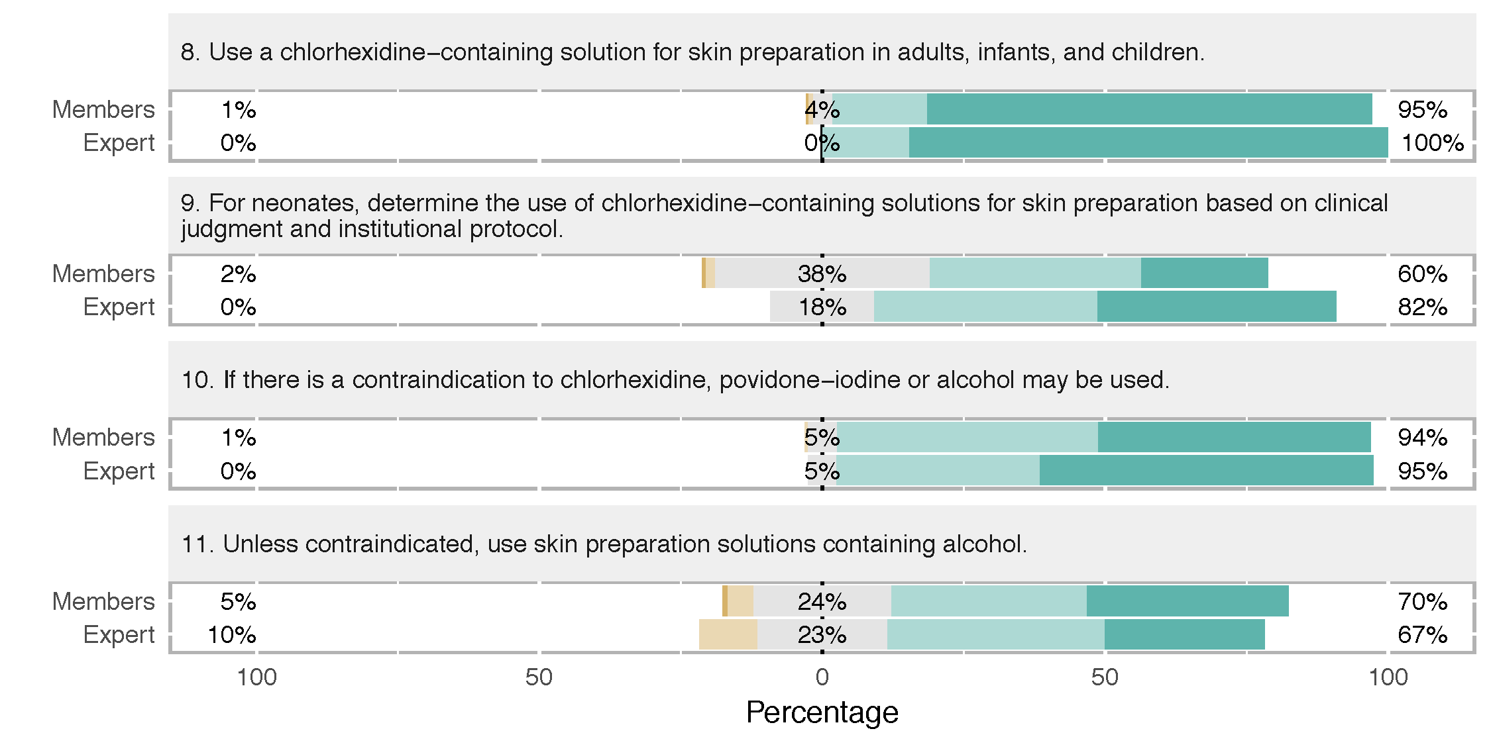

Catheters Containing Antimicrobial Agents
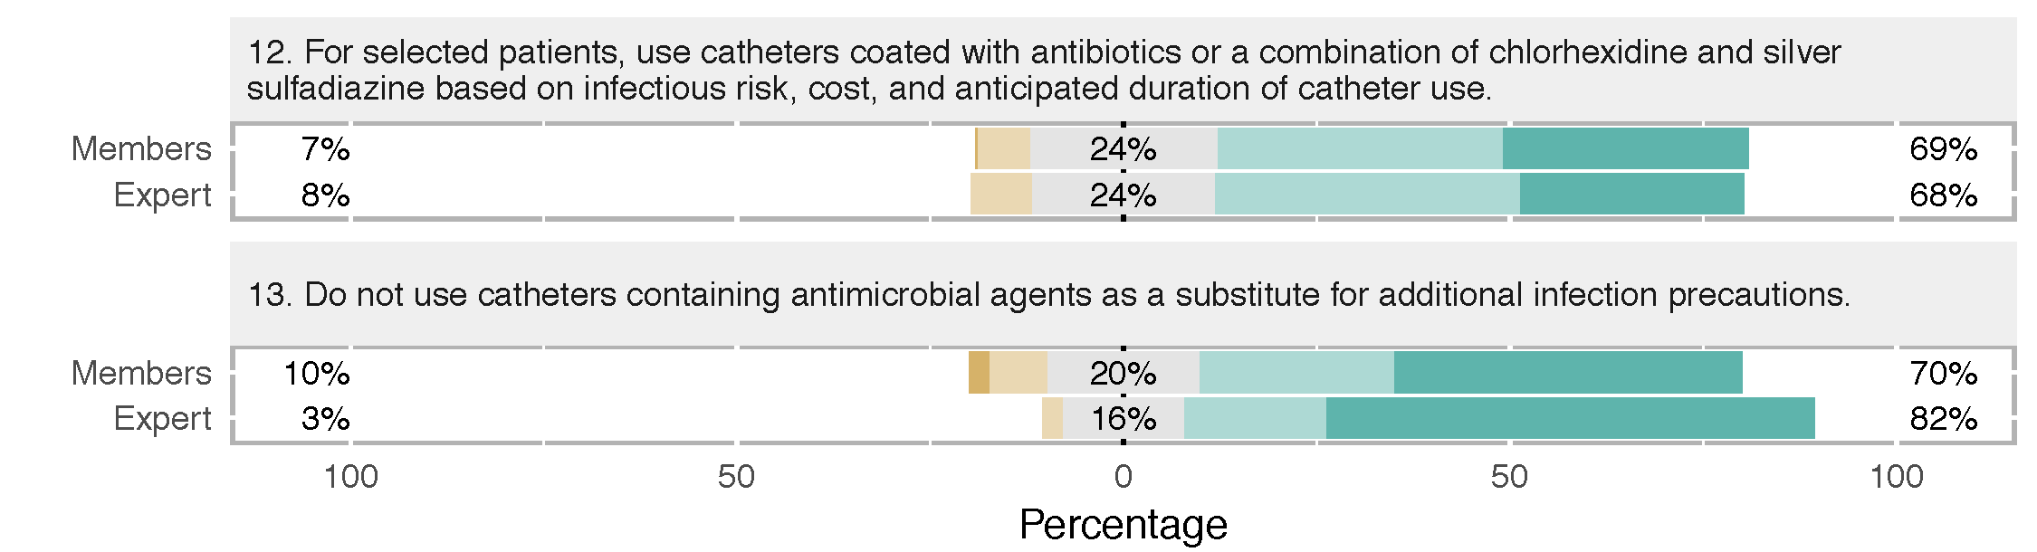

Selection of Catheter Insertion Site
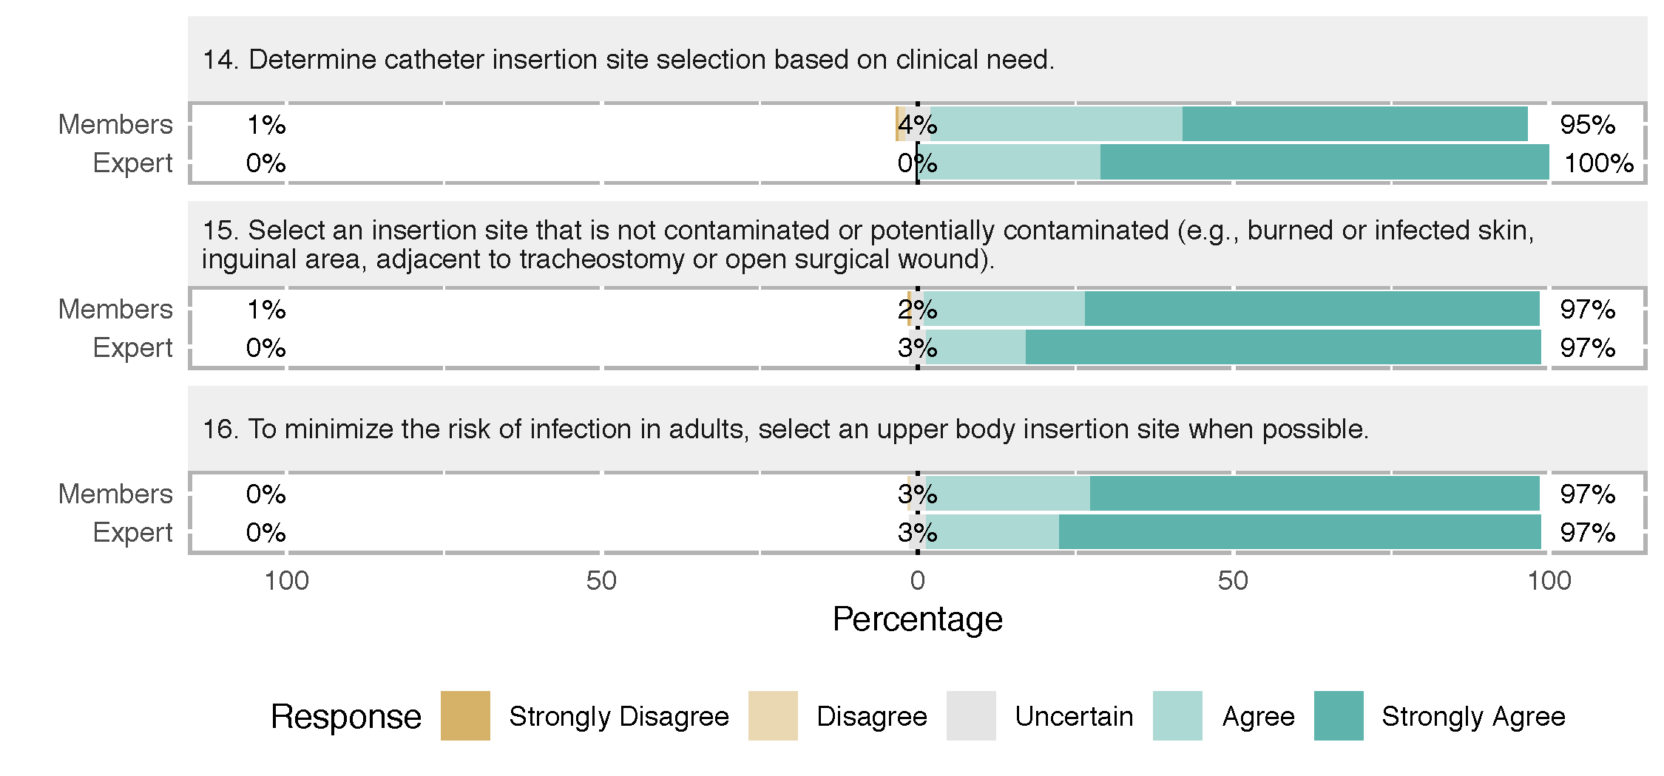

Catheter Fixation
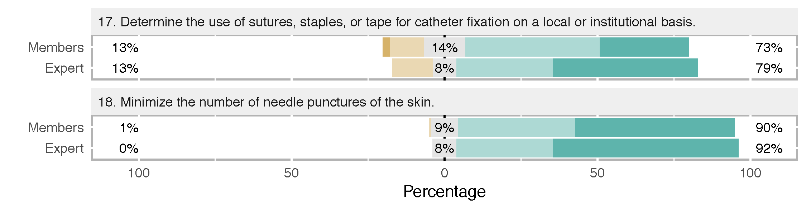

Insertion Site Dressings
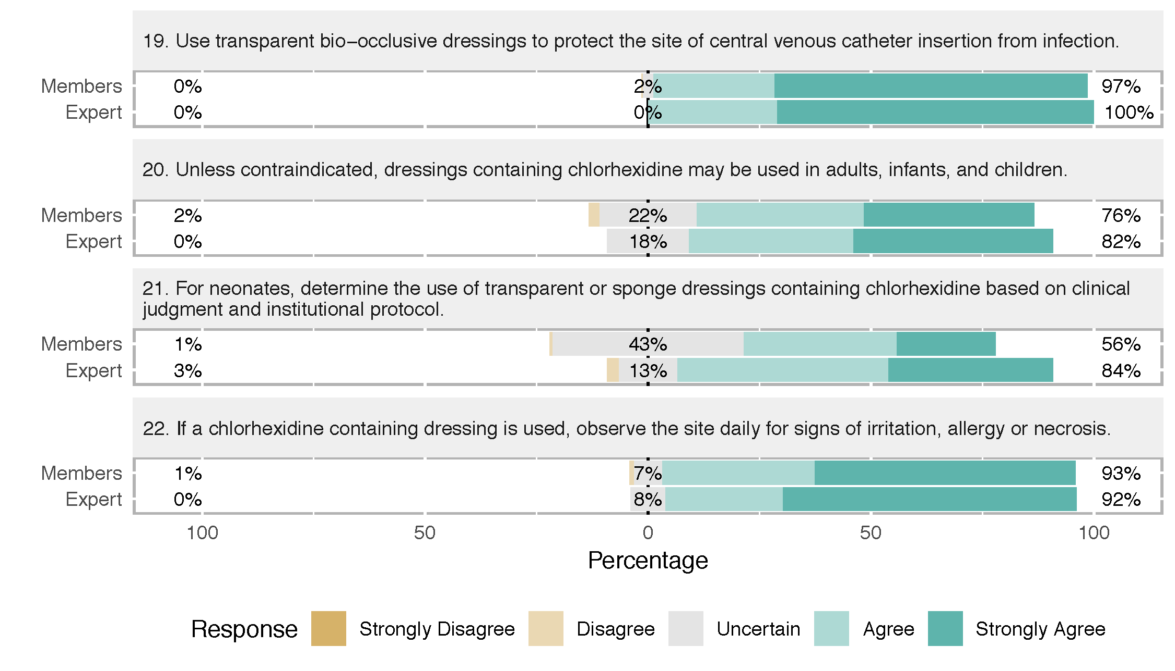

Catheter Maintenance
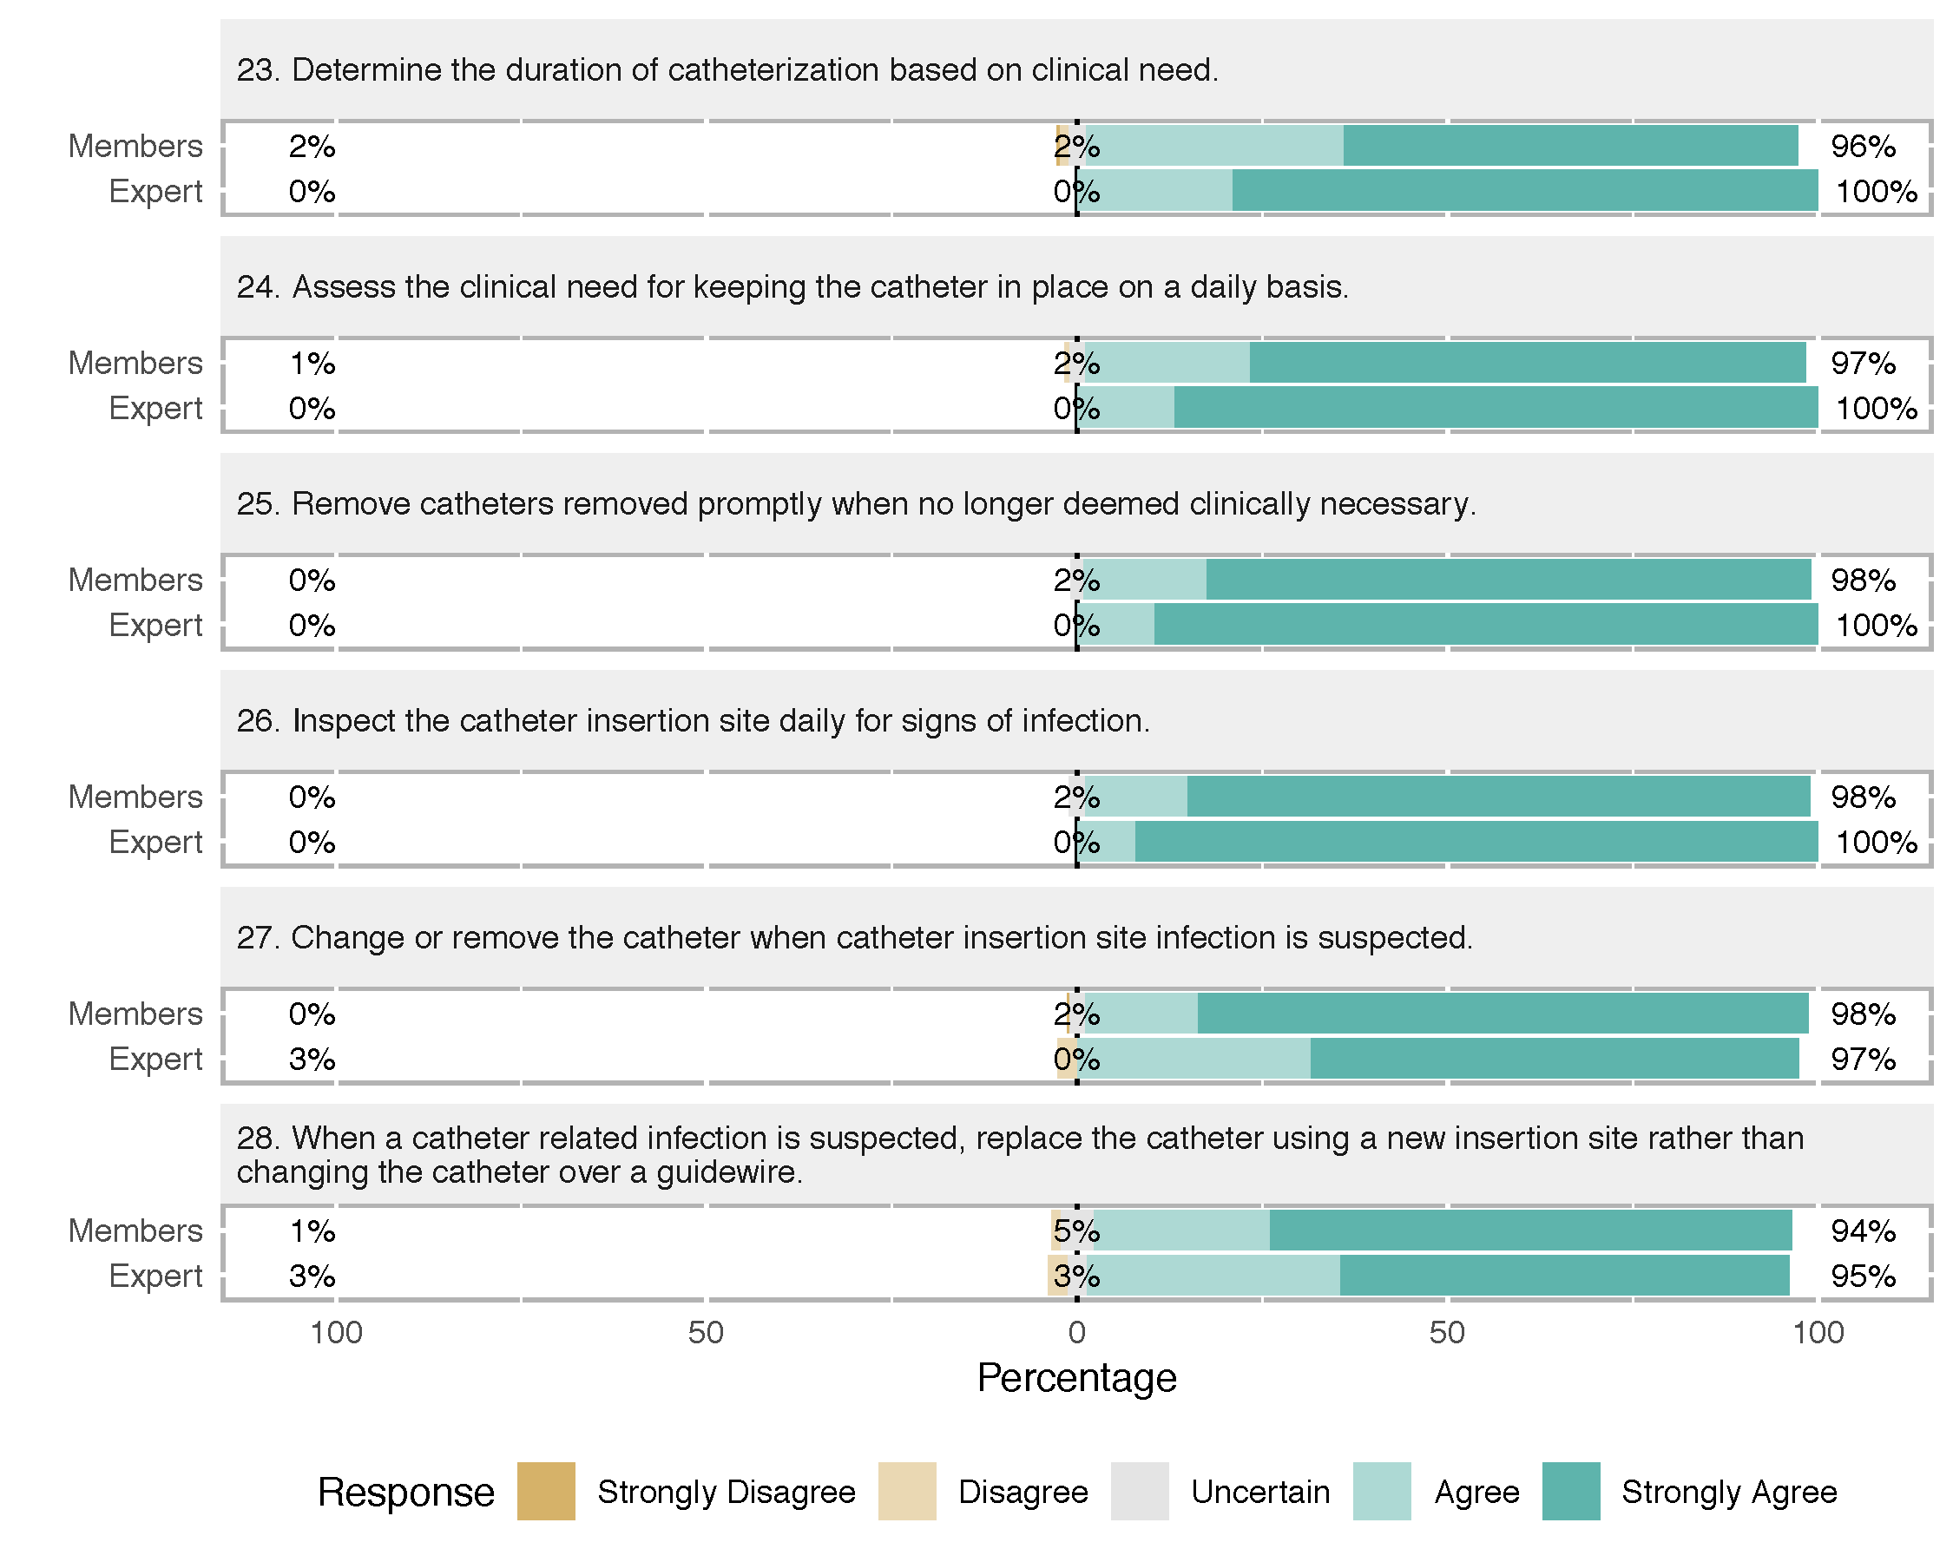

Aseptic Techniques Using an Existing Central Venous Catheter for Injection or Aspiration
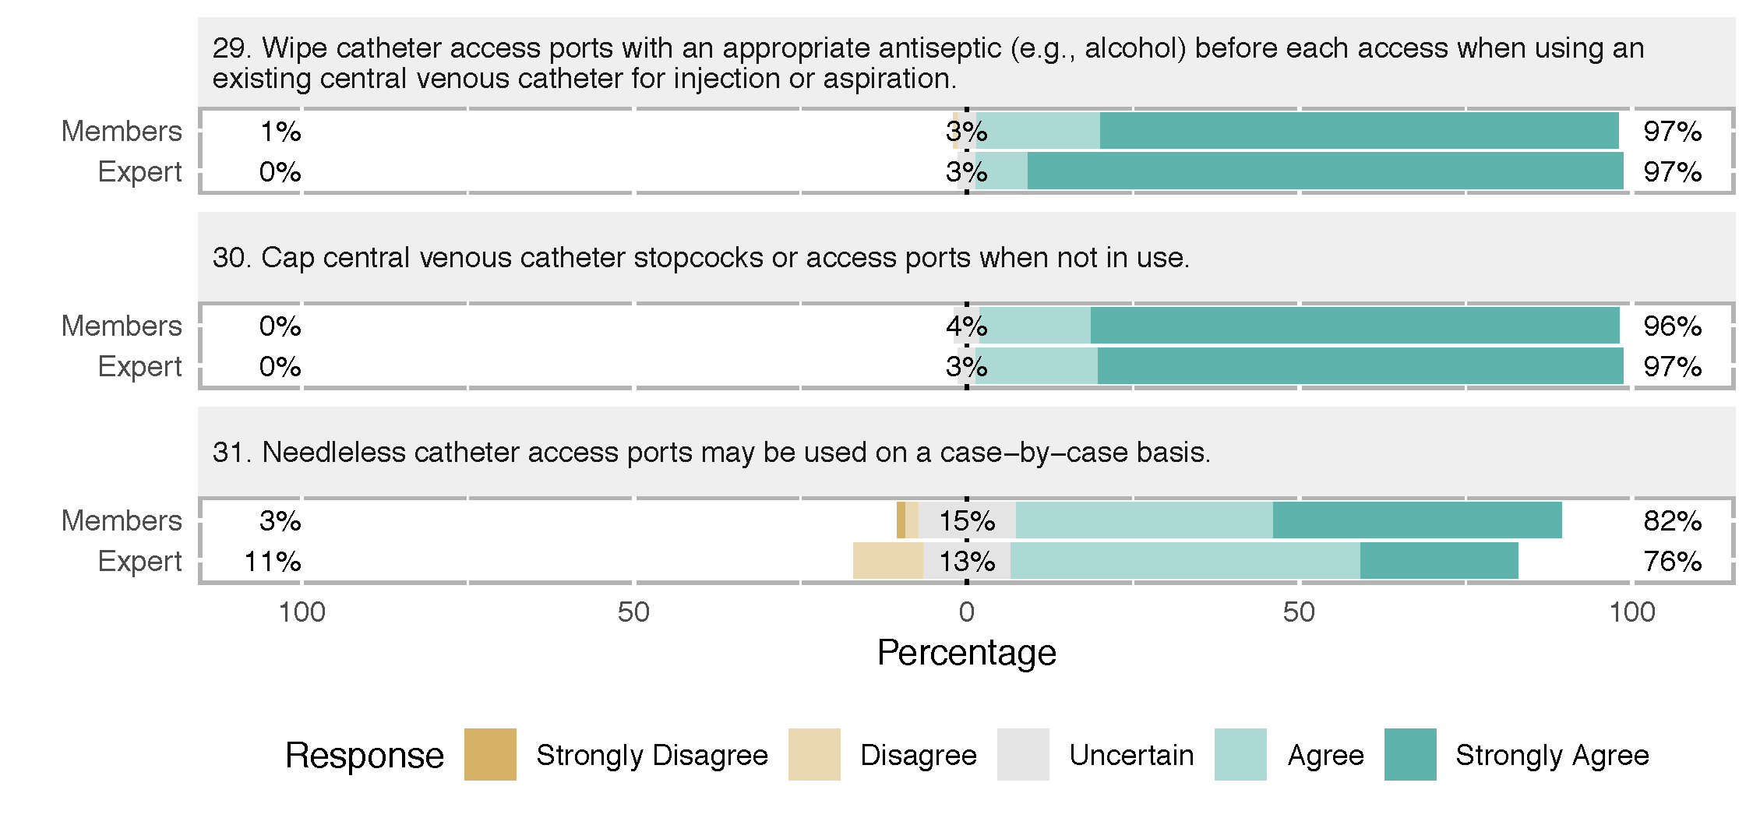

Prevention of Mechanical Trauma or Injury
Catheter Insertion Site Selection
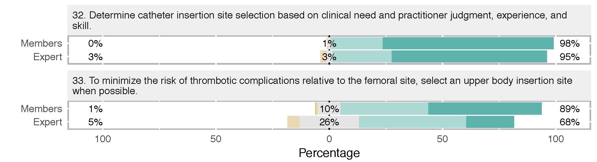

Positioning the Patient for Needle Insertion and Catheter Placement
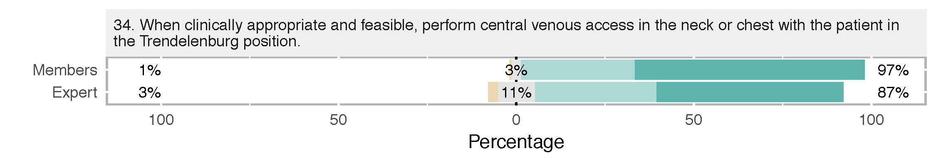
Needle Insertion, Wire Placement, and Catheter Placement
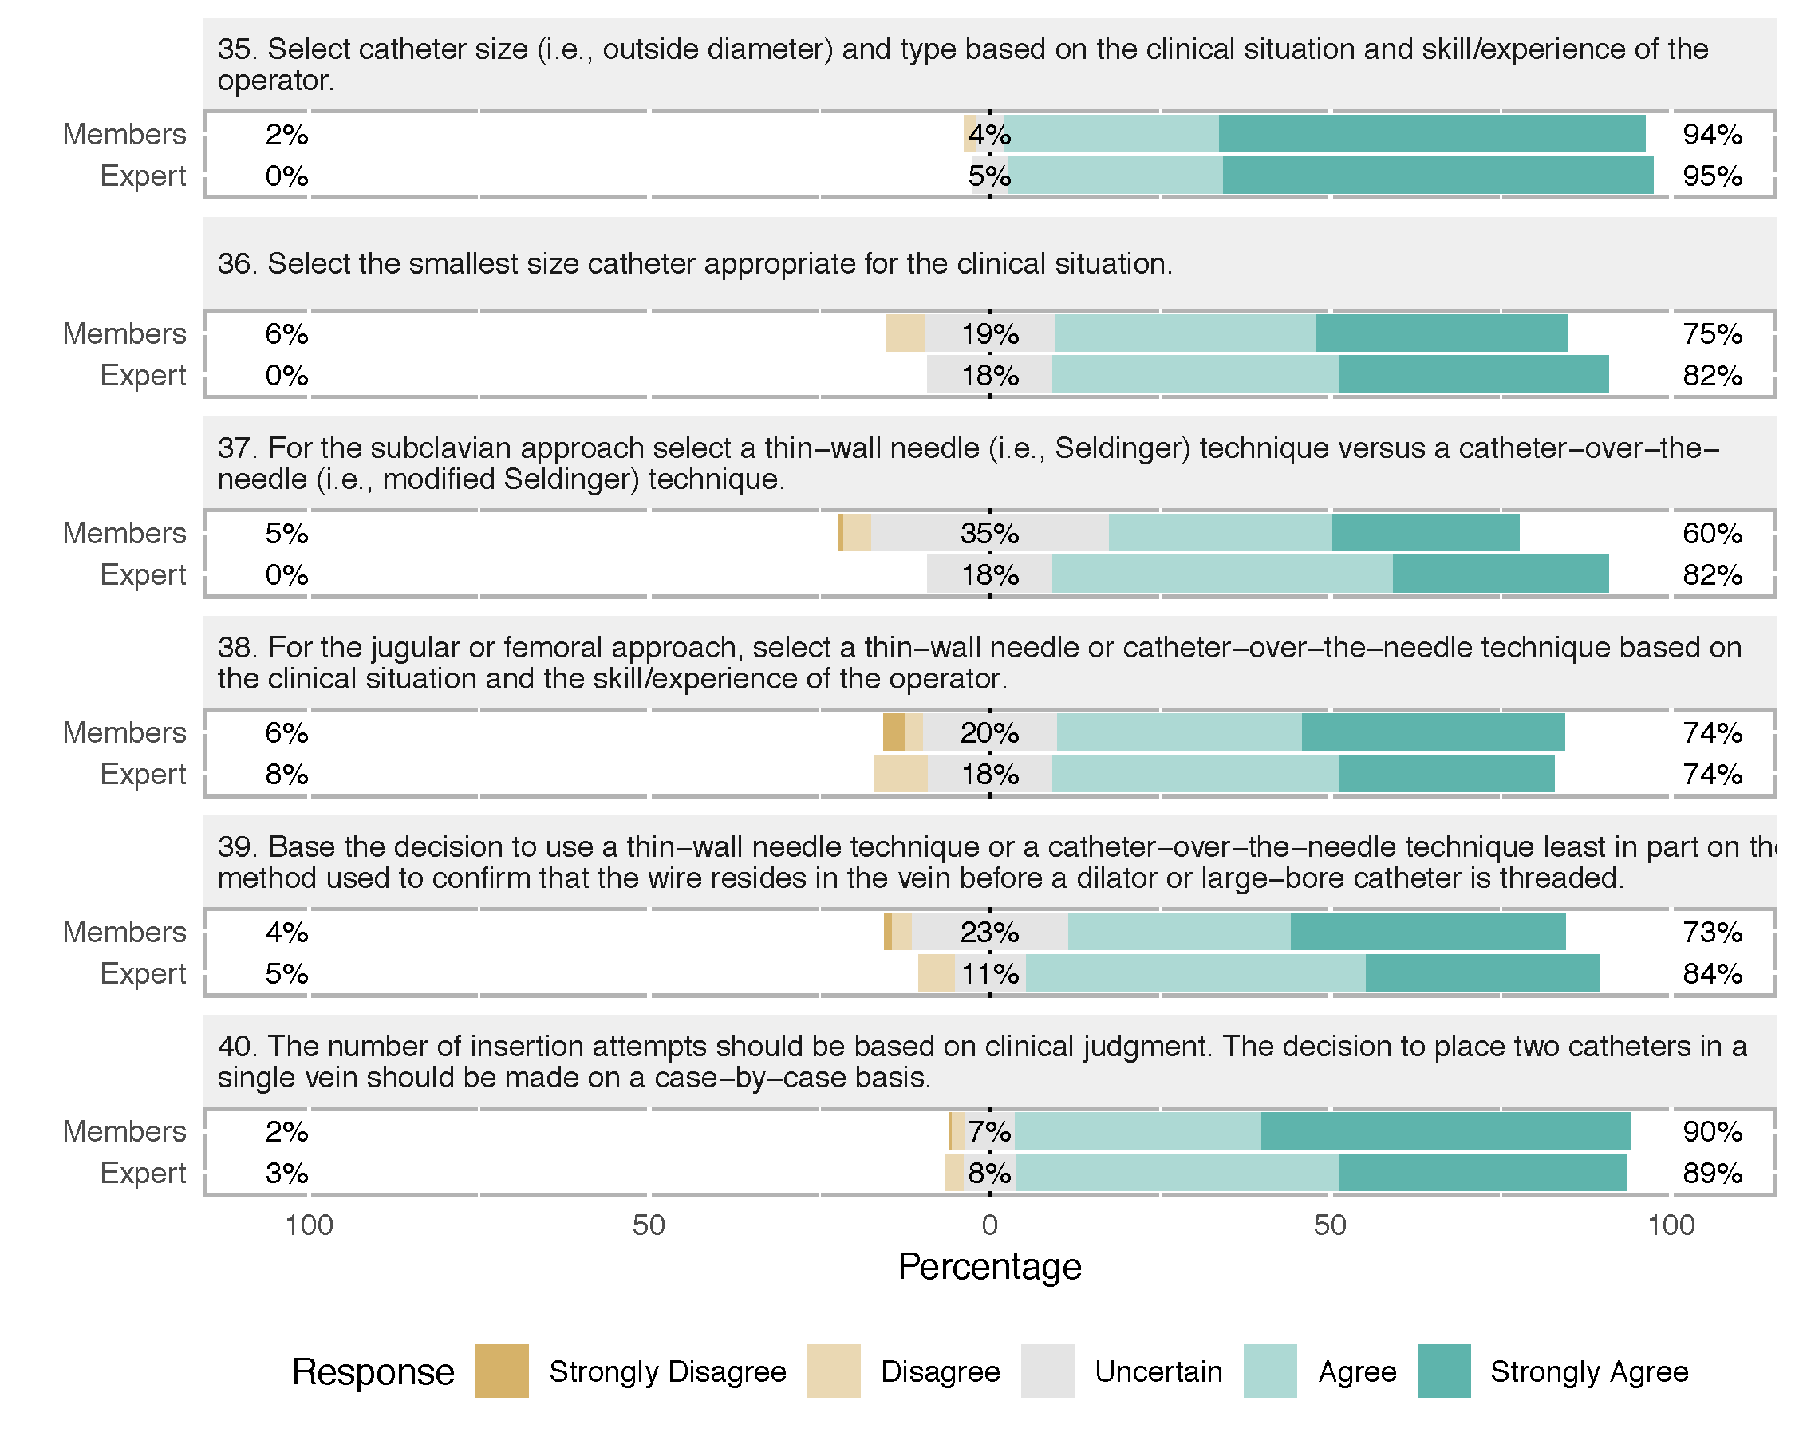

Guidance of Needle, Wire, and Catheter Placement
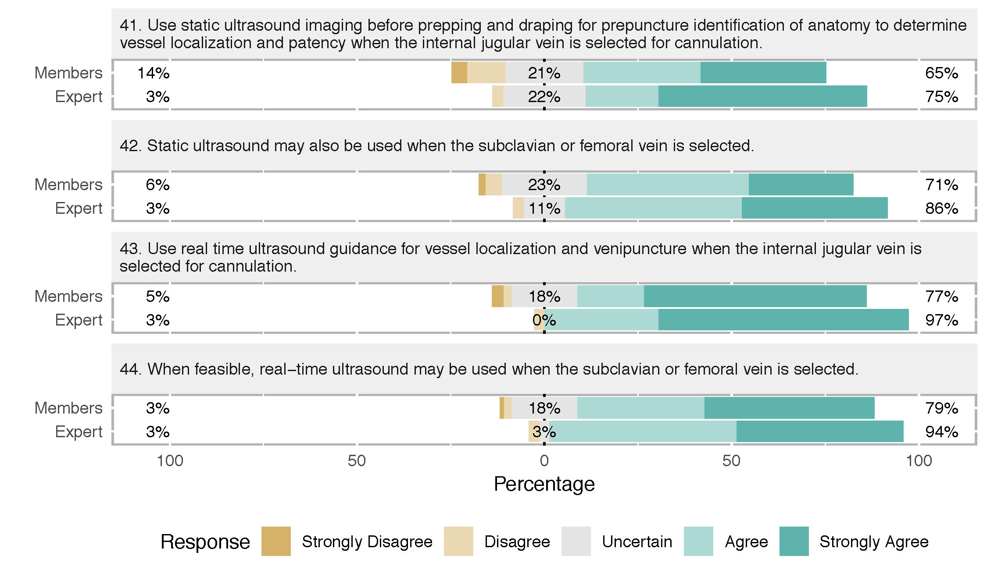

Verification of Needle, Wire, and Catheter Placement
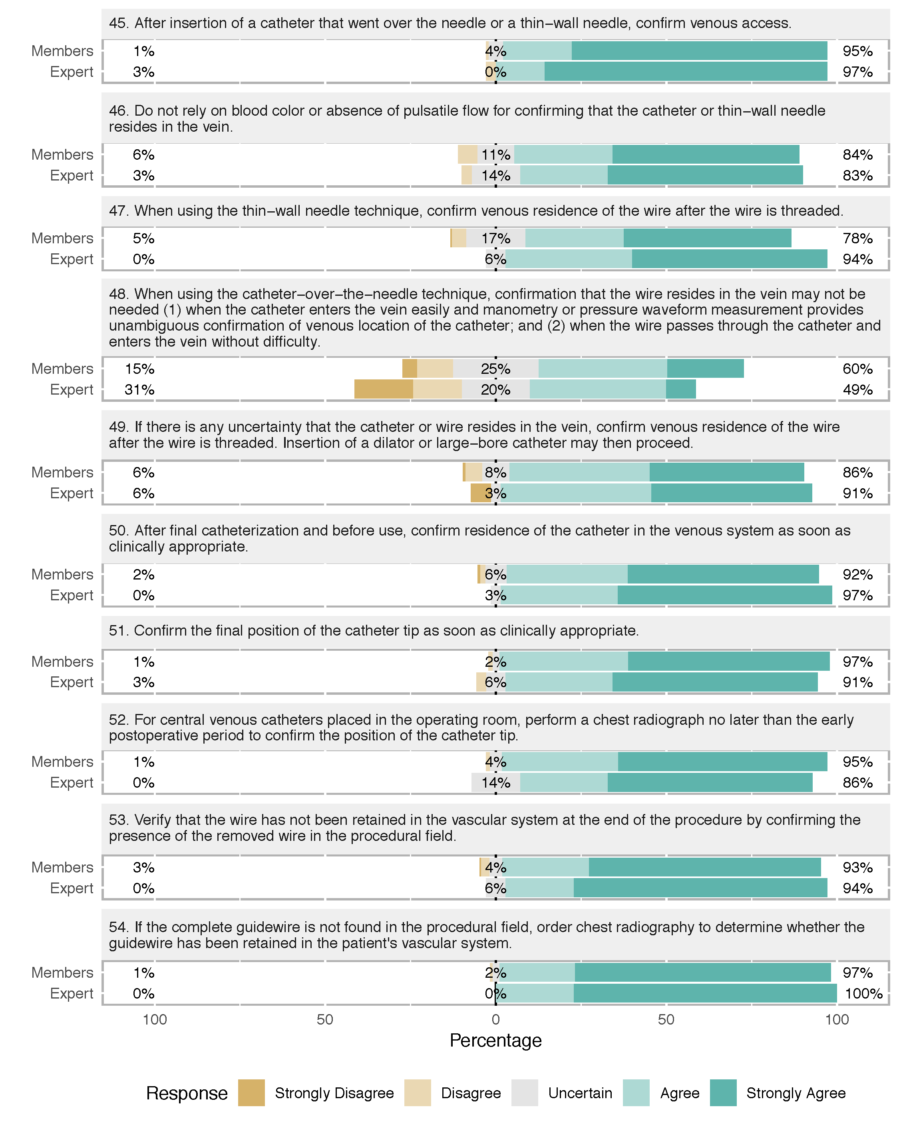

Management of Arterial Trauma or Injury Arising from Central Venous Catheterization
