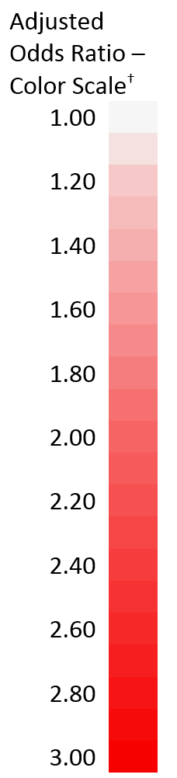
Supplemental Digital Content 9: Risk of Acute Kidney Injury Associated with Intraoperative Hypotension by Preoperative Risk Quartile, Adjusted for Intraoperative Estimated Blood Loss
Absolute Hypotension - Derivation Cohort

Intraoperative Hypotension† – Absolute MAP Values | Quartile 1*  Low Preoperative Risk  (N = 17,733) | Quartile 2*  Medium Preoperative Risk  (N = 17,732) | Quartile 3*  High Preoperative Risk  (N = 17,732) | Quartile 4*  Highest Preoperative Risk  (N = 17,732)
No Absolute Hypotension | (reference)  n = 10,186 | (reference)  n = 10,426 | (reference)  n = 10,248 | (reference)  n = 9,176
MAP 60-64 mmHg | 0.87 (0.62-1.21)  n = 3,840 | 1.02 (0.81-1.28)  n = 3,646 | 1.16 (0.99-1.36)  n = 3,710 | 1.06 (0.94-1.19)  n = 3,900
MAP 55-59 mmHg | 0.93 (0.63-1.36)  n = 2,441 | 1.13 (0.88-1.46)  n = 2,366 | 1.18 (0.98-1.41)  n = 2,367 | 1.34 (1.18-1.51)  Increased AKI  n = 2,794
MAP 50-54 mmHg | 1.15 (0.67-1.98)  n = 853 | 1.21 (0.83-1.77)  n = 844 | 1.27 (0.97-1.67)  n = 828 | 1.46 (1.23-1.73)  Increased AKI  n = 1,116
MAP <50 mmHg | 1.23 (0.60-2.54)  n = 413 | 1.63 (1.05-2.53)  Increased AKI  n = 450 | 1.58 (1.18-2.12)  Increased AKI  n = 579 | 1.88 (1.55-2.28)  Increased AKI  n = 746

Relative Hypotension - Derivation Cohort

Intraoperative Hypotension† – Relative MAP Values | Quartile 1*  Low Preoperative Risk  (N = 17,733) | Quartile 2*  Medium Preoperative Risk  (N = 17,732) | Quartile 3*  High Preoperative Risk  (N = 17,732) | Quartile 4*  Highest Preoperative Risk  (N = 17,732)
No Relative Hypotension | (reference)  n = 4,958 | (reference)  n = 5,580 | (reference)  n = 5,723 | (reference)  n = 6,361
MAP 20-30% Below Baseline | 1.17 (0.82-1.69)  n = 4,710 | 0.99 (0.77-1.27)  n = 4,504 | 1.00 (0.84-1.20)  n = 4,504 | 0.85 (0.75-0.96)  Decreased AKI  n = 4,316
MAP 30-40% Below Baseline | 1.07 (0.74-1.55)  n = 4,832 | 1.07 (0.84-1.36)  n = 4,567 | 1.12 (0.94-1.33)  n = 4,422 | 0.89 (0.79-1.01)  n = 3,962
MAP > 40% Below Baseline | 1.61 (1.11-2.34)  Increased AKI  n = 3,233 | 1.42 (1.11-1.83)  Increased AKI  n = 3,081 | 1.30 (1.08-1.56)  Increased AKI  n = 3,083 | 1.08 (0.95-1.23)  n = 3,093

Values presented as adjusted odds ratio and 95% confidence interval.
* Patients were stratified by risk of postoperative AKI using the full multivariable model.
† Color scale used only for adjusted odds ratios demonstrating statistically significant associations.
Regression within each quartile included all four blood pressure ranges, operative duration (log transformed), and intraoperative estimated blood loss (log transformed).
AKI = acute kidney injury; MAP = mean arterial pressure

