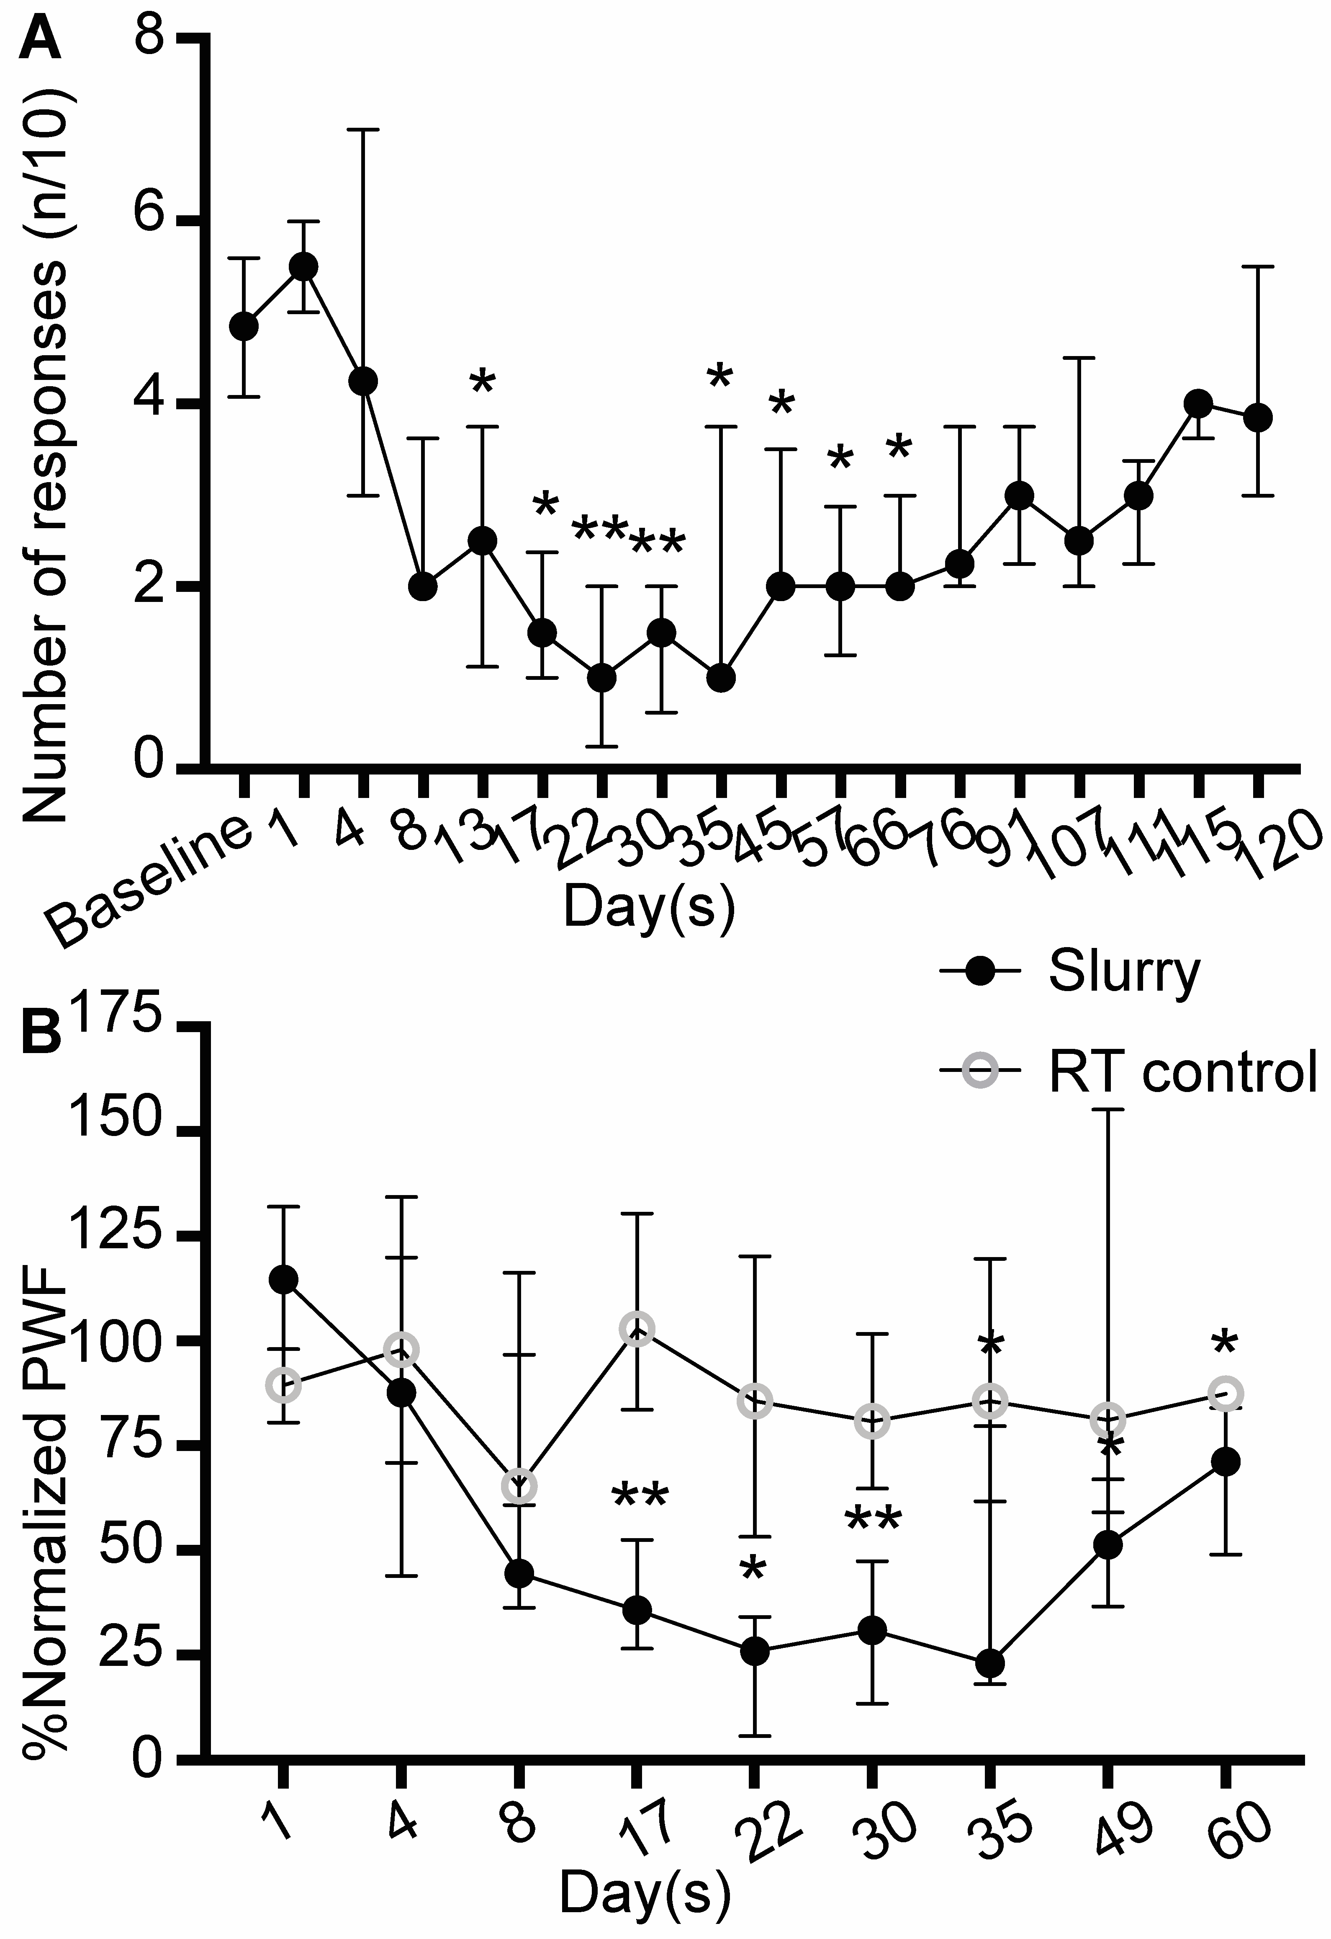
Supplementary Digital Content 3. Ice slurry injection leads to long lasting and reversible functional loss. (A) Paw withdrawal frequency in response to stimulation with 10g VFH force at different time points post ice slurry injection. Data are presented as median with interquartile range. n=8 per group; * P < 0.05, ** P < 0.001 compared to baseline values by Friedman test followed by Dunn’s multiple comparisons test. (B) Paw withdrawal frequency in response to stimulation with 10g VFH force at different time points post injection of ice slurry or injection of room temperature control solution. Paw withdrawal frequency values at each time point are normalized by dividing it by the value in the same animal at baseline and results are shown as percentage of the baseline value. n=8 per group; *P < 0.05, **P < 0.001 compared to the room temperature solution control group by two-tailed Mann-Whitney U-test; RT, room temperature.

