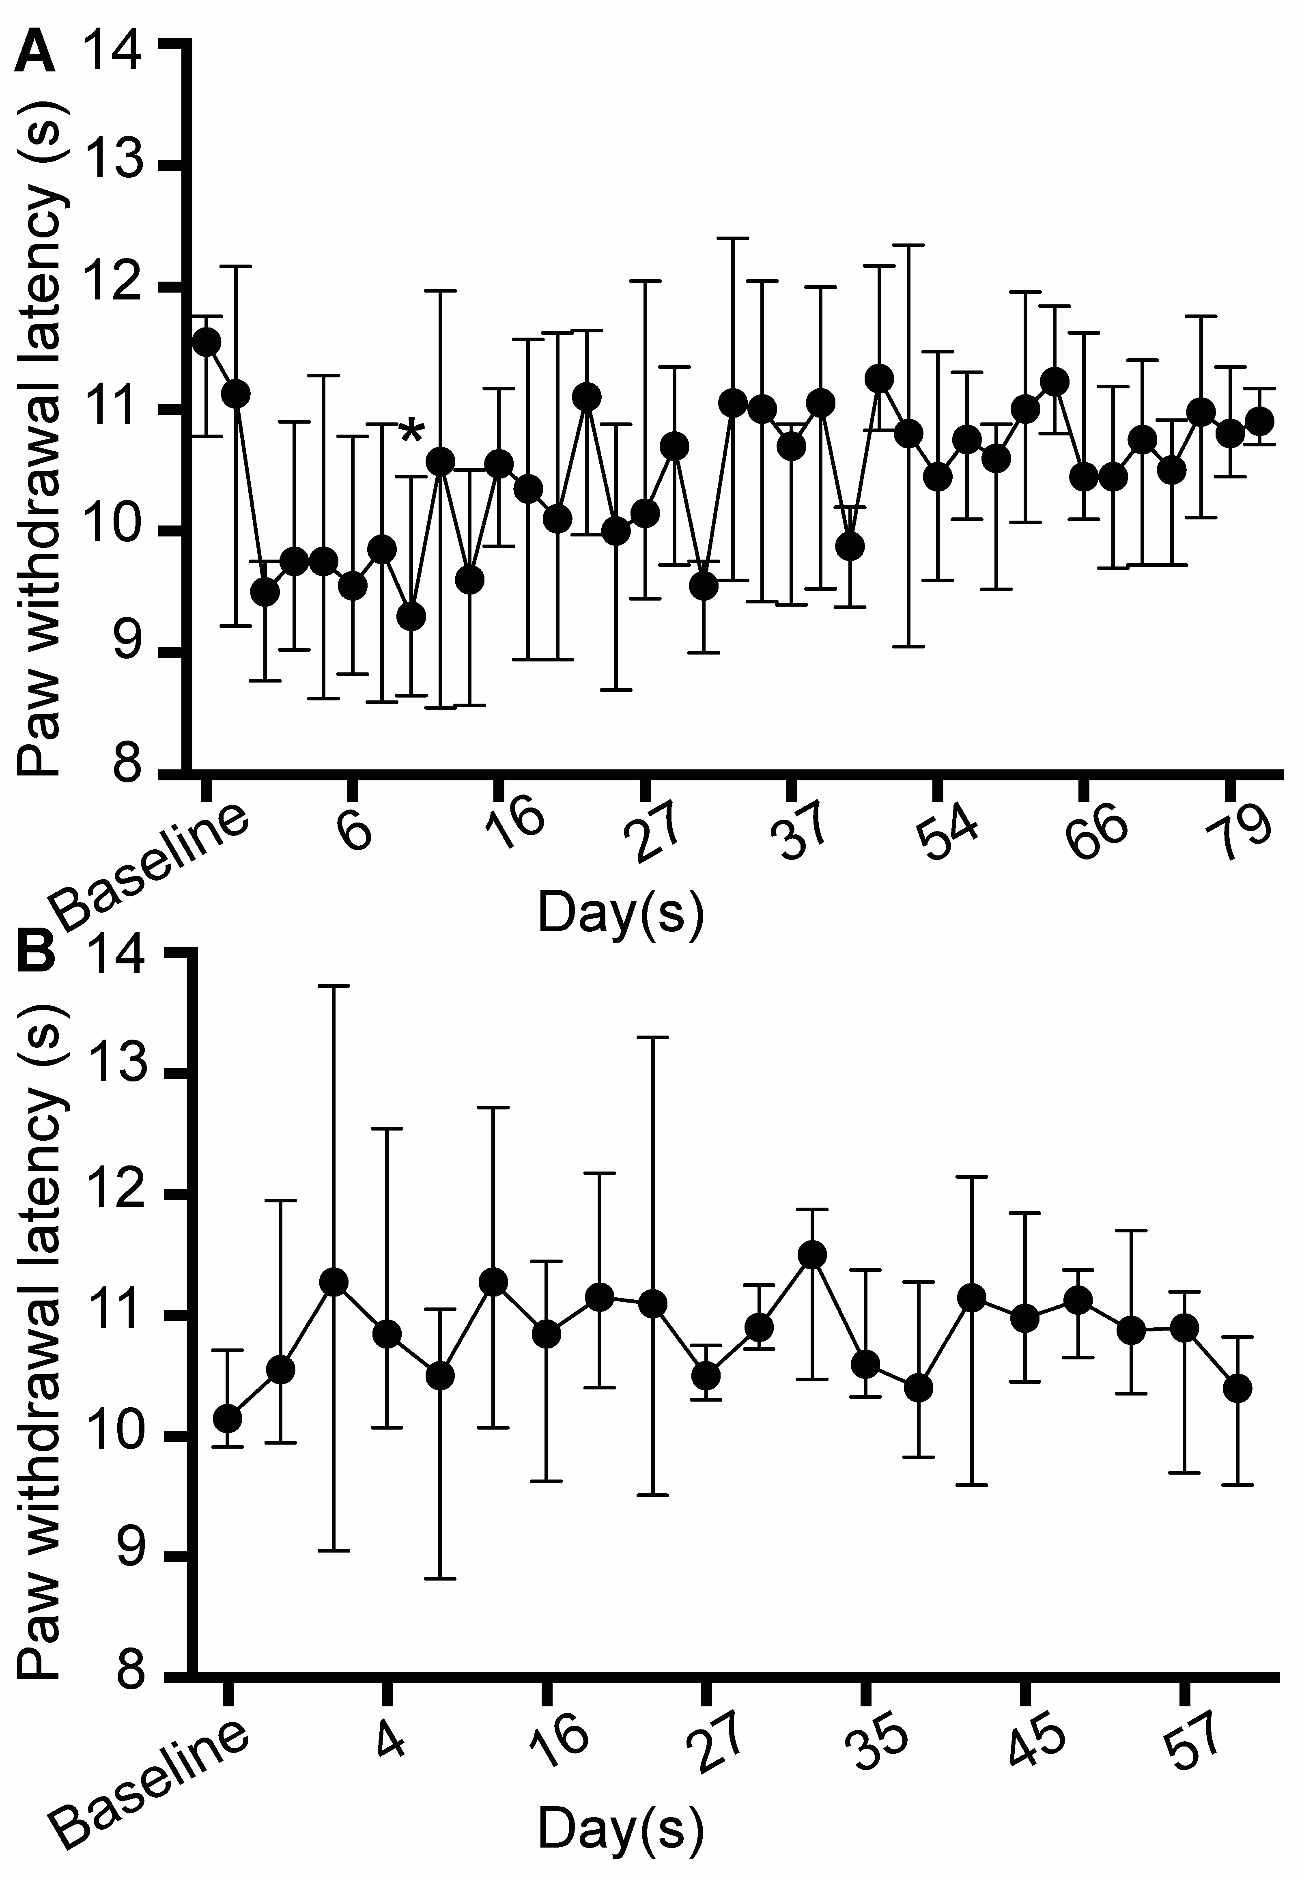
Supplementary Digital Content 4. Injection of ice slurry showed minimum effect on paw withdrawal latency in response to noxious heat stimulation. (A) Graph shows paw withdrawal latency in response to heat stimulation post ice slurry injection. Minor decrease of PWL in response to heat stimulation was observed in slurry-treated hind limbs, which reached significance compared to baseline values only at day 10 (B) Graph shows paw withdrawal latency in response to heat stimulation post injection of room temperature control solution. No significant changes were found in PWLs in controls, following the injection of room temperature control solution. Data are presented as median with interquartile range. n=8 per group; * P < 0.05 compared to baseline by Friedman test followed by Dunn’s multiple comparisons test.

