Figure Individualized positive end-expiratory pressure and regional gas exchange in porcine lung injury

Muders T, Luepschen H, Meier T, Reske A, Zinserling J, Kreyer S, Pikkemaat R, Maripuu E, Leonhardt S, Hedenstierna G, Putensen C, and Wrigge H

Supplemental Digital Content 3 – SPECT vs. EIT

Lung regions captured by Single Photon Emission Computed Tomography (SPECT) and Electrical Impedance Tomography (EIT) and resulting voxel or pixels sizes were different due to several technical reasons.
SPECT provides linear propagation of gamma rays from tracer substance to gamma camera. The collimator ensures that only perpendicular gamma rays are captured. The origin of the gamma rays (i.e., the SPECT voxel) can thus be precisely located. The size of the SPECT voxel depends on the chosen collimator. In our study SPECT resulted in 4.42 x 4.42 x 4.2 mm (=0.0821ml/voxel). The whole lung was captured and analyzed (figure S3).
In contrast, during EIT measurements the injected currents do not propagate through the body tissue in a linear way. Instead their pathways strongly depend non-linearly on the (unknown) conductivity distribution inside the thorax. Therefore, the “size” of an EIT pixel cannot be directly compared to a SPECT voxel but rather depends on the so-called “EIT sensitivity region”, which is traditionally described as a “lens-shaped” region extending to half the body diameter above and below the electrode plane [1]. The sensitivity region is influenced by numerous factors, one being the utilized current injection and voltage measurement pattern [2]. A detailed analysis, including definitions of forward- and inverse-sensitivity regions, is given in [3].
Assuming a median chest diameter of 18.5 cm in our study EIT covered a lens-shaped region of approximately 18.5 x 18.5 x 9.25 cm of the chest. Reconstruction resulted in 32 x 32 pixels of approximately 5.8 x 5.8 mm (figure S3).

Figure S3
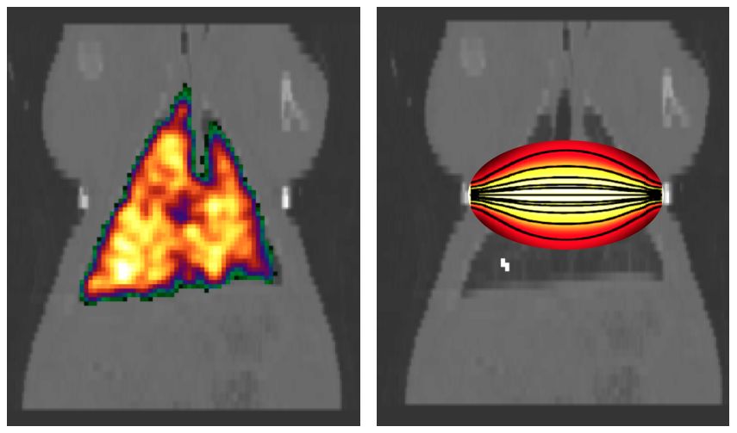
Left: SPECT image showing regional distribution of counts of Krypton during ventilation scan. Right: SPECT image without Krypton signal. Schematic picture (adapted from [1]) of the assumed lens-shaped lung region captured by EIT.

[1] A. Adler and A. Boyle, “Electrical Impedance Tomography: Tissue Properties to Image Measures,” IEEE Transactions on Biomedical Engineering, vol. 64, no. 11, pp. 2494–2504, Nov. 2017.
[2] A. Adler, I. Frerichs, and B. Grychtol, “The off-plane sensitivity of EIT,” presented at the 16th International Conference on Biomedical Applications of Electrical Impedance Tomography, Neuchâtel, Switzerland, 2015, p. 68.
[3] B. Grychtol, B. Müller, and A. Adler, “3D EIT image reconstruction with GREIT,” Physiological Measurement, vol. 37, no. 6, pp. 785–800, Jun. 2016.

