Individualized positive end-expiratory pressure and regional gas exchange in porcine lung injury

Muders T, Luepschen H, Meier T, Reske A, Zinserling J, Kreyer S, Pikkemaat R, Maripuu E, Leonhardt S, Hedenstierna G, Putensen C, and Wrigge H

Supplemental Digital Content 13 – PEEP titration based on driving pressure

We retrospectively compared our RVDI-method to PEEP-titration based on driving pressure. Both measures showed different courses during the decremental PEEP trial and led to different “optimal” PEEP-levels. Comparison of RVDI and driving pressure using inter- and intra-individual linear correlation (Pearson´s r) (figure S7) showed heterogeneous results (table S5).

Figure S7
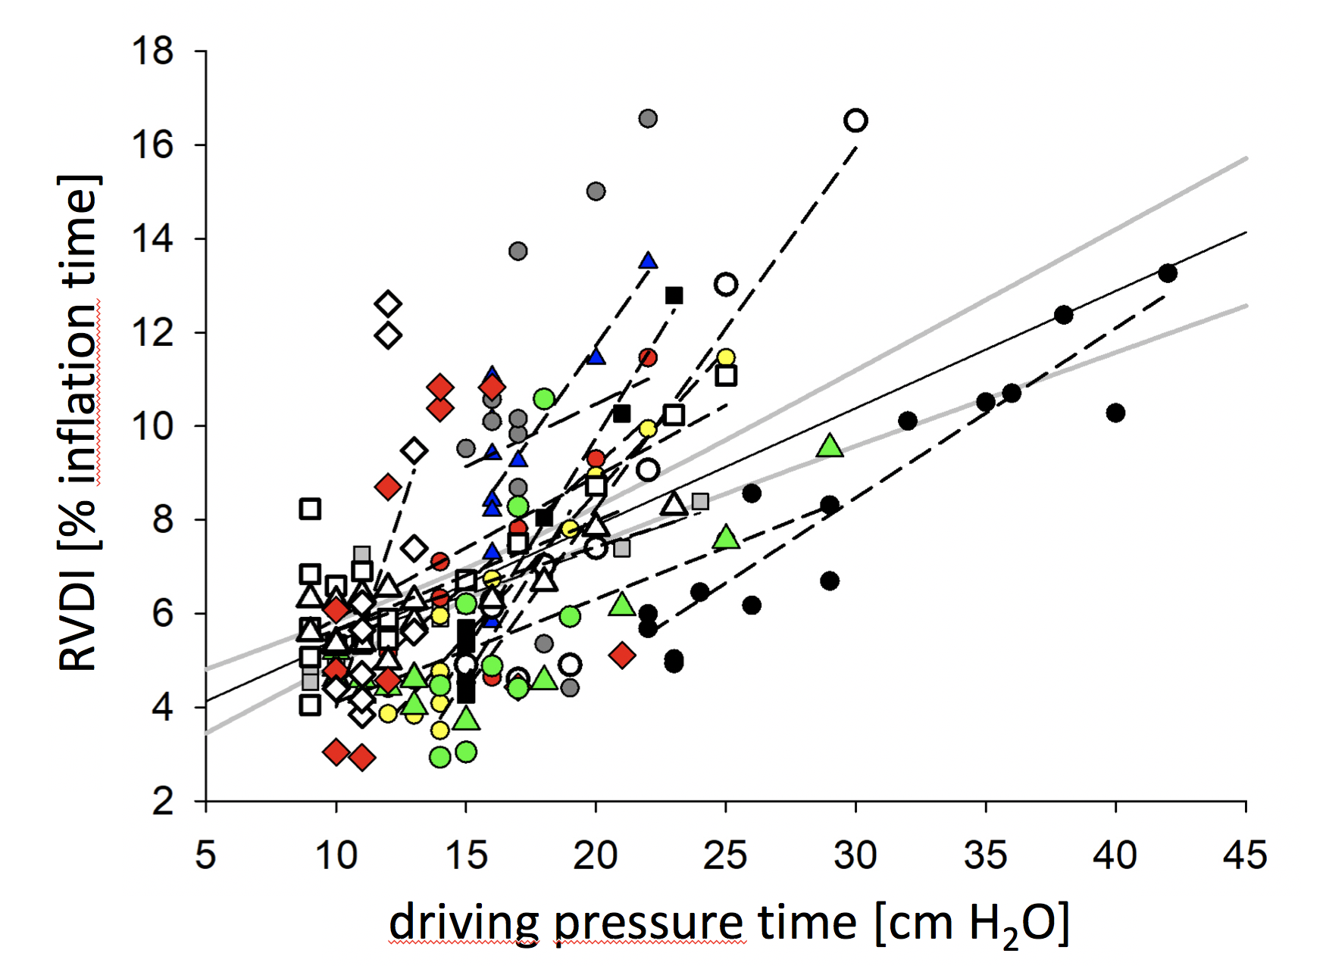
Linear correlation (Pearson´s r) of Regional-ventilation-delay-inhomogeniety (RVDI) as measured by EIT and driving pressure. Analyses were performed inter-individually (for all animals, solid black line: regression line; solid grey lines: 95% CI) and intra-individually (for any single pig, dashed lines: individual regression lines). For symbol legend and determination coefficients see table S8.

Table S5
Pig |  | Symbol |  | R²  RVDI vs. Pdrive |  | PEEP by EIT  [cm H₂O] |  | PEEP by Pdriv  [cm H₂O]
all animals mean (SD) |  |  |  | 0.33 |  | 22 (3) |  | 19 (3)
intra-individually
1 |  | black closed circle |  | 0.87  0,69 |  | 20 |  | 24
3 |  | green closed quadrat |  | 0.69 |  | 20 |  | 20
4 |  | red closed circle |  | 0.51 |  | 24 |  | 20
5 |  | blue closed triangle |  | 0.57 |  | 24 |  | 18
6 |  | black closed quadrat |  | 0.97 |  | 22 |  | 22
7 |  | yellow closed circle |  | 0.93 |  | 24 |  | 22
8 |  | black open circle |  | 0.90 |  | 22 |  | 22
9 |  | grey closed triangle |  | 0.74 |  | 20 |  | 18
10 |  | black open quardat |  | 0.67 |  | 24 |  | 16
11 |  | black open triangle |  | 0.16 |  | 20 |  | 16
12 |  | grey closed circle |  | 0.07 |  | 28 |  | 18
13 |  | green closed triangle |  | 0.30 |  | 18 |  | 14
14 |  | black open diamond |  | 0.39 |  | 18 |  | 18
15 |  | red closed diamond  0,87  ed closed diamond |  | 0.33 |  | 22 |  | 20
Determination coefficients (R2) of linear correlation analyses (Pearson´s r) for Regional-ventilation-delay-inhomogeniety (RVDI) versus driving pressure inter- and intraindividually. Mean (standard deviation) and individual PEEP levels determined by electrical impedance tomography (EIT) (based on RVDI) and driving pressure.

Table S5 gives PEEP-levels derived from RVDI-measurements (minimal-tidal- recruitment-PEEP) and driving pressure (lowest PEEP that ensures lowest driving pressure). Results were compared using linear correlation (Pearson´s r) and Bland-Altman-Analysis (figure S8).

Figure S8
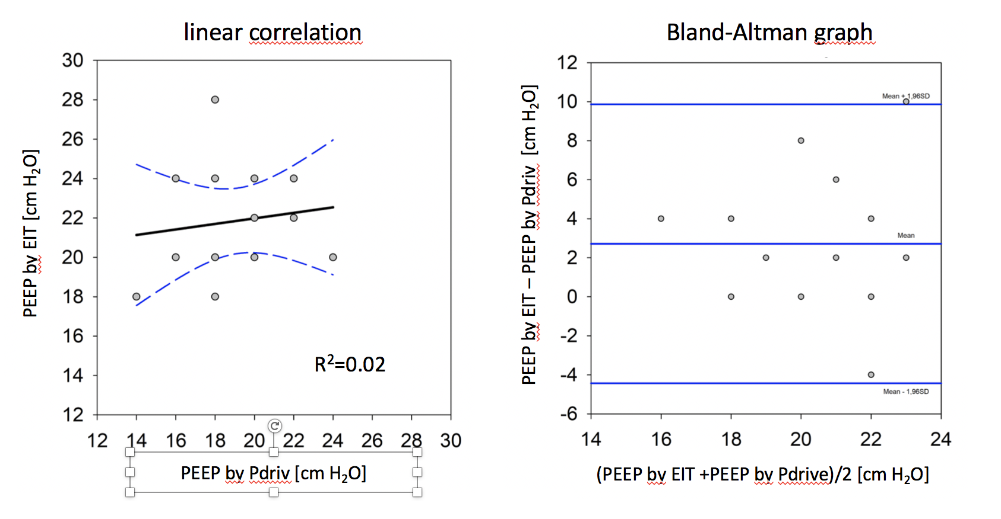
Linear correlation analyses (Pearson´s r, left panel) and Bland-Altman-analysis (right panel) for PEEP determined by electrical impedance tomography (EIT) and PEEP estimated by driving pressure (Pdriv).

In conclusion both techniques lead to different “optimal” PEEP levels. These analyses suggest that RVDI-measurements by EIT to analyze regional mechanical heterogeneity are not interchangeable with measures of global lung mechanics such as driving pressure.

