Individualized positive end-expiratory pressure and regional gas exchange in porcine lung injury

Muders T, Luepschen H, Meier T, Reske A, Zinserling J, Kreyer S, Pikkemaat R, Maripuu E, Leonhardt S, Hedenstierna G, Putensen C, and Wrigge H

Supplemental Digital Content 14 -Comparison of SPECT, CT, and blood gases
Results from blood gas analyses, SPECT- and CT-scans have been compared using linear correlation (Pearsons correlation) and Bland-and-Altman analysis, when appropriate.
Physiological shunt calculated from blood gas analyses (according to Berggren) showed a very good linear correlation mostly with a slope different from one (R²=0.82, P<0.001) to SPECT-derived shunt perfusion (figure S9). Bland-and-Altman analysis showed good agreement with low but increasing bias with higher values, revealing a slight systematic overestimation of shunt using the SPECT method (figure S9). This might be explained by a limited spatial resolution of SPECT, especially at very low V/Q ratios.

Figure S9
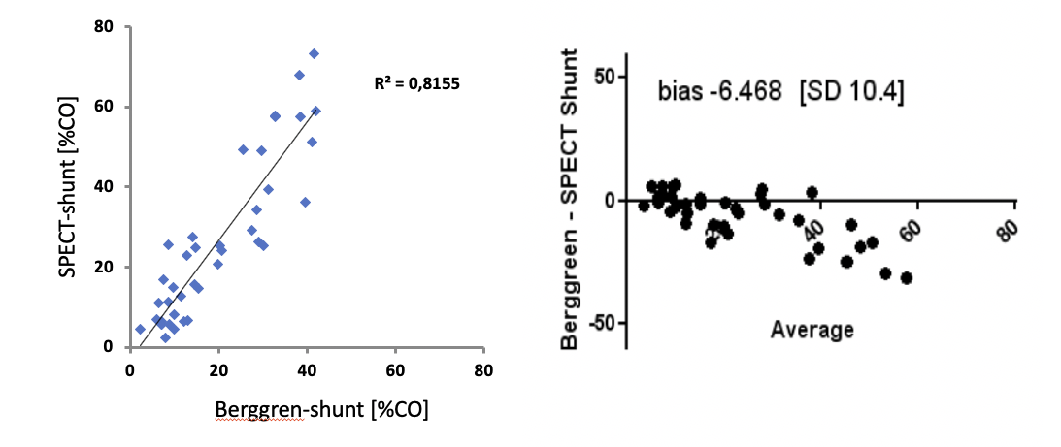
Comparison of physiological shunt in [% of cardiac output] calculated from blood gas analyses (according to Berggren) and SPECT-derived shunt perfusion [% of cardiac output]; left: linear correlation (Pearson); right: Bland-and-Altman analysis.

Since increasing bias with higher shunt values might have affected results on shunt during table PEEP more than during both other PEEP strategies, we also analyzed differences between PEEP strategies in physiological shunt (according to Berggren, table S6). Theses analyzes support our findings derived from SPECT (figure 4B) showing that shunt was highest during table PEEP, whereas no differences were found between minimal tidal recruitment and maximal oxygenation PEEP. Thus, reduced accuracy of our SPECT method to measure shunt (especially at higher values, see above) did not basically affect our findings.

Table S6
PEEP strategy | table PEEP | minimal tidal recruitment PEEP | maximal oxygenation PEEP | repeated measures ANOVA
Berggren-shunt [%] | 34 ± 6 ^{a,b} | 12 ± 5 ^{a,c} | 12 ± 7 ^{b,c} | <0.0001

Physiological shunt in [% of cardiac output] calculated from blood gas analyses (according to Berggren) during ventilation using different PEEP strategies. Comparison by repeated measures ANOVA followed by post hoc tests (Newman-Keuls): a: p<0.0001 table PEEP vs. minimal tidal recruitment PEEP, b: p<0.0001 table PEEP vs. maximal oxygenation PEEP, c: 0.9979 minimal tidal recruitment PEEP vs. maximal oxygenation PEEP.

The amount of shunt perfused lung tissue measured by SPECT was well correlated to the volume (R²=0.76, P<0.001, figure S10) and the mass (R²=0.76, P<0.001, figure S11) of lung tissue that appeared as non-aerated in the CT analysis. Furthermore, acceptable linear correlations mostly with a slope different from one were found when comparing shunt perfused lung tissue with the cumulative volume of non- and poorly-aerated lung tissue (R²=0.61 and R²=0.58, P<0.001, respectively, figures S10 and figure S11). That fact that the left but not the right plots of figures S10 and S11 show an intercept unequal to zero data suggest that poorly aerated lung tissue contributes sunt perfusion.

Figure S10
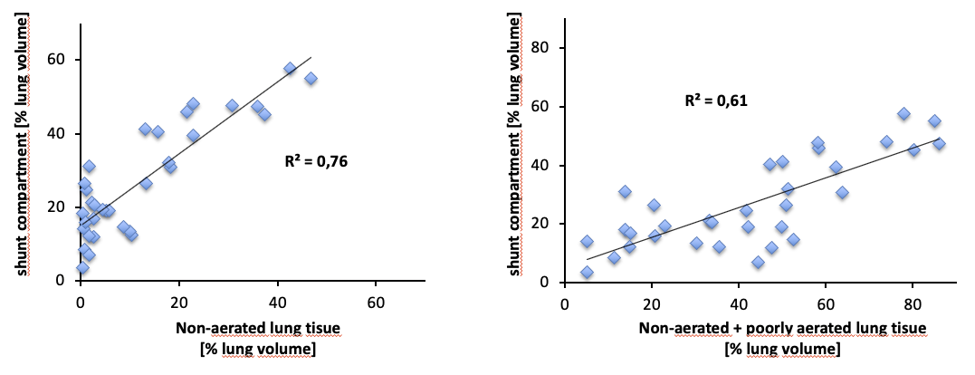
Left: comparison of shunt perfused lung region in [% of lung volume] measured by SPECT and CT-derived amount of non-aerated lung tissue in [% of lung volume]; right: comparison of shunt perfused lung region in [% of lung volume] measured by SPECT and cumulative volume of non- or poorly-aerated lung tissue in [% of lung volume]; linear regression analyses, p<0.001, respectively.

figure S11
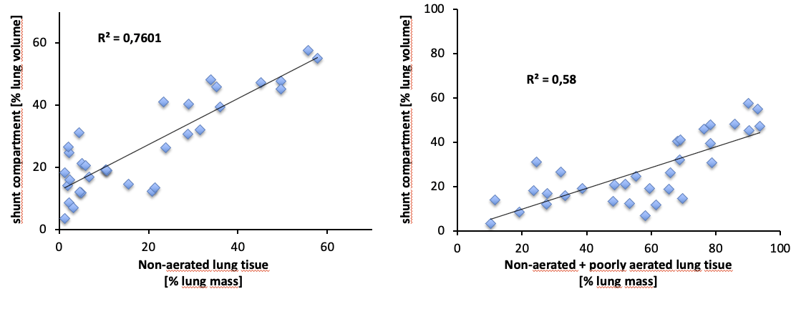
Left: comparison of shunt perfused lung region in [% of lung volume] measured by SPECT and CT-derived amount of non-aerated lung tissue in [% of lung volume]; right: comparison of shunt perfused lung region in [% of lung volume] measured by SPECT and cumulative volume of non- or poorly-aerated lung tissue in [% of lung volume]; linear regression analyses, p<0.001, respectively.

