Supplemental Digital Content 4. Regression Coefficients and Model Fit Characteristics for the Various Models Tested

Table e1. Logistic Regression for Postoperative Delirium (N = 1,113)
Feature | Coefficient | Odds Ratio (99.5% CI) | P value
Intercept | -1.79
Preoperative Abnormal Cognition | 0.793 | 2.21 (1.46 to 3.33) | <0.001
EEG Suppression (per 5 min) | 0.043 | 1.04 (1.03 to 1.06) | <0.001
Hosmer-Lemeshow goodness of fit test: χ²(8) = 6.079, p = 0.638
C statistic: 0.679

Table e2. Logistic Regression for Postoperative Delirium, with Interaction (N = 1,113)
Feature | Coefficient | Odds Ratio (99.5% CI) | P value
Intercept | -1.75
Preoperative Abnormal Cognition | 0.702 | 2.02 (1.23 to 3.30) | <0.001
EEG Suppression (per 5 min) | 0.037 | 1.04 (1.01 to 1.06) | <0.001
Preoperative Abnormal Cognition *EEG Suppression | 0.012 | 1.01 (0.98 to 1.05) | 0.350
Hosmer-Lemeshow goodness of fit test: χ²(8) = 5.369, p = 0.718
C statistic: 0.679

Table e3. Poisson Regression for Duration of EEG Suppression (N = 1,113)ª
Feature | Coefficient | Bootstrapped 99.5% Confidence Interval
Intercept | -2.49
Preoperative Abnormal Cognition | 0.430 | 0.142 to 0.717
a – Model used duration of anesthesia (minutes) as an offset.
Model R squared: 0.0837
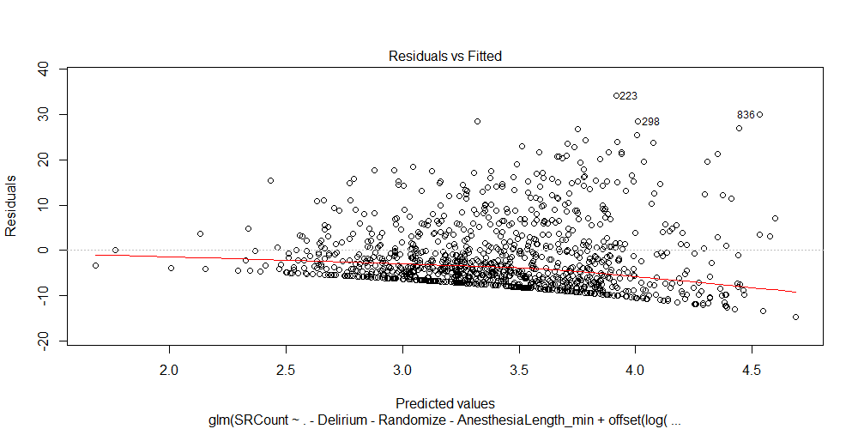
Figure e1. Residuals versus predicted values for the Poisson regression shown in Table e3.
The loess smoother (red curve) suggests a model violation; duration of EEG suppression is slightly less in higher predicted value (primarily longer) cases than one would expect based on a pure per-minute risk. Visual inspection suggests that the response may be somewhat zero-inflated either because of a true hurdle effect or because of technical difficulties causing EEG values to register as unsuppressed.
Table e4. Logistic Regression for Postoperative Delirium, Adjusting for Baseline Patient Characteristics and Intraoperative Factors (N = 961)
Feature | Coefficient | Odds Ratio (99.5% CI) | P value
Intercept | -4.764
Preoperative Abnormal Cognition | 0.741 | 2.10 (1.31 to 3.35) | <0.001
EEG Suppression (per 5 min) | 0.026 | 1.03 (1.01 to 1.05) | <0.001
Age (per year) | 0.024 | 1.02 (0.99 to 1.06) | 0.050
Male Sex | -0.413 | 0.66 (0.41 to 1.08) | 0.018
White Race | -0.456 | 0.63 (0.30 to 1.32) | 0.081
American Society of Anesthesiologists class > 3 | 0.267 | 1.31 (0.76 to 2.24) | 0.166
Ever Smoked | 0.384 | 1.47 (0.89 to 2.41) | 0.030
Number of Comorbid Conditions (per condition) | 0.125 | 1.13 (1.02 to 1.26) | 0.001
Procedure Risk (per unit) | 0.216 | 1.24 (0.98 to 1.58) | 0.012
Duration of Anesthesia (per hr) | 0.166 | 1.18 (1.04 to 1.34) | <0.001
Packed Red Blood Cell (per unit) | 0.144 | 1.15 (1.01 to 1.32) | <0.001
Hosmer-Lemeshow goodness of fit test: χ²(8) = 13.103, p = 0.1084
C statistic: 0.773

Table e5. Poisson Regression for Duration of EEG Suppression, Adjusting for Baseline Patient Characteristics and Intraoperative Factors (N = 961)ª
Feature | Coefficient | Bootstrapped 99.5% Confidence Interval
Intercept | -7.429
Preoperative Abnormal Cognition | 0.389 | 0.093 to 0.685
Age (per year) | 0.032 | 0.008 to 0.056
Male Sex | -0.200 | -0.495 to 0.094
White Race | -0.261 | -0.699 to 0.178
American Society of Anesthesiologists class > 3 | 0.346 | 0.002 to 0.690
Ever Smoked | 0.008 | -0.303 to 0.319
Number of Comorbid Conditions (per condition) | 0.055 | -0.016 to 0.127
Procedure Risk (per unit) | -0.057 | -0.211 to 0.096
Mean End-Tidal Anesthetic Concentration (per minimum alveolar concentration unit) | 3.188 | 2.184 to 4.191
Total Opioid Dose (per morphine equivalent in mg) | 0.003 | -0.001 to 0.007
Total Propofol Dose (per mg) | 0.001 | -0.001 to 0.002
a – Model used duration of anesthesia (minutes) as an offset.
Model R squared: 0.2088
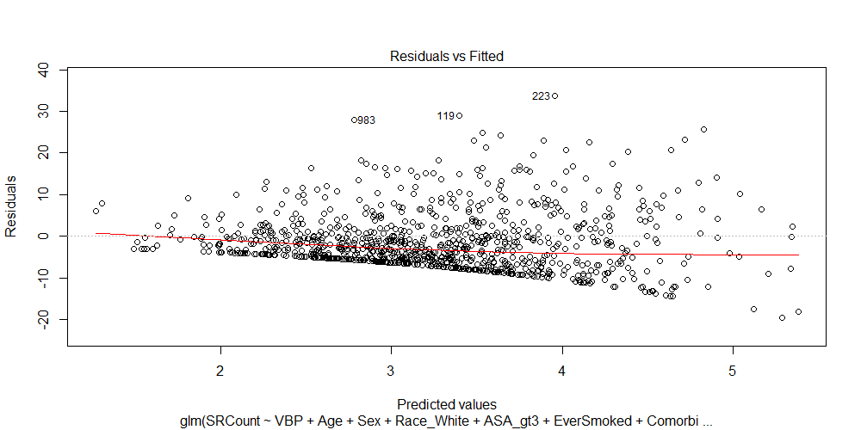
Figure e2. Residuals versus predicted values for the Poisson regression shown in Table e5.
The loess smoother (red curve) suggests a model violation; duration of EEG suppression is slightly less in higher predicted value (primarily longer) cases than one would expect based on a pure per-minute risk. Visual inspection suggests that the response may be somewhat zero-inflated either because of a true hurdle effect or because of technical difficulties causing EEG values to register as unsuppressed.

Table e6. Linear Regression for Duration of EEG Suppression (N = 1,113)
Feature | Coefficient | Bootstrapped 99.5% Confidence Interval
Intercept | -11.424
Preoperative Abnormal Cognition | 14.612 | 4.809 to 24.415
Duration of Anesthesia (per min) | 0.118 | 0.092 to 0.144
Model R squared: 0.0844
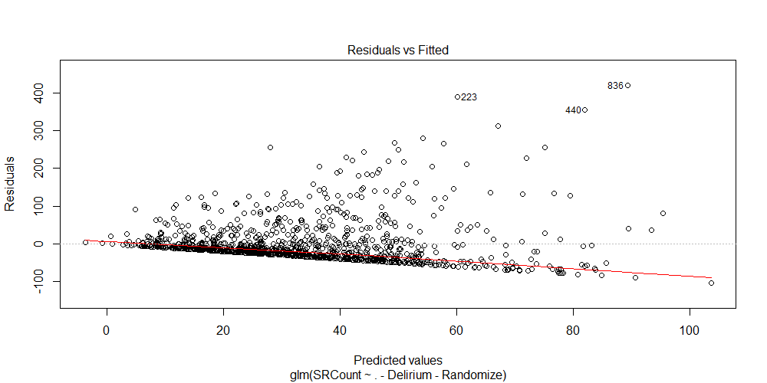
Figure e3. Residuals versus predicted values for the linear regression shown in Table e6.
The loess smoother (red curve) suggests a model violation; duration of EEG suppression is slightly less in higher predicted value (primarily longer) cases than one would expect based on a pure per-minute risk. Visual inspection suggests that the response may be somewhat zero-inflated either because of a true hurdle effect or because of technical difficulties causing EEG values to register as unsuppressed.

Table e7. Logistic Regression for Postoperative Delirium (Alternative Definition of Duration of EEG Suppression), Adjusting for Baseline Patient Characteristics and Intraoperative Factors (N = 931)
Feature | Coefficient | Odds Ratio (99.5% CI) | P value
Intercept | -4.707
Preoperative Abnormal Cognition | 0.758 | 2.13 (1.32 to 3.45) | <0.001
EEG Suppression (per 5 min)ª | 0.102 | 1.11 (1.03 to 1.20) | <0.001
Age (per year) | 0.021 | 1.02 (0.99 to 1.06) | 0.093
Male Sex | -0.393 | 0.68 (0.41 to 1.12) | 0.029
White Race | -0.529 | 0.59 (0.28 to 1.24) | 0.045
American Society of Anesthesiologists class > 3 | 0.118 | 1.12 (0.64 to 1.98) | 0.560
Ever Smoked | 0.409 | 1.50 (0.90 to 2.51) | 0.025
Number of Comorbid Conditions (per condition) | 0.150 | 1.16 (1.04 to 1.30) | <0.001
Procedure Risk (per unit) | 0.266 | 1.30 (1.02 to 1.67) | 0.003
Duration of Anesthesia (per hr) | 0.182 | 1.20 (1.06 to 1.36) | <0.001
Packed Red Blood Cell (per unit) | 0.148 | 1.16 (1.01 to 1.33) | 0.002
a – The alternative definition defines duration of EEG suppression as the number of seconds with an isoelectric EEG, rather than number of minutes with suppression ratio >1.
Hosmer-Lemeshow goodness of fit test: χ²(8) = 9.546, p = 0.298
C statistic: 0.782

Table e8. Poisson Regression for Duration of EEG Suppression (Alternative Definition of Duration of EEG Suppression), Adjusting for Baseline Patient Characteristics and Intraoperative Factors (N = 931)ª
Feature | Coefficient | Bootstrapped 99.5% Confidence Interval
Intercept | -6.416
Preoperative Abnormal Cognition | 0.481 | 0.084 to 0.877
Age (per year) | 0.034 | 0.004 to 0.064
Male Sex | -0.342 | -0.779 to 0.095
White Race | -0.267 | -0.980 to 0.447
American Society of Anesthesiologists class > 3 | 0.726 | 0.229 to 1.224
Ever Smoked | 0.079 | -0.378 to 0.536
Number of Comorbid Conditions (per condition) | 0.018 | -0.091 to 0.127
Procedure Risk (per unit) | -0.100 | -0.344 to 0.144
Mean End-Tidal Anesthetic Concentration (per minimum alveolar concentration unit) | 4.670 | 3.215 to 6.124
Total Opioid Dose (per morphine equivalent in mg) | 0.004 | -0.002 to 0.010
Total Propofol Dose (per mg) | 0.001 | -0.001 to 0.002
a – Model used duration of anesthesia (minutes) as an offset.
Model R squared: 0.2142
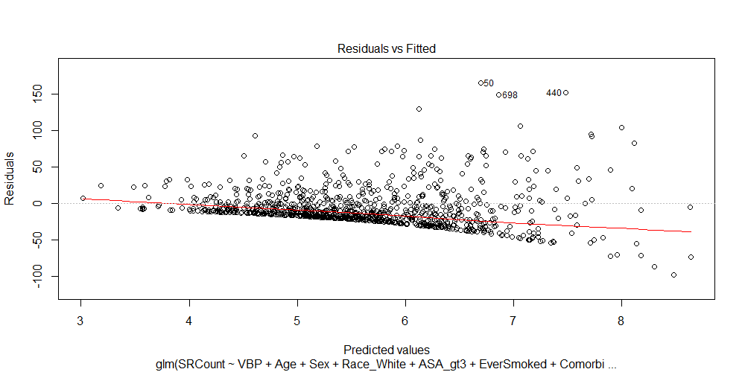

Figure e4. Residuals versus predicted values for the Poisson regression shown in Table e8.
The loess smoother (red curve) suggests a model violation; duration of EEG suppression is slightly less in higher predicted value (primarily longer) cases than one would expect based on a pure per-minute risk. Visual inspection suggests that the response may be somewhat zero-inflated either because of a true hurdle effect or because of technical difficulties causing EEG values to register as unsuppressed.
Table e9. Logistic Regression for Postoperative Delirium (Using Duration of Bispectral Index < 40), Adjusting for Baseline Patient Characteristics and Intraoperative Factors (N = 931)
Feature | Coefficient | Odds Ratio (99.5% CI) | P value
Intercept | -5.229
Preoperative Abnormal Cognition | 0.787 | 2.20 (1.38 to 3.50) | <0.001
Bispectral Index < 40 (per 5 min)ª | 0.012 | 1.01 (1.00 to 1.01) | 0.015
Age (per year) | 0.030 | 1.03 (1.00 to 1.07) | 0.012
Male Sex | -0.369 | 0.69 (0.42 to 1.12) | 0.033
White Race | -0.515 | 0.60 (0.29 to 1.24) | 0.047
American Society of Anesthesiologists class > 3 | 0.314 | 1.37 (0.80 to 2.34) | 0.101
Ever Smoked | 0.393 | 1.48 (0.91 to 2.43) | 0.025
Number of Comorbid Conditions (per condition) | 0.133 | 1.14 (1.03 to 1.27) | <0.001
Procedure Risk (per unit) | 0.188 | 1.21 (0.95 to 1.54) | 0.028
Duration of Anesthesia (per hr) | 0.160 | 1.17 (1.04 to 1.33) | <0.001
Packed Red Blood Cell (per unit) | 0.160 | 1.17 (1.02 to 1.34) | 0.001
a – The alternative definition defines duration of EEG suppression as the number of seconds with an isoelectric EEG, rather than number of minutes with suppression ratio >1.
Hosmer-Lemeshow goodness of fit test: χ²(8) = 15.472, p = 0.051
C statistic: 0.768

Table e10. Poisson Regression for Duration of Bispectral Index < 40, Adjusting for Baseline Patient Characteristics and Intraoperative Factors (N = 931)ª
Feature | Coefficient | Bootstrapped 99.5% Confidence Interval
Intercept | -1.231
Preoperative Abnormal Cognition | 0.135 | -0.063 to 0.333
Age (per year) | -0.021 | -0.036 to -0.005
Male Sex | -0.321 | -0.516 to -0.126
White Race | 0.008 | -0.319 to 0.335
American Society of Anesthesiologists class > 3 | 0.049 | -0.179 to 0.277
Ever Smoked | -0.071 | -0.268 to 0.126
Number of Comorbid Conditions (per condition) | -0.006 | -0.053 to 0.041
Procedure Risk (per unit) | 0.072 | -0.020 to 0.165
Mean End-Tidal Anesthetic Concentration (per minimum alveolar concentration unit) | 1.565 | 0.808 to 2.321
Total Opioid Dose (per morphine equivalent in mg) | 0.001 | -0.002 to 0.004
Total Propofol Dose (per mg) | <0.001 | -0.001 to 0.001
a – Model used duration of anesthesia (minutes) as an offset.
Model R squared: 0.1770
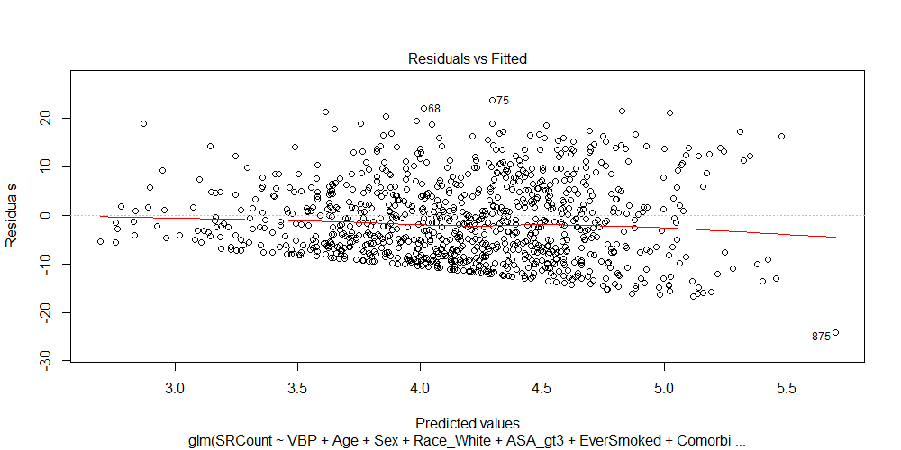
Figure e5. Residuals versus predicted values for the Poisson regression shown in Table e10.
The loess smoother (red curve) suggests a model violation; duration of EEG suppression is slightly less in higher predicted value (primarily longer) cases than one would expect based on a pure per-minute risk. Visual inspection suggests that the response may be somewhat zero-inflated either because of a true hurdle effect or because of technical difficulties causing EEG values to register as unsuppressed.

