Relative effects of tidal volume, respiratory rate and PEEP, when delivered at similar mechanical power, on ventilator-induced lung injury

Francesco Vassalli*, MD, Iacopo Pasticci*, MD, Federica Romitti, MD, Eleonora Duscio, MD, David Jerome Aßmann, MS, Hannah Grünhagen, MS, Francesco Vasques, MD, Matteo Bonifazi, MD, Mattia Busana, MD, Matteo Maria Macrì, MD, Lorenzo Giosa, MD, Verena Reupke, DVM, Peter Herrmann, MSc, Günter Hahn, MSc, Orazio Leopardi, MD, Onnen Moerer, MD, Michael Quintel, MD, John J. Marini, MD, Luciano Gattinoni, MD, FRCP
* These authors equally contributed to the paper

SUPPLEMENTAL DIGITAL CONTENT

Additional introduction

In a passive patient undergoing mechanical ventilation in volume controlled mode, the pressures existing at the end of inspiration in the respiratory system (Prs) can be described as:
$$P_{rs}=∆P+(P_{peak}-P_{plat})+PEEP$$
Where Ppeak is the peak airway pressure, Pplat is the airway plateau pressure during an end-inspiratory occlusion, ΔP is the driving pressure, calculated as Pplat – PEEP, and PEEP is the airway pressure during an end-expiratory occlusion.
The classical equation of motion of the respiratory system describes Prs and its components in terms of flow, volume and the elastic and dynamic properties of the lung (provided that they are constant in the range of volume and flow examined), accordingly:
$$P_{rs}=∆V∙E_{rs}+F∙R_{rs}+PEEP$$
Where $∆V$ is the tidal volume, ERS is the elastance of the respiratory system, F is the flow across the lung and Rrs represents the airway and tissue resistances. In fact,
$$∆P=∆V∙E_{rs}$$
This term represents the pressure needed to overcome the elastic forces of the respiratory system.
$$P_{peak}-P_{plat}=F∙R_{rs}$$
This term represents the pressure needed to overcome the airway and tissue resistances.
In addition, in order to generate a pressure and air movement, the ventilator must be able to overcome the static pressure that is already existing in the respiratory system at the end of the mechanically ventilated breath, i.e. PEEP.
We define the energy delivered by the ventilator in the respiratory system (J_{rs}) per breath as the integral of absolute pressure and change in volume:
$$J_{rs}=\int_{0}^{ΔV}{P}∙dV$$
Accordingly and simplifying, we define the elastic energy as:
$$Elastic energy=\frac{1}{2}∙∆V∙E_{rs}$$
We define the dynamic energy as:
$$Dynamic energy=∆V∙{(P}_{peak}-P_{plat})$$
We define the static energy as:
$$Static energy=∆V∙PEEP$$
The energy delivered by the ventilator to the respiratory system (J_{rs}) per breath equals the sum of elastic, dynamic and static energy. Mechanical power of ventilation is calculated as J_{rs} times respiratory rate (RR) and represents the energy delivered by the ventilator in 1 minute. In formula, adjusting and simplifying we can express the mechanical power as:
$${Power}_{rs}=0.098∙RR∙\left\{{∆V}^{2}∙\left[\frac{1}{2}∙E_{rs}+RR∙\frac{\left(1+I:E\right)}{60sec ∙I:E}∙R_{rs}\right]+∆V∙PEEP\right\}$$
$${Power}_{rs}=0.098∙RR∙∆V∙{(P}_{peak}-\frac{1}{2}∙∆P)$$

Where 0.098 is the conversion factor from L*cmH2O to Joules.

Additional material and methods

Experimental procedure

This study was approved by local authorities (LAVES, Niedersächsisches Landesamt für Verbraucherschutz und Lebensmittelsicherheit, Projekt 18/2795). The experiments were performed in a dedicated operating room of the animal facility of Göttingen medicine university (UMG), Göttingen, Germany, between June and November 2019. We performed two experiments in parallel under the constant supervision of a dedicated veterinarian. The animals were randomly assigned to one of the six experimental group and the experiments were performed in a random order without investigators blinding.
We used healthy domestic female piglets weighing 24.2 ± 2 kg (circa 2 months of age), a validated model for the study of ventilator-induced lung injury. We chose female animals for anatomical reasons related to the ease of urinary catheter placement.
Before entering the operating room, the veterinarian administered to the animal an anxiolytic premedication with azaperon 2 mg/kg and ketamin 10 mg/kg through muscular injection into the neck. Thereafter, a peripheral venous access (20-22 Gauge) was placed at the ear and propofol (10-20 mg) was injected. The pigs were positioned on their side to facilitate breathing, then washed and shaved. After this phase, the pig was transported in the operating room and placed on the operating table in prone position. Initial monitoring included peripheral oxygen saturation at the tail or the ear and 3-lead electrocardiography. After pre-oxygenation via a nose cone connected to a bag valve mask, anesthesia was induced with sufentanil (30-50 μg) and propofol (40-80 mg) iv bolus. Laringoscopy was performed with a Wisconsin laryngoscope blade and endotracheal tube (6.5-7.5 mm internal diameter) was positioned with the help of a stylet. Once intubated, the animal was connected to the Avea ventilator. The correct tube placement was confirmed by clinical assessment and capnometry. Before the beginning of the mechanical ventilation protocol, ventilation was set in volume-controlled mode, 40% fraction of inspired oxygen, tidal volume 8-10 ml/kg, respiratory rate 15-25 and PEEP 5 cmH2O, inspiratory-to-expiratory ratio 1:1 in order to obtain an EtCO2 between 35-45 mmHg.
General anesthesia was maintained with propofol, sufentanil and midazolam throughout the experiment at a level adequate to fully abolish any response to painful stimuli, depth of anesthesia was regularly checked by dedicated veterinarian. The average dosages were sufentanil 2.04 ± 0.65 mcg/kg/hour, propofol 10.7±2 mg/kg/hour and midazolam 1.06±0.39 mg/kg/hour. In addition, we administered a standard dose of heparin 1000 UI/h and amoxicillin 15 mg/kg every 24 hours.
Animals were instrumented with the following devices:
- urinary catheter (6 Fr)
- adult esophageal catheter (8 Fr) Smart Cath with esophageal balloon; the correct positioning of the esophageal catheter was checked by means of an occlusion test
- central venous catheter (5 Fr) in the external jugular vein, ultrasound-guided
- Swan-Ganz catheter (5 Fr) through an introducer (7 Fr) in the external jugular vein, ultrasound guided
- arterial PICCO catheter (5 Fr) in the femoral artery, ultrasound guided
Central temperature was continuously monitored via the Swan-Ganz catheter and hypothermia was avoided during the experiment by using warmed infusions and/or heating blankets.
We set Stereofundin 1:1 at a rate of infusion of 4 ml/kg/h via dial-a-flow. We also added potassium and glucose as needed to maintain normokalemia and normoglycemia.
The main hemodynamic goal was to maintain the animal alive for 48 hours by maintaining a mean arterial pressure (MAP) of at least 60 mmHg. As we expected, due to the ventilatory protocol, relative hypovolemia as a primary cause of hypotension, the first line treatment of MAP < 60 mmHg was Gelafundin 4%, up to a maximum of 1500 ml in 6 hours. Norepinephrine could be added by the investigator only after a minimum of 500 ml fluid bolus in presence of hypotension. Epinephrine was implemented in presence of low mean arterial pressure, systemic vascular resistance and urinary output, despite increasing norepinephrine.
Each couple of experiments started in the morning of day 1 and ended in the afternoon of day 3: dedicated personnel monitored the animals for 48 hours and measured respiratory, hemodynamic and gas exchange variables every 6 hours. At the end of the experiment, euthanasia was performed with pentobarbital overdose and potassium chloride 40-60 mEq. Thereafter, we executed the autopsy of the animal and collected the relevant anatomical samples.

Measured variables

Baseline weight, nose-to-tail length, chest circumference. End-experiment weight, lung and heart weight. Three samples of approximately 1 cm³ were taken from three zones of each lung (upper, medium and lower segments), 1 sample from liver, kidney, small bowel and skeletal muscle were obtained for wet-to-dry analysis. The samples were dried in the oven for 24 hours at 50°C. Wet-to-dry ratio is defined as the ratio between wet and dry weight.
Functional residual capacity (FRC) was measured at the beginning of the experiment and every 12 hours (0, 12, 24, 36, 48 hour) via a simplified multiple breath helium dilution technique: we filled a Hamilton super-syringe with 1 L (vol_{start}) of a gas mixture with helium 14%, subsequently we emptied the content of the super-syringe into a test balloon and clamped the balloon. We measured the starting helium concentration (C_{start}) with a helium analyser (TEMC DE-OX, Milano, Italy). The animal was disconnected from the ventilator and, after at least 20 seconds of apnea at atmospheric pressure, the balloon was connected to the animal. We performed 15 manual breaths in a period of circa 60-90 seconds, then the balloon was clamped and the animal was re-connected to the ventilator. At this point, we measured the final helium concentration (C_{final}) in the balloon. The FRC was computed as:
$$FRC= {vol}_{start}⸱\frac{(C_{start}-C_{fin})}{C_{fin}}$$
Being vol_{start} = 1 L, we calculated FRC in L as:
$$FRC= \frac{(C_{start}-C_{fin})}{C_{fin}}$$

Measured respiratory mechanics variables (Avea ventilator): fraction of inspired oxygen (FIO₂), tidal volume, respiratory rate, inspiratory time, inspiratory-to-expiratory (I:E) ratio, inspiratory flow, minute ventilation, mean airway pressure, peak inspiratory pressure (P_{peak}), airway plateau pressure during inspiratory pause (Paw_{plat}), airway pressure during expiratory pause at PEEP (Paw_{PEEP}), airway pressure during expiratory pause at ZEEP (Paw_{ZEEP}), volume release from PEEP to ZEEP, esophageal plateau pressure during inspiratory pause (Pes_{plat}), esophageal pressure during expiratory pause at PEEP (Pes_{PEEP}), esophageal pressure during expiratory pause at ZEEP (Pes_{ZEEP}), CO₂ elimination (VCO₂).

Computed respiratory mechanics variables:
Respiratory system driving pressure (cmH₂O) = Paw_{plat} – Paw_{PEEP}
Chest wall driving pressure (cmH₂O) = Pes_{plat} – Pes_{PEEP}
Lung driving pressure (cmH₂O) = (Paw_{plat} – Paw_{PEEP}) – (Pes_{plat} – Pes_{PEEP})
Respiratory system elastance (cmH₂O/L) = (Paw_{plat} – Paw_{PEEP}) / tidal volume
Chest wall elastance (cmH₂O/L) = (Pes_{plat} – Pes_{PEEP}) / tidal volume
Lung elastance (cmH₂O/L) = [(Paw_{plat} – Paw_{PEEP}) – (Pes_{plat} – Pes_{PEEP})] / tidal volume
Stress (cmH₂O) = (Paw_{plat} – Paw_{ZEEP}) – (Pes_{plat} – Pes_{ZEEP})
Strain = (tidal volume + release volume) / FRC
Specific lung elastance (cmH₂O) = stress / strain
Resistive pressure = P_{peak} - Paw_{plat}
Respiratory system mechanical power (J/min) = 0.098 * respiratory rate * tidal volume * (P_{peak} – 0.5*(Paw_{plat} – Paw_{PEEP}))

Measured hemodynamic variables (Solar 8000, PiCCO): heart rate, systemic and pulmonary artery pressures (systolic, diastolic, mean), wedge and central venous pressures during expiration, thermodilution cardiac output (PiCCO).

Derived hemodynamic variables: systemic and pulmonary artery resistances, extravascular lung water

Measured gas exchange variables (GEM 3000): pH, PO₂ (mmHg), PCO₂ (mmHg), hematocrit (%), sodium (mmol/L), potassium (mmol/L), calcium (mmol/L), lactate (mmol/L)

Derived gas exchange variables:
Hemoglobin (g/dL): computed from hematocrit by GEM3000
Oxygen saturation (%): computed from PO₂ by GEM3000
Oxygen content of O₂ (ml O₂/dl blood): 0.0031 * PO₂ + (hemoglobin * oxygen saturation/100 * 1.39); for capillary oxygen content of O₂, oxygen saturation is assumed to be 100%
Oxygen consumption (ml O₂ / min): (arterial oxygen content – mixed venous oxygen content) * cardiac output (PiCCO)
Respiratory quotient: CO₂ elimination / oxygen consumption
Alveolar pressure of oxygen (PAO₂) (mmHg): (barometric pressure – water vapour pressure) * FIO₂ – arterial PCO₂ / respiratory quotient
Venous admixture (shunt) fraction = 100 * $\frac{{CcO}_{2}-{CaO}_{2}}{{CcO}_{2}-{CvO}_{2}}$
Where CcO₂ is the capillary oxygen content, CaO₂ is the arterial oxygen content and CvO₂ is the mixed venous oxygen content.
Physiological dead space fraction = 100 * $\frac{{PaCO}_{2}- {PECO}_{2}}{{PaCO}_{2}}$
Where PaCO₂ is the arterial CO₂ pressure (mmHg), as obtained by the blood gas machine, and PECO₂ is the mean expiratory CO₂ (mmHg), as measured by the AVEA ventilator.

Fluid-related variables: urinary output, esophageal catheter output, maintenance fluids, pumps (propofol, sufentanil, midazolam, heparin, norepinephrine, epinephrine), resuscitation fluids. Fluid balance was calculated as input (maintenance, resuscitation, pumps) – output (urinary, esophageal) fluids.

Histology
The lungs were fixed in 4% formalin for at least one week. Ten samples of lung tissue were obtained from each lung for histological examination according to the scheme displayed in figure E2. The samples were fixed, dehydrated in a graded alcohol series, cleared in xylene and embedded in paraffin. Two µm sections were cut with a microtome, mounted on slides, and stained with hematoxylin-eosin for histological analysis. The sections were viewed under a light microscope, and histological scoring was performed by an investigator (O. L.) blinded to the group allocation of the animals. A score from 0 (not present) to 100% (extensive) was attributed to each sample for each of the following categories: emphysema, inflammation, vascular congestion, perialveolar/alveolar hemorrhage, alveolar edema, ruptures/septal dilation, alveolar collapse/atelectasis, perivascular edema, intravascular thrombi, hyaline membranes.

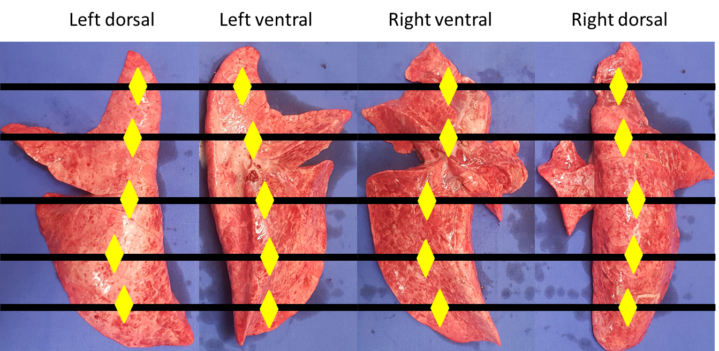

Figure S1: Picture of the lung of pig 34 (low power, high respiratory rate group). Schematic representation of lung sampling for histological analysis. As shown, both for left and right lung, 5 samples were taken from dorsal (non-dependent) and ventral (dependent) regions. Therefore, 20 samples were taken for each pig.

Additional material and methods
In the following figures we report the time course of mechanics, hemodynamics and gas exchange variables. We present mean and standard error of each variable according to power level (high vs low) (panel A), ventilatory strategy (high tidal volume, high respiratory rate or high PEEP) (panel B) and single groups of intervention (panel C). For each figure, we report the result of the corresponding linear mixed model (baseline values are excluded from this model): the fixed effects are the ventilatory strategy (high tidal volume, high respiratory rate, high PEEP groups), the mechanical power (high and low groups) and the interactions between each of them and time, while the animals are the random effect.

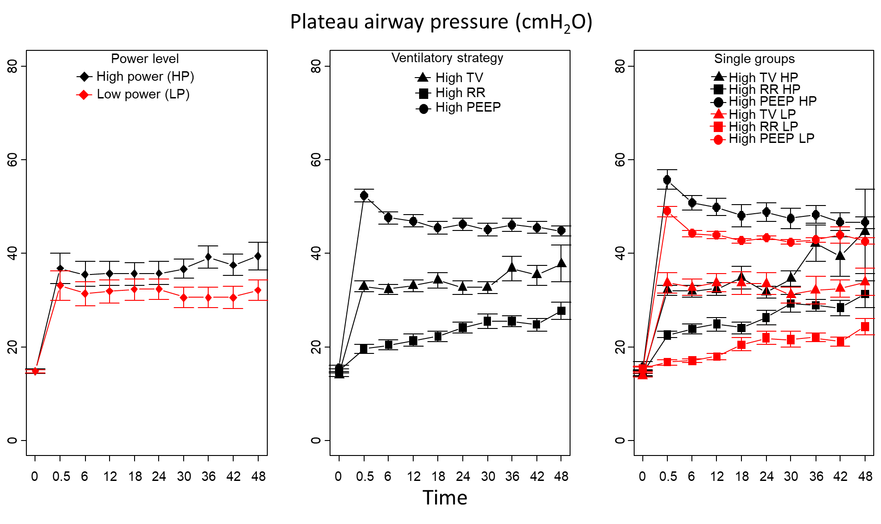
Figure S2: Power level: < 0.001, power level:time interaction: < 0.001, ventilatory strategy: <0.001, ventilatory strategy:time interaction: <0.001, power level:ventilatory strategy interaction: 0.445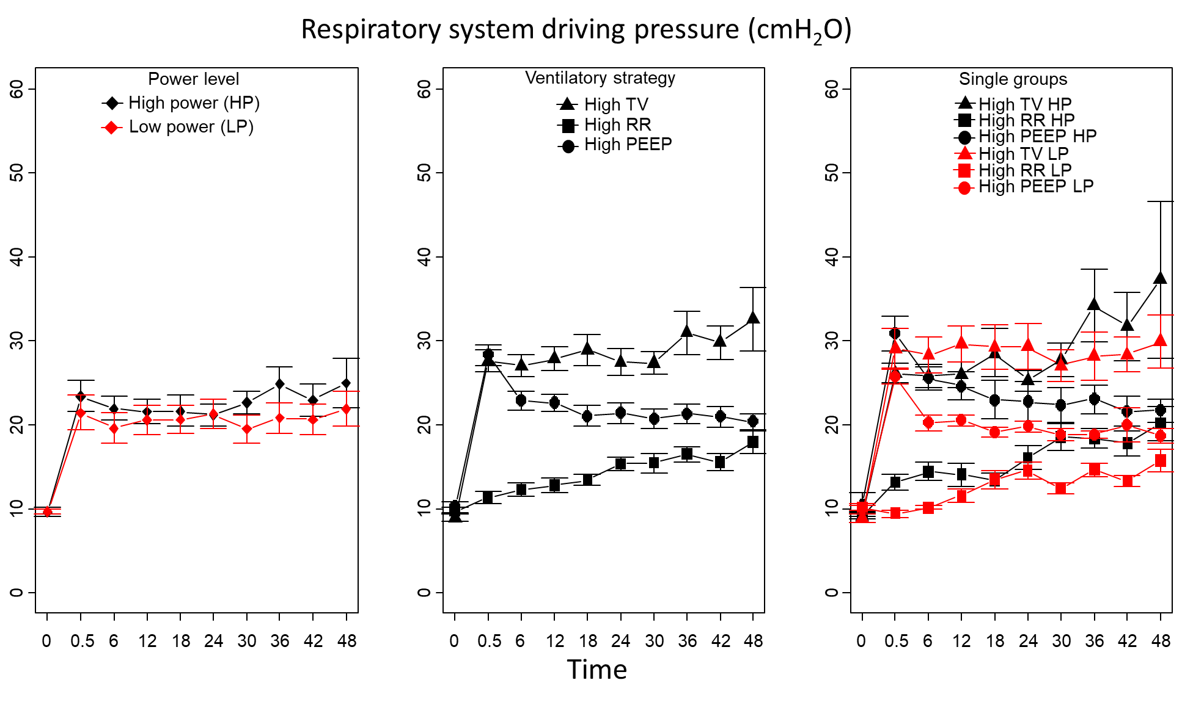
Figure S3: Power level: 0.051, power level:time interaction: < 0.001, ventilatory strategy: <0.001, ventilatory strategy:time interaction: <0.001, power level:ventilatory strategy interaction: 0.467

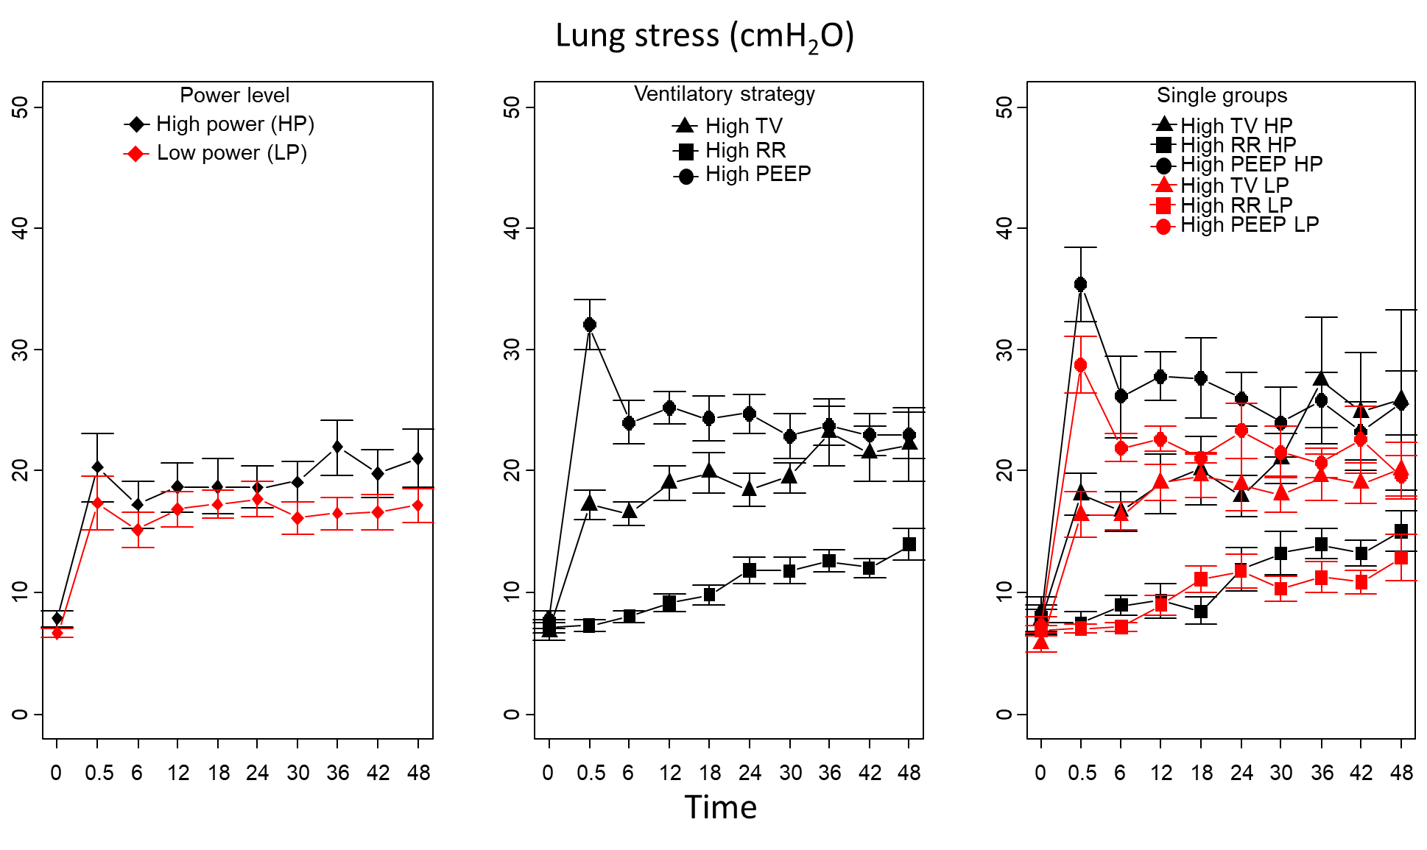
Figure S4: Power level: 0.027, power level:time interaction: 0.012, ventilatory strategy: <0.001, ventilatory strategy:time interaction: <0.001, power level:ventilatory strategy interaction: 0.552
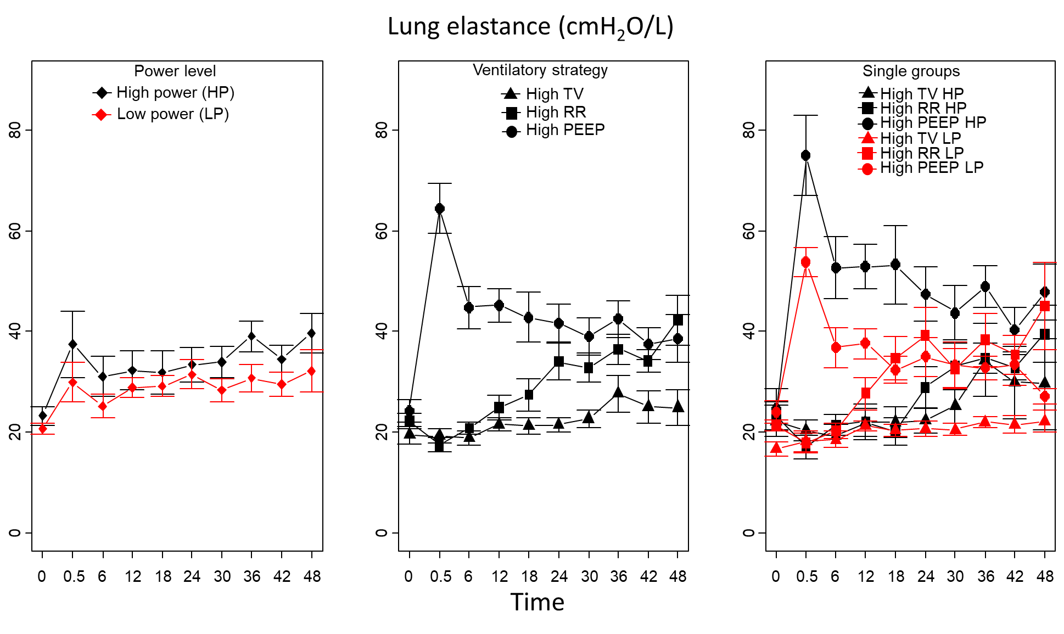
Figure S5: Power level: 0.030, power level:time interaction: 0.330, ventilatory strategy: <0.001, ventilatory strategy:time interaction: <0.001, power level:ventilatory strategy interaction: 0.004

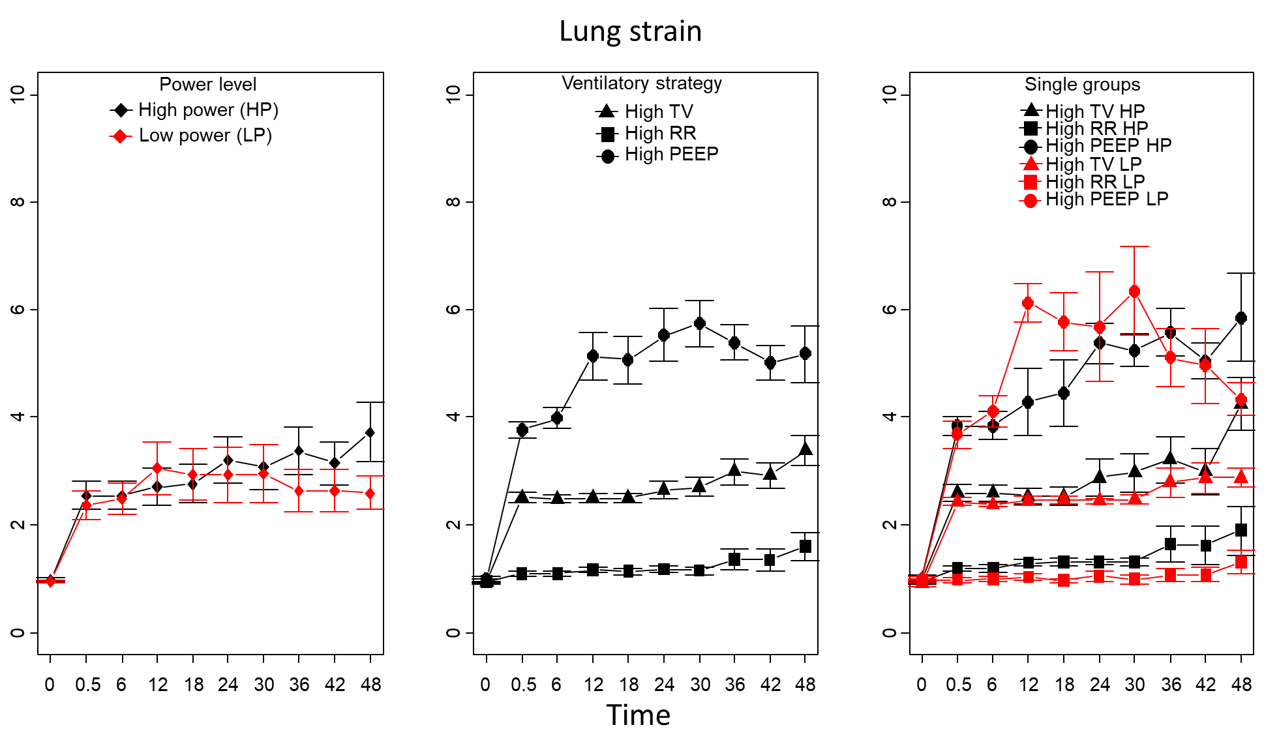
Figure S6: Power level: 0.364, power level:time interaction: 0.005, ventilatory strategy: <0.001, ventilatory strategy:time interaction: <0.001, power level:ventilatory strategy interaction: 0.391
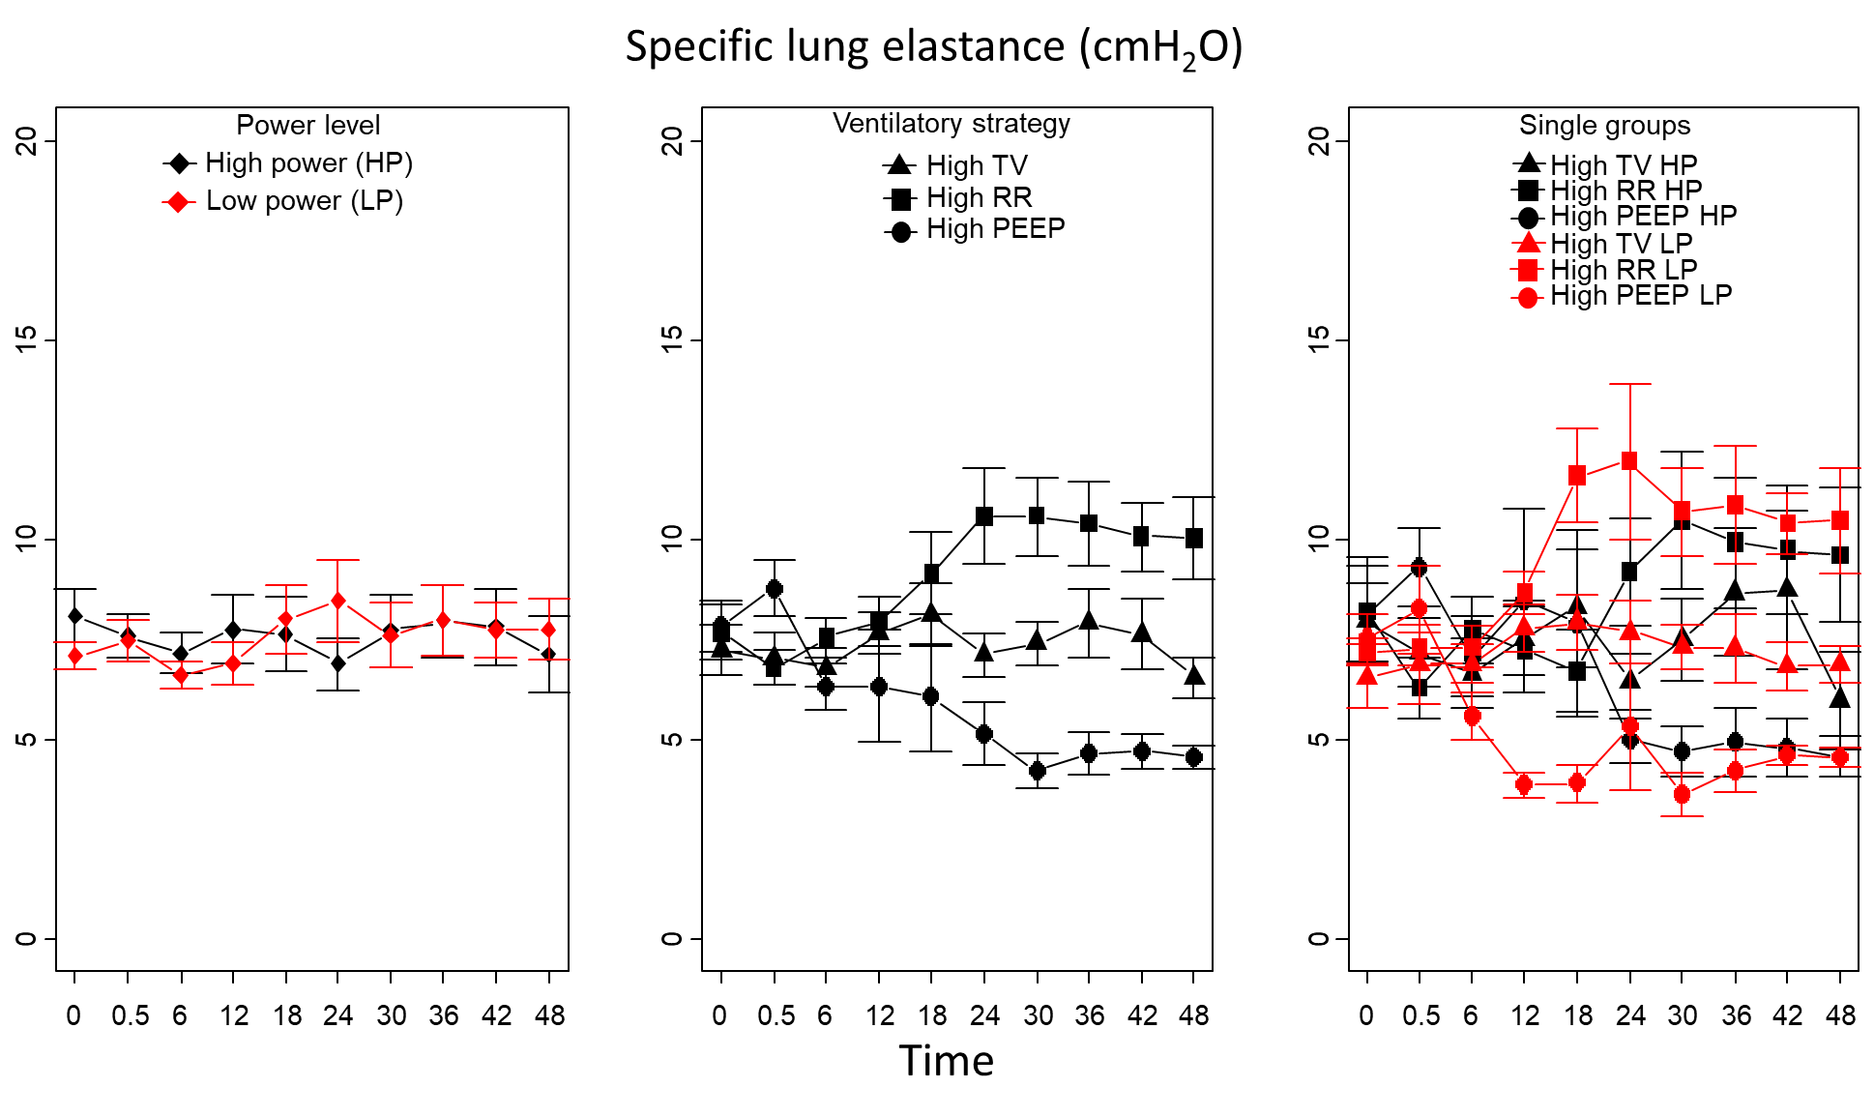
Figure S7: Power level: 0.888, power level:time interaction: 0.835, ventilatory strategy: < 0.001, ventilatory strategy:time interaction: <0.001, power level:ventilatory strategy interaction: 0.208

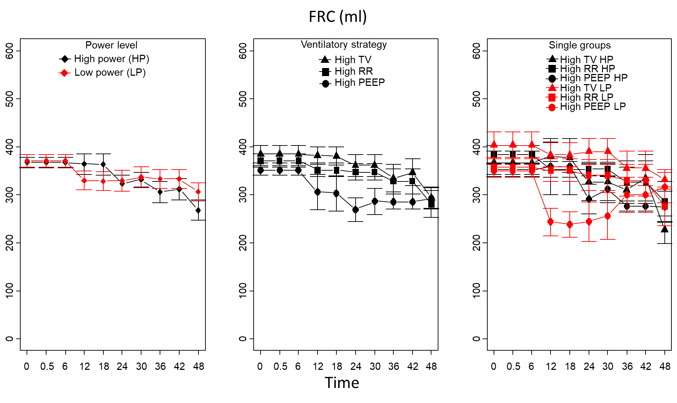
Figure S8: Power level: 0.881, power level:time interaction: 0.093, ventilatory strategy: 0.048, ventilatory strategy:time interaction: <0.001, power level:ventilatory strategy interaction: 0.542
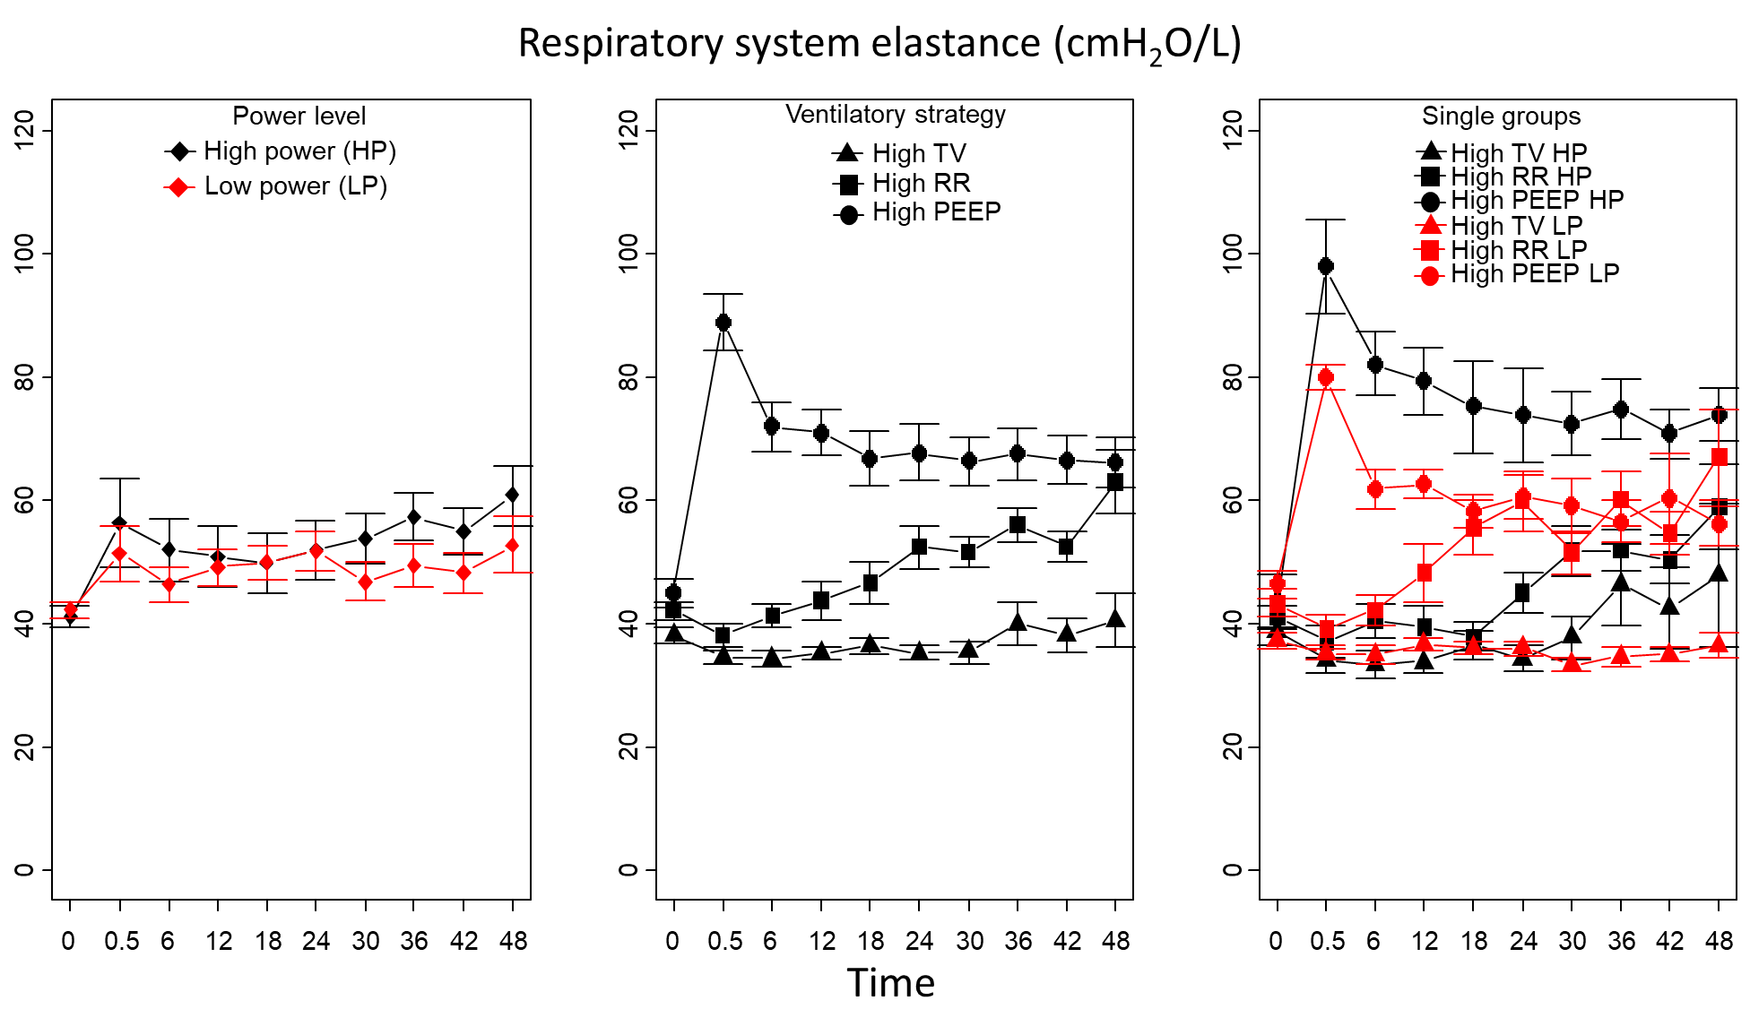
Figure S9: Power level: 0.124, power level:time interaction: 0.155, ventilatory strategy: <0.001, ventilatory strategy:time interaction: <0.001, power level:ventilatory strategy interaction: 0.002
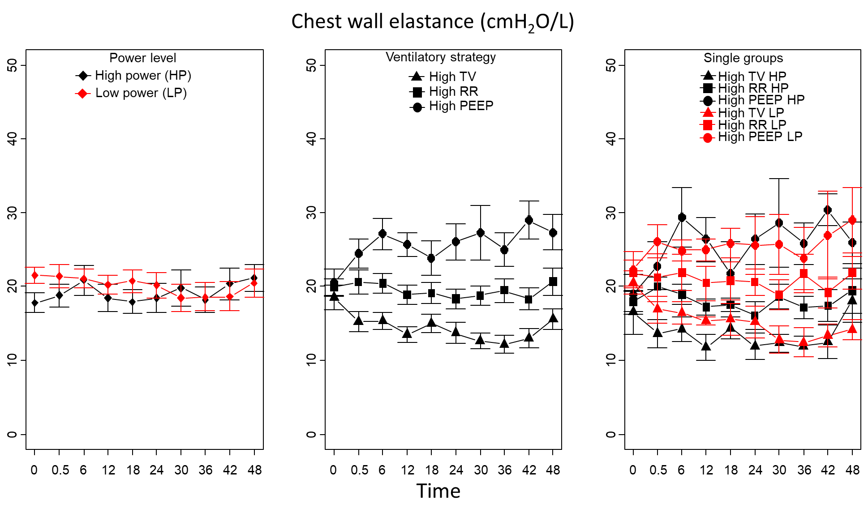
Figure S10: Power level: 0.316, power level:time interaction: 0.548, ventilatory strategy: <0.001, ventilatory strategy:time interaction: 0.241, power level:ventilatory strategy interaction: 0.660

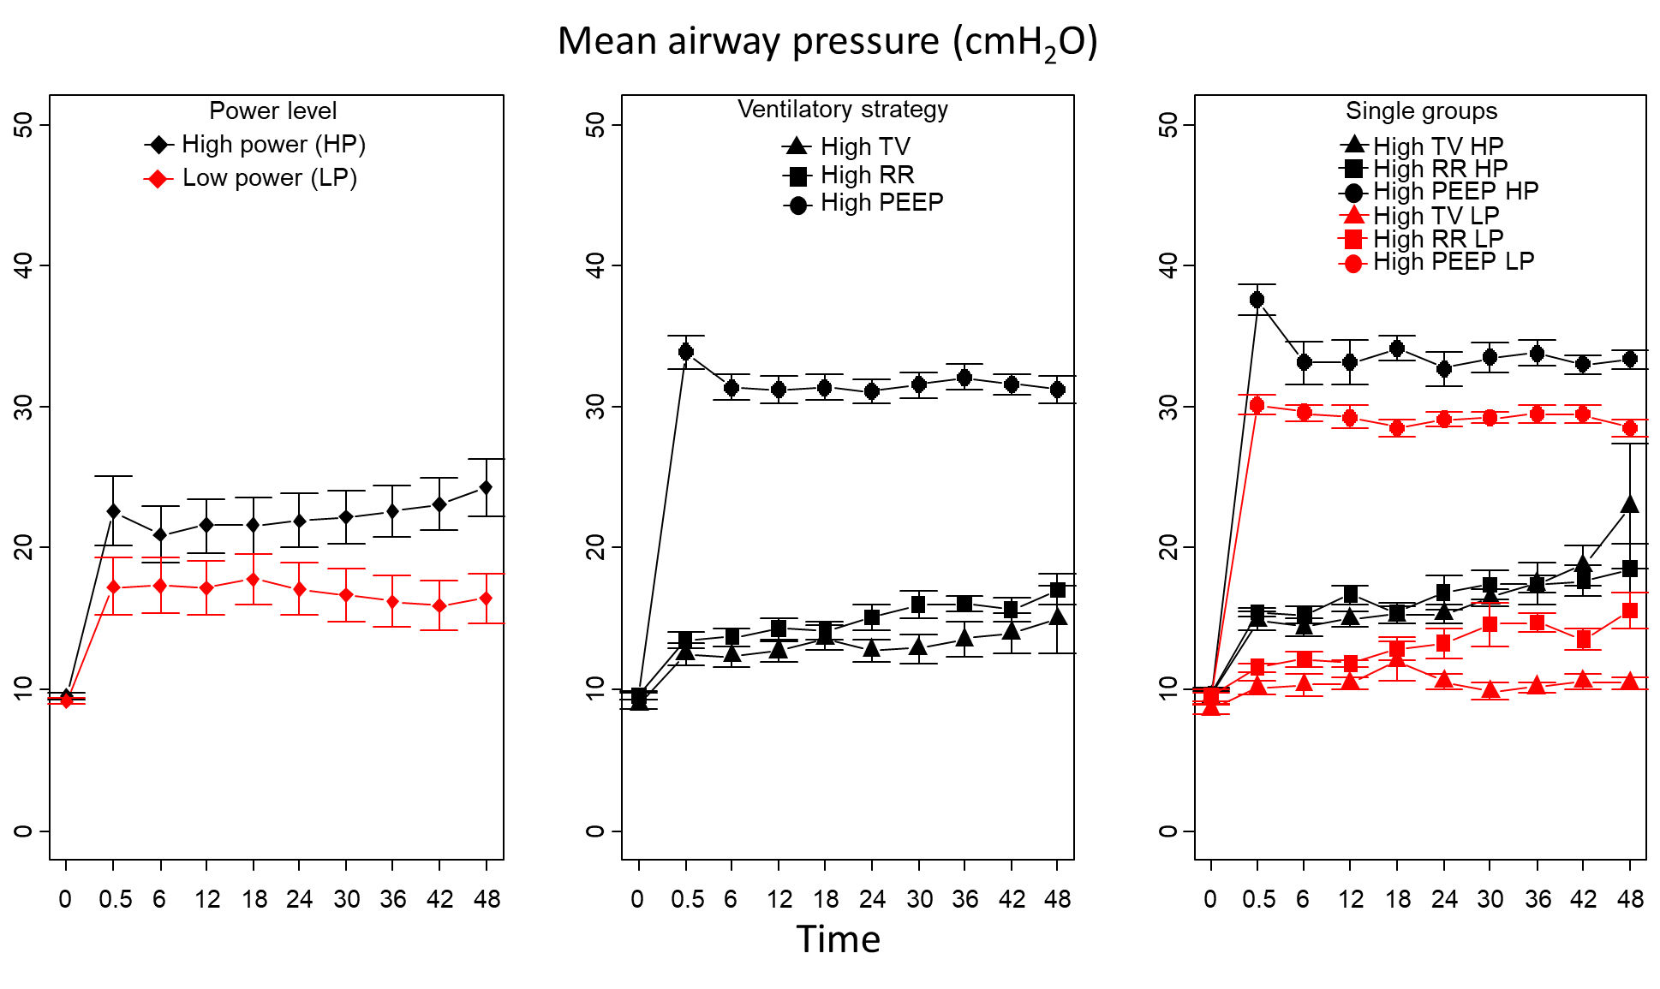
Figure S11: Power level: < 0.001, power level:time interaction: 0.041, ventilatory strategy: < 0.001, ventilatory strategy:time interaction: < 0.001, power level:ventilatory strategy interaction: 0.195
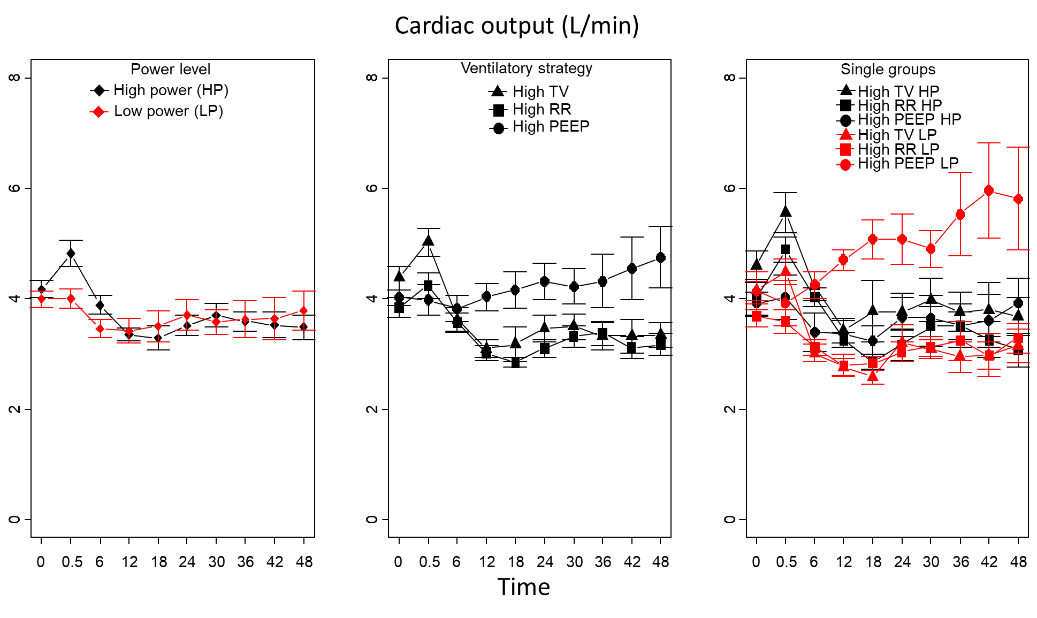
Figure S12: Power level: 0.936, power level:time interaction: <0.001, ventilatory strategy: <0.001, ventilatory strategy:time interaction: <0.001, power level:ventilatory strategy interaction: <0.001

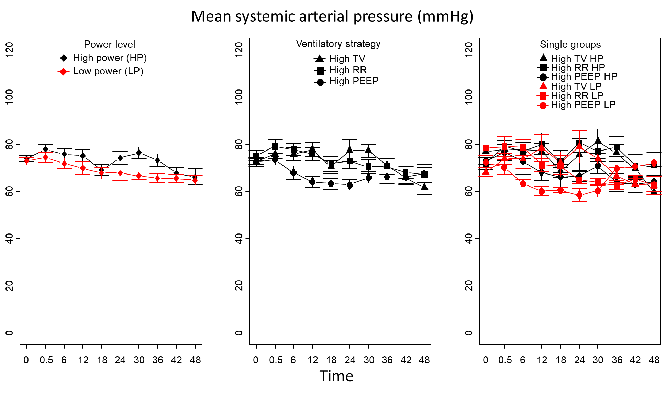
Figure S13: Power level: 0.011, power level:time interaction: 0.625, ventilatory strategy: 0.010, ventilatory strategy:time interaction: <0.001, power level:ventilatory strategy interaction: 0.587
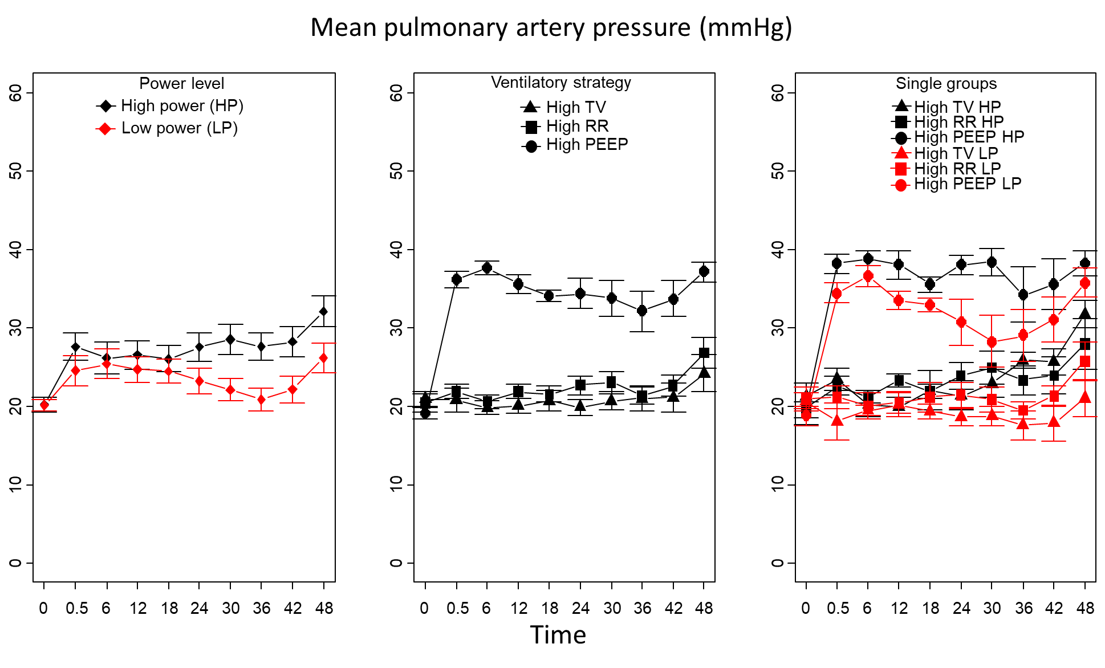
Figure S14: Power level: 0.002, power level:time interaction: 0.021, ventilatory strategy: <0.001, ventilatory strategy:time interaction: < 0.001, power level:ventilatory strategy interaction: 0.677
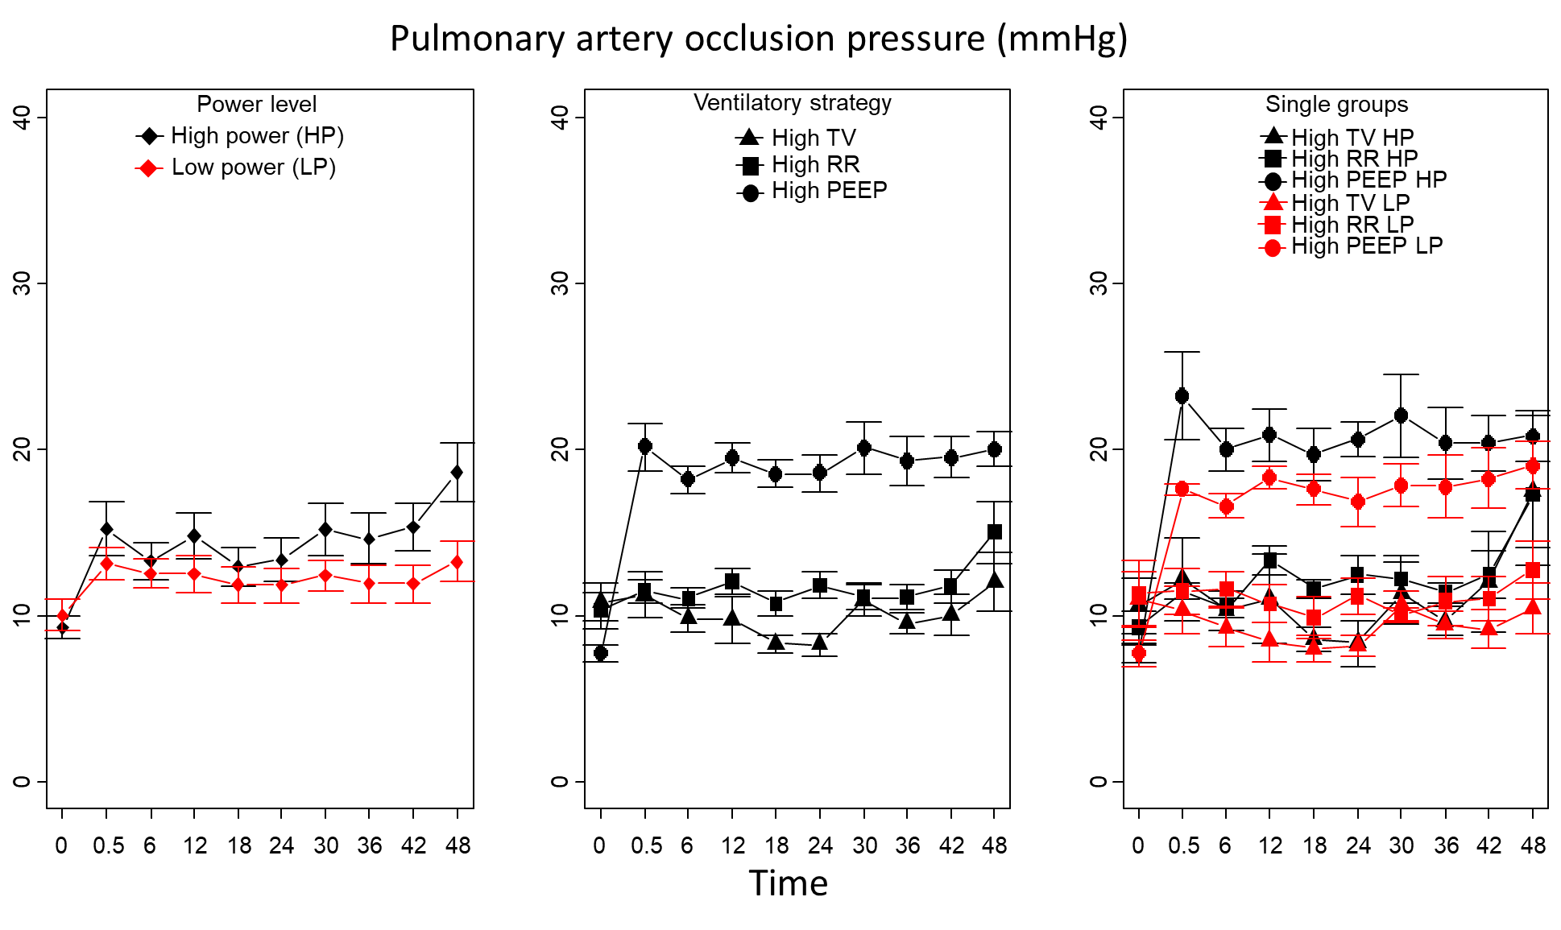
Figure S15: Power level: 0.037, power level:time interaction: 0.494, ventilatory strategy: <0.001, ventilatory strategy:time interaction: 0.037, power level:ventilatory strategy interaction: 0.602

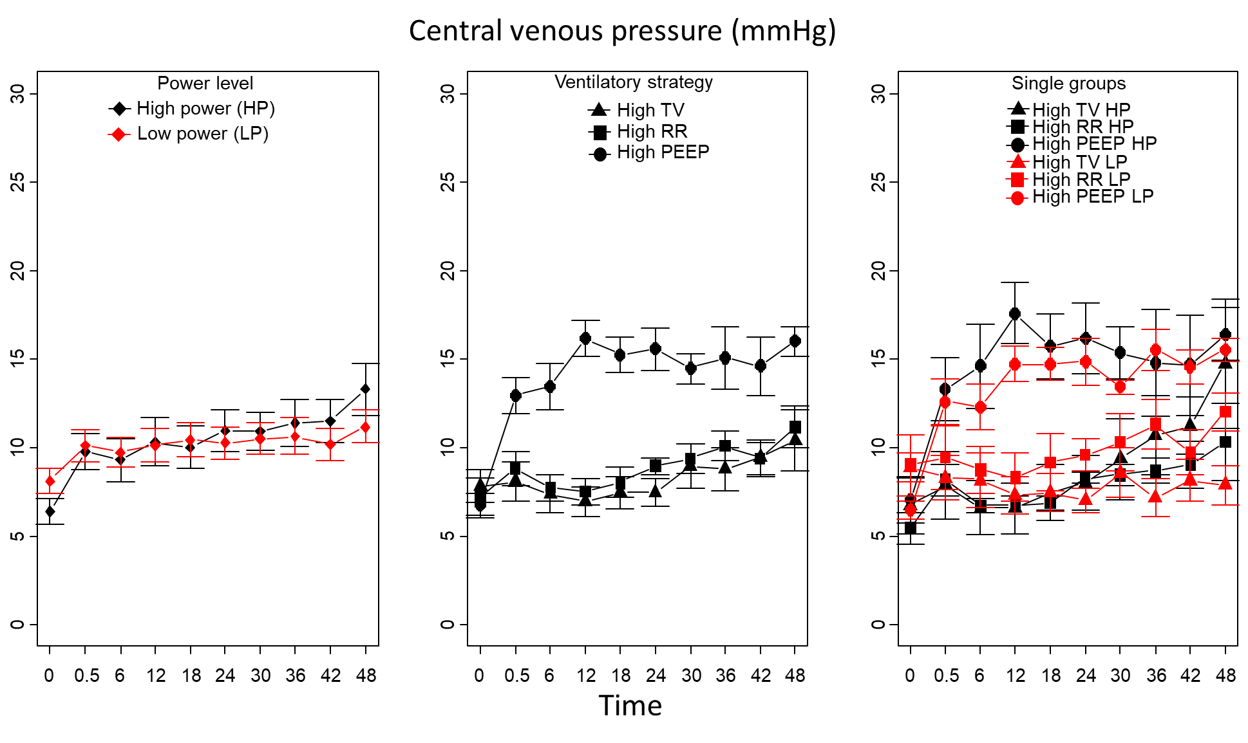
Figure S16: Power level: 0.885, power level:time interaction: 0.090, ventilatory strategy: <0.001, ventilatory strategy:time interaction: <0.001, power level:ventilatory strategy interaction: 0.437
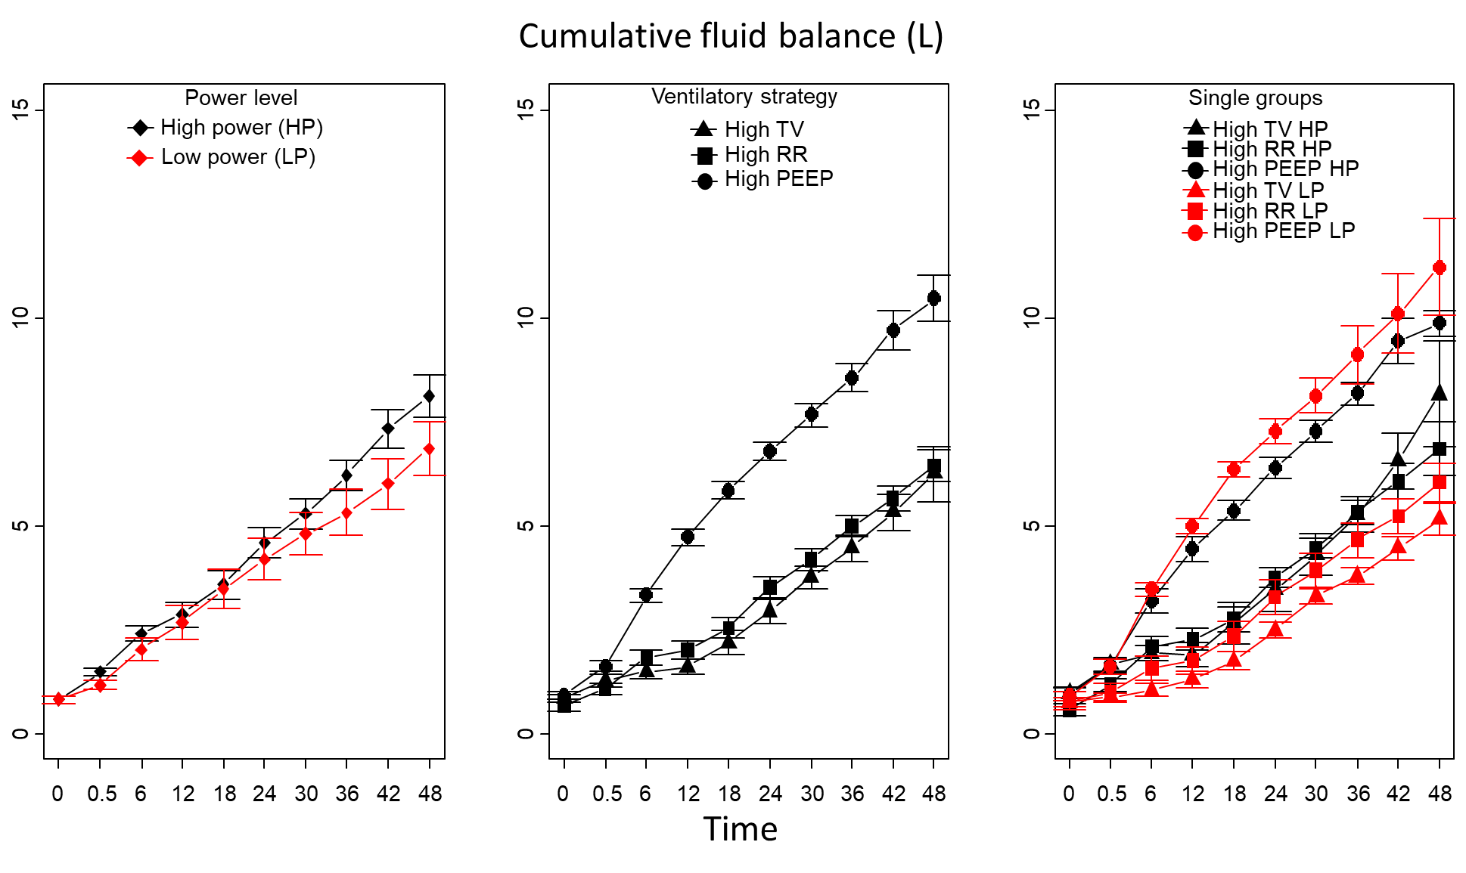
Figure S17: Power level: 0.072, power level:time interaction: 0.149, ventilatory strategy: <0.001, ventilatory strategy:time interaction: <0.001, power level:ventilatory strategy interaction: 0.187

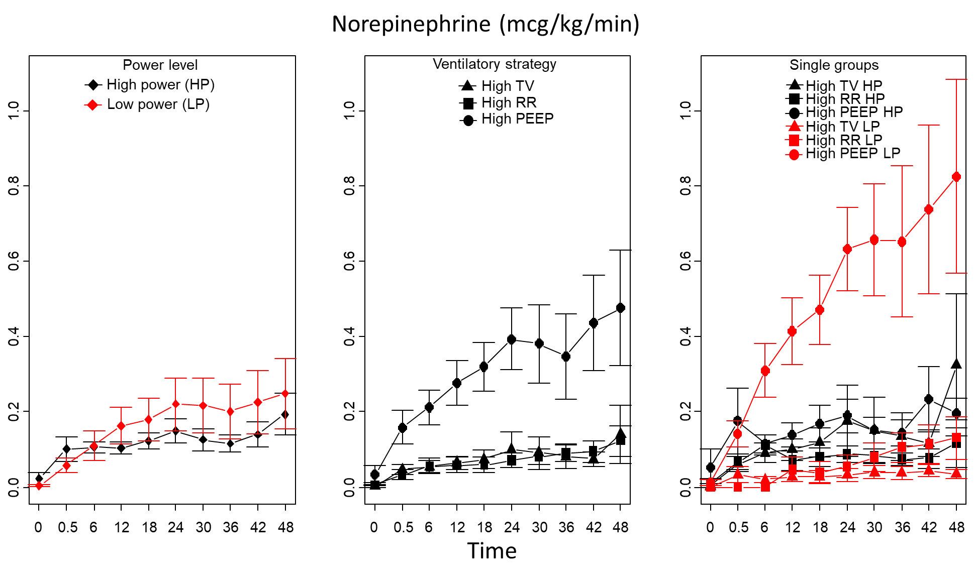
Figure S18: Power level: 0.129, power level:time interaction: <0.001, ventilatory strategy: <0.001, ventilatory strategy:time interaction: <0.001, power level:ventilatory strategy interaction: <0.001
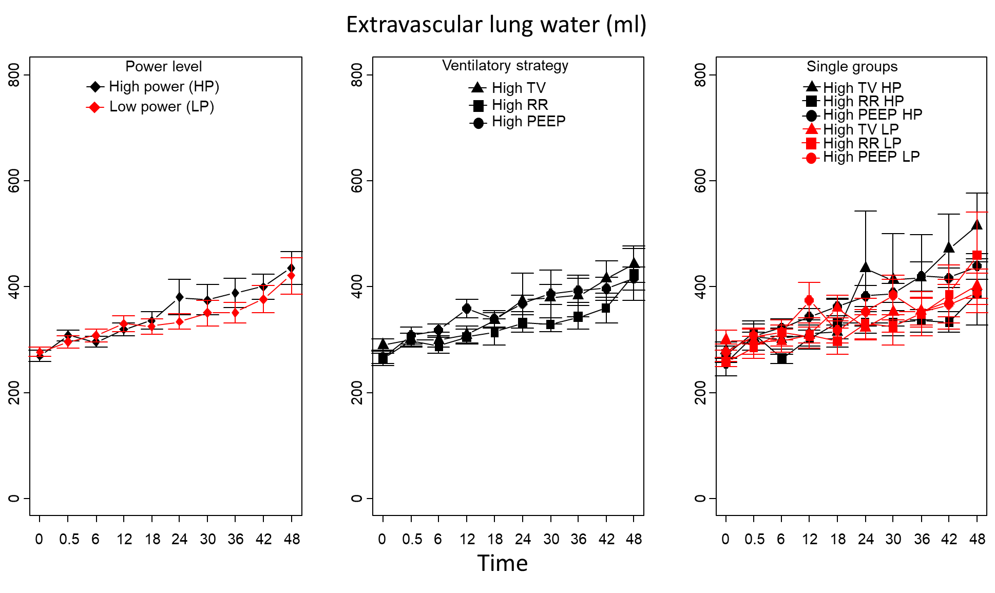
Figure S19: Power level: 0.569, power level:time interaction: 0.248, ventilatory strategy: 0.557, ventilatory strategy:time interaction: <0.001, power level:ventilatory strategy interaction: 0.682

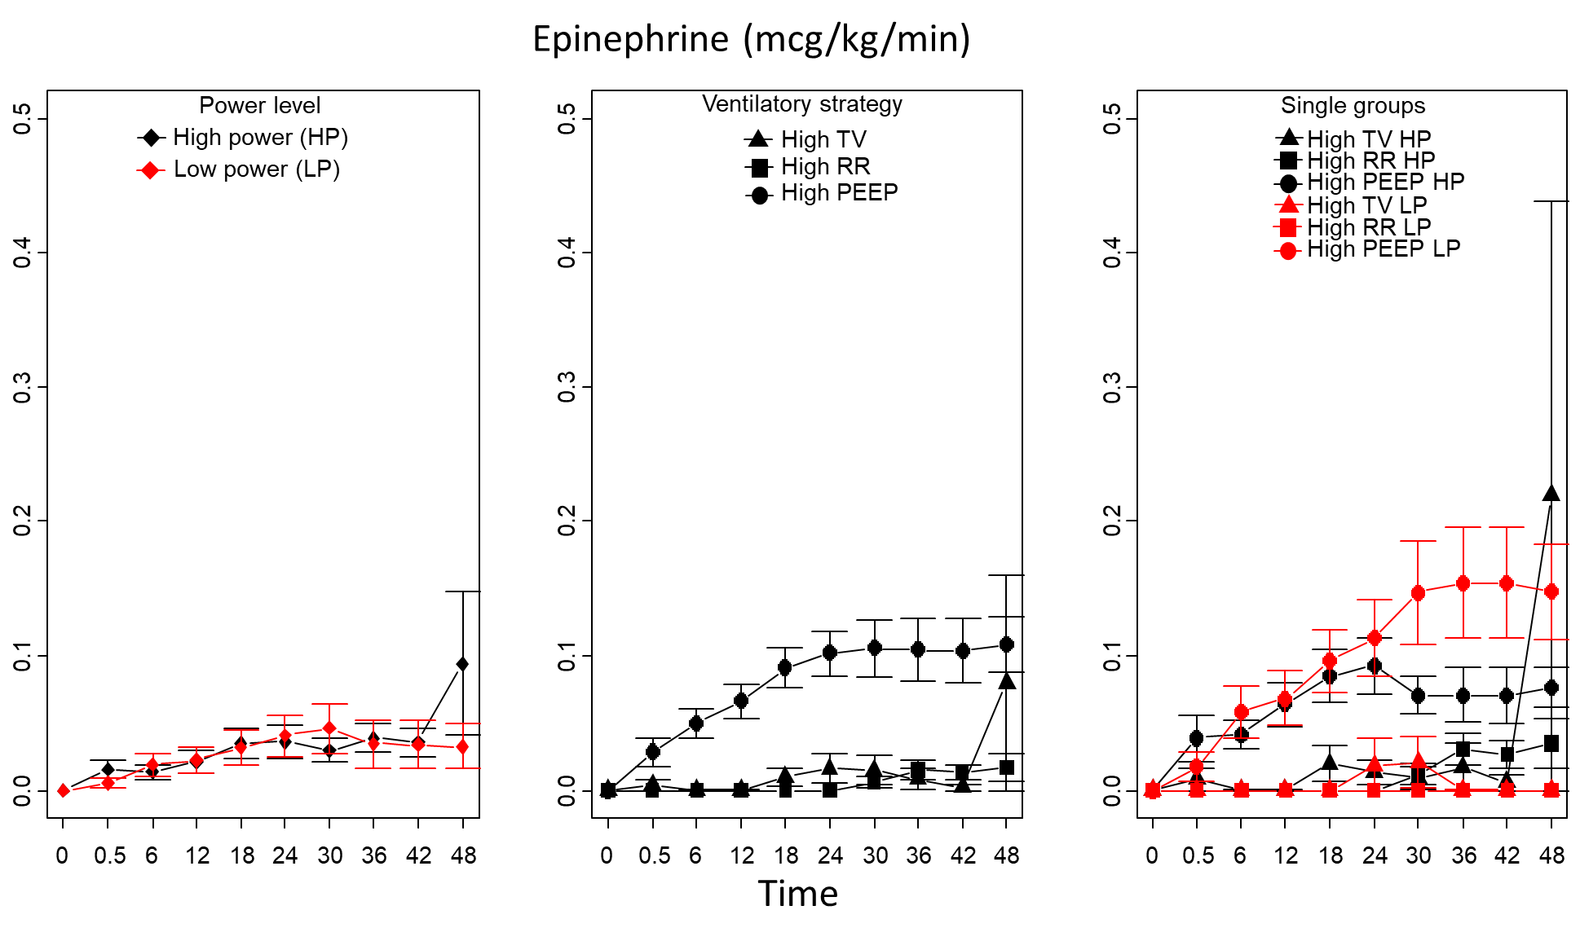
Figure S20: Power level: 0.714, power level:time interaction: 0.435, ventilatory strategy: <0.001, ventilatory strategy:time interaction: <0.001, power level:ventilatory strategy interaction: 0.144
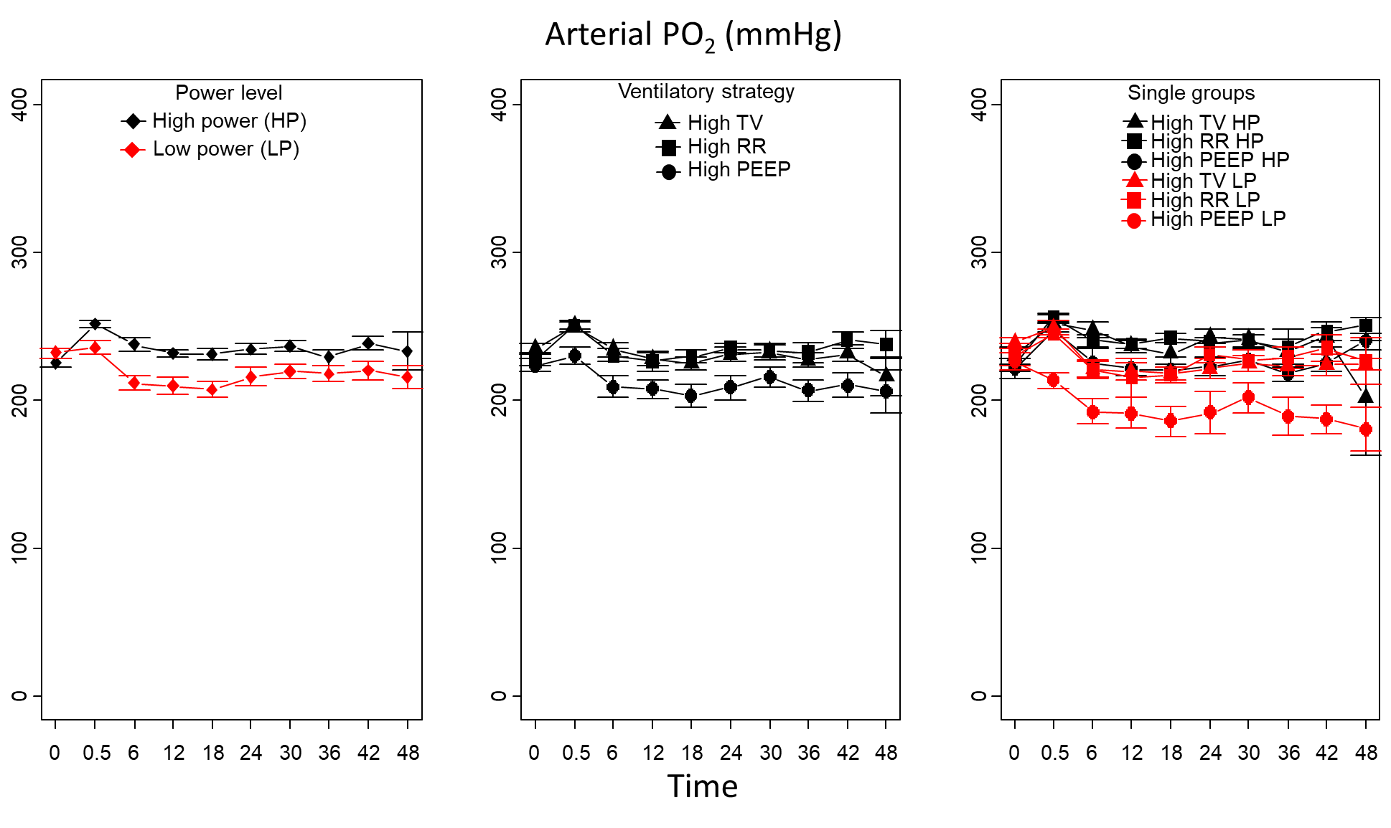
Figure S21: Power level: <0.001, power level:time interaction: 0.772, ventilatory strategy: <0.001, ventilatory strategy:time interaction: <0.001, power level:ventilatory strategy interaction: 0.147

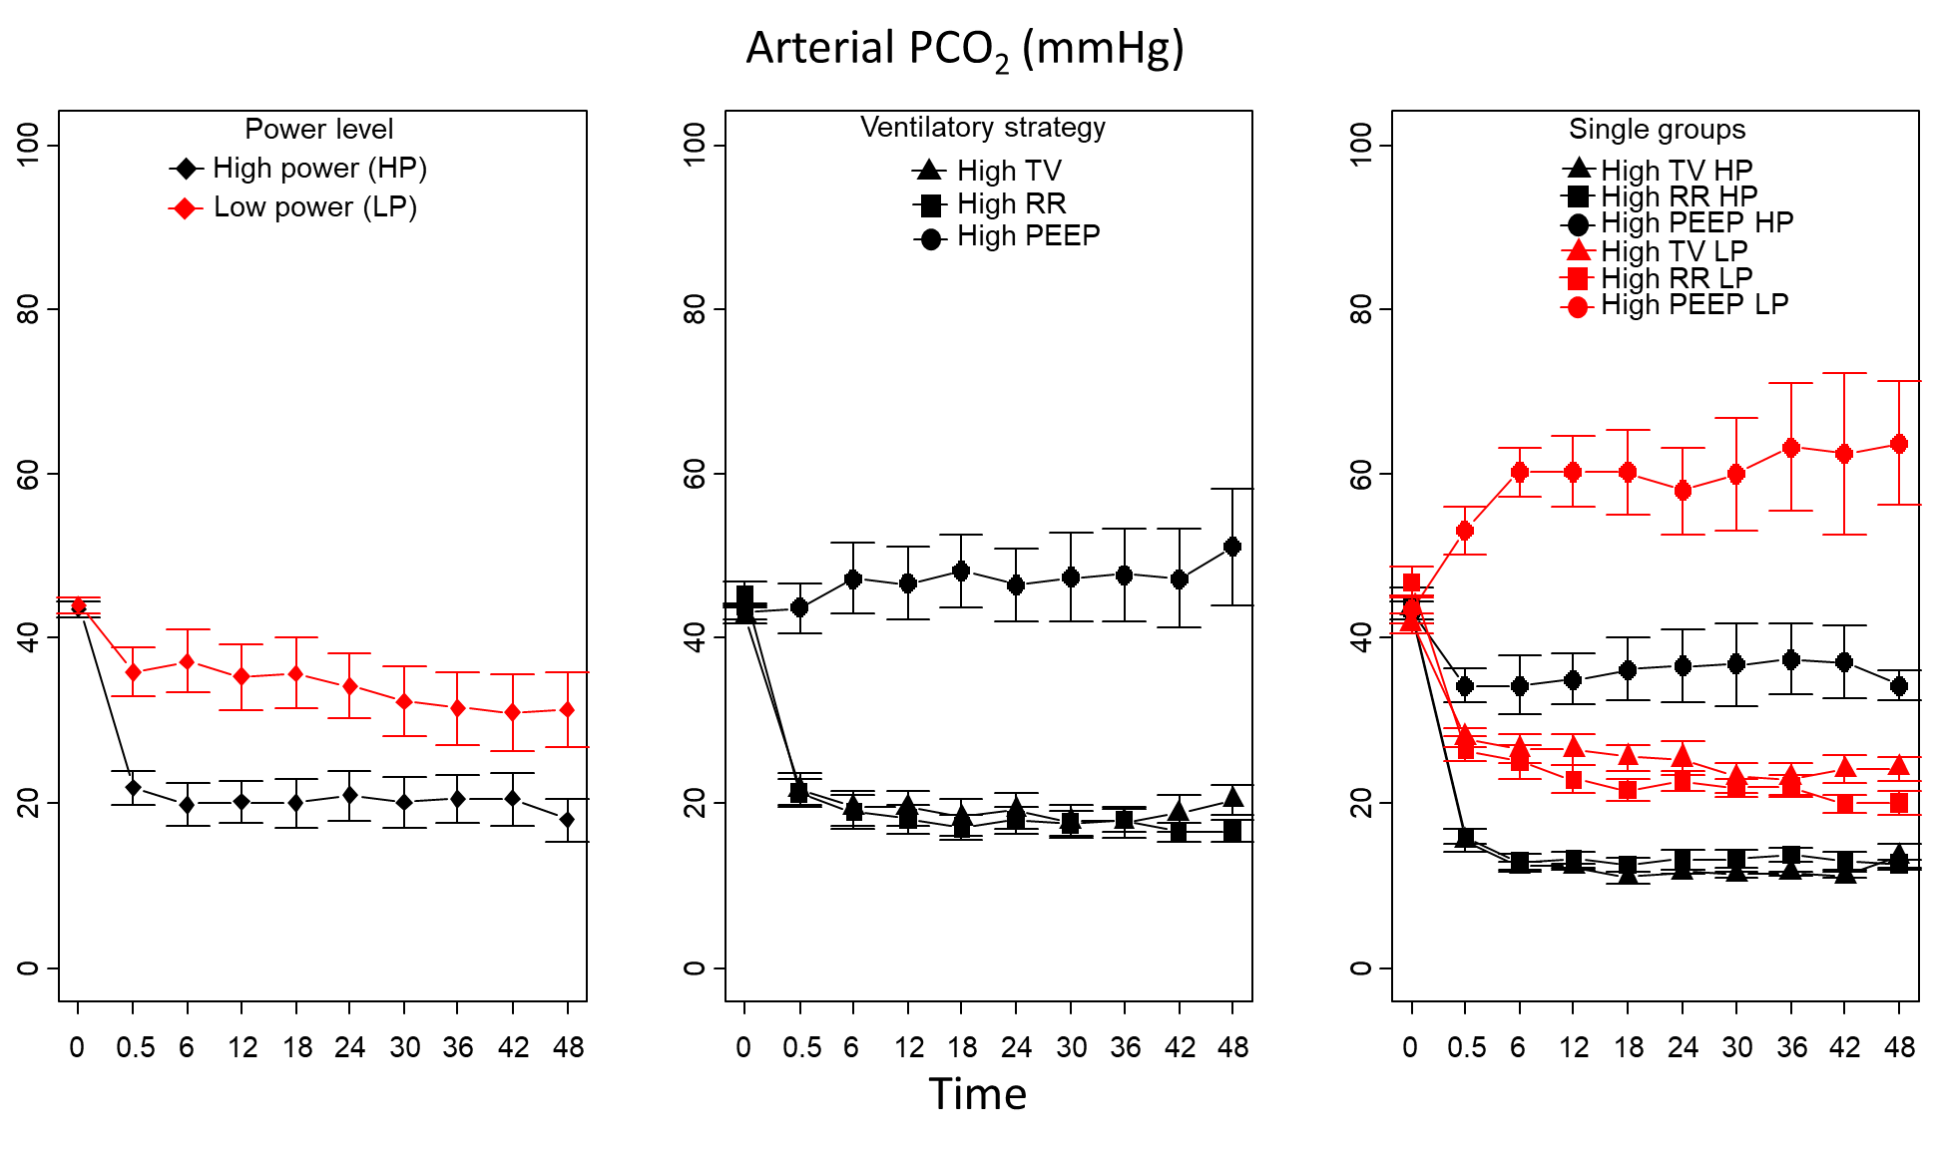
Figure S22: Power level: <0.001, power level:time interaction: 0.097, ventilatory strategy: <0.001, ventilatory strategy:time interaction: <0.001, power level:ventilatory strategy interaction: 0.016
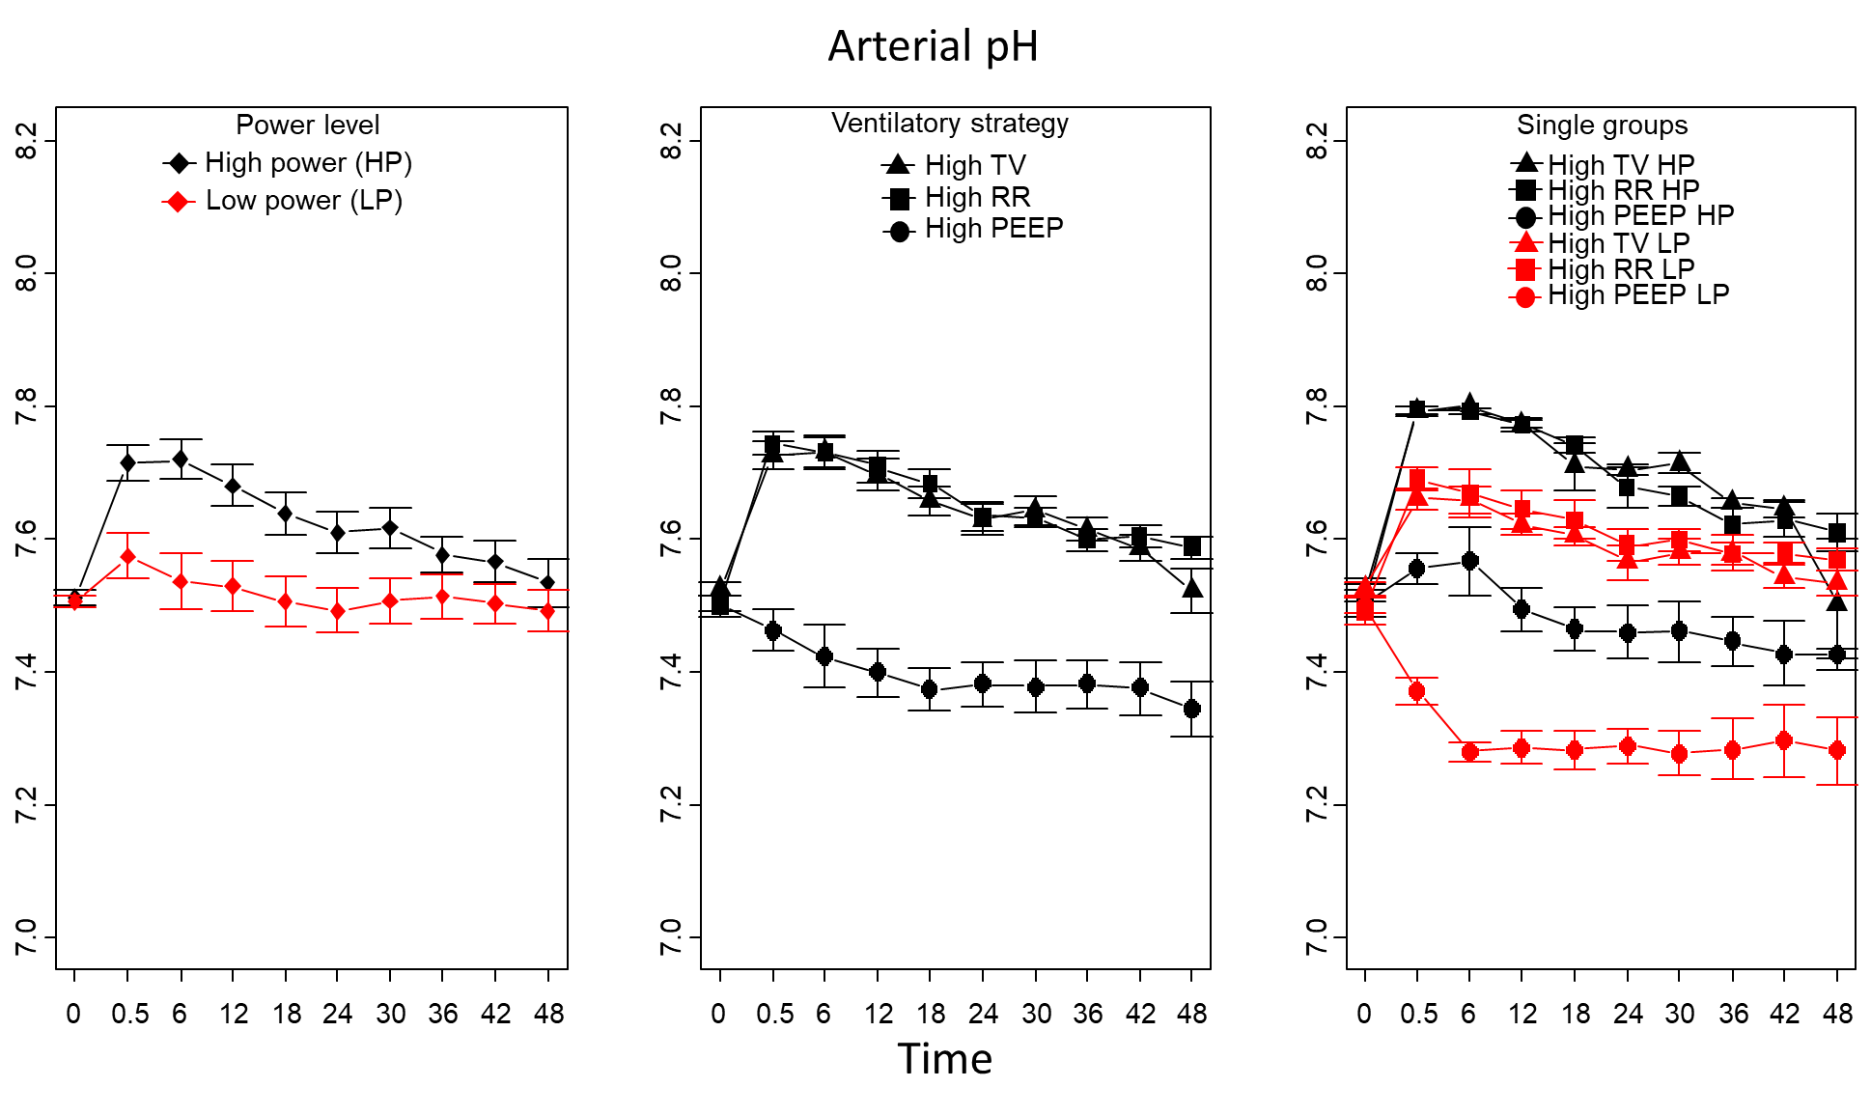
Figure S23: Power level: <0.001, power level:time interaction: <0.001, ventilatory strategy: <0.001, ventilatory strategy:time interaction: <0.001, power level:ventilatory strategy interaction: 0.026
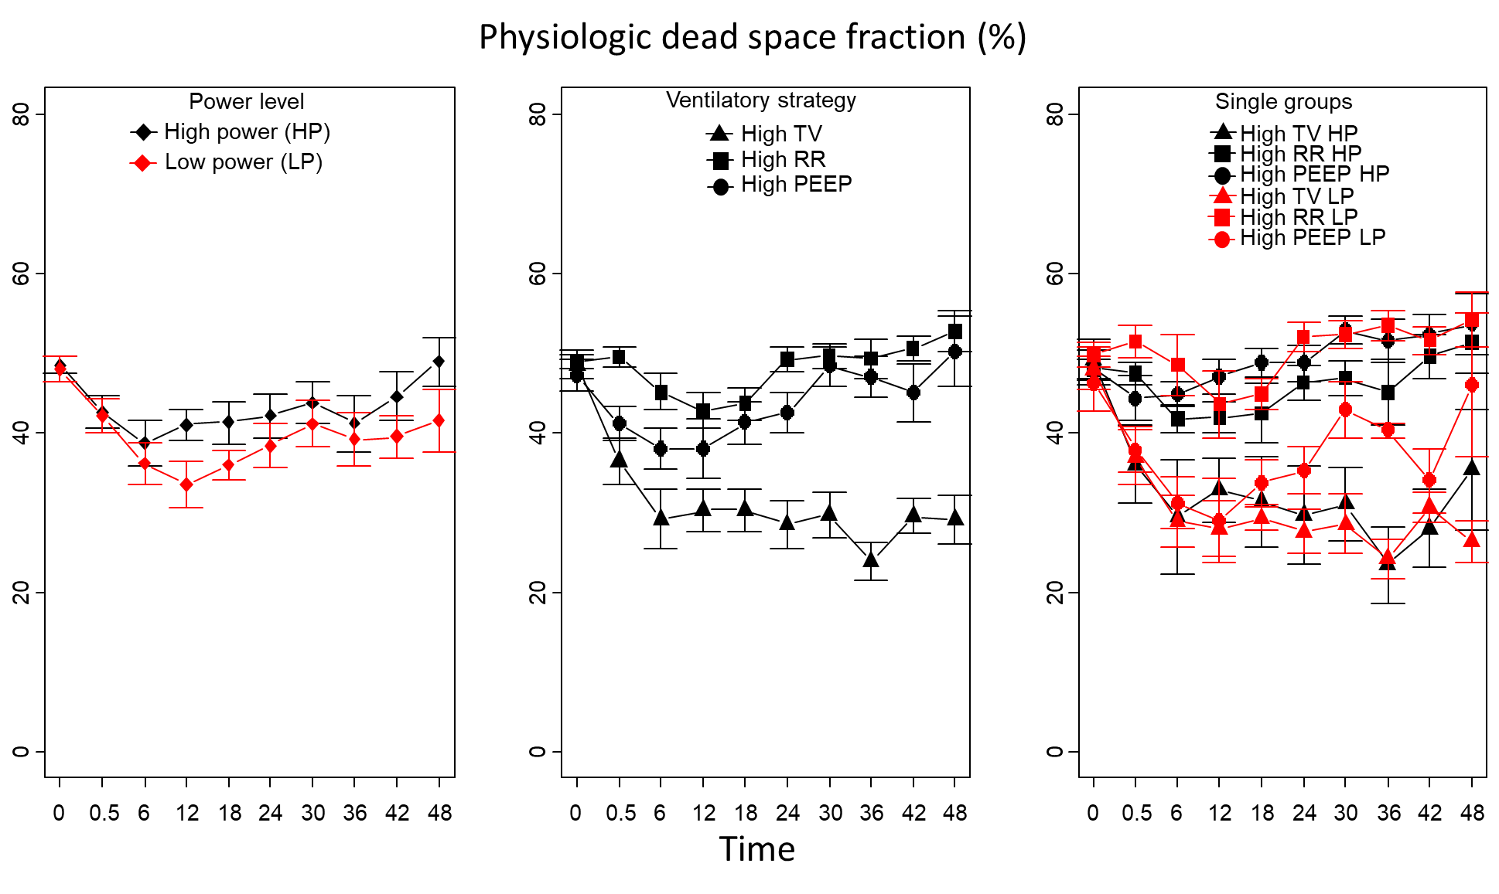
Figure S24: Power level: 0.038, power level:time interaction: 0.248, ventilatory strategy: <0.001, ventilatory strategy:time interaction: <0.001, power level:ventilatory strategy interaction: 0.001
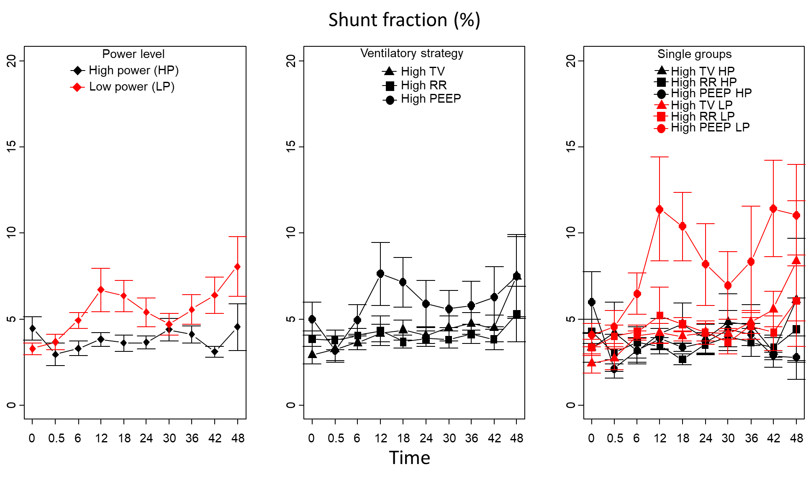
Figure S25: Power level: 0.005, power level:time interaction: 0.002, ventilatory strategy: 0.051, ventilatory strategy:time interaction: <0.001, power level:ventilatory strategy interaction: 0.020
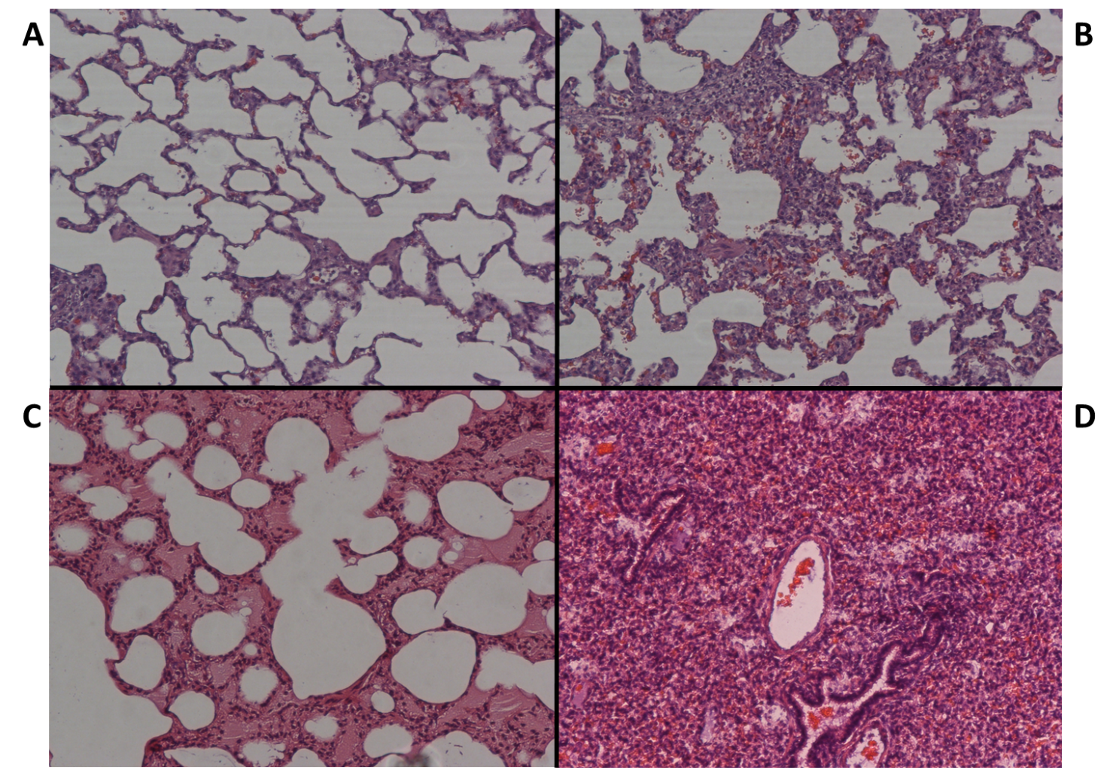
Figure S26: Typical histological pattern: A: near normal, B: septal ruptures at the interface with the atelectasis/consolidation zone, C: emphysema associated with alveolar edema, D: complete loss of lung structure.

