Supplemental results

A B
Figure S1. SphKs mRNA expression in peripheral blood mononuclear cells of septic patients and non-septic patients. SphK1 (A) and SphK2 (B) mRNA expression in peripheral blood mononuclear cells of septic patients (n=4) and non-septic patients (n=4) were assessed by real-time quantitative polymerase chain reaction. Dots represent data from individual subjects. Data are presented as means±SD with Mann-Whitney test. *P<0.05.

A B
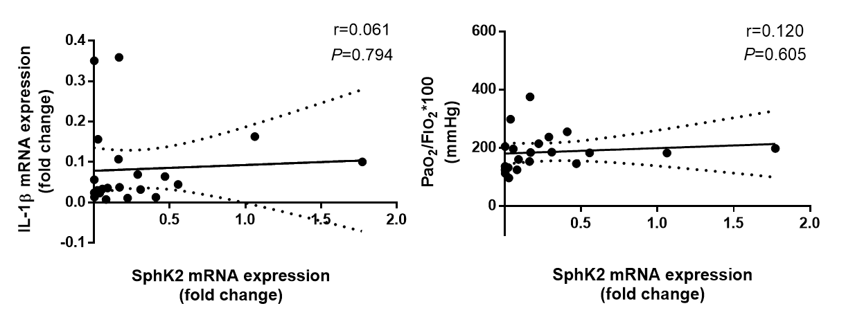
Figure S2. SphK2 mRNA expression does not correlate with IL-1 β mRNA expression of peripheral blood mononuclear cells or PaO₂/FIO₂ ratios in septic patients. Correlation of SphK2 mRNA expression with IL-1β mRNA expression in peripheral blood mononuclear cells (A) and with PaO₂/FIO₂ ratios (B) in septic patients (n=21). Data were analyzed with linear regression analysis with a 95% confidence interval.
Figure S3. Inhibition of SphK1 improves lung injury in septic mice. Mice were subjected to sham surgery or cecal ligation and puncture. Immediately after surgery, mice were intraperitoneally injected with PF-543 (10mg/kg) or control. Lung tissues were harvested 24 hours after surgery for Hematoxylin and Eosin staining. Scare bar: 200um.

A B
Figure S4. SphK1 deletion suppresses NLRP3 inflammasome activation in macrophages. Wild-type and SphK1^{-/-} macrophages were primed with lipopolysaccharide (LPS, 1ug/ml) for 3 hours, and subsequently incubated with adenosine triphosphate (ATP, 5mM) for 30 min. (A) Representative immunoblot of caspase-1 p20 and IL-1β in cell lysates. (B) IL-1β release in supernatants was measured by enzyme linked immunosorbent assay. Data are presented as means±SD with Student‘s t test (n=3). ***P<0.001.
Figure S5. SphK1 deletion inhibits NLRP3 inflammasome activation in lungs of septic mice. Lung tissues were harvested from wild type and SphK1^{-/-} mice 24 hours after surgery. Immunoblot of caspase-1 activation and IL-1β maturation in whole lung lysates.

Figure S6. SphK1 deletion improves lung injury in septic mice. SphK1^{-/-} and wild-type mice were subjected to sham surgery or cecal ligation and puncture. Lung tissues were harvested 24 hours after surgery for Hematoxylin and Eosin staining. Scare bar: 200um.

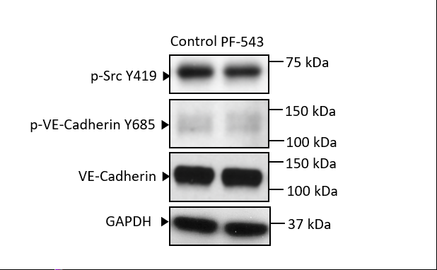
Figure S7. PF-543 does not affect VE-Cadherin and Src activation in endothelial cells. Human lung microvascular endothelial cells were incubated with PF-543 or control for 24 hours. The cell lysates were immunoblotted with antibodies as indicated.

Figure S8. IL-1β induces VE-Cadherin internalization on endothelial cells. Human lung microvascular endothelial cells were challenged with recombinant human IL-1β (200ng/ml) or control for 24 hours. Cell membrane fraction and intracellular fraction were immunoblotted with VE-Cadherin.

Figure S9. Inhibition of sphingosine kinase 1 attenuates sepsis-induced microvascular leakage via inhibiting macrophage NLRP3 inflammasome activation. NLRP3 inflammasome activation includes initial transcriptional upregulation of NLRP3 and pro-IL-β via stimulation of Toll-like receptor by lipopolysaccharide (LPS), and secondary activation of NLPR3 by damage-associated molecular patterns such as ATP, resulting in activation of caspase-1, which cleaves pro-IL-1β into bioactive pro-inflammatory mediator. Cleaved IL-1β released from macrophages activates Src in endothelial cells. VE-Cadherin in endothelial cell membrane is phosphorylated by activated Src and internalized into cytosol, leading to disassembly of adherens junctions and increased vascular permeability. Selective inhibition of SphK1 with PF-543 suppresses NLRP3 inflammasome activation, sequentially blocks release of IL-1β from macrophages, and thereby improves sepsis-induced microvascular leakage.

Table S1. Primers
Gene | Forward Primer | Reverse Primer
GAPDH | 5’- GGAGCGAGATCCCTCCAAAAT -3’ | 5’- GGCTGTTGTCATACTTCTCATGG -3’
SPHK1 | 5’- GGCTGCTGTCACCCATGAA-3’ | 5’-TCACTCTCTAGGTCCACATCAG-3’
SPHK2 | 5’- AGCGTGGTAGCCACTTCAG-3’ | 5’- GAGCAGTGTACCGATGCCA-3’
IL-1β | 5’- ATGATGGCTTATTACAGTGGCAA-3’ | 5’-GTCGGAGATTCGTAGCTGGA-3’

Table S2. Key Reagents and Antibodies
Reagents or Antibodies | Manufacturer | Model Number
Reagents
Ficoll-Hypaque | GE Healthcare | 17544202
TRIzol reagent | Invitrogen | 15596026
Reverse Transcription Master Mix | EZbioscience | A0010
SYBR Green qPCR Master Mix | EZbioscience | A0001
Evan Blue Dye | Sigma | E2129-10G
PF543 | Sigma | PZ0234-5MG
ATP | Sigma | A2383-1G
Recombinant human IL-1β | Sino Biological | 10139-HNAE
Protein A/G PLUS Agarose beards | Santa Cruz | sc-2003
Primary antibodies
anti-NLRP3 | AdipoGen | AG-20B-0014-C100
anti-Caspase-1 (p20) | AdipoGen | AG-20B-0042-C100
anti-IL-1β | R&D systems | AF-401-NA
anti-VE-Cadherin | Santa Cruz | sc6458
anti-p-VE-Cadherin Y685 | Abcam | ab119785
anti-c-Src Tyr416 | Cell signaling | 2109S
anti-p-Src | Cell Signaling | 6943S
anti-Na⁺-K⁺ATPase | Abcam | ab58475
anti-β-actin | Santa Cruz | sc47778
anti-GAPDH | Proteintech | 60004

Table S3. Clinical Characteristics of Septic Patients
Patients  number | Sex | Age | SOFA  24h | PaO₂/FiO₂ ratio | Site of infection | Diagnosis
1 | Male | 31 | 7 | 145 | Acute suppurative appendicitis | Septic shock
2 | Female | 70 | 4 | 184 | Acute cholangitis | Sepsis
3 | Male | 46 | 4 | 237 | Acute peritonitis | Sepsis
4 | Male | 61 | 12 | 255 | Acute peritonitis | Sepsis
5 | Male | 77 | 11 | 375 | Acute peritonitis | Sepsis
6 | Male | 67 | 17 | 124 | Acute suppurative cholangitis | Septic shock
7 | Male | 68 | 4 | 185 | Pyothorax | Sepsis
8 | Male | 52 | 5 | 182.5 | Pyothorax | Sepsis
9 | Male | 72 | 5 | 182 | Pyothorax | Sepsis
10 | Male | 68 | 11 | 160 | Acute peritonitis | Sepsis
11 | Male | 73 | 5 | 124 | Pyothorax | Sepsis
12 | Male | 64 | 11 | 136 | Pyothorax | Sepsis
13 | Male | 68 | 5 | 204 | Pyothorax | Sepsis
14 | Male | 66 | 5 | 153 | Peumonia | Sepsis
15 | Male | 71 | 4 | 112 | Pyothorax | Sepsis
16 | Male | 19 | 4 | 196 | Peumonia | Sepsis
17 | Female | 34 | 5 | 298 | Acute cholangitis | Sepsis
18 | Male | 59 | 4 | 214 | Peumonia | Sepsis
19 | Male | 61 | 3 | 132 | Pyothorax | Sepsis
20 | Male | 77 | 11 | 96 | Acute peritonitis | Sepsis
21 | Female | 73 | 10 | 198 | Acute peritonitis | Septic shock

