Supplemental Digital Content 1
Materials and Methods

Experimental Protocol
Protocols were approved by the Subcommittee on Research Animal Care and the Institutional Animal Care and Use Committee of the Massachusetts General Hospital (Boston, Massachusetts), and followed National Institutes of Health and ARRIVE (Animal Research: Reporting of In Vivo Experiments) guidelines.
All experiments lasted for approximately 12h, starting in the early morning. After premedication, twelve female sheep (weight 18.2±2.3 kg) were anesthetized, paralyzed, intubated, and mechanically ventilated. Anesthesia was maintained with a continuous infusion of propofol (5 mg·kg⁻¹·hour⁻¹), xylazine (50 µg·kg⁻¹·hour⁻¹) and fentanyl (10 μg·kg⁻¹·hour⁻¹). Paralysis was established with a rocuronium bolus at induction (0.5 mg/kg) and subsequent continuous infusion (0.5 mg·kg⁻¹·hour⁻¹). For monitoring and collection of blood samples, we percutaneously cannulated a femoral artery and introduced a pulmonary artery catheter via the jugular vein using sterile techniques. As a surrogate for pleural pressure, esophageal pressure was measured by an esophageal balloon placed in the lower third of the esophagus. A stepwise lung recruitment maneuver was performed with PEEP steps of 2-3 cmH₂O for 30-60s up to a plateau pressure of 30-32 cmH₂O. After a period of stabilization, baseline physiological variables, arterial and central venous blood samples were acquired. After a period of stabilization, baseline physiological variables, arterial and central venous blood samples were acquired.
To achieve lung atelectasis, animals were placed in the right lateral recumbent position and lateral thoracotomy was performed in the fifth intercostal space. Left lung isolation was produced with a bronchial blocker, while the right lung was mechanically ventilated for eight hours. Aiming to increase normally aerated lung compartments, tidal volume (V_{T})=10 ml/kg was used throughout the whole experiment as previous studies^{1,2}. Additional ventilation settings were as follows: volume control mode; positive end-expiratory pressure (PEEP)=2 cmH₂O; inspired oxygen fraction (F_{IO2})=0.3; inspiratory-to-expiratory ratio=1:2; and initial respiratory rate=25 breaths/min and adjusted to maintain the arterial carbon dioxide partial pressure between 32 and 45 mmHg (normocapnia). F_{IO2} was increased if needed to maintain oxygenation (oxygen saturation > 88%). If normal blood gases were not obtained with F_{IO2}=1, then PEEP was increased in steps of 1 cmH₂O. A new set of physiological measurements were collected following stabilization of cardiopulmonary variables (Atelectasis-0h).
Then, animals were divided in two groups: lipopolysaccharide (LPS)-unexposed (n=6, 18.1±2.4 kg) or LPS-exposed (n=6, 18.3±2.4 kg) groups. Each animal was studied in a separate day, and group allocation consisted of alternate sequences of 3 experiments for each group, starting from LPS exposure. In LPS exposure group, an intravenous infusion of LPS (10 ng·kg⁻¹·min⁻¹, Escherichia coli O55:B5; List Biologic Laboratories Inc., USA) was started for 30 minutes and continued (5 ng·kg⁻¹·min⁻¹) for the whole experiment. In order to ensure cardiovascular stability while maintaining continuity of the extrapulmonary inflammatory stimulus, an algorithm was followed to manage hypotension with lactated Ringer's solution and reduction in endotoxin infusion (Figure S13)³. Respiratory mechanics and hemodynamic parameters were continuously monitored. At the end of the study, physiologic data were collected, and animals were euthanized under deep general anesthesia (Atelectasis-8h).

Image acquisition
High resolution computed tomography and positron emission tomography imaging were performed for assessment of regional aeration, strain, and inflammation. After six hours of one-lung collapse and mechanical ventilation, computed tomography images (tube current of 7 mA and voltage of 140 kVp) were acquired during end-inspiratory and end-expiratory breath holds for lung aeration and strain analysis. An additional mean lung volume computed tomography image for positron emission tomography attenuation correction and delineation of regions-of-interest was acquired during tidal breathing (2 min). Reconstructed computed tomography images consisted of a matrix of 512 × 512 × 82 voxels of 0.49 × 0.49 × 2.5 mm³ each⁴.
The acquisition protocol for dynamic positron emission tomography imaging of ¹⁸F-FDG has been previously described^{3,5}. Briefly, starting 30 s before a fast injection (30 s) of ¹⁸F-FDG (~2 mCi) in the central venous port of a Swan-Ganz catheter, sequential positron emission tomography frames were acquired for a total of 90 min. Blood samples (1 ml) were collected from the pulmonary artery at 3.0, 5.5, 7.5, 9.5, 25, 37, and 42.5 min and centrifuged. Plasma tracer concentration was measured in a well counter cross calibrated with the positron emission tomography camera and corrected for radioactivity decay from time of injection for posterior calibration of the image derived input function⁶.

Image analysis
Computed Tomography: Lung aeration and strain analyses have been described in detail previously⁴.
Selection of Regions of Interest for Analysis
Two regions of interest were studied: the atelectatic left lung and a homogeneously aerated region of the ventilated lung. The delineation of both regions was manually performed by one of two investigators with knowledge of the sheep lung anatomy using a computed tomography image acquired at mean lung volume just before the positron emission tomography acquisition. In the ventilated lung, the homogeneously aerated region was defined as contiguous voxels with gas fraction ≥0.4 in the upper two thirds of the lung (approximately the right upper or middle lobes).

Aeration
Briefly, lung aeration was quantified as voxel gas fraction (F_{gas}) = voxel Hounsfield units/-1000 with air =-1000 Hounsfield units and tissue =0 Hounsfield units. Aeration is reported as the mean voxel aeration within the mask defining the aerated or atelectatic regions in each animal.

Strain
Strain analysis was performed at the voxel level using image registration to calculate the Jacobian of the transformation that mapped each end-inspiratory image to the corresponding end-expiratory image^{7–10}. Before registration, images were rescaled to convert Hounsfield units inside the parenchyma from their maximum (=tissue density) to zero and from their minimum (=air) to one. Each dimension was then cropped to the limits of the end-inspiratory mask and padded with a margin of 50 voxels at each side. Registration was implemented with diffeomorphic transforms and B-Spline regularization in a multistage approach (increasing image resolution and decreasing B-Spline knots distance), using Advanced Normalization Tools 2.1.0 (ANTs)¹¹. The cost function used cross-correlation inside a radius of four voxels and the B-spline knots were initialized with 26 mm, and halved in each of the subsequent three steps. The registration framework used was previously validated using landmarks⁴. The volumetric strain of the aerated and atelectatic regions were computed as the median volumetric strain of the voxels within the corresponding regional mask.
Positron Emission Tomography:
Lung ¹⁸F-FDG kinetics was analyzed with a four-compartment model¹². ¹⁸F-FDG is transported into cells by the same mechanism as glucose. Once in the cell, ¹⁸F-FDG is phosphorylated by hexokinase to ¹⁸F-FDG-6-phosphate, which stays trapped in the cell. During acute lung injury, neutrophils are highly activated and the pulmonary ¹⁸F-FDG signal is predominantly determined by their number and state of activation¹³. Therefore, the ¹⁸F-FDG uptake rate (K_{i}) has been used as a measure of pulmonary regional neutrophilic inflammation^{3,5}. K_{i} is expressed as K_{i}=F_{e} × k₃, where F_{e} is the fractional distribution volume of ¹⁸F-FDG available for phosphorylation and k₃ the phosphorylation rate. The utilized 4-compartment model includes an additional compartment to the classic Sokoloff model of vascular, tissue and metabolized ¹⁸F-FDG pools^{12,14}. This additional compartment describes the volume of distribution of ¹⁸F-FDG not immediately available for phosphorylation (F_{ee}), interpreted as indicative of lung edema¹⁵. Additionally, the model fitting provides an estimation of the fractional blood volume within a region-of-interest. With this, values of K_{i}, F_{e} and F_{ee} were normalized for lung tissue by dividing those variables by (1-gas fraction-fractional blood volume) to yield K_{is}, F_{es} and F_{ees}.

Purification of total RNA
Immediately following collection, lung tissues were immersed in RNAlaterTM solution (Invitrogen) and stored at -80°C. Total RNA from lung tissues was extracted using PAXgene tissue RNA kit (Qiagen, Germany) according to the manufacturer's instruction. Concentration and purity was determined with Nanodrop 2000 spectrophotometer (Thermo Fisher Scientific, USA) and integrity of RNA was assessed using the RNA 6000 Nano Kit and a Bioanalyzer (both Agilent Technologies, USA). RNA integrity numbers typically vary between 5 and 10 depending on species and tissue. If RNA integrity numbers were below that threshold, samples were not used.

RNA-Sequencing
Gene expressions were quantified by RNA-sequencing in an Illumina HiSeq2500 providing 20-30 million single-end reads per sample. The raw reads were processed using an RNA-seq pipeline implemented in the bcbio-nextgen project (https://bcbio-nextgen.readthedocs.org/en/latest/) and examined for quality issues using FastQC (http://www.bioinformatics.babraham.ac.uk/projects/fastqc/) to ensure library generation and sequencing were suitable for further analysis. The RNA-seq pipeline provided two matrixes of counts, one generated by featureCounts¹⁶ from reads aligned by STAR¹⁷ (sheep genome build Oar_v31), and other from quasi-alignments using Salmon¹⁸. The first matrix provided extended quality metrics for quality control and clustering of per sample gene counts, while the Salmon counts have been shown to be more accurate for differential expression analysis^{19,20}.

Gene set enrichment analysis
Differential gene expression was assessed with DESeq2 Bioconductor package²¹. Statistical significance was calculated by the Wald test, which fits the count data with the negative binomial model distribution. Differentially expressed genes were defined by an absolute fold change > 1.5 and an adjusted P value (Padj, Benjamini-Hochberg) < 0.05. Fold change values were estimated using fold-shrinkage as implemented in the DESeq2 package. To link differentially expressed genes to known biological functions, functional analysis of enriched biological process gene ontology was performed with a cut-off-free gene set enrichment analysis using clusterProfiler²² (1000 permutations and gene set sizes between 100 and 500) and p-value weighted fold change calculations from DESeq2. Functional redundancy in enriched gene ontology terms was reduced by semantic similarity using REVIGO²³. The quality control, differential expression and functional analyses on the count data were performed in R, based on templates from the bcbioRNASeq package²⁴. Network based on gene set enrichment analysis was generated and visualized by using EnrichmentMap (version 3.1.0)²⁵ and WordCloud (version 3.1.2)²⁶ in Cytoscape (http://www.cytoscape.org). In the resulting networks, the color and size of nodes indicate the corresponding FDR-adjusted enrichment P values (Q values)²⁵. Overlaps of genes between gene sets are indicated by edges in figures. Significantly enriched gene sets (Padj<0.05) were also visualized in either GraphPad Prism software v.7.0 (GraphPad Software, USA) or Rstudio (R version 3.4.4). Cells were colored according to normalized enrichment scores, the primary statistic for examining gene set enrichment results. Enrichment P values were plotted in log₁₀ scale. The interferon-stimulated genes (ISGs) included in INTERFEROME database (http://www.interferome.org) were further analyzed based on the most significantly enriched immune-related processes in atelectatic lung tissue during LPS exposure.

Transcription-factor prediction analysis
We used transcription factor prediction analysis in iRegulon (version 1.3) in combination with the provided 10K position weight matrices (PWMs) motif collection²⁷ to predict potential transcription regulators involved in the observed gene expression patterns. Differentially expressed genes between atelectatic and aerated lung regions in the absence or presence of LPS exposure were used as input. To identify only highly enriched transcription factor predictions, we filtered the results by an enrichment score of 3 and only reported transcription factors with a maximum false discovery rate (FDR-adjusted P value) of less than 0.001. Resulting transcriptional regulators were grouped into clusters with high motif similarity using the STAMP algorithm with iRegulon standard parameters. The transcriptional regulators in their respective clusters were ordered by decreasing fold change and their gene expression was visualized as log₂FC.

Wet/dry weight ratio
Used to estimate lung water content in samples from the atelectatic and aerated lungs. Samples were weighted before and after drying for 72 hours in an oven at 80°C. Wet/dry ratios were calculated as the average of the ratios of three samples from each region.

Validation of RNA-seq by Real-time PCR
For real-time polymerase chain reaction (PCR) validation, total RNA was isolated from frozen lung tissue samples using a RNeasy Mini Kit (Qiagen) according to the manufacturer’s standard protocol. The concentration and purity of the isolated RNA were assessed using a NanoDrop 2000 spectrophotometer. Complementary DNA was generated by ProtoScript® First Strand cDNA Synthesis Kit (New England BioLabs® Inc., USA). TaqMan reverse transcription PCR (using TaqMan™ Gene Expression Master Mix (Thermo Fisher Scientific, USA) was performed in an ABI Prism 7300 Sequence Real-time PCR System (Applied Biosystems, USA) using universal thermal cycling parameters. Gene expression was analyzed using the comparative threshold cycle (ΔΔCt) method with the housekeeping gene β-actin as the endogenous control.

Immunofluorescent Staining and Analysis
YAP staining was performed on 5 µm paraffin sections from aerated and atelectatic regions of LPS treated and untreated lungs. Sections were dewaxed and antigen retrieval was performed using a standard microwave procedure in a citrate-based buffer (Vector Laboratories, H-3300). Blocking was done for 1 hour in 5% donkey serum in TBS-T. Samples were incubated in primary antibody (Cell Signaling Technology, YAP [D8H1X] XP) diluted 1:100 in blocking solution at 4˚C overnight. After washing with TBS-T samples were incubated in secondary antibody (Jackson ImmunoResearch, 711-606-152) diluted 1:500 in blocking solution for 1 hour, washed in TBS-T, and mounted with Prolong Gold (Life Technologies, P36930). Images were acquired using a Zeiss AxioObserver D1 equipped with a X-Cite 120LED System. For each sample, five images were randomly taken by an investigator blinded to lung region and treatment. The pixel intensity of YAP in the nucleus was quantified using CellProfiler by masking on nuclei after subtracting the autofluorescence contributed by red blood cells. The values of YAP nuclear intensity based on these five images for each sample were then averaged to yield a single value for each animal and condition.
Histological examination and myeloperoxidase measurement
After sample collection for gene expression analysis, the lungs were excised and filled with trump fixative to 27 cm H₂O. After fixation, tissue blocks from atelectatic (left) lung, and normal aeration in the ventilated (right) lung based on computed tomography images were sampled and analyzed. Paraffin sections (5 um) were examined by two investigators blinded to the lung region using stereologic point-counting technique at a magnification of ×400 across random, noncoincident microscopic fields. Lung histology was assessed by using a score based on 4 measures of lung injury: capillary congestion, alveolar hemorrhage, alveolar wall thickness, and infiltration of neutrophils²⁸. Each measure was examined semi-quantitatively according to a five-point scale of damage: 0 = minimal, 1 = mild, 2 = moderate, 3 = severe, and 4 = maximal. Neutrophils were assessed by visual characterization based on size, color, cellular and nuclear morphology²⁹. Neutrophil infiltration was scaled in the alveolar space or vessel wall per high power field (HPF) as 0 = 0 cells/HPF, 1 < 5 cells/HPF, 2 = 5-10 cells/HPF, 3 = 10-15 cells/HPF, 4 >15 cells/HPF. An average lung histopathology score was calculated for each section by summarizing the values from the aforementioned criteria.
Myeloperoxidase staining measurement was performed to assess extravasation of neutrophils. All IHC was performed on the Leica Bond III automated staining platform. Antibody myeloperoxidase from Dako, catalogue # A0398, Polyclonal, was run at 1:1000 dilution using the Leica Biosystems Refine Detection Kit with EDTA antigen retrieval. A semi-quantitative score was used to evaluate the density of myeloperoxidase staining within the field of representative area in each lung regions³⁰. Briefly, 10 random fields (400 × magnification) were evaluated and a score ranging from 0-3 (where 0 corresponds to no staining, 1 corresponds to mild, 2 corresponds to moderate and 3 corresponds to extensive staining) was given to each field, and then an average obtained.
Immunoblotting
To detect total NFKB and STAT1 relative to β-actin, we obtained whole lysates by lysing lung tissues in RIPA buffer containing protease and phosphatase inhibitors. SDS-PAGE and western blotting were carried out. The following primary antibodies were used for sheep tissues: NF-κB p65 (Cell Signaling Technology, 4764, Leiden, Netherlands), STAT1 (Cell Signaling Technology, 14994, Leiden, Netherlands), and β-actin (Cell Signaling Technology, 4970, Leiden, Netherlands). Appropriate anti-rabbit horseradish-peroxidase-conjugated secondary antibody (Cell Signaling Technology, 93702, Leiden, Netherlands) were obtained from Cell Signaling. Protein bands were visualized with the enhanced chemiluminescence system and quantified by densitometric analysis with the ChemiDoc MP System with Image Lab Software v.4.0 (all from Bio-Rad Laboratories, CA, USA).
Enzyme-linked immunosorbent assay (ELISA)
Regional lung tissues were harvested from atelectatic and normally aerated regions. Protein levels in lung tissue were measured in duplicate using the commercial ELISA kits for CXCL8 (MyBioSource, San Diego, CA, USA), CXCL10 (Lifespan Biosciences, Inc., Seattle, WA, USA), CCL5 (RayBiotech, Inc., Norcross, GA, USA), THBS1 (MyBioSource, San Diego, CA, USA) and SERPINE1 (Lifespan Biosciences, Inc., Seattle, WA, USA), according to the manufacturer's instructions. Protein levels in the lung were normalized to total protein concentrations in the tissue homogenate. The absorbance was determined at 450 nm using a microplate reader.
Statistical Analysis
No statistical power calculation was conducted prior to the study and sample size was determined based on a previous study indicating six biological replicates as a general guideline for RNA-seq experiments³¹. Outliers for cardiopulmonary physiology and imaging variables were assessed by visual inspection, with no data deletion. No samples for genomic analysis were excluded after quality control. Samples were examined for technical failure via various metrics, including mapping percentage, gene detection (how many genes had at least one read mapped to them), genomic mapping context (i.e. intronic, exonic or intergenic) and ribosomal RNA mapping. No technical failures were detected. PCA analysis of transcriptomic data also failed to identify any outliers.
Data are presented as mean ± SD if normally distributed and median and interquartile interval (25 to 75%) otherwise. Global cardiopulmonary variables were compared using repeated-measures ANOVA with post hoc Tukey test for normally distributed data and Kruskal–Wallis test otherwise. The effects of ventilation (atelectatic vs aerated) and systemic LPS in the parameters of ¹⁸F-FDG kinetics were assessed by two-way ANOVA for repeated measurements. The interaction between conditions was included when significant. Multiple comparisons were corrected by Tukey method. The statistical significance of mRNA expression, densitometric analyses of protein levels was calculated by a paired, two-tailed Student's t-test. The Pearson correlation between wet/dry ratios and the standardized tissue volume of distribution of ¹⁸F-FDG not immediately available for phosphorylation (F_{ees}) was computed from measurements in atelectatic and normally aerated lung samples from each one of the studied animals (n=12). Tests were two tailed and performed in R (R version 3.4.4). Significance was considered at P<0.05 and only corrected values were reported.

References
1. Kozian A, Schilling T, Schütze H, Senturk M, Hachenberg T, Hedenstierna G: Ventilatory protective strategies during thoracic surgery: effects of alveolar recruitment maneuver and low-tidal volume ventilation on lung density distribution. Anesthesiology 2011; 114:1025–35
2. Kozian A, Schilling T, Schütze H, Heres F, Hachenberg T, Hedenstierna G: Lung computed tomography density distribution in a porcine model of one-lung ventilation. Br J Anaesth 2009; 102:551–60
3. Wellman TJ, Prost N de, Tucci M, Winkler T, Baron RM, Filipczak P, Raby B, Chu J, Harris RS, Musch G, Reis Falcao LF dos, Capelozzi V, Venegas JG, Vidal Melo MF: Lung Metabolic Activation as an Early Biomarker of Acute Respiratory Distress Syndrome and Local Gene Expression Heterogeneity. Anesthesiology 2016; 125:992–1004
4. Motta-Ribeiro GC, Hashimoto S, Winkler T, Baron RM, Grogg K, Paula LFSC, Santos A, Zeng C, Hibbert K, Harris RS, Bajwa E, Vidal Melo MF: Deterioration of Regional Lung Strain and Inflammation during Early Lung Injury. Am J Respir Crit Care Med 2018; 198:891–902
5. Costa ELV, Musch G, Winkler T, Schroeder T, Harris RS, Jones HA, Venegas JG, Vidal Melo MF: Mild Endotoxemia during Mechanical Ventilation Produces Spatially Heterogeneous Pulmonary Neutrophilic Inflammation in Sheep. Anesthesiology 2010; 112:658–69
6. Schroeder T, Vidal Melo MF, Musch G, Harris RS, Venegas JG, Winkler T: Image-Derived Input Function for Assessment of 18F-FDG Uptake by the Inflamed Lung. Journal of Nuclear Medicine 2007; 48:1889–96
7. Reinhardt JM, Ding K, Cao K, Christensen GE, Hoffman EA, Bodas SV: Registration-based estimates of local lung tissue expansion compared to xenon CT measures of specific ventilation. Medical Image Analysis 2008; 12:752–63
8. Kaczka DW, Cao K, Christensen GE, Bates JHT, Simon BA: Analysis of Regional Mechanics in Canine Lung Injury Using Forced Oscillations and 3D Image Registration. Ann Biomed Eng 2011; 39:1112–24
9. Choi S, Hoffman EA, Wenzel SE, Tawhai MH, Yin Y, Castro M, Lin C-L: Registration-based assessment of regional lung function via volumetric CT images of normal subjects vs. severe asthmatics. Journal of Applied Physiology 2013; 115:730–42
10. Du K, Bayouth JE, Cao K, Christensen GE, Ding K, Reinhardt JM: Reproducibility of registration-based measures of lung tissue expansion. MedPhys 2012; 39:1595–608
11. Tustison NJ, Avants BB: Explicit B-spline regularization in diffeomorphic image registration. Front Neuroinform 2013; 7
12. Schroeder T, Vidal Melo MF, Musch G, Harris RS, Venegas JG, Winkler T: Modeling Pulmonary Kinetics of 2-Deoxy-2-[18F]fluoro-d-glucose During Acute Lung Injury. Academic Radiology 2008; 15:763–75
13. Prost N de, Tucci MR, Melo MFV: Assessment of Lung Inflammation With ¹⁸ F-FDG PET During Acute Lung Injury. American Journal of Roentgenology 2010; 195:292–300
14. Prost N de, Feng Y, Wellman T, Tucci MR, Costa EL, Musch G, Winkler T, Harris RS, Venegas JG, Chao W, Vidal Melo MF: 18F-FDG kinetics parameters depend on the mechanism of injury in early experimental acute respiratory distress syndrome. J Nucl Med 2014; 55:1871–7
15. Dittrich AS, Winkler T, Wellman T, Prost N de, Musch G, Harris RS, Vidal Melo MF: Modeling 18F-FDG Kinetics during Acute Lung Injury: Experimental Data and Estimation Errors. PLoS ONE Edited by Salluh JIF. 2012; 7:e47588
16. Liao Y, Smyth GK, Shi W: featureCounts: an efficient general purpose program for assigning sequence reads to genomic features. Bioinformatics 2014; 30:923–30
17. Dobin A, Davis CA, Schlesinger F, Drenkow J, Zaleski C, Jha S, Batut P, Chaisson M, Gingeras TR: STAR: ultrafast universal RNA-seq aligner. Bioinformatics 2013; 29:15–21
18. Patro R, Duggal G, Love MI, Irizarry RA, Kingsford C: Salmon provides fast and bias-aware quantification of transcript expression. Nat Methods 2017; 14:417–9
19. Robert C, Watson M: Errors in RNA-Seq quantification affect genes of relevance to human disease. Genome Biol 2015; 16:177
20. Soneson C, Love MI, Robinson MD: Differential analyses for RNA-seq: transcript-level estimates improve gene-level inferences. F1000Res 2016; 4:1521
21. Love MI, Huber W, Anders S: Moderated estimation of fold change and dispersion for RNA-seq data with DESeq2. Genome Biol 2014; 15:550
22. Yu G, Wang L-G, Han Y, He Q-Y: clusterProfiler: an R Package for Comparing Biological Themes Among Gene Clusters. OMICS: A Journal of Integrative Biology 2012; 16:284–7
23. Supek F, Bošnjak M, Škunca N, Šmuc T: REVIGO Summarizes and Visualizes Long Lists of Gene Ontology Terms. PLoS ONE Edited by Gibas C. 2011; 6:e21800
24. Steinbaugh MJ, Pantano L, Kirchner RD, Barrera V, Chapman BA, Piper ME, Mistry M, Khetani RS, Rutherford KD, Hofmann O, Hutchinson JN, Ho Sui S: bcbioRNASeq: R package for bcbio RNA-seq analysis. F1000Res 2018; 6:1976
25. Merico D, Isserlin R, Stueker O, Emili A, Bader GD: Enrichment Map: A Network-Based Method for Gene-Set Enrichment Visualization and Interpretation. PLoS ONE Edited by Ravasi T. 2010; 5:e13984
26. Oesper L, Merico D, Isserlin R, Bader GD: WordCloud: a Cytoscape plugin to create a visual semantic summary of networks. Source Code Biol Med 2011; 6:7
27. Janky R, Verfaillie A, Imrichová H, Van de Sande B, Standaert L, Christiaens V, Hulselmans G, Herten K, Naval Sanchez M, Potier D, Svetlichnyy D, Kalender Atak Z, Fiers M, Marine J-C, Aerts S: iRegulon: From a Gene List to a Gene Regulatory Network Using Large Motif and Track Collections. PLoS Comput Biol Edited by Bussemaker HJ. 2014; 10:e1003731
28. Takao Y, Mikawa K, Nishina K, Obara H: Attenuation of Acute Lung Injury with Propofol in Endotoxemia. Anesthesia & Analgesia 2005; 100:810–6
29. Matute-Bello G, Downey G, Moore BB, Groshong SD, Matthay MA, Slutsky AS, Kuebler WM: An Official American Thoracic Society Workshop Report: Features and Measurements of Experimental Acute Lung Injury in Animals. Am J Respir Cell Mol Biol 2011; 44:725–38
30. Araos J, Alegria L, Garcia P, Cruces P, Soto D, Erranz B, Amthauer M, Salomon T, Medina T, Rodriguez F, Ayala P, Borzone GR, Meneses M, Damiani F, Retamal J, Cornejo R, Bugedo G, Bruhn A: Near-Apneic Ventilation Decreases Lung Injury and Fibroproliferation in an Acute Respiratory Distress Syndrome Model with Extracorporeal Membrane Oxygenation. Am J Respir Crit Care Med 2019; 199:603–12
31. Schurch NJ, Schofield P, Gierliński M, Cole C, Sherstnev A, Singh V, Wrobel N, Gharbi K, Simpson GG, Owen-Hughes T, Blaxter M, Barton GJ: How many biological replicates are needed in an RNA-seq experiment and which differential expression tool should you use? RNA 2016; 22:839–51

Additional Tables
Table S1. Cardiopulmonary variables in one-lung atelectasis and mechanical ventilation.
 | Lipopolysaccharide(-) |  |  | Lipopolysaccharide(+) |  |  | P-value
 | Baseline | Atelectasis-0h | Atelectasis-8h | Baseline | Atelectasis-0h | Atelectasis-8h | Group | Time | Group×Time
Respiratory
variables
V_{T}, ml/kg | 9.7±0.3 | 9.6±0.3 | 10.0±0.7 | 9.5±0.2 | 9.4±0.1 | 9.3±0.4 | 0.038 | 0.031 | 0.056
PEEP, cm H₂O | 2±0 | 2±0 | 2±0 | 2±0 | 2±0 | 5±3 | 0.083 | 0.079 | 0.029
RR, min⁻¹ | 29±4 | 28±4 | 28±4 | 26±4 | 26±4 | 25±3 | 0.342 | 0.163 | 0.870
P_{MAX}, cm H₂O | 19.7±5.9 | 23.9±2.7 | 32.5±12.0 | 16.3±1.6 | 24.7±3.8 | 38.8±8.4 | 0.577 | <0.001 | 0.140
P_{plateau}, cm H₂O | 15.7±2.7 | 22.5±2.9 | 28.6±10.6 | 14.5±1.4 | 22.5±4.1 | 32.8±6.1 | 0.602 | <0.001 | 0.404
C_{dyn}, ml/cm H₂O | 14±3 | 9±2 | 8±3 | 15±4 | 9±1 | 6±2 | 0.791 | <0.001 | 0.241
Driving Pressure, cm H₂O | 13.6±2.6 | 20.3±2.8 | 28.4±11.0 | 12.0±1.3 | 21.0±4.0 | 30.3±7.4 | 0.834 | <0.001 | 0.654
P_{esophageal}, cm H₂O | 5.7±2.5 | 3.6±1.6 | 2.6±0.5 | 5.5±1.5 | 2.6±1.3 | 4.9±3.0 | 0.690 | 0.009 | 0.130
pH | 7.37±0.05 | 7.41±0.08 | 7.34±0.05 | 7.44±0.05 | 7.42±0.06 | 7.11±0.26 | 0.370 | <0.001 | 0.006
P_{aCO2}, mm Hg | 42 ±5 | 40±6 | 44±12 | 36±4 | 37±6 | 52±11 | 0.913 | 0.004 | 0.039
P_{aO2}, mm Hg | 145±25 | 88±13 | 79±14 | 176±50 | 76±12 | 78±31 | 0.507 | <0.001 | 0.032
F_{iO2} | 0.50±0.00 | 0.50±0.00 | 0.55±0.12 | 0.50±0.00 | 0.50±0.00 | 1.00±0.00 | <0.001 | <0.001 | <0.001
P_{aO2}/F_{iO2}, mm Hg | 299±46 | 175±24 | 146±42 | 351±91 | 152±21 | 81±30 | 0.871 | <0.001 | 0.008
P_{vO2}, mm Hg | 47±5 | 44±3 | 42±5 | 49±8 | 42±5 | 43±17 | 0.912 | 0.215 | 0.878
Bicarbonate, mM | 23.40±1.65 | 24.56±2.82 | 22.65±3.28 | 24.30±2.95 | 23.63±2.95 | 16.45±5.88 | 0.251 | <0.001 | 0.006
ET_{CO2}, mm Hg | 38±4 | 34±5 | 34±5 | 26±2 | 32±3 | 32±3 | 0.257 | 0.002 | 0.962
Cardiovascular variables
HR, beats/min | 123±25 | 113±14 | 112±6 | 114±27 | 115±19 | 137±52 | 0.585 | 0.479 | 0.182
BP, mm Hg | 93±11 | 88±16 | 85±10 | 89±10 | 99±12 | 64±18 | 0.353 | 0.004 | 0.018
MPAP, mm Hg | 19±3 | 22±2 | 22±3 | 16±3 | 23±2 | 39±6 | 0.007 | <0.001 | <0.001
PCWP, mm Hg | 9±3 | 9±2 | 11±4 | 9±2 | 7±2 | 18±6 | 0.177 | <0.001 | 0.005
CO, L/min | 3.1±0.7 | 3.3±0.8 | 3.5±0.9 | 3.0±0.7 | 3.2±0.4 | 2.1±0.8 | 0.124 | 0.230 | 0.030
Temperature, ºF | 101.1±1.1 | 101.5±1.5 | 102.6±0.7 | 101.2±1.1 | 100.1±1.7 | 99.8±3.0 | 0.113 | 0.553 | 0.004
Cardiopulmonary function in mechanically ventilated sheep after anesthesia induction (baseline, two lung ventilation), shortly after induction of one-lung atelectasis (Atelectasis-0h, one lung ventilation) and after 8h of atelectasis (Atelectasis-8h) under lipopolysaccharide (LPS)-unexposed (-) and LPS-exposed (+) conditions.
V_{T} = tidal volume; PEEP = positive end-expiratory pressure; RR = respiratory rate; P_{MAX} = peak airway pressure; P_{plateau} = plateau airway pressure; C_{dyn} = dynamic compliance; P_{esophageal} = esophageal pressure; P_{aCO2} = arterial carbon dioxide tension; P_{aO2} = arterial oxygen tension; F_{IO2} = inspired oxygen fraction; P_{aO2}/F_{IO2} = ratio of P_{aO2} to inspired oxygen fraction (F_{IO2}); P_{vO2} = mixed venous oxygen tension; ET_{CO2} = end-tidal carbon dioxide; HR = heart rate; BP = blood pressure; MPAP = mean pulmonary arterial pressure; PCWP = pulmonary capillary wedge pressure; CO = cardiac output. The P-values corresponding to each of the analyzed effects (LPS exposure (Group), time point (Time), and the interaction term (Group×Time)) are indicated in the table.

Table S2. Histological lung injury assessment.
Histological lung injury in atelectatic and aerated lung regions was assessed in the absence or the presence of systemic lipopolysaccharide (LPS) exposure. The scoring system was based on 4 parameters of lung injury: capillary congestion, alveolar hemorrhage, alveolar wall thickness, and neutrophils infiltration. LPS exposure increased total lung injury scores in both atelectatic and aerated regions (P=0.018), with severe capillary congestion (P=0.017) and infiltration of neutrophils (P=0.046). The P-values corresponding to analyzed effects (LPS exposure (Group), lung regions (Lung), and their interaction (Group×Lung)) are indicated in the table.
 | Lipopolysaccharide(-) |  | Lipopolysaccharide(+) |  | P-value
 | Aerated | Atelectatic | Aerated | Atelectatic | Group | Lung | Group×Lung
Capillary congestion | 1.5±0.2 | 1.9±0.6 | 3.1±0.7 | 2.9±0.9 | 0.017 | 0.703 | 0.103
Alveolar hemorrhage | 1.1±0.6 | 1.1±0.5 | 1.4±1.1 | 1.4±0.2 | 0.528 | 0.966 | 0.702
Alveolar wall thickness | 3.5±0.1 | 2.9±0.7 | 3.7±0.3 | 3.6±0.4 | 0.085 | 0.086 | 0.317
Neutrophils infiltration | 0.5±0.1 | 0.4±0.1 | 0.9±0.3 | 0.7±0.3 | 0.046 | 0.145 | 0.521
Total | 6.6±0.7 | 6.4±1.6 | 9.1±1.4 | 8.5±1.4 | 0.018 | 0.464 | 0.710

Additional Figures
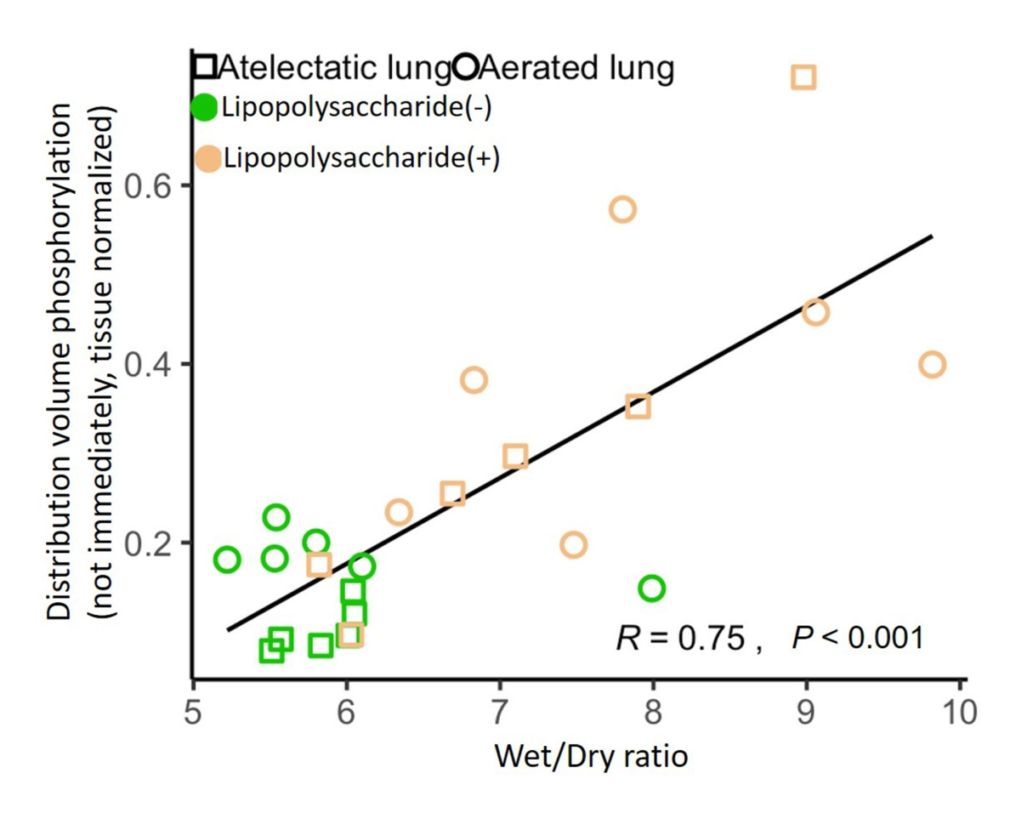
Figure S1. Wet/Dry ratios correlate with the volume of distribution of lung tissue 2-deoxy-2-[18F] fluoro-D-glucose (¹⁸F-FDG) not immediately available for phosphorylation (F_{ees}). Wet/Dry ratios correlated directly with the in vivo lung edema parameter F_{ees} derived from the ¹⁸F-FDG kinetics (R=0.75, P<0.001). Each point represents samples from atelectatic and aerated lung from studied animals exposed or not to systemic lipopolysaccharide.

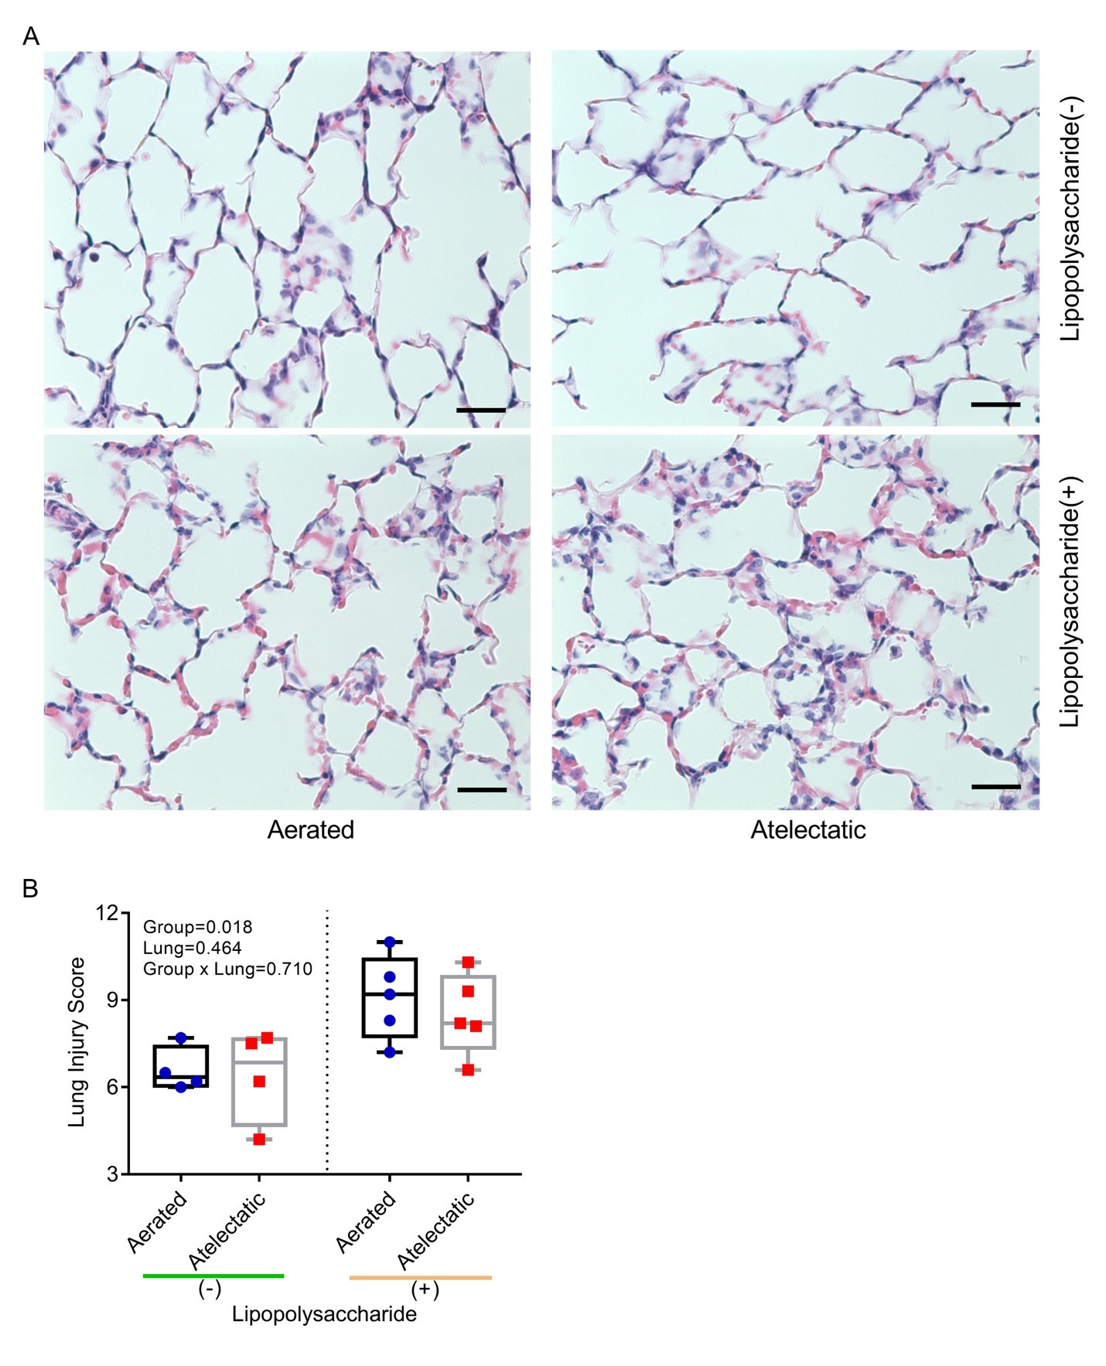
Figure S2. Histological injury in aerated and atelectatic lung regions according to lipopolysaccharide (LPS) exposure. (A) Worsened lung injury included severe capillary congestion and neutrophil infiltration (in high-power fields, magnification, ×400). Scale bars represent 50 µm. (B) Histological assessment showed that LPS exposure increased the lung injury scores (P=0.018; n=4 animals in LPS(-), n=5 animals in LPS(+)). The P-values corresponding to analyzed effects (LPS exposure (Group), lung region (Lung), and their interaction (Group × Lung)) are indicated in the figure.

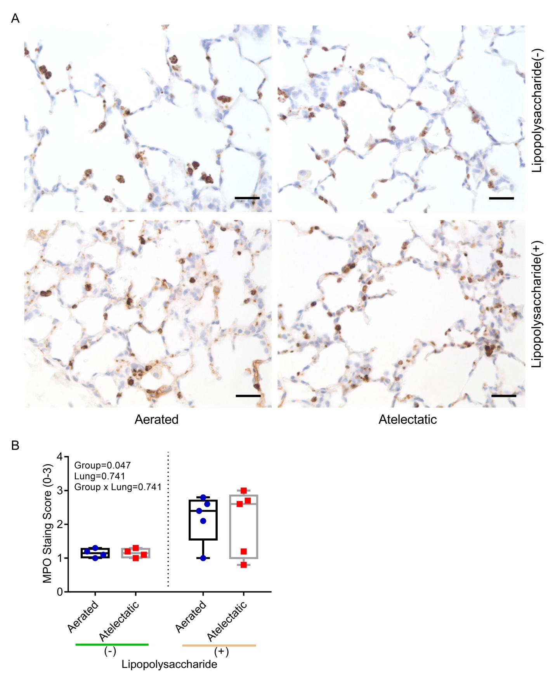
Figure S3. Myeloperoxidase staining in aerated and atelectatic lung regions according to lipopolysaccharide (LPS) exposure. (A) The representative images (in high-power fields, magnification, ×400) showing increased neutrophils in atelectatic and aerated regions after LPS exposure. Scale bars represent 50 µm. (B) The quantitative scores of myeloperoxidase (from 0 = no staining to 3 = maximal staining) showed that exposure to LPS increased the number of neutrophils in both atelectatic and aerated regions (P=0.047; n=4 animals in LPS(-), n=5 animals in LPS(+)). The number of neutrophils in atelectatic regions was comparable to that in aerated regions, independent of LPS exposure (P=0.741). The P-values corresponding to analyzed effects (LPS exposure (Group), lung region (Lung), and their interaction (Group × Lung)) are indicated.

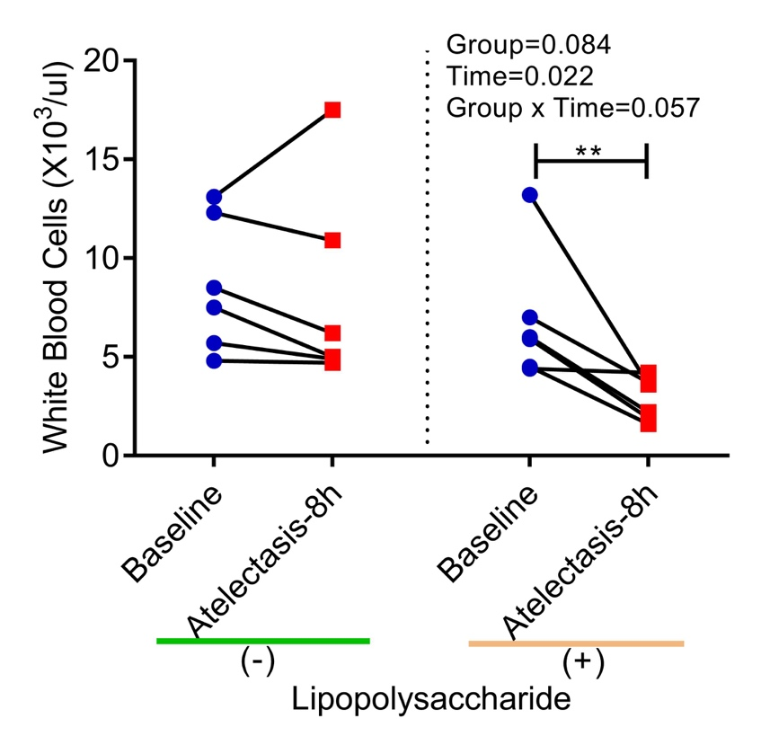
Figure S4. Peripheral white blood cells at baseline and 8 hours later of lung atelectasis with or without lipopolysaccharide (LPS) exposure. Peripheral white blood cells were decreased at the end of 8 hours lung atelectasis. LPS exposure dramatically decreased peripheral white blood cells after 8 hours of lung atelectasis when compared with baseline blood samples (P=0.022). The P-values corresponding to analyzed effects (LPS exposure (Group), time point (Time), and their interaction (Group × Time) are indicated. ** P < 0.01.

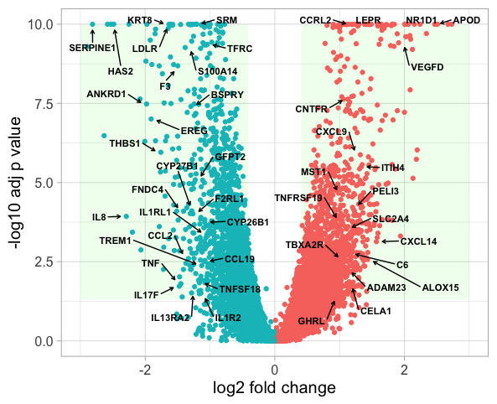
Figure S5. Volcano plot visualization of differential gene expression in atelectatic vs aerated lung in the absence of lipopolysaccharide exposure. Differentially expressed gene are defined by fold change>1.5 and adjusted P<0.05. The x-axis shows the fold-change in gene expression between (paired) atelectatic and aerated lung, and the y-axis shows the statistical significance of the differences. Colors represent different genes: red for genes upregulated in atelectasis and blue for genes downregulated in atelectasis. Top 50 differentially expressed genes are labeled with gene names. Each dot represents a specific gene transcript.

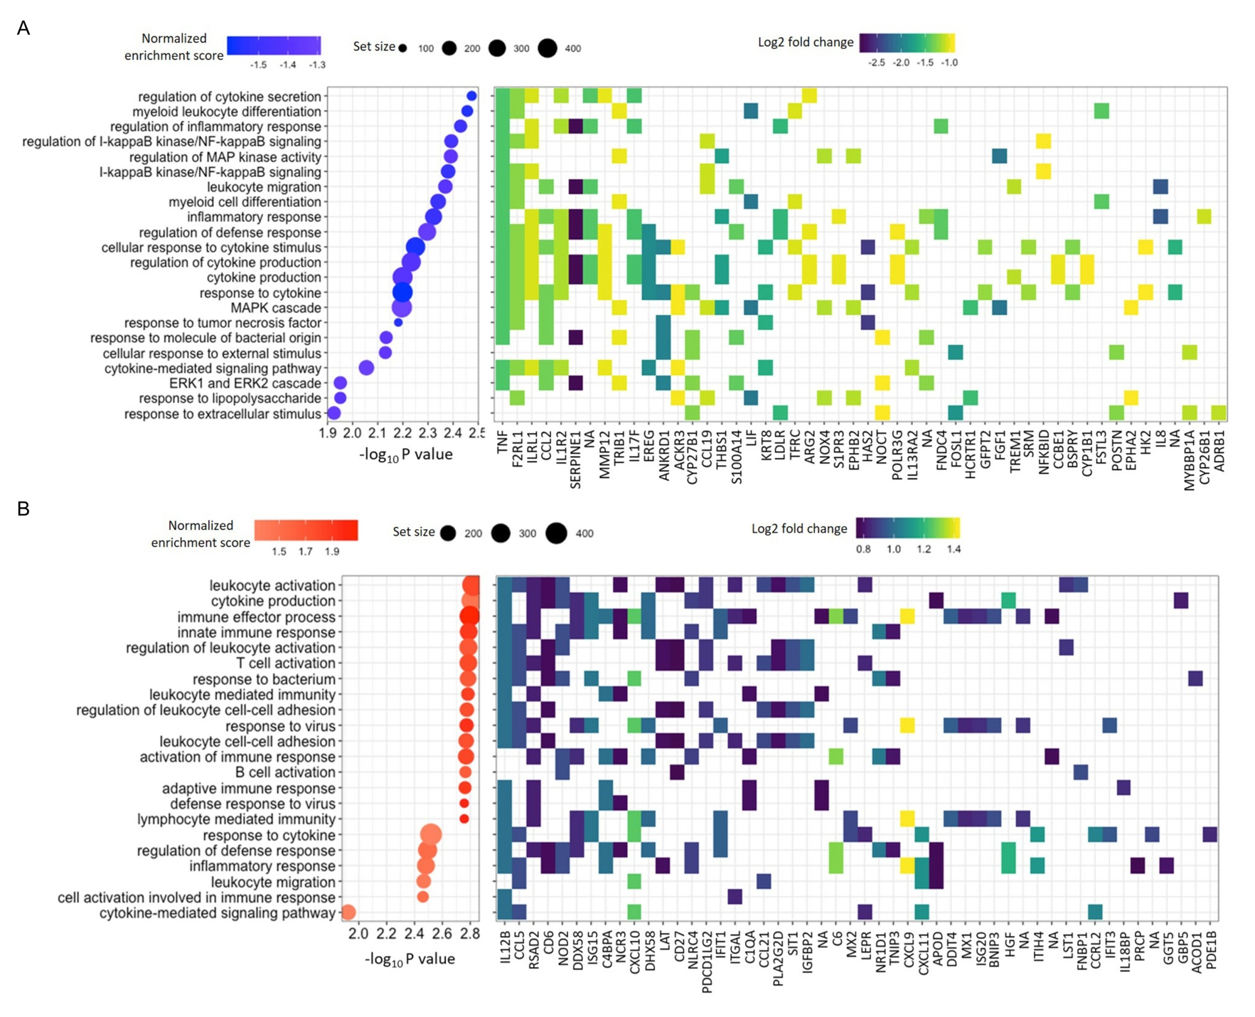
Figure S6. Transcriptomic changes associated with immune function enriched in atelectasis in the absence or presence of lipopolysaccharide (LPS) exposure. (A) Panel of negatively enriched gene sets relevant to immune response in the absence of LPS exposure and excluding redundant gene sets, along with genes mostly involved in these biological processes. For the gene sets, node color represents normalized enrichment score and node size represents set size. For the gene list, color is log-fold change with dark blue as stronger downregulation in atelectasis vs aerated regions. NA represents RNA sequences without a known symbol for sheep. (B) Panel of positively enriched gene sets relevant to pulmonary immunity and excluding redundant ontologies in the condition of LPS exposure, along with genes mostly involved in these biological processes. For the gene sets, node color represents normalized enrichment score and node size represents set size. For the gene list, color is log-fold change with light yellow as stronger upregulation in atelectasis vs aerated regions. NA represents RNA sequences without a known symbol for sheep.

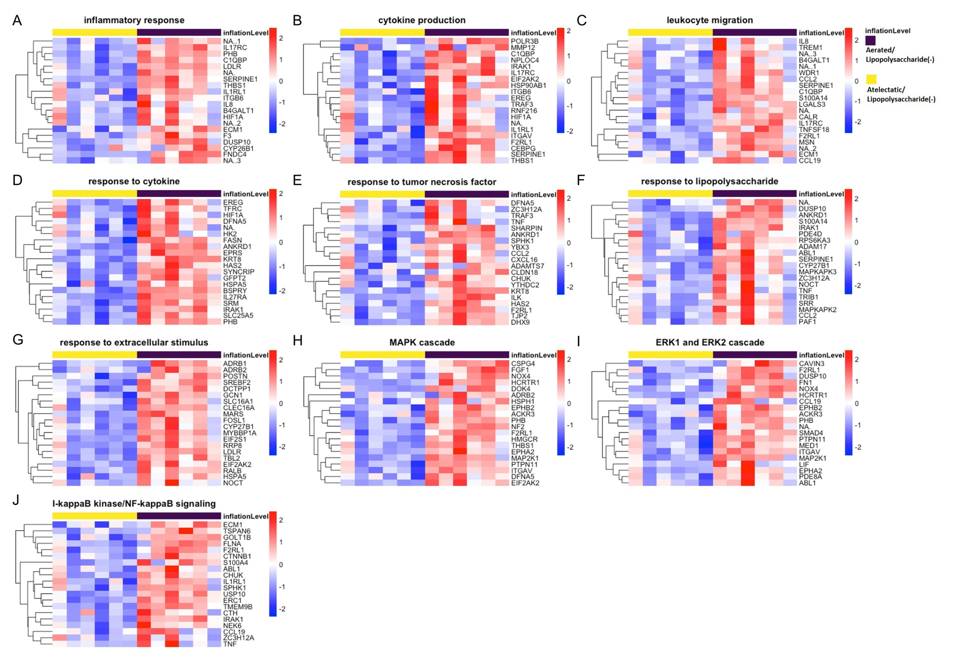
Figure S7. Atelectasis dysregulated immune response in the absence of lipopolysaccharide (LPS). (A-C) Heat map showing gene sets involved in immunity system, such as inflammatory response (A), cytokine production (B), as well as leukocyte migration (C), were downregulated in atelectatic regions as compared to aerated regions in the absence of LPS. (D-G) Heat map showing gene sets associated with cellular stress responses, including response to cytokine (D), response to TNF (E), response to lipopolysaccharide (F) and response to extracellular stimulus (G), were downregulated in atelectatic regions compared to aerated regions in the absence of LPS. (H-J) Heat map showing gene sets associated with immune-associated signaling pathways, such as MAPK cascade (H), ERK1 and ERK2 cascade (I), as well as NF-κB signaling (J), were downregulated in LPS-unexposed atelectatic regions relative to aerated regions.

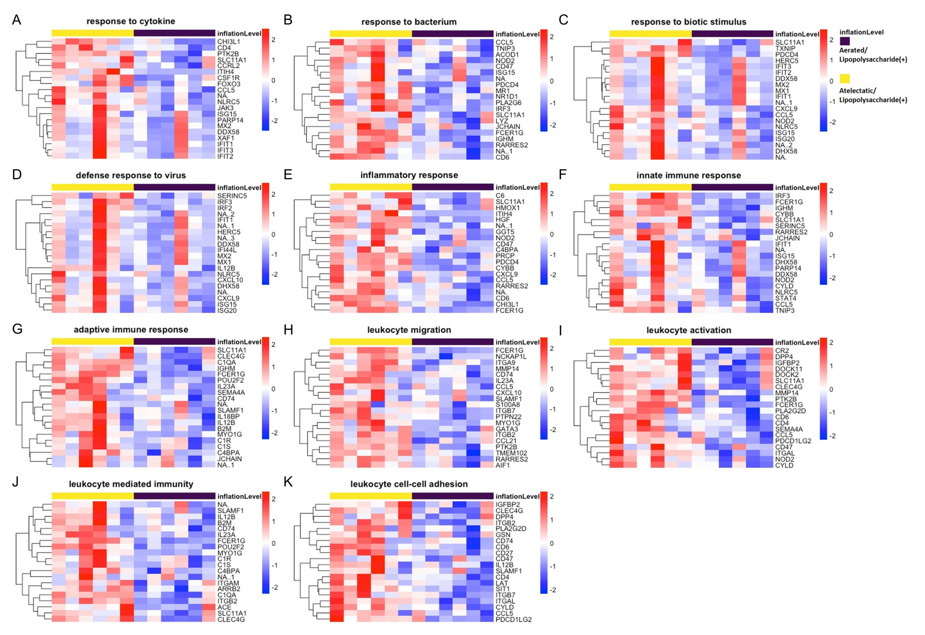
Figure S8. Atelectasis was associated with positively enriched immune-related processes during lipopolysaccharide (LPS) exposure. (A-C) Heat map showing gene sets associated with stress responses to cytokine (A), to bacterium (B) and to biotic stimulus (C) were upregulated in atelectatic vs aerated lung tissue during LPS exposure. (D-G) Heat map showing gene sets associated with immune responses, such as defense response to virus (D), inflammatory response (E) as well as innate (F) and adaptive (G) immune response, were upregulated in LPS-exposed atelectatic vs aerated lung tissue. (H-K) Heat map showing gene sets associated with leukocyte-related processes, such as leukocyte migration (H) and activation (I), leukocyte-mediated immunity (J) and leukocyte cell-cell adhesion (K), were upregulated in atelectatic vs aerated lung tissue during LPS exposure.

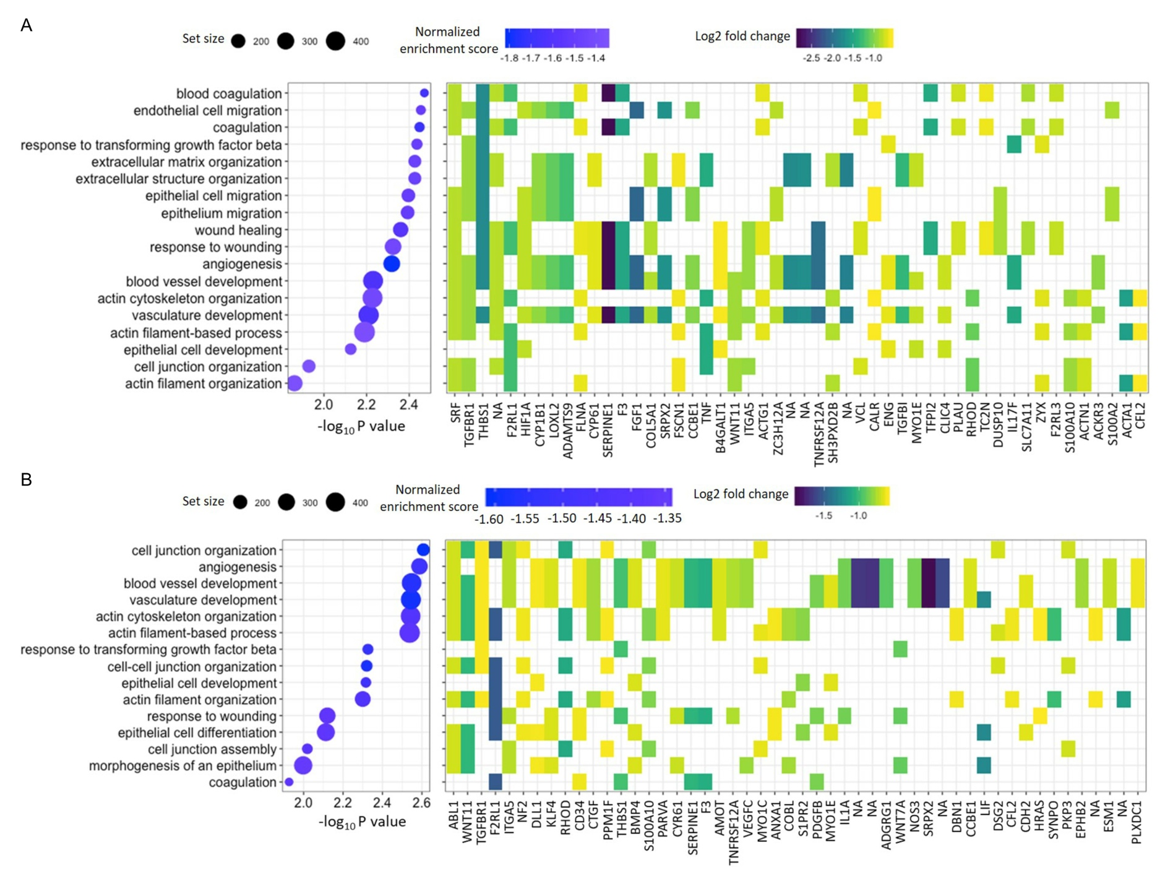
Figure S9. Transcriptomic changes in barrier function enriched in atelectasis in the presence or absence of lipopolysaccharide (LPS) exposure. Panel of negatively enriched gene sets in the absence (A) or the presence (B) of LPS exposure relevant to barrier function identified by gene set enrichment analysis and excluding redundant gene sets, along with genes mostly involved in these biological processes. For the gene sets, node color represents normalized enrichment score and node size represents set size. For the gene list, color is log-fold change with dark blue as stronger downregulation in atelectasis. NA represents RNA sequences without a known symbol for sheep.

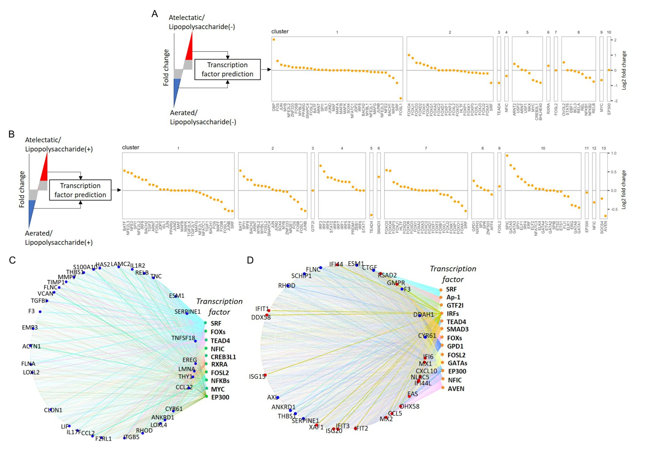
Figure S10. Transcription factor analysis in atelectasis in the presence or absence of lipopolysaccharide (LPS) exposure. (A, B) Transcription factor prediction analysis based on differentially expressed genes of atelectatic lung tissue in the absence (A) or the presence (B) of LPS exposure as compared to the corresponding aerated lung tissue. The transcription factors in their respective clusters were ordered by decreasing fold change and their gene expression was visualized as log2 fold change. (C, D) Gene targets involved in immune and barrier function in transcription factor prediction analysis in the absence (C) or the presence (D) of LPS exposure as compared to the corresponding aerated lung tissue. Predicted targets based on positive log₂ fold change are depicted by red nodes, and those based on negative log₂ fold change by blue nodes.

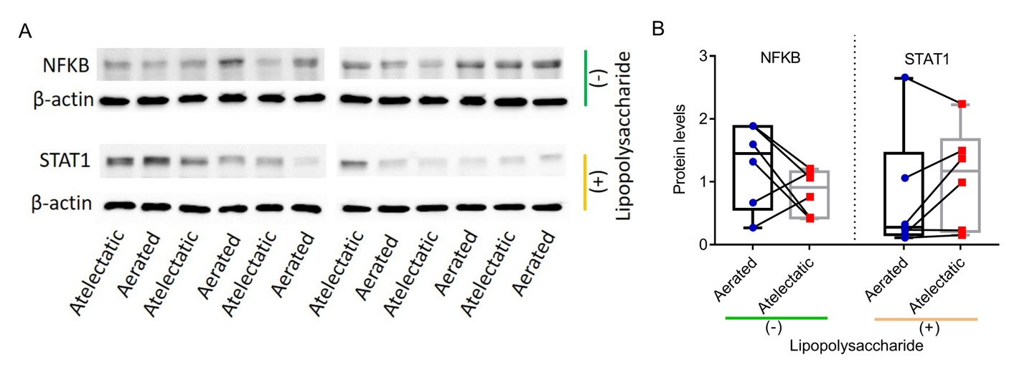
Figure S11. Transcription factor validations in atelectasis in the presence or absence of lipopolysaccharide (LPS) exposure. Western blot analysis (A) and quantification (B) showing the protein levels of transcription factors NFKB p65 in the absence of LPS and STAT1 in the presence of LPS condition, in both atelectatic and aerated lung tissues. Representative results from six animals are shown.
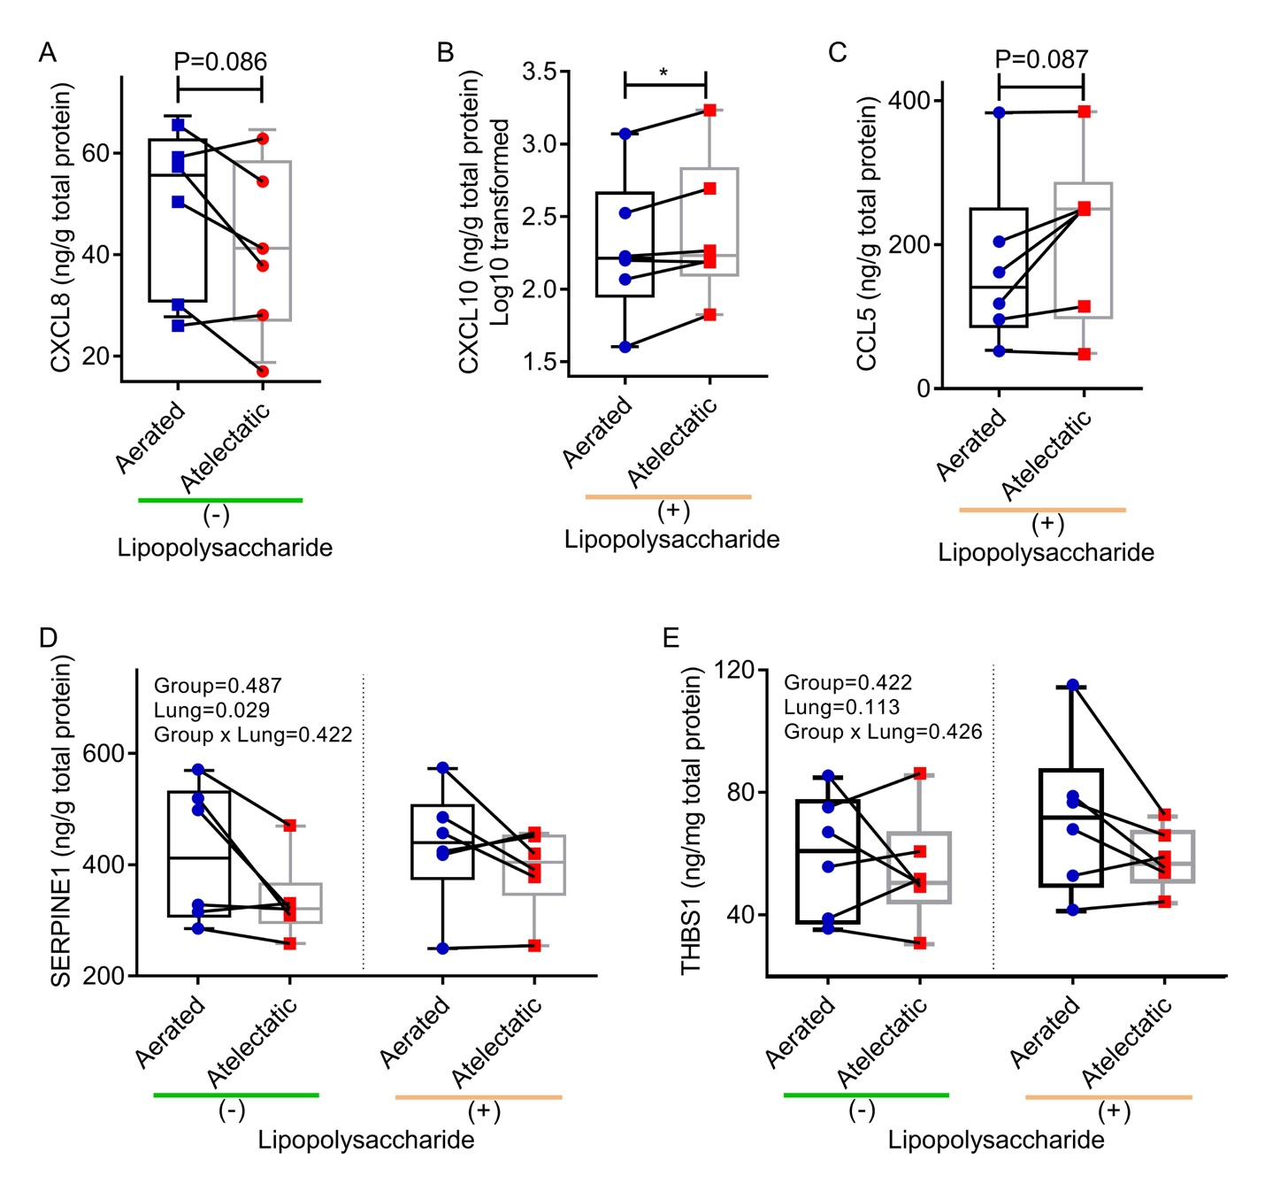
Figure S12. Quantification of protein levels in atelectatic and aerated lung tissues related to the observed transcriptomic findings. (A) Protein levels of NF-κB-related factor CXCL8 by enzyme-linked immunosorbent assay (ELISA) tended to be lower in atelectatic regions than those in aerated regions in the absence of lipopolysaccharide (LPS) exposure (P=0.086, n=6 animals). (B and C) With LPS exposure, the protein levels of interferon-stimulated genes (ISGs) such as CXCL10 (P=0.022) and CCL5 (P=0.087) increased in atelectatic regions vs aerated regions (n=6 animals), consistent with the magnified transcriptomic response. (D and E) Protein levels of Yes-associated protein (YAP)-responsive genes including SERPINE1 (P=0.029) and THBS1 (P=0.113) were found low expression in atelectasis when compared to aerated regions, independent of LPS exposure (n=6 animals). The P-values corresponding to each of the analyzed effects (LPS exposure (Group), lung region (Lung), and the interaction term (Group × Lung) are indicated. * P<0.05.

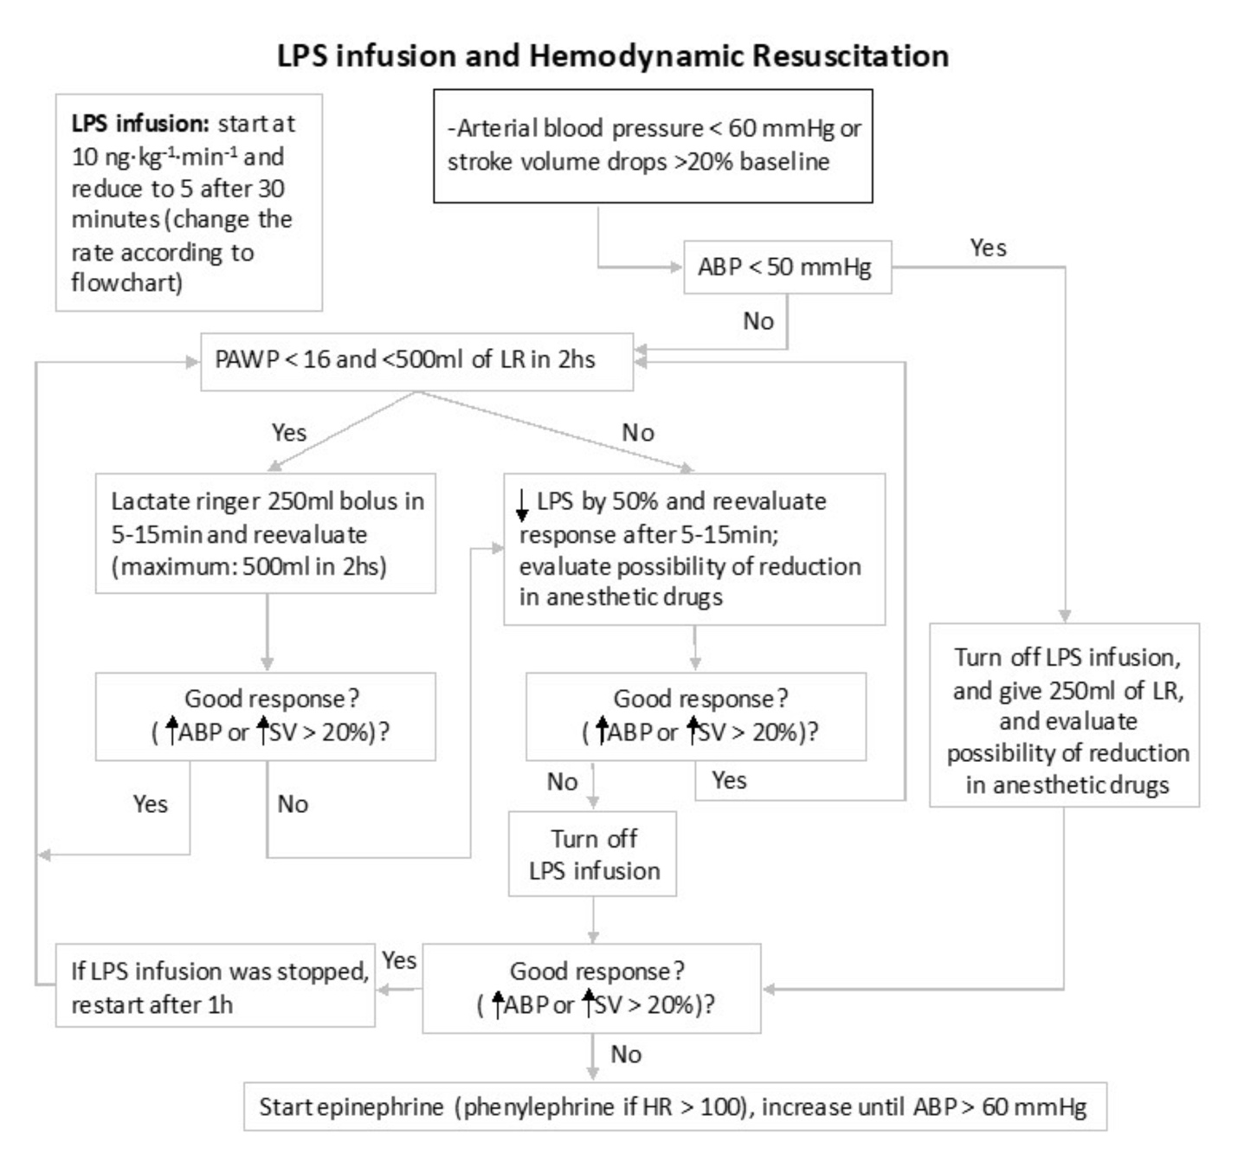
Figure S13. Algorithm for hemodynamic management and adjustment of lipopolysaccharide infusion rate.

