Prevalence of reverse triggering 24 hours after initiation of mechanical ventilation
SUPPLEMENTARY MATERIAL
Ricard Mellado Artigas^{1,2,3}*, L. Felipe Damiani^{1,2,4,5}*, Thomas Piraino⁶, Tai Pham^{1,2}, Lu Chen^{1,2}, Michela Rauseo^{1,2}, Irene Telias^{1,2}, Ibrahim Refaat Soliman^{1,2}, Detajin Junhasavasdikul^{1,2}‎, César Santis^{1,2}, Orla Smith^{1,7}, Ewan Goligher^{2,8,9}, Norman Comtois¹, Christer Sinderby¹, Leo Heunks^{1,10}, Laurent Brochard^{1,2,}
List of contents
- Appendix 1. Methodology …………………………………………………………………………………2
- Figure Legends ………………………………………………………………………………………………….5
- Tables ……………………………………………………………………………………………………………….8

Appendix 1
Methodology
Derivation of the automated detection of reverse triggering
To detect reverse triggering, we first designed a simple algorithm consisting in a combination of three parameters coming from Neurosync output: 1) Presence of an Electrical activity of the diaphragm waveform; 2) Electrical activity of the diaphragm waveform starting after the ventilator insufflation; and 3) Peak electrical activity of the diaphragm >1 microvolt. This algorithm was tested on our derivation cohort (10 patients in assist-control mode) with good results. However, when we tested the same algorithm on different 2000 breaths from patients in assisted modes, we observed a high proportion of false positive results. To avoid this, we added a third element into our algorithm to differentiate machine-triggered from patient-triggered breaths. Since Servo-Tracker does not store data from the ventilator about, whether or not, pressure/flow trigger has been reached, we analyzed the airway pressure drop between the airway pressure at pressurization onset and the minimal inspiratory airway pressure (see below). A decrease in Paw threshold at 0.3 cm H20 provided the best cut-off between patient-triggered events and reverse-triggered breaths (Figure S1). We finally combined these two 10-patient cohorts; one in assist-control mode and the second one in assisted modes (4000 breaths in total) to test the final algorithm with improved results.

Criteria for the automatic detection method to classify each event as a reverse-triggered breath
When a mechanical breath presented with an electrical activity of the diaphragm waveform (>1 microvolt) that started after pressurization onset, the decrease in pressure between pressurization onset and the minimum pressure during the inspiratory phase was calculated by the software; if this value exceeded 0.3 cm H20, the breath was labelled as a patient-triggered event and if less or equal to this value, it was considered reverse-triggering (See Figure S1). Several cut-offs were tested and 0.3 was chosen based on ROC curve analysis. This approach was needed because the software used in this study did not record whether an effort had been patient or machine-triggered based on the ventilator logbook.
Sensitivity analysis of different definitions
Among all breaths visually analyzed, 541 were labeled as reverse triggering by all the reviewers, 668 by at least two of them and 758 by one or more reviewer. In order to present a better idea of the uncertainty of the utilized “gold standard”, we performed a sensitivity analysis using 3 different types of definitions. Combinations for detecting each breath are as following:
- Definition 1: Reverse triggering detected by at least one reviewer
- Definition 2: Reverse triggering detected by at least two reviewers
- Definition 3 (Gold standard): Reverse triggering detected by the three reviewers.
Table S1 shows the incidence of reverse triggering and the diagnostic accuracy of the new method as compared with the 3 different gold standards.
In addition, Diagnostic accuracy of the new algorithm using Neurosync for reverse triggering detection using a total of 4000 breaths (from patients in assist-control mode and pressure support ventilation) considering GS3 as a reference was as follows: sensitivity 0.84 (0.80 to 0.87), specificity 0.96 (0.95 to 0.97), PPV 0.75 (0.72 to 0.79), NPV 0.98 (0.97 to 0.98); whereas for double cycling detection results were: sensitivity 0.70 (0.55 to 0.83), specificity 1 (0.99 to 1), PPV 0.81 (0.66 to 0.92), NPV 0.99 (0.99 to 1).
Reverse triggering detection based on expiratory time (Te).
When a ventilator is set to a control mode (pressure or volume), we assume (by definition) that the Maximum Expiratory time (Max-Te) must be determined by the set respiratory rate and percentage of inspiratory pause. Thus, Max-Te was determined using all breaths where no electrical activity of the diaphragm was found. Then, to determine if a breath was either a machine or patient triggered, we analyzed the “Te” duration using the Max-Te as a reference. If the “Te” of the previous breath was >= (“Max-Te” – 0.016 seconds) (Neurosync samples every 16 milliseconds), the current breath must be mandatory and initiated by the ventilator. In contrast, if the “Te” of the previous breath was < to “Max-Te” – 0.016 seconds, the current breath was labeled as patient triggered (See Figure S1).
Detection of reverse triggering using expiratory time method was determined according to the following criteria: 1. Machine triggered breath (when previous “Te” was >= to Max-Te); 2. electrical activity of the diaphragm delay (electrical activity of the diaphragm starting after the pneumatic event); 3. Electrical activity of the diaphragm breath (when the sum of consecutive electrical activity of the diaphragm sample differences exceed the trigger level of 0.5 microvolts and electrical activity of the diaphragm time integral > 0.5 microvolts after cycling off at 70% of peak electrical activity of the diaphragm); and 4. Peak electrical activity of the diaphragm >1 microvolt. Comparative results for detection of reverse triggering breaths between Neurosync algorithm and this expiratory time method is shown in Figure S2.

FIGURE LEGENDS
Figure S1. Definition of patient or machine triggered breath by Neurosync or expiratory time method. A. Representative tracing of a patient triggered breath where preceding Te is less than set Te and the drop in Paw is greater than 0.3 cmH20. B. Representative tracing of a machine triggered breath where preceding Te is equal to the set Te and the drop in Paw is less than 0.3 cmH20. Te: expiratory time; Max-Te: maximum expiratory time.
Figure S2. Comparison of reverse triggering breaths detected by Neurosync algorithm and Expiratory time method.
Figure S3. Inclusion flow diagram.

Figure S1.
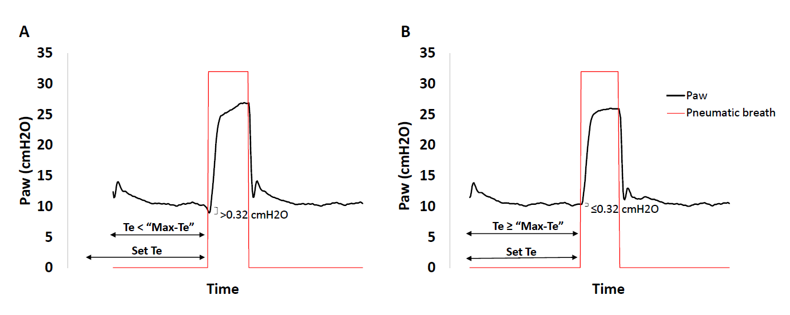

Figure S2.
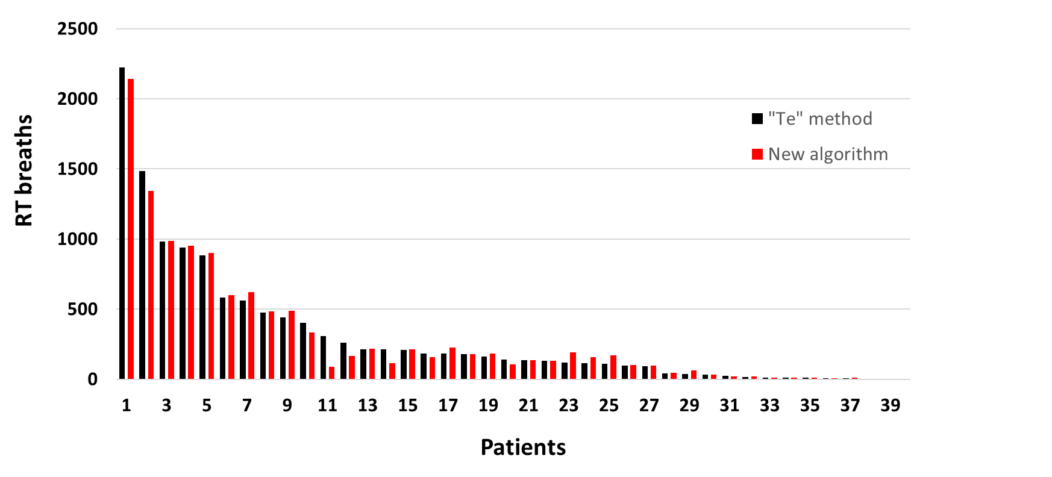

Figure S3.

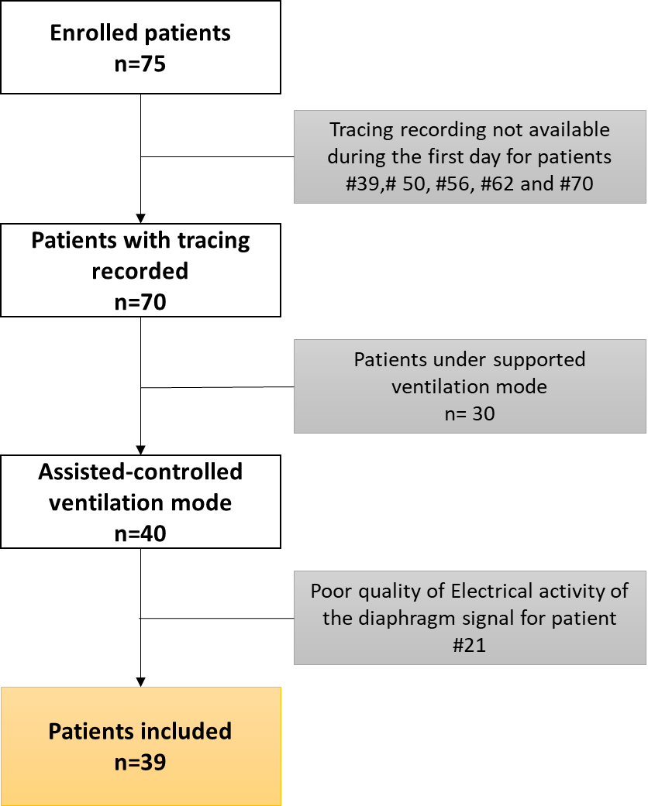

TABLES
Table S1. Sensitivity analysis on 2000 breaths (n=10) on assist-control mode in order to estimate variability of diagnostic value of proposed algorithm.
 | Defintion 1 | Definition 2 | Defintion 3 (Gold standard)
Incidence of reverse triggering | 758/2000 | 668/2000 | 541/2000
Sensitivity (95%IC) | 0.66 (0.62, 0.69) | 0.73 (0.69, 0.76) | 0.84 (0.80, 0.87)
Specificity (95%IC) | 0.95 (0.94, 0.96) | 0.94 (0.93, 0.96) | 0.93 (0.91, 0.94)
Positive predictive value (95%IC) | 0.89 (0.86, 0.92) | 0.87 (0.84, 0.89) | 0.81 (0.77, 0.84)
Negative predictive value (95%IC) | 0.82 (0.80, 0.84) | 0.87 (0.85, 0.89) | 0.94 (0.93, 0.95)
Positive likelihood ratio (95%IC) | 13.4 (10.4, 17.12) | 12.9 (10.3, 16.1) | 11.4 (9.5, 13.8)
Negative likelihood ratio (95%IC) | 0.36 (0.33, 0.40) | 0.29 (0.26, 0.33) | 0.18 (0.14, 0.21)

Table S2: Outcomes, demographic and respiratory variables grouped by prevalence of reverse triggering; using a 3 microvolts cutoff
 | Reverse triggering
Variable | >2% | ≤ 2% | p-value
Age, y | 54 ±18 | 61±15 | 0.237
Male (%) | 10 (52%) | 13 (65%) | 0.432
Number of breaths studied | 1623 ±604 | 1772 ±588 | 0.391
Time to recording from intubation, h | 26 (21-27) | 24 (21-26) | 0.608
APACHE II | 20 (16-27) | 26 (21-30) | 0.127
Pulmonary cause of intubation, n (%) | 7 (42%) | 14 (70%) | 0.079
SAS | 2 (1-3) | 2 (1-3) | 0.235
MV, days | 5 (2-9) | 6 (4-10) | 0.252
Switch to a partial support mode or extubation the next day, n (%) | 13 (68%) | 7 (35%) | 0.039
PF ratio, mmHg | 200 (148-353) | 124 (100-229) | 0.042
Respiratory rate, bpm | 20 (18-24) | 28 (23-30) | 0.020
TV PBW, ml | 7 ±1.3 | 6.4 ±0.96 | 0.188
PEEP, cmH2O | 8 (5-10) | 9 (6-12) | 0.265
Median Peak Electrical activity of the diaphragm, microvolts | 1.7 (0.9-4.2) | 0.7 (0.7-0.8 | <0.001
Patient-triggered breaths over the 1-hour recording, % | 11 (9-23) | 1 (0-4) | <0.001
Double Cycling, % | 0 (0-0.6) | 0 (0-0) | 0.268
All numeric variables are presented as median (IQR) except for age, number of breaths studied and TV; which are expressed as a mean ±SD.
APACHE II: Acute Physiology And Chronic Health Evaluation II; SAS: Riker Sedation-Agitation Scale (ranging from 1 to 7; with lower values indicating deeper sedation); MV: Mechanical ventilation; P/F ratio: pO2/FIO2; TV: Tidal volume; PEEP: Positive end-expiratory Pressure

