Supplementary material

Changes in respiratory muscle thickness during mechanical ventilation:
Focus on expiratory muscles

Zhong-Hua Shi, MD, Heder de Vries, MD, Harm-Jan de Grooth, MD PhD, Annemijn H. Jonkman, MSc, Yingrui Zhang, MD, Mark Haaksma, MSD, Peter M. van de Ven, PhD, Angelique A.M.E. de Man, MD, PhD, Armand Girbes, MD, PhD, Pieter R. Tuinman, MD, PhD, Jian-Xin Zhou, MD, PhD, Coen Ottenheijm, PhD, Leo Heunks, MD, PhD

Corresponding author: Prof. Leo Heunks, MD, PhD, E-mail: L.Heunks@amsterdamumc.nl
Postal address corresponding author: Amsterdam UMC, location VUmc, Postbox 7505, 1007 MB Amsterdam, The Netherlands

ADDITIONAL METHODS

Sensitivity analysis
Threshold selection for the group divisions in the cohort study
We constructed Bland-Altman plots to determine the threshold to categorize patients in the cohort study. These Bland-Altman plots show the difference (y-axis) against mean thickness (x-axis) for inter-rater and intra-rater repeated measurements. The limits of agreement in the Bland-Altman plot show the range within which 95% of the differences in measurements are expected to lie. Because repeated measurements of expiratory muscle thickness in the same subjects were performed under identical conditions within a short period of time, these differences are likely based on random variation or measurement error [1]. We reasoned that any difference that exceeds these limits is likely to be attributable to biological processes such as atrophy, hypertrophy or inflammation, and not measurement error. The limits of agreement for percentage of differences in the expiratory muscle thickness were -13% to 7% between raters and -10% to 12% for rater M.H and -11% to 14% for rater Z.S.
Accordingly, we selected a threshold above these limits (absolute difference of at least 15% compared to baseline) to categorize the patients for the analysis in the cohort study. If the predicted thickness of the expiratory muscles of the last measurement within the first week, obtained with linear regression using all the available measurements for each subject, differed by more than 15% from the baseline in either direction, the patient would be categorized to either the increase or decrease group, respectively. If the difference from baseline was less than 15% the patient was assigned to the “no change” group (Figure E1).
To ensure that conclusions are not different when we selecting other thresholds, analysis was also conducted for 10%, 12.5%, 13.5%, and 20% of change in thickness. Patients clinical characteristics and outcomes were analyzed based on different thresholds and these data are presented in table E1 and E2.
Linear mixed models for clinical risk factors and patient outcomes
Evolution of expiratory muscle thickness over time
We employed linear mixed models to assess the changes in thickness of the expiratory muscles over time, and to assess associations with baseline risk factors and the slope of expiratory muscle thickness over time.
We constructed a linear mixed model with a random intercept and a random slope using an unstructured covariance matrix for the random effects. The thickness of the expiratory muscles was the dependent variable and a fixed effect for day was included. Linearity was tested by including fixed and random quadratic terms for day to the model and comparing the model with quadratic terms to the model with only linear terms using the likelihood ratio test.
As adding the quadratic terms did not improve model fit (LR = 4.7, df = 4, p = 0.32), results are based on a model assuming linear relationship between thickness of the expiratory muscles and day. On average, the thickness of the expiratory muscles was found to decrease by 0.2 mm/day (95% CI: 0.1, 0.3 mm/day, p = 0.005).
Risk factors for the evolution of expiratory muscle thickness
Associations between risk factors and slope of expiratory muscle thickness were tested by adding the risk factor and its interaction with day to the linear mixed model. A significant interaction term indicates that the slope of expiratory muscle thickness is associated with the risk factor.
The p-values for the association between the slope of expiratory muscle thickness and the risk factors are given in Table E6. None of the tested risk factors were found to have a significant association with the slope of expiratory muscle thickness.
Clinical outcomes
To test for associations between slope of expiratory muscle thickness and clinical outcomes first slopes were determined for the individual patients using linear regression using only the individual’s data. Logistic regression was subsequently used to test for associations between dichotomous outcomes and slopes, whereas linear regression was used for continuous outcomes. The slopes estimated on individual data were negative for 48 patients (62.3%) and positive for 29 patients (37.7%) and ranged from -9.0 to 7.2 mm per day. The distribution of slopes is shown in figure E6.
Odds ratios and regression coefficients for the associations of slopes of expiratory muscle thickness with clinical outcomes are given in Table E4 and E5, respectively. The only significant association found was for slope and length of stay, with larger (less negative/more positive) slopes associated with shorter length of stay. After removal of the two most extreme slopes (one negative and one positive) the association was no longer significant. The size of regression coefficient, however, remained similar (beta = -0.081, 95% CI: [-0.20, 0.03], p = 0.16).

Supplementary figures
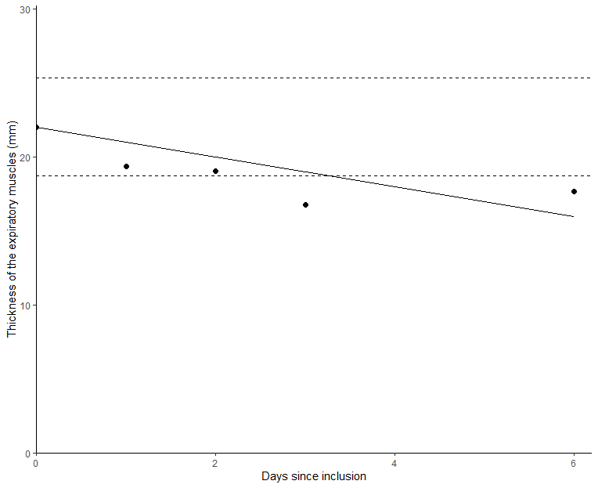
Figure E1. Example of classification of a subject in the cohort study. The y-axis shows the absolute thickness of the expiratory muscles, the x-axis shows the days since inclusion. Each dot represents the average of 3 measurements on that day. The straight line has been obtained by fitting a linear regression (forced to start at the baseline of this subject) using only the measurements of this subject. It shows the predicted thickness of the expiratory muscles per day. The straight dashed lines represent an increase or decrease of 15% from baseline for this subject . Any change from baseline that falls between these two dashed lines could be attributable to measurement variance alone based on the repeatability coefficient obtained in the reproducibility study. If the predicted thickness on the last day of measurement was below this dashed line, a subject would be assigned to the “decrease”-group. If the thickness was between the two dashed lines, a subject would be assigned to the “no change”-group. If the thickness on the last day of measurement was above the dashed line, a subject would be assigned to the “increase”-group. Conversely, this individual subject was assigned to the “decrease”-group. The absolute difference between baseline thickness and the estimated thickness on the last day of measurement (in this case 24 – 17 = 7 mm) was used in the linear regression model to assess the association between changes in thickness of the expiratory muscles and the diaphragm.

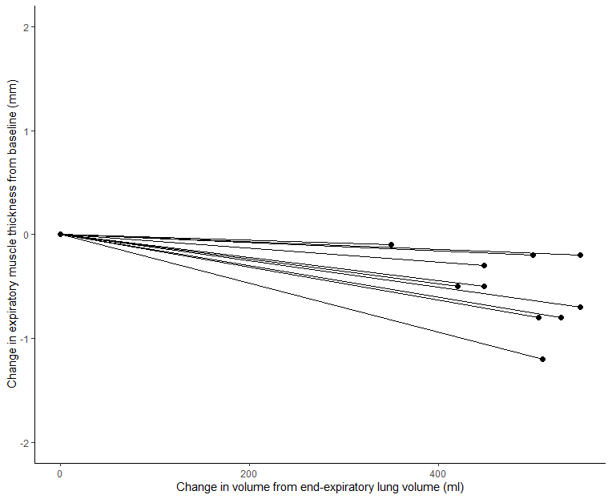
Figure E2. Effect of lung volume on the thickness of the expiratory muscles for each individual patient in the substudy of reproducibility study ( n = 10). The mean change in expiratory muscle thickness within each patient between the two lung volumes was -0.5 mm (95% confidence interval -0.8 to -0.3, p = 0.001) assessed with a paired sample t-test. Although statistically significant, this difference was 8 times smaller than the difference in thickness observed between patients, and 4 times smaller than the difference in thickness observed within patients.

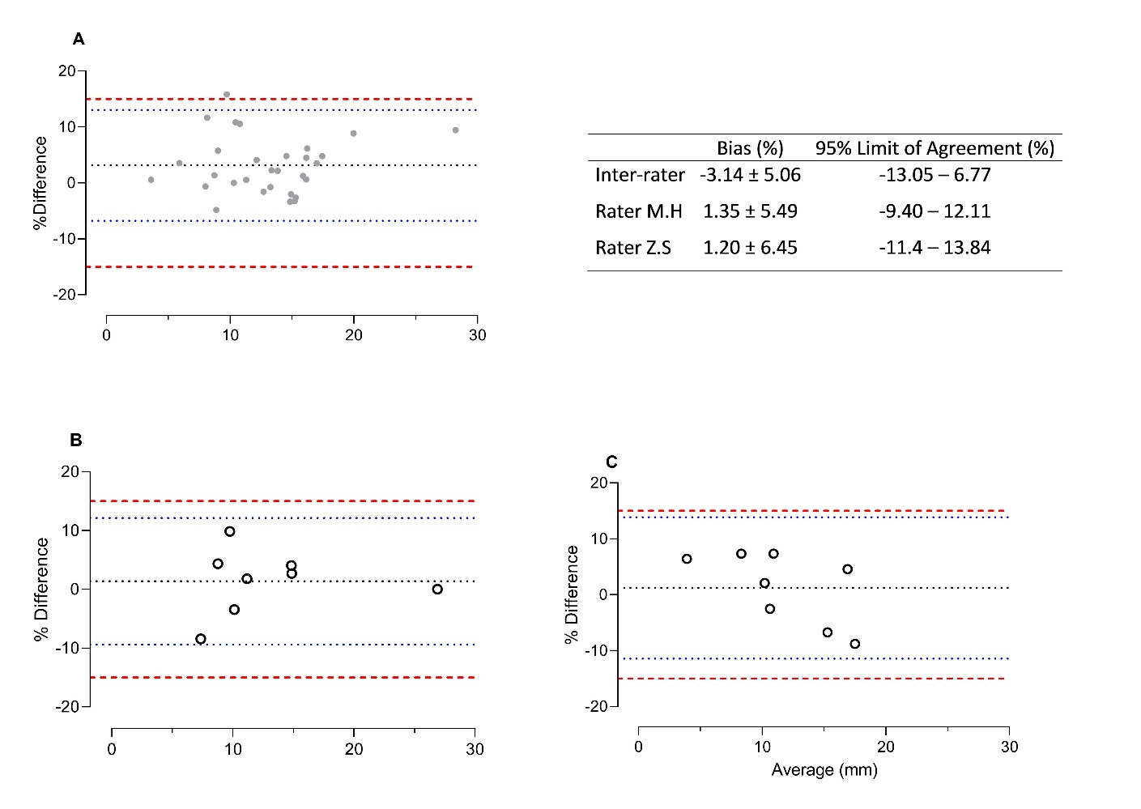
Figure E3. Bland-Altman plots percentage difference (y-axis) against mean (x-axis) for inter-rater (A) and intra-rater (B and C) measurements, with mean percentage difference (black dotted line), and upper and lower limit of agreement (blue dotted line). The red dashed line are the threshold for group division in study B (±15%).

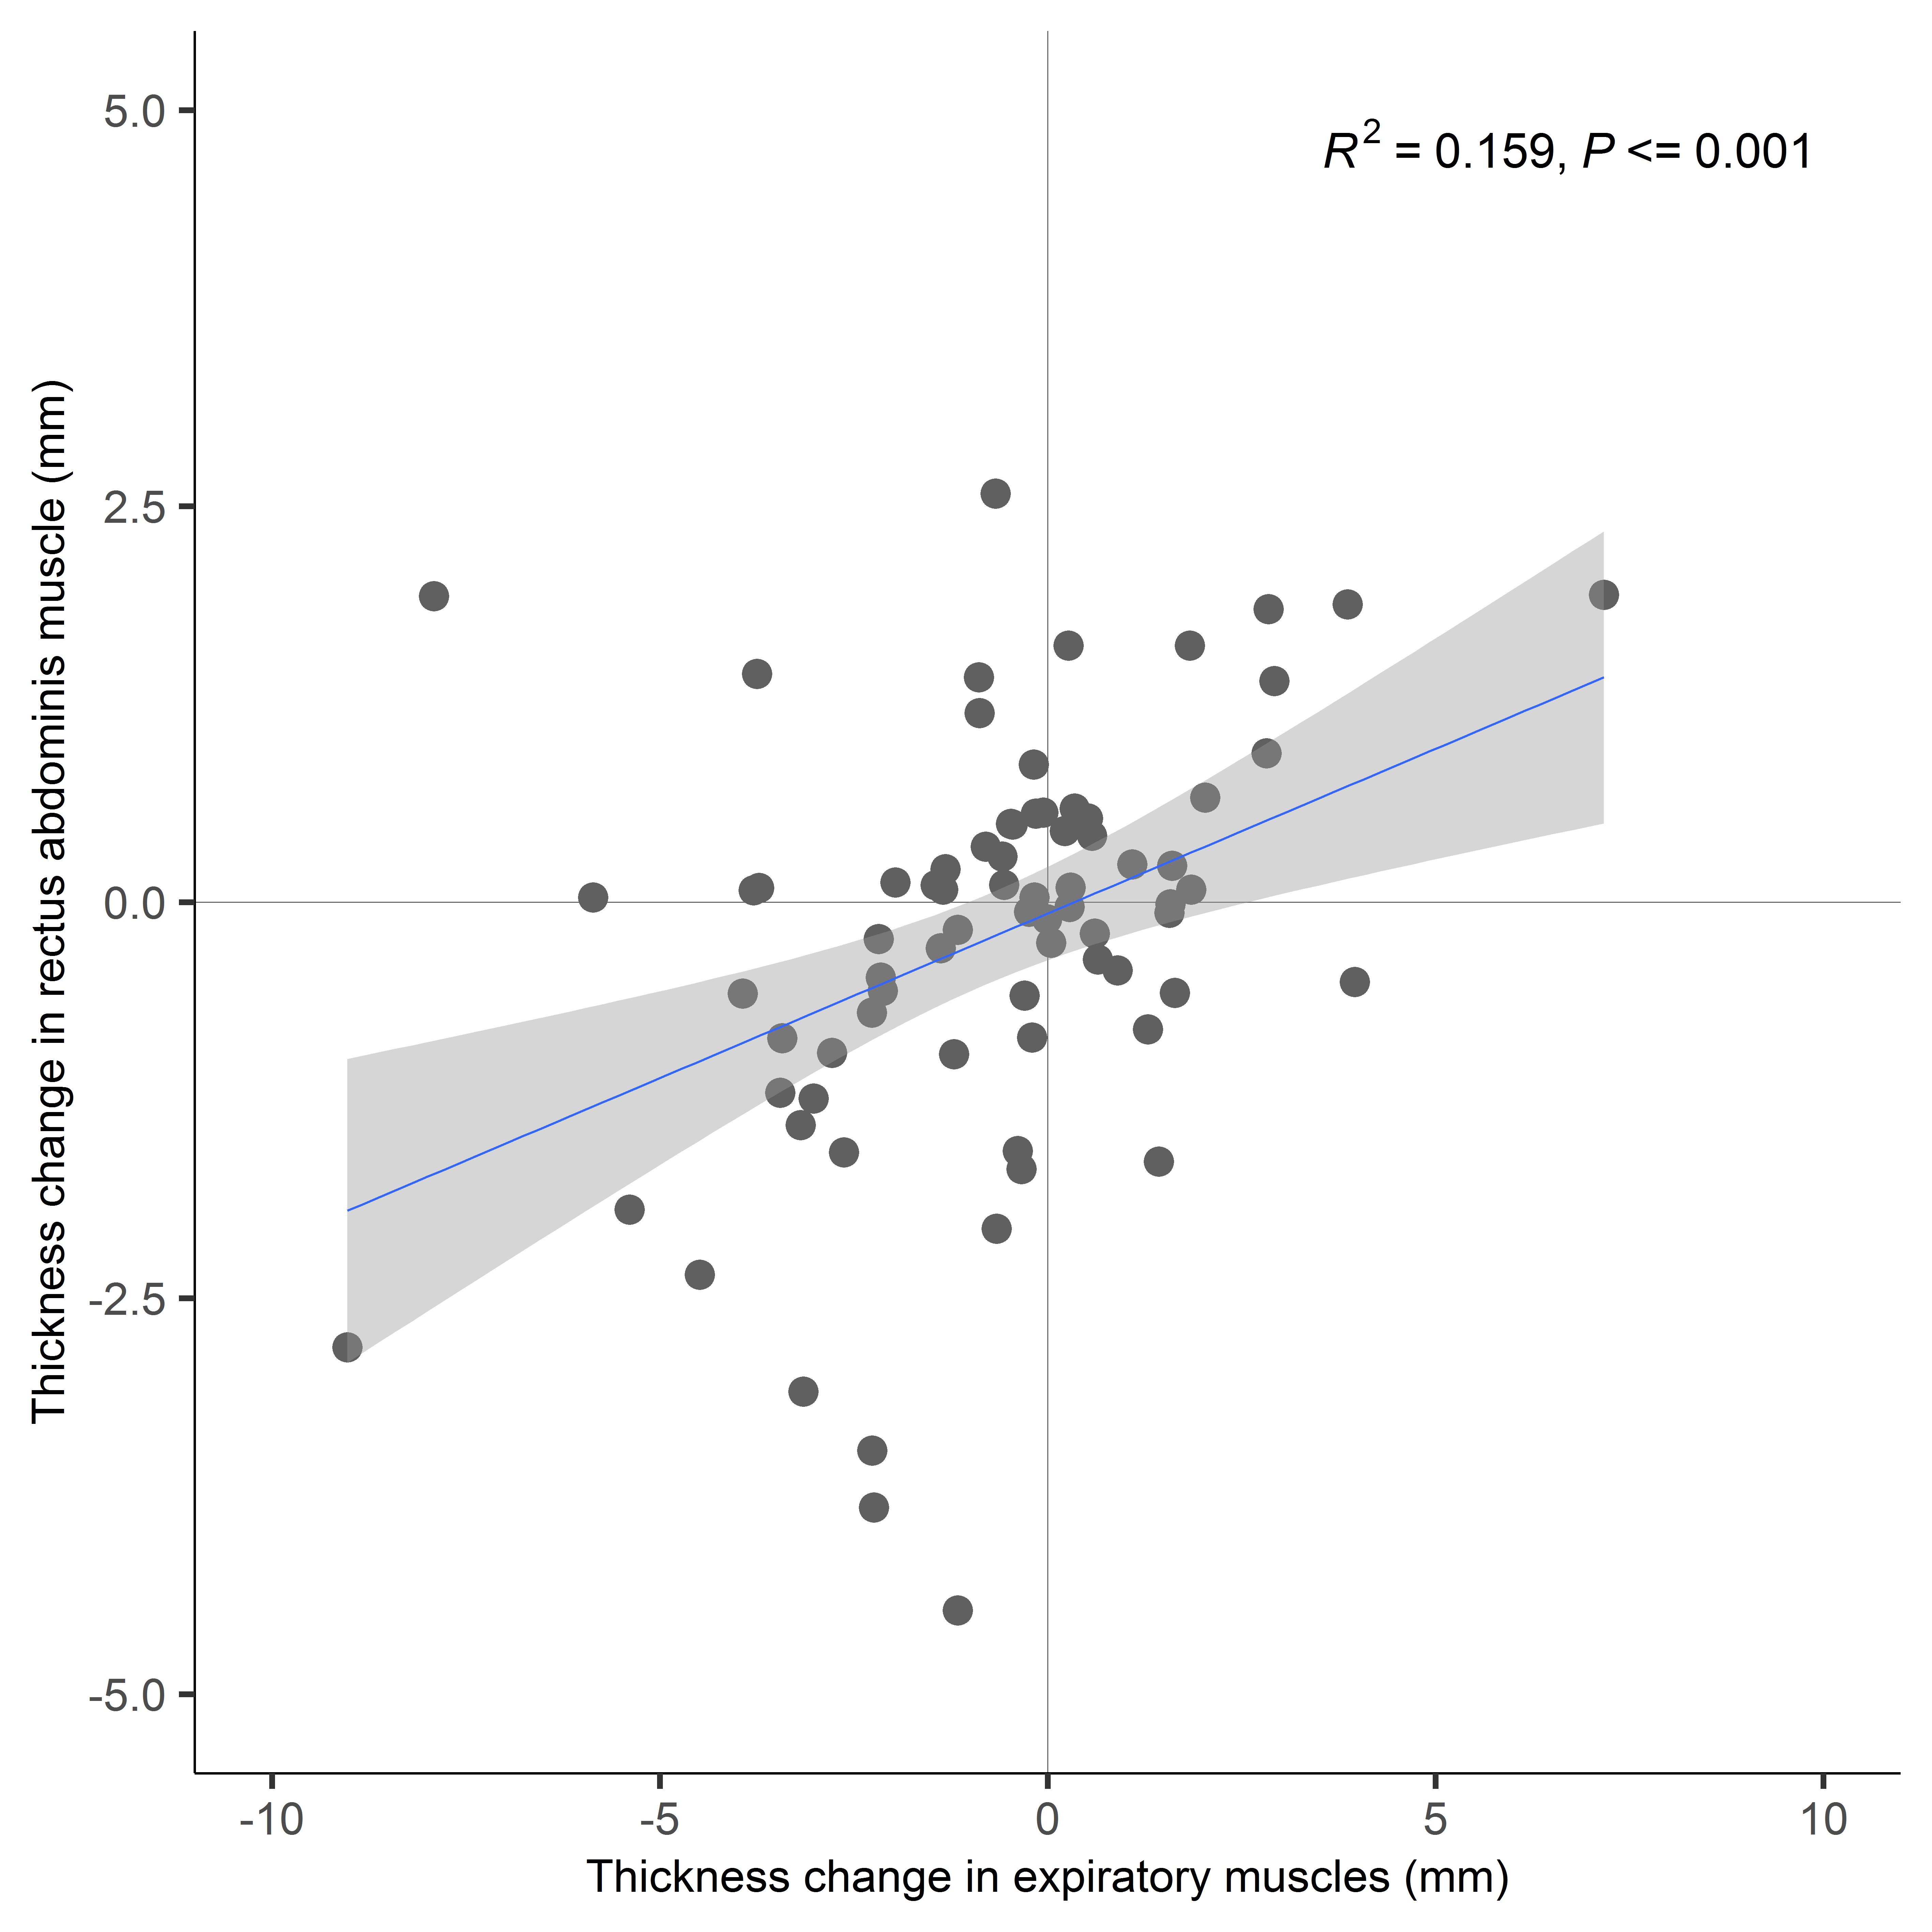
Figure E4. Correlation between changes in thickness of the rectus abdominis muscle and the expiratory muscles. The blue line is the predictive value of the rectus abdominis muscle thickness under the corresponding thickness of the expiratory muscles. Each dot represents the difference between the estimated thickness of the last measurement within first week and the baseline measured thickness. R² and p-value were analyzed using a linear regression model. The estimated muscle thickness was obtained by simple linear regression models.
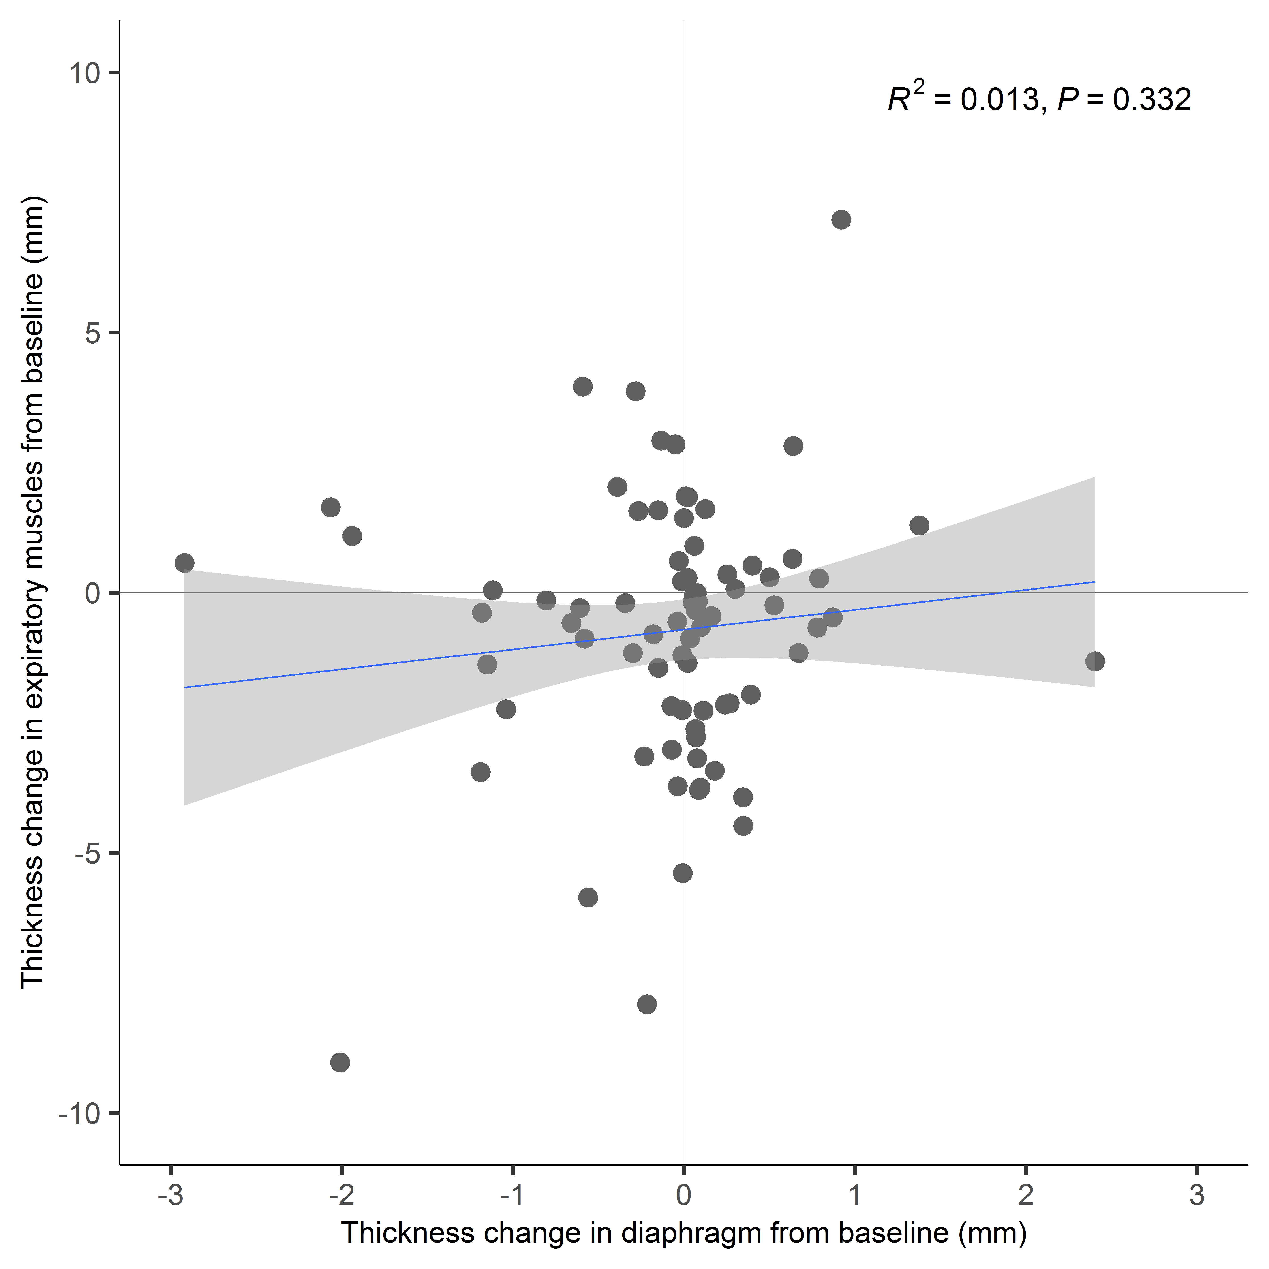

Figure E5. Correlation between changes in thickness of the rectus abdominis muscle and the diaphragm. The blue line is the predictive value of the rectus abdominis muscle thickness under the corresponding thickness of the expiratory muscles. Each dot represents the difference between the estimated thickness of the last measurement within first week and the baseline measured thickness. R² and p-value were analyzed using a linear regression model. The estimated muscle thickness was obtained by simple linear regression models.

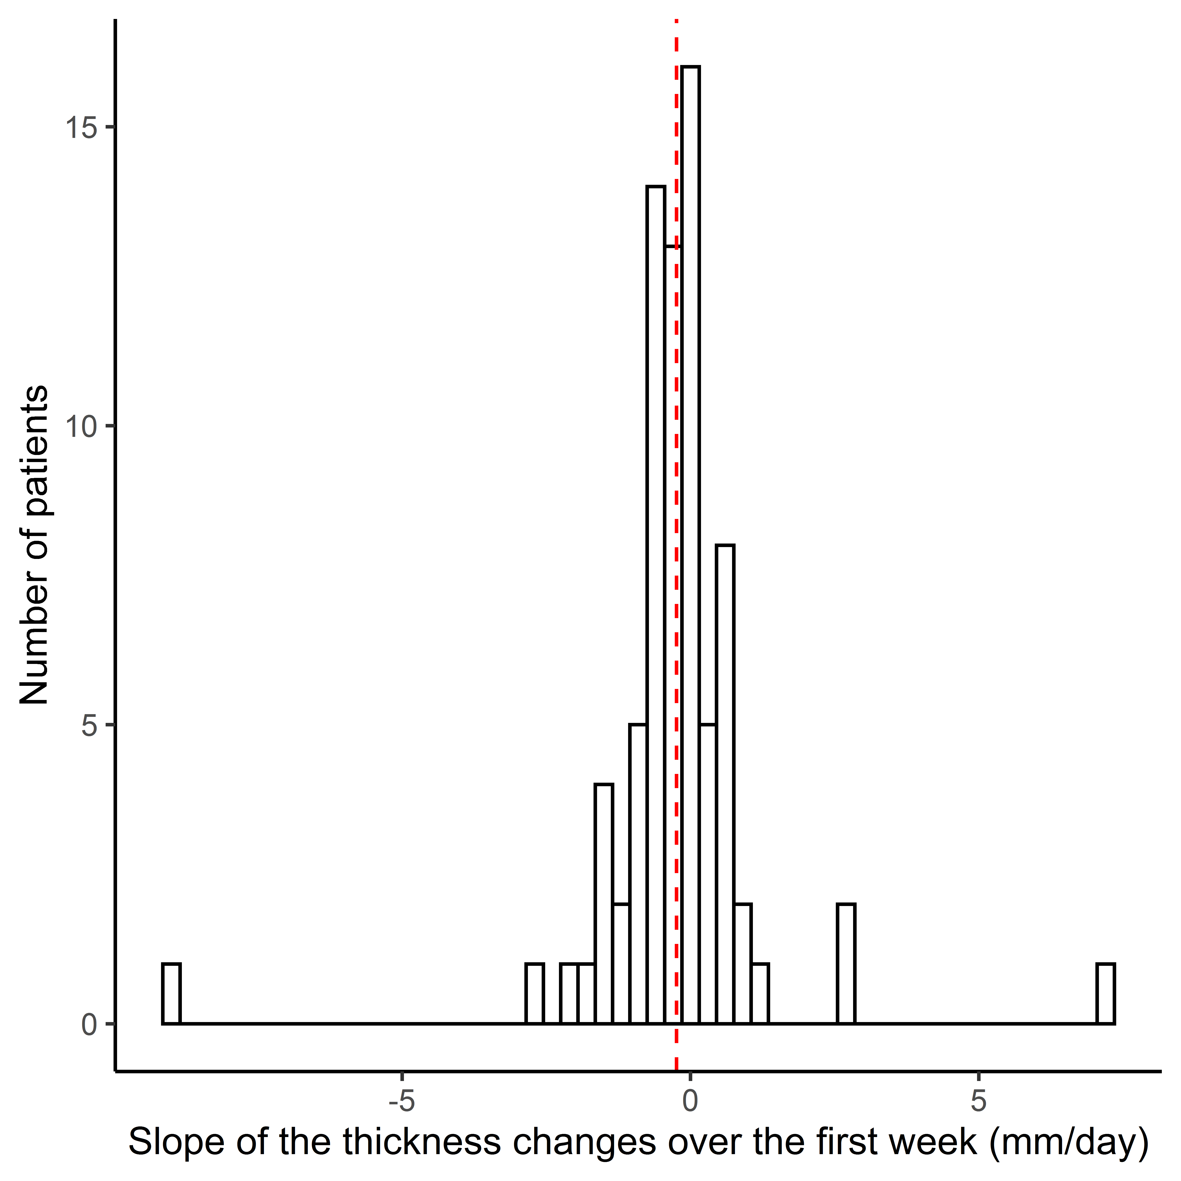
Figure E6. Distribution of the average change in expiratory muscle thickness per day (slope) for each patient in the cohort study. The slope for each patient was calculated using simple linear regression on the individual patient data. The average slope is 0.2 ± 1.6 mm per day. 48/77 (62%) patients had a slope below 0 (meaning they tended to decrease in thickness over time), and 29/77 (38%) patients had a slope above 0 (meaning they tended to increase in thickness over time).

Supplementary tables
Table E1: Sensitivity analysis for comparing the clinical characteristics between subgroups based on different thresholds.
Variables |  | Thresholds
 |  | 10% | 12.5% | 13.5% | 15% | 20%
Number of patients in each group | Stable, n(%) | 39 (50) | 44 (57) | 45 (59) | 51 (66) | 59 (77)
 | Decrease, n(%) | 25 (33) | 22 (29) | 21 (27) | 17 (22) | 13 (17)
 | Increase, n(%) | 13 (17) | 11 (14) | 11 (14) | 9 (12) | 5 (6)
 |  | P-value
Age, year |  | 0.592 | 0.380 | 0.390 | 0.526 | 0.819
Sex, male |  | 0.705 | 0.402 | 0.320 | 0.269 | 0.025
Body mass index, kg/m² |  | 0.528 | 0.633 | 0.573 | 0.742 | 0.689
C-reactive protein, mg/L |  | 0.794 | 0.723 | 0.535 | 0.847 | 0.704
APACHE II score |  | 0.874 | 0.998 | 0.947 | 0.906 | 0.544
Sepsis at admission |  | 0.471 | 0.337 | 0.343 | 0.866 | 0.495
Septic shock at admission |  | 0.311 | 0.328 | 0.359 | 0.411 | 0.529
Indications for mechanical ventilation |  | 0.219 | 0.103 | 0.113 | 0.445 | 0.742
Medical history
COPD |  | 0.827 | 1.000 | 0.997 | 0.866 | 0.678
Hypertension |  | 0.141 | 0.402 | 0.608 | 0.915 | 0.879
Diabetes |  | 0.087 | 0.171 | 0.212 | 0.139 | 0.320
Ventilator settings at baseline
Controlled mode of ventilation, hrs |  | 0.739 | 0.741 | 0.876 | 0.901 | 0.723
PEEP, cmH₂O |  | 0.564 | 0.444 | 0.492 | 0.576 | 0.472
Total respiratory rate, breaths/min |  | 0.123 | 0.278 | 0.155 | 0.191 | 0.132
Driving pressure, cmH₂O |  | 0.948 | 0.86 | 0.925 | 0.654 | 0.567
Tidal volume per kg of IBW, ml/kg IBW |  | 0.222 | 0.312 | 0.165 | 0.342 | 0.093
PaO2/FiO2 ratio |  | 0.734 | 0.377 | 0.356 | 0.383 | 0.693
Ventilator settings over the first week
Controlled mode of ventilation, hrs |  | 0.408 | 0.157 | 0.167 | 0.316 | 0.567
PEEP, cmH₂O |  | 0.891 | 0.778 | 0.755 | 0.683 | 0.871
Total respiratory rate, breaths/min |  | 0.156 | 0.138 | 0.145 | 0.079 | 0.098
Driving pressure, cmH₂O |  | 0.642 | 0.366 | 0.483 | 0.129 | 0.274
Tidal volume per kg of IBW, ml/kg IBW |  | 0.522 | 0.331 | 0.285 | 0.320 | 0.260
PaO2/FO2 ratio |  | 0.563 | 0.382 | 0.46 | 0.225 | 0.534
Medical treatment over the first week
Neuromuscular blockers |  | 0.586 | 0.837 | 0.892 | 0.900 | 0.434
Corticosteroids |  | 0.563 | 0.388 | 0.597 | 0.892 | 0.852
Opioids |  | 0.326 | 0.172 | 0.194 | 0.363 | 0.664
Vassopressors |  | 0.399 | 0.31 | 0.278 | 0.762 | 0.690
Sedatives |  | 0.710 | 0.771 | 0.769 | 0.762 | 0.690
Fluid balance, ml |  | 0.716 | 0.823 | 0.958 | 0.814 | 0.934
* The driving pressure applied by the ventilator was defined as peak pressure minus PEEP, both for controlled and partially assisted modes of ventilation. Data are expressed as p-value when comparing the groups based on different thresholds using either ANOVA for normally-distributed parameters, Kruskal-Wallis test for non-parametric parameters, and chi-square for test for categorical variables. Missing data ranged from 2.6% to 6.5% depending on the variable, the mean was imputed for these cases. Explanation of abbreviations: APACHE II, Acute Physiology And Chronic Health Evaluation II; COPD, Chronic Obstructive Pulmonary Disease; PEEP Positive end-expiratory pressure; IBW, Idea Body Weight.

Table E2. Comparison of clinical outcomes between subgroups based on different thresholds.
Variables | Thresholds
 | 10% | 12.5% | 13.5% | 15% | 20%
 | P value
Mechanical ventilation, hours | 0.016¹ | 0.038² | 0.071 | 0.369 | 0.812
Ventilator free days (28 days) | 0.072 | 0.384 | 0.508 | 0.569 | 0.511
Tracheostomy | 0.330 | 0.428 | 0.332 | 0.281 | 0.588
Reconnected to mechanical ventilation < 7 days after extubation | 0.670 | 0.514 | 0.511 | 0.783 | 0.376
Length of ICU stay, days | 0.068 | 0.093 | 0.161 | 0.513 | 0.807
Length of hospital stay, days | 0.567 | 0.481 | 0.550 | 0.985 | 0.908
ICU mortality, n(%) | 0.214 | 0.723 | 0.862 | 0.747 | 0.545
Hospital mortality, n (%) | 0.131 | 0.514 | 0.638 | 0.470 | 0.154
^{1, 2,}Patients in the “decrease”-group received significantly more hours of mechanical ventilation compared with patients in the “no change”-group when assessed in post-hoc tests. Data are expressed as p-value obtained when comparing the groups based on different thresholds using either ANOVA for normally-distributed parameters, Kruskal-Wallis test for non-parametric parameters, and chi-square for test for categorical variables. There were no missing data.

Table E3. The thickness of the respiratory muscles thickness (mm) over the first week of mechanical ventilation
Group | Muscles | Day of study
 |  | 1 | 2 | 3 | 4 | 5 | 6 | 7
No change  (n = 51) | Expiratory muscles | 13.2 ± 3.9 | 13.7 ± 4.9 | 13.1 ± 3.2 | 14.5 ± 5.2 | 11.6 ± 5.5 | 11.6 ± 3.7 | 13.1 ± 3.5
 | External oblique | 3.4 ± 1.2 | 3.6 ± 1.6 | 3.5 ± 1.2 | 3.9 ± 1.9 | 3.3 ± 2.3 | 2.9 ± 0.9 | 3.4 ± 1.3
 | Internal oblique | 4.5 ± 1.9 | 4.9 ± 2.3 | 4.5 ± 1.7 | 5.2 ± 2.7 | 3.6 ± 2.2 | 4.4 ± 2.4 | 4.6 ± 2.2
 | Transversus abdominis | 2.9 ± 1.0 | 2.8 ± 0.9 | 2.6 ± 0.7* | 2.7 ± 0.8 | 2.4 ± 0.7 | 2.2 ± 0.7 | 2.7 ± 0.9*
 | Rectus abdominis | 8.0 ± 2.6 | 8.0 ± 2.8 | 8.1 ± 2.8 | 8.42 ± 3.27 | 7.9 ± 3.4 | 7.4 ± 2.2 | 7.9 ± 2.8*
 | Diaphragm | 1.5 ± 0.6 | 1.6 ± 0.5 | 1.6 ± 0.5 | 1.46 ± 0.46 | 1.4 ± 0.2 | 1.4 ± 0.5 | 1.5 ± 0.3
Decrease  (n = 17) | Expiratory muscles | 15.7 ± 4.3 | 13.9 ± 4.2* | 13.1 ± 3.5* | 12.7 ± 3.6# | 12.0 ± 5.0# | 7.0 | 11.6 ± 4.5#
 | External oblique | 3.8 ± 1.7 | 3.6 ± 1.5 | 3.6 ± 1.6 | 3.1 ± 1.2 | 3.4 ± 2.0 | 1.9 | 3.1 ± 1.5
 | Internal oblique | 5.7 ± 2.1 | 5.2 ± 2.1 | 4.5 ± 1.3* | 4.6 ± 1.5# | 4.0 ± 2.0# | 2.8 | 4.1 ± 2.0#
 | Transversus abdominis | 3.4 ± 1.3 | 2.8 ± 1.1* | 2.7 ± 1.0* | 2.7 ± 1.2# | 2.6 ± 1.3* | 1.2 | 2.5 ± 1.3*
 | Rectus abdominis | 8.1 ± 2.6 | 8.0 ± 3.2 | 8.1 ± 2.9 | 8.2 ± 3.2 | 8.4 ± 4.3 | 4.3 | 6.7 ± 2.9
 | Diaphragm | 1.5 ± 0.6 | 1.4 ± 0.3 | 1.3 ± 0.2 | 1.6 ± 0.3 | 1.5 ± 0.3 | 1.1 | 1.3 ± 0.1
Increase  (n = 9) | Expiratory muscles | 13.7 ± 7.4 | 18.1 ± 10.5* | 13.5 ± 2.5 | 12.7 ± 3.2 | 16.1 ± 8.2 | __ | 13.9 ± 6.9*
 | External oblique | 3.7 ± 1.7 | 5.0 ± 2.2* | 3.7 ± 0.4 | 3.8 ± 1.4 | 4.1 ± 2.7 | __ | 3.9 ± 2.1
 | Internal oblique | 5.4 ± 3.7 | 6.8 ± 4.8 | 4.3 ± 1.6 | 4.3 ± 1.4 | 6.9 ± 2.9 | __ | 5.4 ± 3.1
 | Transversus abdominis | 3.0 ± 1.2 | 3.4 ± 2.0 | 3.4 ± 0.7 | 2.7 ± 0.8 | 3.2 ± 2.2 | __ | 2.7 ± 1.3
 | Rectus abdominis | 7.8 ± 3.2 | 9.6 ± 3.1 | 8.2 ± 2.6 | 8.3 ± 4.0 | 8.3 ± 7.5 | __ | 7.4 ± 6.9
 | Diaphragm | 1.8 ± 0.6 | 2.0 ± 0.6 | 1.5 ± 0.1 | 1.8 ± 0.5 | 1.8 ± 0.7 | __ | 1.5 ± 0.6*
Note: compared to the thickness on the first day (baseline thickness). * P < .05 # P < .001. The data are presented as mean and standard deviation. Significance was analyzed by linear mixed model using subject as random factor baseline thickness as covariate and day of study and group as fixed factor. At the 7th day of study, there were 3 patients in the increase group, 8 patients in the decrease group, and 15 patients left the stable group. At day 6, one measurement was obtained in the decrease group and no measurements were obtained in the increase group.

Table E4. Associations between slope of expiratory muscle thickness and risk factors.
Risk factor | p-value
Age, year | 0.652
Gender, male | 0.503
Body mass index, kg/m² | 0.574
APACHE II | 0.952
Indication of mechanical ventilation | 0.586
Airway driving pressure at inclusion | 0.117
PEEP at inclusion | 0.273
Cumulative dose of corticosteroids before inclusion | 0.618
Cumulative dose of rocuronium before inclusion | 0.554
Cumulative dose of sedatives before inclusion | 0.202
Age, BMI, APACHE II, Airway driving pressure, PEEP, and doses of medication were coded as continuous variables. Gender and indication of mechanical ventilation were coded as categorical variables. APACHE II Acute Physiology And Chronic Health Evaluation II, PEEP Positive end-expiratory pressure.

Table E5. Relationship between slope of expiratory muscle thickness and patients outcomes.
Outcome | 0.1mm per day increase in slope |  | p-value
 | OR/beta* | 95% CI
ICU mortality | 1.10 | [0.81, 1.49] | 0.560
In-hospital mortality | 1.11 | [0.81, 1.51] | 0.519
Tracheostomy | 0.99 | [0.64, 1.54] | 0.967
R eintubation | 0.95 | [0.65, 1.40] | 0.811
Ventilator-free days at 28 days¹ |  |  | 0.767²
▪ equal to or below 21 days | 0.94 | [0.62, 1.40] | 0.746
▪ above 21 days | 0.88 | [0.63, 1.26] | 0.490
ICU length-of-stay (log-transformed) | -0.026* | [-0.082, 0.30] | 0.352
Hospital length-of-stay (log-transformed) | -0.077* | [-0.14, -0.016] | 0.014
¹ Treated as categorical variable, because for many patients this variable was either 0 or 28. Analyzed using multinominal logistic regression with ventilator-free days at day 28 of 0 days as reference category; ²overall p-value for association between slope and Ventilator-free days categories. Odds ratios (OR) for relationship between slope and categorical outcomes. Regression coefficients (beta) for relationship between slope and log-transformed continuous outcomes.

References
1. Bland JM, Altman DG, (1999) Measuring agreement in method comparison studies. Stat Methods Med Res 8: 135-160

