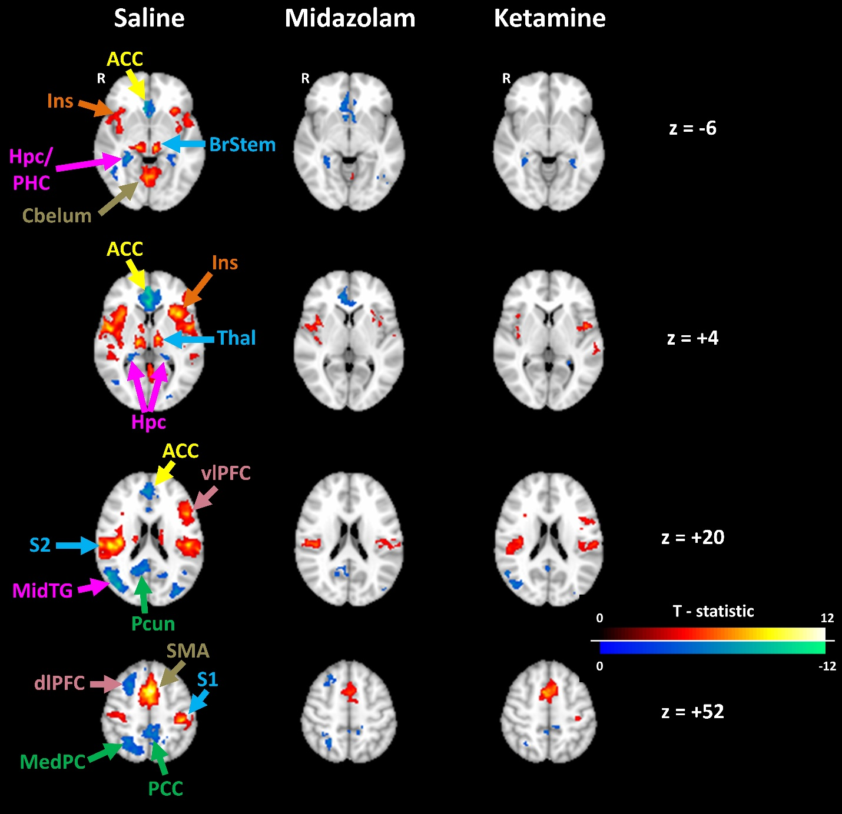Figure, Supplemental Digital Content 9: Group average fMRI activation for experimental items paired with painful stimulation under saline and drug conditions. Clusters are thresholded for significance in all columns, as described in the methods section. The Montreal Neurologic Institute standard space brain was used as the underlay, with axial slices locations listed. Labels for anatomic regions of interest are color-coded based on predominant functional organization: memory encoding in purple (Hpc= hippocampus, PHC= parahippocampus, MidTG= middle temporal gyrus), fear response areas in yellow (ACC= anterior cingulate cortex), pain processing areas in orange (Ins= insula), sensory processing in blue (BrStem= Brain Stem, Thal= thalamus, S2 & S1 = secondary & primary (respectively) somatosensory cortices), parietal areas (including default-mode network structures) in green (Pcun= precuneus, PCC= posterior cingulate cortex, MedPC= medial parietal cortex), prefrontal cortex (PFC) in pink (vlPFC= ventrolateral PFC, dlPFC= dorsolateral PFC), and motor areas are in olive (Cbelum= cerebellum, SMA= supplementary motor area)

