Supplemental Digital Content
Computational model of ripples
The hippocampal cornu ammonis 1 (CA1) computational model includes 800 pyramidal neurons and 160 interneurons. ¹ All-to-all connectivity pattern between each neuron (all pyramidal neurons and interneurons included in this model) was used in this model. To model each neuron, this model was based on the Adaptive Exponential Integrate-and-Fire model because it is simple and controllable variables and has been proven to reproduce many different spiking behaviors. ² Each neuron in this model received a mean direct current and a different independent Ornstein-Uhlenbeck noise to set neuronal baseline excitability to account for heterogeneity. The noise represents the in vivo state of the voltage in each neuron. The Ornstein-Uhlenbeck noise was used to model a white noise in order to mimic in vivo state in hippocampal slice electrophysiological recordings. Fast time scales were assigned to the synapses, it was consistent with in vitro estimates. The integrated input currents from hippocampal cornu ammonis 3 (CA3) were delivered to all neurons with different magnitudes for pyramidal neurons and interneurons.
For each neuron, default parameter values are as follows. For pyramidal neurons: C = 200 pF; g_{L} = 10 nS; E_{L} = -58 mV; a = 2; b = 100 pA; Δ_{T} = 2 mV; T_{w} =120 ms; V_{t} = −50 mV; V_{r} = −46 mV, V_{thr} = 0 mV. For fast spiking inhibitory interneurons: C = 200 pF; g_{L} = 10 nS; E_{L} = −70 mV; a = 2; b = 10 pA; Δ_{T} = 2 mV; T_{w} = 30 ms; V_{t} = −50 mV; V_{r} = -58 mV. Interpretation of parameter: C is membrane capacitance; g_{L} is leak conductance; E_{L} is leak reversal potential; a is subthreshold adaptation and represent the level of subthreshold adaptation; b is spike-triggered adaptation; Δ_{T} is slope factor; T_{w} is adaptation time constant, at each firing time, the variable w is increased by an amount b, which accounts for spike-triggered adaptation; V_{t} is spike threshold. Equations and algorithm of the model has been described previously in detail. ^{1, 2}
In this study, we found adaptation parameters including E_{L} (leak reversal potential), b (spike-triggered adaption) and T_{w} (adaptation time constant) were critical for neuronal firing rate. Simulated effects of isoflurane on ripples were conducted by adjusting the parameters according to the electrophysiological effects of isoflurane on action potentials frequency of pyramidal neurons and interneurons from cornu ammonis 1.

The simulation based on recordings of neonatal mice slices
Based on the electrophysiological recording results of neonatal mice, isoflurane at 0.5% increased action potentials frequency by 20% ± 2% in pyramidal neurons and reduced action potentials frequency by 30% ± 5% in fast-spiking interneurons (Supplemental Figure 2B and 2D). The neuronal parameters of pyramidal neurons and/or fast-spiking interneurons under ~0.5% isoflurane condition was set to change action potentials frequency (Supplemental Figure 3A and 3B) according to our recordings in acute neonatal mice brain slices as: E_{L} = −57 mV; b = 105 pA; T_{w} = 114 ms for pyramidal neurons and E_{L} = −70 mV; b = 8.1 pA; T_{w} = 35.7 ms for fast-spiking interneurons. The simulated results indicated that isoflurane increased firing of pyramidal neurons by ~20% and suppressed firing of interneurons by ~30% (Supplemental Figure 3A and 3B), consistent with our data that isoflurane at 0.5% increased action potential frequency of pyramidal neurons and decreased action potentials frequency of fast-spiking interneurons. A representative simulated ripple is shown in Supplemental Figure 3C and 3D. Ripple amplitude decreased from 46.5 ± 6.1 to 42.9 ± 7.4 μV (P = 0.002, Supplemental Figure 3E), and ripple duration decreased from 41.5 ± 7.0 to 28.8 ± 11.2 ms (P < 0.001, Supplemental Figure 3F); while ripple frequency increased from 176 ± 16 to 185 ± 17 Hz (P < 0.001, Supplemental Figure 3G) and inter-arrival time between ripples increased from 177.5 ± 6.8 to 191.0 ± 11.0 ms (P < 0.001, Supplemental Figure 3H). A total of 76 ripple events were included in the analysis of a 20-s simulation. The simulated effects of isoflurane on hippocampal cornu ammonis 1 ripples were comparable to the recordings of local field potentials in vivo (Supplemental Figure 3I, 3J, 3K and 3L).

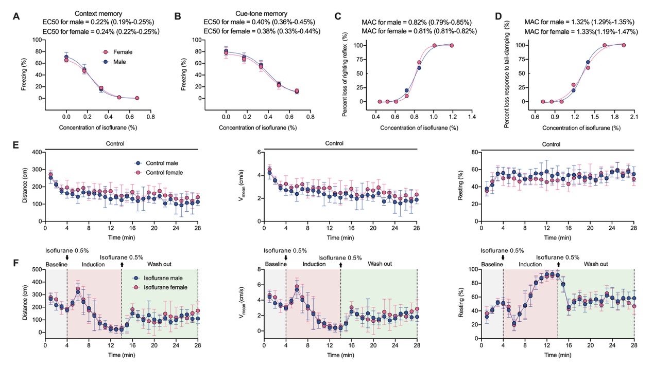 Supplemental Figure 1. Sex differences of isoflurane effects on memory and overall behaviors in vivo.
Concentrations-response curves of isoflurane for suppressing fear-conditioning memory to context (A) and cue-tone (B), respectively (n = 14/group; 7/7 males/females). EC50 for inhibition of context memory was 0.22% (0.19% to 0.25%) for male mice; and 0.24% (0.22% to 0.25%) for female mice (P = 0.147). EC50 for inhibition of cue-tone memory was 0.40% (0.36% to 0.45%) for male mice; and 0.38% (0.33% to 0.44%) for female mice (P = 0.561). Concentrations-response curves of isoflurane that inducing loss of righting reflex (C) and loss response to tail-clamping (D) in mice (n = 20, 10/10 males/females). MAC of isoflurane that inducing loss of righting reflex was 0.82% (0.79% to 0.85%) for male mice; and 0.81% (0.81% to 0.82%) for female mice (P = 0.086). MAC of isoflurane for loss of response to tail-clamping was 1.32% (1.29% to 1.35%) for male mice; and 1.33% (1.19% to 1.47%) for female mice (P = 0.666). The time-course of travel distance, mean speed and percentage of resting time between male mice and female mice for control condition (E) and 0.5% isoflurane (F) (n = 14/group; 7/7 males/females). The concentration-response curves were fitted by sigmoidal dose-response model with a four-parameter logistic in nonlinear regression (A, B, C and D). Sex differences were analyzed by extra sum-of-squares F test (A, B, C and D). Data are presented as EC50 (95% confidence interval) (A, B, C and D) or mean and SD (E and F). *P < 0.05, **P < 0.01, ***P < 0.001 by a two-way repeated-measures ANOVA followed by the Bonferroni post-hoc multiple comparison test (E and F).

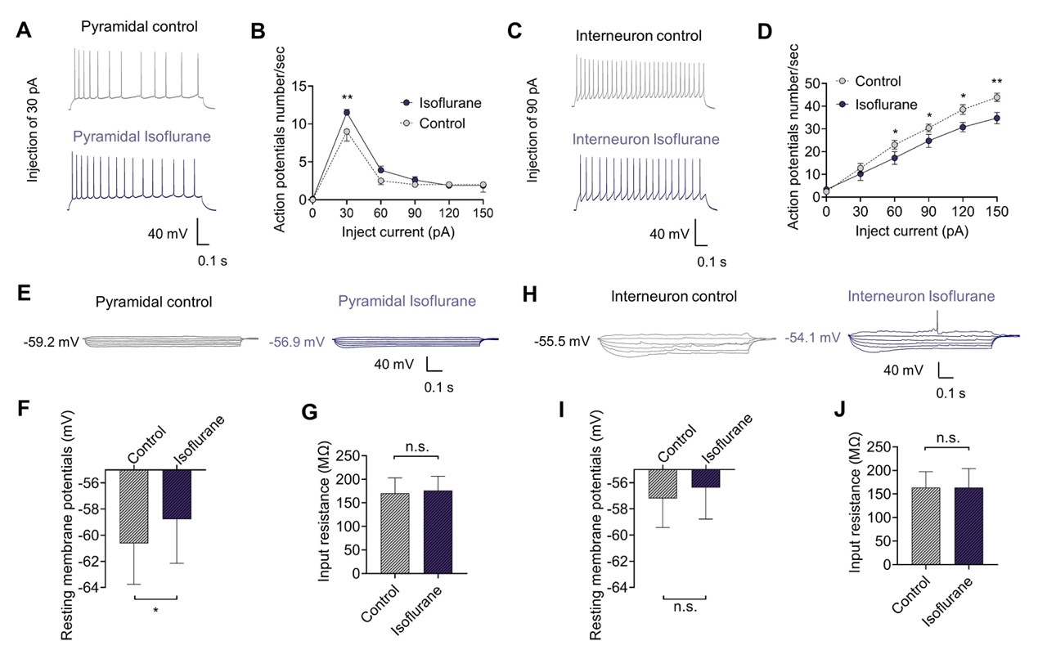
Supplemental Figure 2. Isoflurane differentially regulates action potential firing of pyramidal neurons and fast-spiking interneurons in neonatal mice.
Frequency of action potentials in fast-spiking interneurons was much higher than that of pyramidal neurons with the same current injection. The effect of 0.12-0.15 mM (~0.43-0.53 MAC, 25°C) solution isoflurane on the neuronal excitability of pyramidal neurons and fast-spiking interneurons was evaluated in the hippocampal cornu ammonis 1 region of acute brain slices. For pyramidal neurons, isoflurane increased action potentials frequency from 8.6 ± 0.4 Hz to 11.5 ± 0.4 Hz (A and B, P < 0.001, n = 15) when injecting 30 pA current for 1000 ms. For fast-spiking interneurons, isoflurane decreased action potentials frequency when injecting 60- to 150-pA currents for 1000 ms (C and D, P < 0.001, n = 15). Isoflurane (0.12-0.15 mM) depolarized the resting membrane potential from −60.6 ± 1.1 mV to −58.8 ± 1.2 mV in pyramidal neurons (E and F, P = 0.027, n = 10), but not in fast-spiking interneurons (H and I). Isoflurane produced no effect on neuronal input resistance of pyramidal neurons (G) and fast-spiking interneurons (J). Data are presented as mean ± SD. *P < 0.05, **P < 0.01 by two-way repeated-measures ANOVA (B and D) or a two-tailed paired t-test (F, G, I and J) (n = 15; 7/8 males/females).

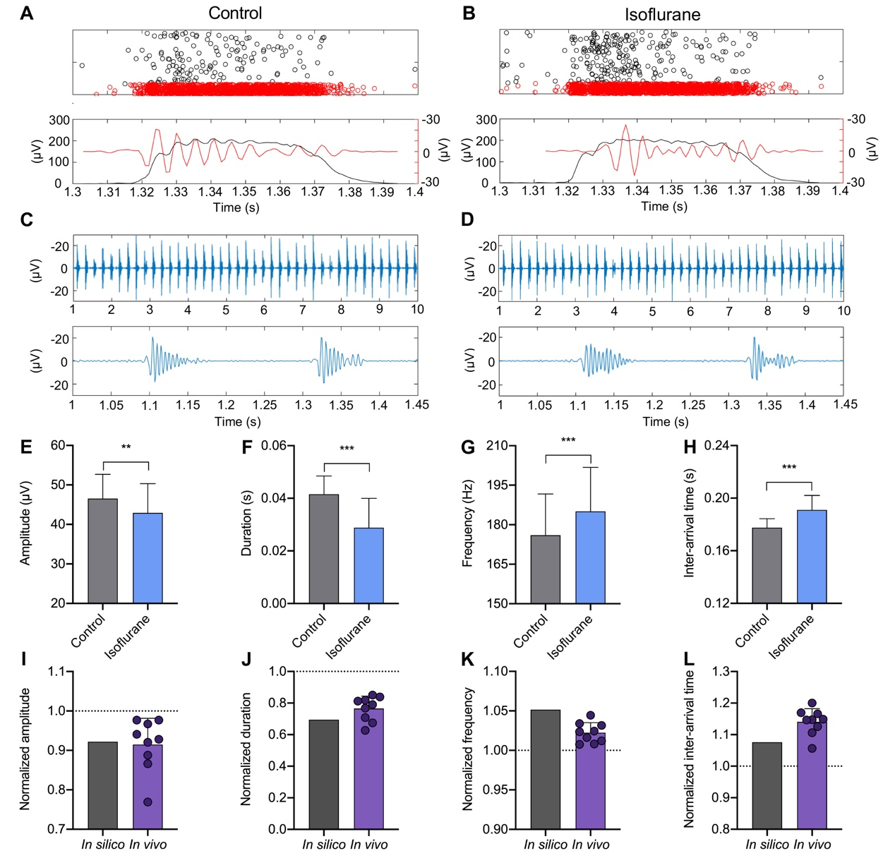
Supplemental Figure 3. Computational model of hippocampal cornu ammonis 1 ripples based on spike firing of pyramidal neurons and fast-spiking interneurons in neonatal mice.
Rastergram of pyramidal neuron (black) and interneuron (red) spikes during a ripple and cornu ammonis 3 input for control (A, upper) and isoflurane at 0.5% (B, upper). Raw (black) and ripple (red) local field potentials (filtered 100 to 300 Hz) in the network for control (A, lower) and isoflurane at 0.5% (B, lower). Representative simulated traces of ripples with a duration of 10 s (upper) and amplification of two ripple events (lower) for control (C) and isoflurane at 0.5% (D). Isoflurane at 0.5 % decreases ripple amplitude (E) and duration (F), and increases frequency (G) and inter-arrival time (H) (A total of 76 ripple events were included in the analysis of a 20 s simulation.). Normalized effects of isoflurane on ripples in silico are similar to the effects seen on local field potentials recordings in vivo, including amplitude (I), duration (J), frequency (K) and inter-arrival time (L). The effects of isoflurane used in the simulation model are based on the results of patch clamp recordings in acute brain slices. Data are presented as mean and SD. *P < 0.05, **P < 0.01, ***P < 0.001 by a two-tailed paired t-test.

References
1. Malerba P, Krishnan GP, Fellous J-M, Bazhenov M: Hippocampal CA1 Ripples as Inhibitory Transients. PLoS Comput Biol 2016; 12:e1004880
2. Brette R, Gerstner W: Adaptive exponential integrate-and-fire model as an effective description of neuronal activity. J Neurophysiol 2005; 94:3637–42

