SUPPLEMENTAL MATERIAL

Description of synchronization of monitoring devices – technical aspects
Crucial to this study was the synchronization of the two monitors without compromising their unique functions. Since the investigators had access to the TetragraphTM software but not to that of the TOF-Watch SX^{R}, the authors decided that the synchronizing source would be the stimulating current delivered by the TOF-Watch SX^{R}.
Evoked EMG signals are known to be sensitive to stimulus artefact⁴⁶ and the TetraGraphTM is designed to minimize this artefact; however, the remnant has to be processed carefully to determine the peak-peak EMG amplitude. To ensure that the artefact is not significantly different from that sensed by the EMG device in normal use, it was important not to increase the capacitive coupling between the stimulus electrodes, EMG circuitry and ground. To achieve this, an optical fiber coupling was chosen to carry a synchronizing signal from the AMG stimulus connections to those of the EMG device (Figure 1).
The optical transmitter uses three silicon diodes in series, connected to the negative driving electrode lead of the AMG device. These diodes have enough forward voltage drop to provide the current for a light emitting diode (LED) in series with a current limiting resistor. This configuration diverts 2 V of the 300 V available for the stimulation constant current, with the benefit that the current diverted to the LED is fed back into the electrode lead such that the stimulation current is unaffected.
A length of one meter of polymer optical fiber connected the transmitter LED to the optical receiver. The receiver is battery powered and connected by a short lead to the RS232 port of the EMG device. The polarity of the pulse at the RS232 port was designed to simulate a character arriving at the port. This arrangement simplified the software changes required of the EMG device and allowed the serial port to be used for uploading the recorded data postoperatively without having to reinstall the production software.

Software Changes to TetraGraphTM
- The software of the EMG device was modified to identify the character arriving at the serial port and initiate the EMG measurement events as if the process had been triggered internally.
- The stimulation capability was disabled.
- The EMG device software has a delay between the stimulus being enabled and the EMG circuitry digitizing the EMG signal. This delay was reduced to account for the synchronization delays so that the interval between the TOF-Watch SX^{R} stimulus and the TetragraphTM EMG digitizing was the same as when the stimulus was generated internally to the Tetragraph.
- The EMG device automatically distinguishes between TOF measurements and ST measurements (and post tetanic ST measurements) by ensuring that T1 of a TOF measurement was preceded by at least 5 s without a stimulus and a second single twitch in a train (T2) occurred within 0.75 s of T1. This arrangement also allows post tetanic count ST responses at 1 s intervals to be counted without reference to the tetanic stimulation.

Formulae used for sample size estimation
To estimate the sample size necessary to detect a 10% difference (5% higher or lower) in repeatability coefficients, we used the following formula:

$\frac{{1.96}^{2} × {\hat{σ}}_{w}}{\sqrt{n}} =0.05$,

where ${\hat{σ}}_{w}$ was estimated as the square root of the residual mean square from a one-way ANOVA on consecutive TOF ratios both for EMG (${\hat{σ}}_{w}$ = 0.190) and AMG (${\hat{σ}}_{w}$ = 0.207). This resulted in 213 and 253 comparisons based on EMG and AMG, respectively.

To estimate the sample size necessary to detect a 10% difference in bias, we used the following formula:

$\frac{1.96 × {\hat{σ}}_{D}}{\sqrt{n}} =0.05$,

where $\hat{σ}$_{D} was estimated as

${\hat{σ}}_{D}^{2}={\hat{σ}}_{\overline{D}}^{2}+ \frac{{\hat{σ}}_{w_{EMG}}^{2}}{2}+ \frac{{\hat{σ}}_{w_{AMG}}^{2}}{2}$,

where ${\hat{σ}}_{\overline{D}}^{2}$ was the variance of all the EMG minus AMG differences, and ${\hat{σ}}_{w_{EMG}}^{2}$ and ${\hat{σ}}_{w_{AMG}}^{2}$ were the within-subject variance in the EMG and AMG groups, respectively.

Finally, to estimate the sample size necessary to detect a 10% difference in limits of agreement (±5%), we used the formula:

$\frac{1.96 × \sqrt{3} × {\hat{σ}}_{D}}{\sqrt{n}} =0.05$,

where ${\hat{σ}}_{D}$ was as above. This formula resulted in a required sample size of 293 comparisons.

Supplemental Results

Primary endpoint based on non-normalized (raw) data
The Bland-Altman analysis of non-normalized, original data showed a bias of 9.3 (± SE 1.06%) between EMG and AMG with limits of agreement between -7.0 and 25.6 when the AMG reading was at or above 80% (Supplemental Table S1). The bias was slightly lower (7.8 ± 1.068) when the EMG reading was at or above 80% (Supplemental Table S1). The positive bias showed that the AMG monitor suggested recovery earlier than EMG. Repeatability was higher for AMG than for EMG when the AMG reading was ≥80% (repeatability coefficients: 7.0 vs. 8.4, respectively, Supplemental Table S1), likely because of the higher number of measurements in the ≥80% range for AMG than for EMG (see also main text). However, repeatability was higher for EMG (4.8) than for AMG (5.5) when the EMG reading was ≥80% (Supplemental Table S1).

Changes in agreement in different TOFR ranges
The bias and the limits of agreement showed variability in the TOFR ranges (Supplemental Table S3 for normalized and Supplemental Table S4 for non-normalized data). A negative bias indicated that measurements were slightly biased towards EMG in the lowest TOFR range, not biased (normalized data) or slightly biased towards AMG (non-normalized data) in TOFR range 20% to 39%, and biased towards AMG in TOFR ranges higher than 40% (Supplemental Tables S3-S4). The limits of agreement became gradually wider as TOFR range increased based on normalized data (Supplemental Table S3), whereas they widened and shifted from more negative to more positive as TOFR range increased based on non-normalized data (Supplemental Table S4). The Bland-Altman plots of recovery TOFRs based on the entire data set and different TOFR ranges confirmed these patterns (Supplemental Figures S3 and S4).

Supplemental Tables

Supplemental Table S1. Results of Bland-Altman analysis of the primary endpoint (TOFR ≥80%) based on non-normalized, raw data. TOFR = train-of-four ratio; CI = confidence interval; SE = standard error; LoA = Limits of Agreement; BSV = between-subjects variance; AMG = acceleromyography; EMG = electromyography.

TOFR ≥80% by | Variable | Value
AMG | Bias ± SE | 9.3 ± 1.1
(N = 2929) | 95% CI of the bias | 7.2 to 11.5
 | SD of the differences ± SE | 8.4 ± 0.6
 | LoA | -7.0 to 25.7
 | 95% CI lower LoA | -10.8 to -4.2
 | 95% CI upper LoA | 22.8 to 29.5
 | Within-subject variance ± SE | 20.7 ± 0.5
 | Between-subjects variance ± SE | 48.9 ± 10.7
 | Spearman's ρ ± SE | -0.1 ± 0.1
 | Ratio of BSV and total variance ± SE | 0.7 ± 0.0
 | Repeatability AMG | 7.0 (95% CI 6.8 to 7.2)
 | Repeatability EMG | 8.4 (95% CI 8.2 to 8.64)
 | Repeatability AMG/EMG | 0.8 (95% CI 0.8 to 0.8)
EMG | Bias ± SE | 7.8 ± 1.07
(N = 2284) | 95% CI of the bias | 5.7 to 10.0
 | SD of the differences ± SE | 8.1 ± 0.7
 | LoA | -8.0 to 23.7
 | 95% CI lower LoA | -11.94 to -5.1
 | 95% CI upper LoA | 20.8 to 27.6
 | Within-subject variance ± SE | 17.3 ± 0.5
 | Between-subjects variance ± SE | 48.3 ± 10.7
 | Spearman's ρ ± SE | 0.42 ± 0.1
 | Ratio of BSV and total variance ± SE | 0.7 ± 0.0
 | Repeatability AMG | 5.5 (95% CI 5.4 to 5.7)
 | Repeatability EMG | 4.8 (95% CI 4.7 to 4.9)
 | Repeatability AMG/EMG | 1.2 (95% CI 1.2 to 1.2)

Supplemental Table S2. Results of Bland-Altman analysis of the secondary endpoint (TOFR <80%) based on non-normalized, original data. TOFR = train-of-four ratio; CI = confidence interval; SE = standard error; LoA = Limits of Agreement; BSV = between-subjects variance; AMG = acceleromyography; EMG = electromyography.

TOFR <80% by | Variable | Value
AMG | Bias ± SE | 6.0 ± 1.3
(N = 2802) | 95% CI of the bias | 3.4 to 8.5
 | SD of the differences ± SE | 10.2 ± 0.8
 | LoA | -14.1 to 26.0
 | 95% CI lower LoA | -18.5 to -10.7
 | 95% CI upper LoA | 22.6 to 30.5
 | Within-subject variance ± SE | 30.0 ± 0.8
 | Between-subjects variance ± SE | 74.4 ± 15.5
 | Spearman's ρ ± SE | 0.4 ± 0.1
 | Ratio of BSV and total variance ± SE | 0.7 ± 0.0
 | Repeatability AMG | 17.9 (95% CI: 17.5 to 18.4)
 | Repeatability EMG | 16.1 (95% CI: 15.7 to 16.6)
 | Repeatability AMG/EMG | 1.1 (95% CI: 1.1 to 1.1)
EMG | Bias ± SE | 7.1 ± 1.2
(N = 3447) | 95% CI of the bias | 4.6 to 9.6
 | SD of the differences ± SE | 10.3 ± 0.7
 | LoA | -13.0 to 27.2
 | 95% CI lower LoA | -17.4 to -9.7
 | 95% CI upper LoA | 23.9 to 31.6
 | Within-subject variance ± SE | 32.5 ± 0.8
 | Between-subjects variance ± SE | 72.8 ± 15.1
 | Spearman's ρ ± SE | 0.6 ± 0.0
 | Ratio of BSV and total variance ± SE | 0.7 ± 0.0
 | Repeatability AMG | 20.6 (95% CI: 20.1 to 21.1)
 | Repeatability EMG | 17.7 (95% CI: 17.3 to 18.1)
 | Repeatability AMG/EMG | 1.2 (95% CI: 1.2 to 1.2)

Supplemental Table S3. Results of Bland-Altman analyses comparing the agreement between AMG and EMG measurement of train-of-four ratios (TOFRs) based on normalized data in different TOFR ranges (Bland-Altman plots are in Supplemental Figure S3). CI = confidence interval; N = number of measurements; SE = standard error.

 |  |  |  | Limits of  Agreement | 95% CI for Limits of Agreement
TOFR range | N | Bias ± SE | 95% CI of bias |  | Lower | Upper
≥80% | 2929 | 1.3 ± 1.0 | –0.6 to 3.3 | –14.0 to 16.6 | –17.3 to –11.5 | 14.1 to 20.0
60-79% | 913 | 4.1 ± 1.4 | 1.4 to 6.8 | –15.9 to 24.0 | –20.9 to –12.1 | 20.2 to 29.0
40-59% | 749 | 2.3 ± 1.2 | 0.0 to 4.6 | –14.9 to 19.5 | –19.2 to –11.7 | 16.3 to 23.8
20-39% | 824 | –0.4 ± 0.8 | –2.0 to 1.3 | –12.4 to 11.7 | –15.4 to –10.2 | 9.5 to 14.6
<20% | 316 | –4.7 ± 0.5 | –5.7 to –3.6 | –10.6 to 1.2 | –12.5 to –9.3 | –0.1 to 3.2
All data | 5731 | 1.2 ± 0.9 | –0.5 to 2.9 | –15.0 to 17.4 | –17.8 to –12.9 | 15.3 to 20.2

Supplemental Table S4. Results of Bland-Altman analyses comparing the agreement between AMG and EMG measurement of train-of-four ratios (TOFRs) based on non-normalized, original data in different TOFR ranges (Bland-Altman plots are in Supplemental Figure S4). CI = confidence interval, N = number of measurements, SE = standard error.

 |  |  |  | Limits of agreement | 95% CI for Limits of Agreement
TOFR range | N | Bias ± SE | 95% CI of bias |  | Lower | Upper
≥80% | 2929 | 9.3 ± 1.1 | 7.2 to 11.5 | -7.0 to 25.7 | -10.8 to -4.2 | 22.8 to 29.5
60-79% | 913 | 9.6 ± 1.4 | 6.7 to 12.4 | -11.1 to 30.3 | -16.4 to -7.2 | 26.3 to 35.6
40-59% | 749 | 6.3 ± 1.2 | 3.9 to 8.7 | -11.5 to 24.1 | -16 to -8.2 | 20.8 to 28.6
20-39% | 824 | 2.2 ± 0.8 | 0.5 to 3.9 | -10.4 to 14.8 | -13.5 to -8.1 | 12.5 to 17.9
<20% | 316 | -3.6 ±0.5 | -4.8 to -2.5 | -10.0 to 2.7 | -12.2 to -8.6 | 1.3 to 4.9
All data | 5731 | 7.0 ± 1.1 | 4.8 to 9.1 | –12.0 to 25.9 | –15.6 to –9.2 | 23.2 to 29.6

SUPPLEMENTAL FIGURES

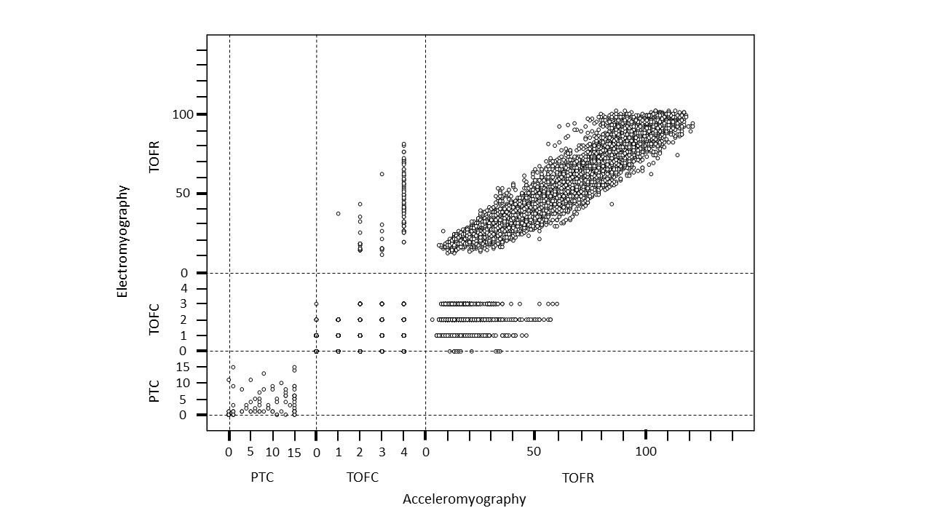
Supplemental Figure S1. Scatterplot of acceleromyography and electromyography-derived post-tetanic count (PTC), train-of-four count (TOFC) and train-of-four ratio (TOFR) data pairs.

Supplemental Figure S2. Bland-Altman plots of the pairwise differences between train-of-four ratios (TOFRs) measured by acceleromyography (AMG) and electromyography (EMG) (Y-axis) against the mean of the two measurements (X-axis) in the range TOFR ≥80% based on the AMG measurement (A) and based on the EMG measurement (B); data are non-normalized, raw data. The center line represents the bias with 95% confidence intervals, and bottom and top lines represent the lower and upper limits of agreement with 95% confidence intervals, respectively. The size of datapoints is proportional to the number of measurements.

Supplemental Figure S3. Bland-Altman plots of the pairwise differences between train-of-four (TOFRs) measured by acceleromyography (AMG) and electromyography (EMG) (Y-axis) against the mean of the two measurements (X-axis), based on normalized data on all measurements (upper left) and in TOFR ranges of 20% based on the AMG measurement. The center line represents the bias with 95% confidence intervals, and bottom and top lines represent the lower and upper limits of agreement with 95% confidence intervals, respectively. The size of datapoints is proportional to the number of measurements.

Supplemental Figure S4. Bland-Altman plots of the pairwise differences between train-of-four ratios (TOFRs) measured by acceleromyography (AMG) and electromyography (EMG) (Y-axis) against the mean of the two measurements (X-axis), based on the non-normalized, raw data on all measurements (upper left) and in TOFR ranges of 20% based on the AMG measurement. The center line represents the bias with 95% confidence intervals, and bottom and top lines represent the lower and upper limits of agreement with 95% confidence intervals, respectively. The size of datapoints is proportional to the number of measurements.

