Supplementary material to the manuscript: “Carbon dioxide clearance during high-flow nasal oxygenation in apneic patients: a single-center randomized controlled noninferiority trial”

Content

Statistical Analysis as outlined in the study protocol 2
Results: Blood gas measurements 3
Non-inferiority 3
Linear trends 7
Results: TCM4 8
Non-inferiority 8
Linear Trends 11
Results: TCM5 12
Non-inferiority 12
Linear Trends 15
Number of patients in each treatment group for each sensitivity analysis 16
Missing values 17
References 19

Statistical Analysis as outlined in the study protocol
As defined in the study protocol (Theiler et al. 2019), the linear increase in PaCO₂ over 15 minutes (mmHg.min⁻¹) for was estimated using a linear mixed effect model. The model includes treatment group and minutes as fixed effects (and their two-way interaction), a random intercept for each patient and an autocorrelation structure of order 1 (AR1) is chosen for the error correlation structure.
For the non-inferiority test, the null hypothesis stated that the difference of mean linear increase of PaCO₂ between any of the four experimental groups and the control group was at least $δ$ = 0.3 mmHg.min⁻¹ (non-inferiority margin). Data from published literature suggested that patients in the control group should have a low linear increase in PaCO₂ of 0.9 mmHg.min⁻¹. A value of 0.3 mmHg.min⁻¹ would result in a total increase of 4.5 mmHg over a 15-minute apnea period. We defined this as clinically acceptable, because the normal range of PaCO₂ is 35.0 – 46.0 mmHg.
To test the non-inferiority hypothesis, a 0.025 $α$-level (one-sided) was used which corresponds to a 2-sided 95% (100 x {1 - 2$α$}) confidence interval (CI). We declared non-inferiority if the upper limit of the 95% CI of the difference in mean linear increase of PaCO₂ was below the pre-defined non-inferiority margin of $δ$ = 0.3 mmHg.min⁻¹. As specified in the study protocol (Theiler et al. 2019), no correction for multiple comparisons was applied. However, the results based on Dunnett’s multiple comparisons adjustment (Dunnett 1955) are provided in the Supplementary Material for completeness.
Three sensitivity tests to assess the robustness and dependence of the declaration of non-inferiority on the underlying blood sample measurements were performed. The reference case is denoted as Raw Data and includes missing blood sample measurements for some patients at varying timepoints. The Complete Data sensitivity test considers only those patients for whom blood sample measurements are available for each timepoint. The sensitivity test denoted as Imputed Data is based on multiple imputation of missing values using the predictive mean matching as imputation method – in total, five imputed datasets based on basic demographic variables (sex, age, height, weight, ASA class) and PaCO$​_{2}$ were computed. A table of missing PaCO$​_{2}$ values is presented in the Supplementary Material. In order to allow for an adjustment period after the induction of apnea, the sensitivity test Complete Data + Adjustment considers only blood sample measurements from the second half of the apnea period (minutes 7 to 15).
To calculate the necessary sample size, a difference in linear group means a PaCO2 of 3 mmHg.min⁻¹ was necessary; assuming a standard deviation of 0.353 mmHg.min⁻¹, 22 patients were required per group (based on a one-sided $α$-value of 0.025 and a power of 80%). We therefore decided to include 25 patients per group. Data are reported as mean ± standard deviation (SD) or as counts and percentages. A P value < 0.05 was considered significant. All statistical analyses were performed with R (R Core Team 2020).

Results: Blood gas measurements

Non-inferiority

Supplementary Figure I.
Corresponding to Figure 3 in the manuscript – but analyzed as described in the BMJopen article

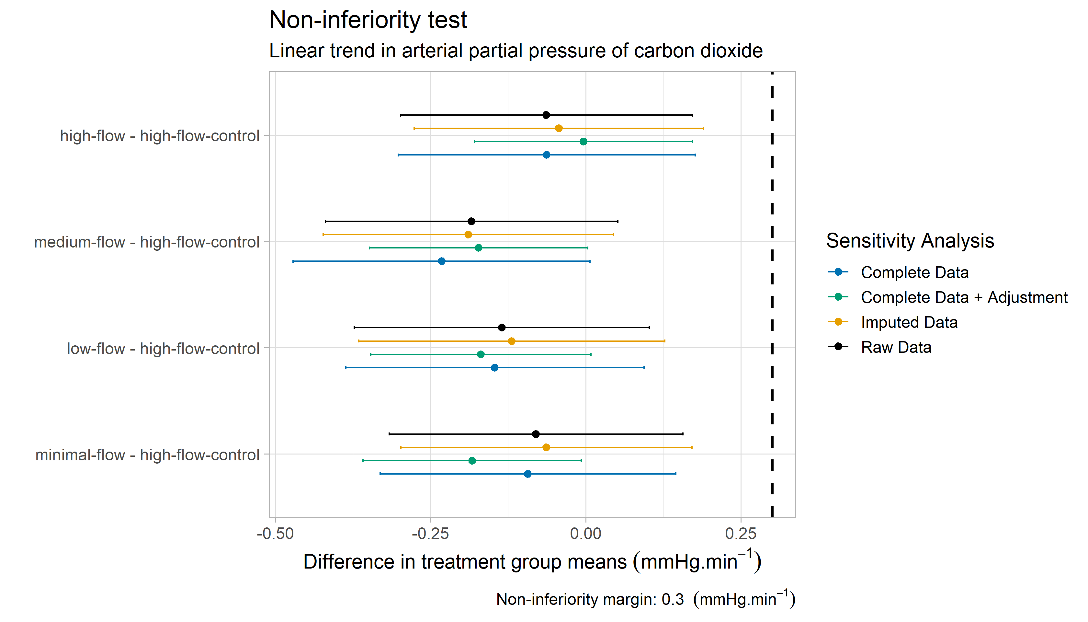
Non-inferiority tests comparing four experimental groups with the control group based on a linear mixed effects model. The null hypothesis (H₀) states that the linear trend in arterial partial pressure of carbon dioxide (PaCO₂) is at least 0.3 mmHg.min-1 (non-inferiority margin) larger than the linear trend of the control group. The differences of the group means and the corresponding 95% confidence intervals are shown. Different colors refer to the sensitivity tests considered in this study. The reference case is denoted as Raw Data and includes missing blood sample measurements for some patients at varying timepoints. The Complete Data sensitivity test considers only those patients for whom blood sample measurements are available for each timepoint. The sensitivity test denoted as Imputed Data is based on imputed missing values computed with the predictive mean matching as imputation method. In order to allow for an adjustment period after the induction of apnea, the sensitivity test Complete Data + Adjustment considers only blood sample measurements from the second half of the apnea period (minutes 7 to 15).

Supplementary Table I to Figure I: Difference in linear trends in arterial partial pressure of carbon dioxide (PaCO₂) with respect to high-flow control group. Data are based on a linear mixed effects model. Units are in mmHg.min⁻¹. P-values for noninferiority are shown in brackets.
 | minimal-flow | low-flow | medium-flow | high-flow
Raw Data | -0.1 (P=0.002) | -0.1 (P<0.001) | -0.2 (P<0.001) | -0.1 (P=0.003)
Sensitivity Tests
Complete Data | -0.1 (P=0.001) | -0.2 (P<0.001) | -0.2 (P<0.001) | -0.1 (P=0.003)
Complete Data + Adjustment | -0.2 (P<0.001) | -0.2 (P<0.001) | -0.2 (P<0.001) | 0 (P<0.001)
Imputed Data | -0.1 (P=0.002) | -0.1 (P<0.001) | -0.2 (P<0.001) | -0.0 (P=0.004)

Supplementary Figure II: Figure I-adjusted: Non-inferiority with adjustment for multiple comparison

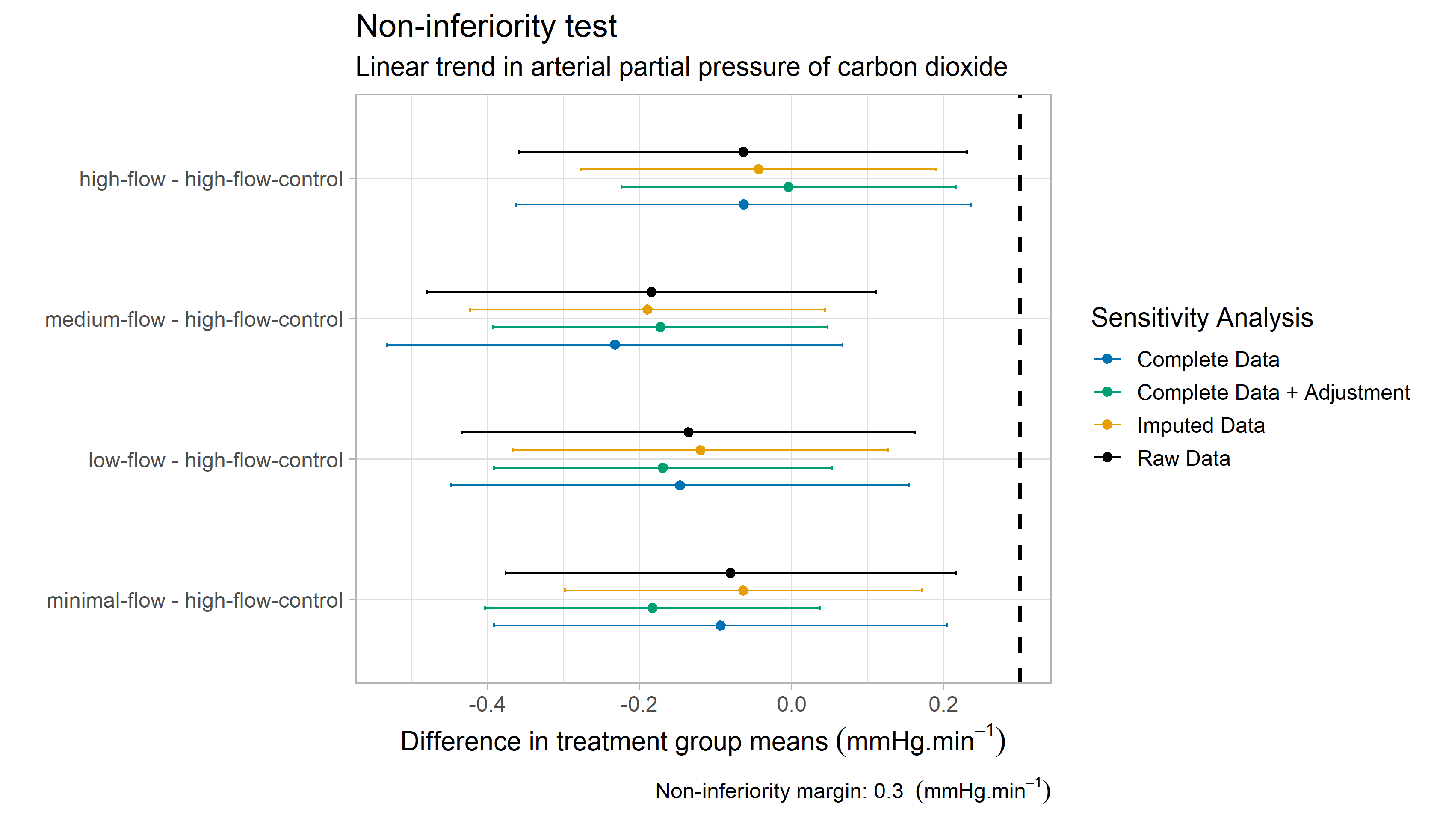
Non-inferiority tests comparing four experimental groups with the control group based on a linear mixed effects model. Dunnett’s method for adjustment of multiple comparisons is used. The null hypothesis (H₀) states that the linear trend in arterial partial pressure of carbon dioxide (PaCO2) is at least 0.3 mmHg.min⁻¹ (non-inferiority margin) larger than the linear trend of the control group. The differences of the group means and the corresponding 95% confidence intervals are shown. Different colors refer to the sensitivity tests considered in this study. The reference case is denoted as Raw Data and includes missing blood sample measurements for some patients at varying timepoints. The Complete Data sensitivity test considers only those patients for whom blood sample measurements are available for each timepoint. The sensitivity test denoted as Imputed Data is based on imputed missing values computed with the predictive mean matching as imputation method. In order to allow for an adjustment period after the induction of apnea, the sensitivity test Complete Data + Adjustment considers only blood sample measurements from the second half of the apnea period (minutes 7 to 15).

Supplementary Table II to Figure II: Difference in linear trends in arterial partial pressure of carbon dioxide (PaCO₂) with respect to high-flow control group. Data are based on a linear mixed effects model. Units are in mmHg.min⁻¹. P-values for noninferiority are shown in brackets.
 | minimal-flow | low-flow | medium-flow | high-flow
Raw Data | -0.1 (P=0.006) | -0.1 (P=0.001) | -0.2 (P<0.001) | -0.1 (P=0.009)
Sensitivity Tests
Complete Data | -0.1 (P=0.005) | -0.2 (P=0.001) | -0.2 (P<0.001) | -0.1 (P=0.011)
Complete Data + Adjustment | -0.2 (P<0.001) | -0.2 (P<0.001) | -0.2 (P<0.001) | 0 (P=0.003)
Imputed Data | -0.1 (P=0.009) | -0.1 (P=0.003) | -0.2 (P<0.001) | -0.0 (P=0.015)

Linear trends

Supplementary Table III
Results of Table 2 of the manuscript analyzed according to BMJopen
 | minimal-flow | low-flow | medium-flow | high-flow | high-flow (control)
Raw Data | 2.1 (1.9,2.3) | 2.1 (1.9,2.2) | 2.0 (1.8,2.2) | 2.1 (2.0,2.3) | 2.2 (2.0,2.4)
Sensitivity Tests
Complete Data | 2.1 (1.9,2.3) | 2.0 (1.9,2.2) | 2.0 (1.8,2.1) | 2.1 (2.0,2.3) | 2.2 (2.0,2.4)
Complete Data + Adjustment | 1.5 (1.4,1.7) | 1.6 (1.4,1.7) | 1.5 (1.4,1.7) | 1.7 (1.6,1.8) | 1.7 (1.6,1.8)
Imputed data | 2.1 (1.9,2.3) | 2.0 (1.9,2.2) | 2.0 (1.8,2.1) | 2.1 (2.0,2.3) | 2.2 (2.0,2.3)
Linear trends in arterial partial pressure of carbon dioxide (PaCO₂). Data are based on a linear mixed effects model and means with corresponding 95% confidence intervals are shown. Units are in mmHg.min⁻¹. The number of patients in each group may differ across the sensitivity tests due to missing data in blood measurements.

Results: TCM4

Non-inferiority

Supplementary Figure III-TCM4: Non-inferiority without adjustment for multiple comparison (TCM4)

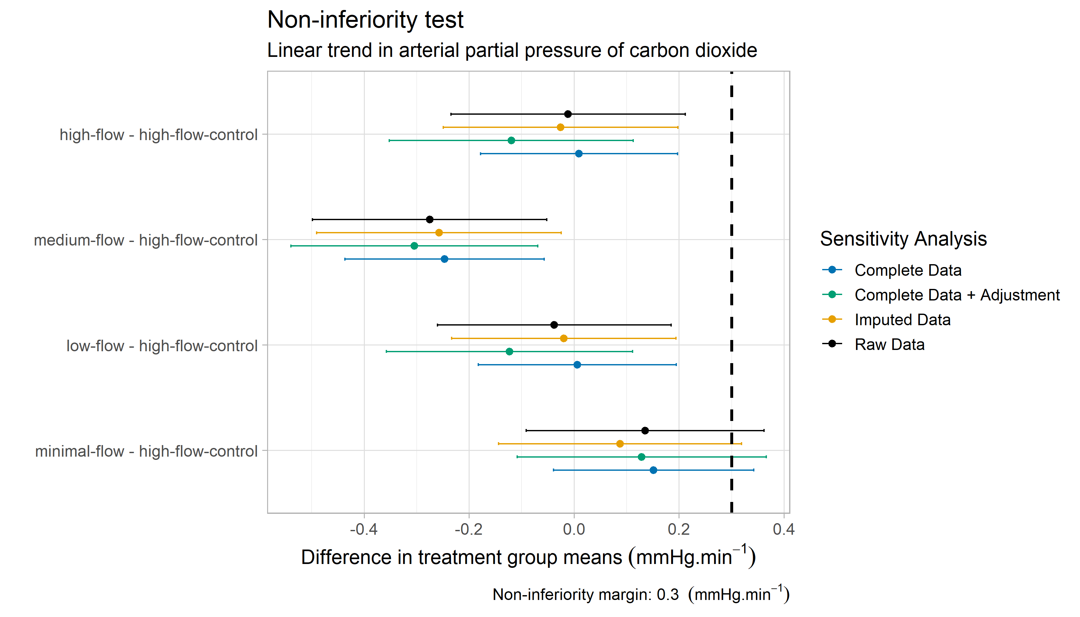
Transcutaneous carbon dioxide (tcCO₂) per minute with the TCM4-monitor: non-inferiority tests comparing four experimental groups with the control group based on a linear mixed effects model.

Supplementary Figure IV-TCM4-adjusted: Non-inferiority with adjustment for multiple comparison (TCM4)

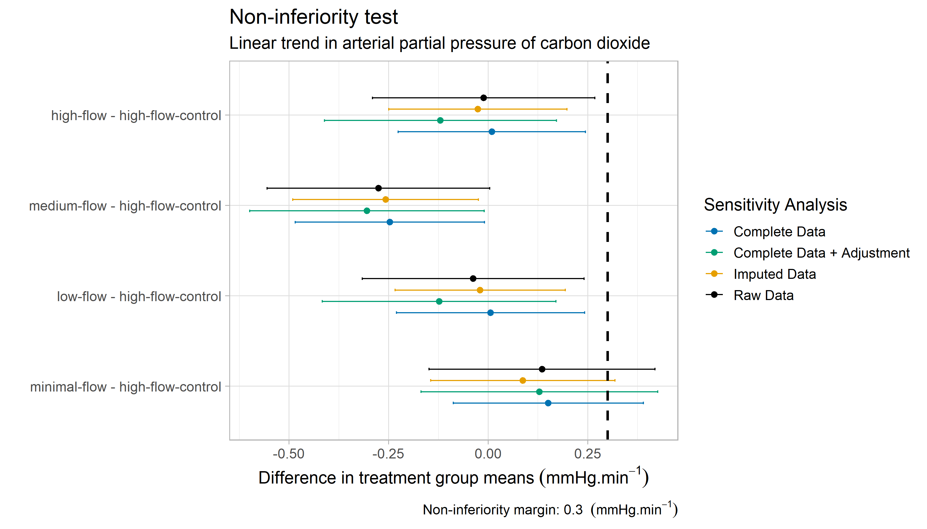
Transcutaneous carbon dioxide (tcCO₂) per minute with the TCM4-monitor: non-inferiority tests comparing four experimental groups with the control group based on a linear mixed effects model. Dunnett’s method for adjustment of multiple comparisons is used.

Supplementary Table IV to Figures III-TCM4 and Figure IV-TCM4-adjusted: TCM4: Difference in transcutaneous carbon dioxide (tcCO₂) per minute with respect to high-flow control group. Data are based on a mixed effects model with treatment group and time as fixed effects and a random intercept for each patient. Units are in mmHg.min⁻¹. P-values for non-inferiority are shown in brackets.

 | minimal-flow | low-flow | medium-flow | high-flow
Raw Data | 0.1 (P=0.155) | -0.0 (P=0.003) | -0.3 (P<0.001) | -0.0 (P=0.006)
Complete Data | 0.2 (P=0.127) | 0.0 (P=0.002) | -0.3 (P<0.001) | 0.01 (P=0.003)
Complete Data + Adjustment | 0.1 (P=0.158) | -0.1 (P<0.001) | -0.3 (P<0.001) | -0.1 (P<0.001)
Imputed Data | 0.1 (P=0.072) | -0.0 (P=0.003) | -0.3 (P<0.001) | -0.0 (P=0.004)
Dunnett’s method for multiple comparisons
Raw Data | 0.1 (P=0.416) | -0.0 (P=0.011) | -0.3 (P<0.001) | -0.0 (P=0.023)
Complete Data | 0.2 (P=0.355) | 0.0 (P=0.009) | -0.3 (P<0.001) | 0.0 (P=0.009)
Complete Data + Adjustment | 0.1 (P=0.421) | -0.1 (P=0.002) | -0.3 (P<0.001) | -0.1 (P=0.002)
Imputed Data | 0.1 (P=0.222) | -0.0 (P=0.013) | -0.3 (P=0.001) | -0.0 (P=0.017)

Linear Trends

Supplementary Table V
Results of Table 3 of the manuscript analyzed as described in BMJopen

 | minimal-flow | low-flow | medium-flow | high-flow | high-flow (control)
Raw Data | 2.0 (1.8,2.1) | 1.8 (1.7,2.0) | 1.6 (1.4,1.7) | 1.8 (1.7 – 2.0) | 1.8 (1.7,2)
Sensitivity Tests
Complete Data | 2.0 (1.8,2.1) | 1.8 (1.7,2.0) | 1.6 (1.4,1.7) | 1.8 (1.7,2.0) | 1.8 (1.7,2.0)
Complete Data + Adjustment | 1.9 (1.8,2.1) | 1.7 (1.5,1.8) | 1.5 (1.3,1.7) | 1.7 (1.5,1.8) | 1.8 (1.6,2.0)
Imputed data | 2.0 (1.8,2.2) | 1.9 (1.7,2.0) | 1.6 (1.5,1.8) | 1.9 (1.7,2.0) | 1.9 (1.7,2.1)
Linear trends in increase of transcutaneous carbon dioxide (tcCO₂) per minute with the TCM4-monitor. Data are based on a linear mixed effects model and means with corresponding 95% confidence intervals are shown. Units are in mmHg.min⁻¹. The number of patients in each group may differ across the sensitivity tests due to missing blood data measurements.

Results: TCM5

Non-inferiority
Supplementary Figure V-TCM5
Non-inferiority without adjustment for multiple comparison (TCM5)

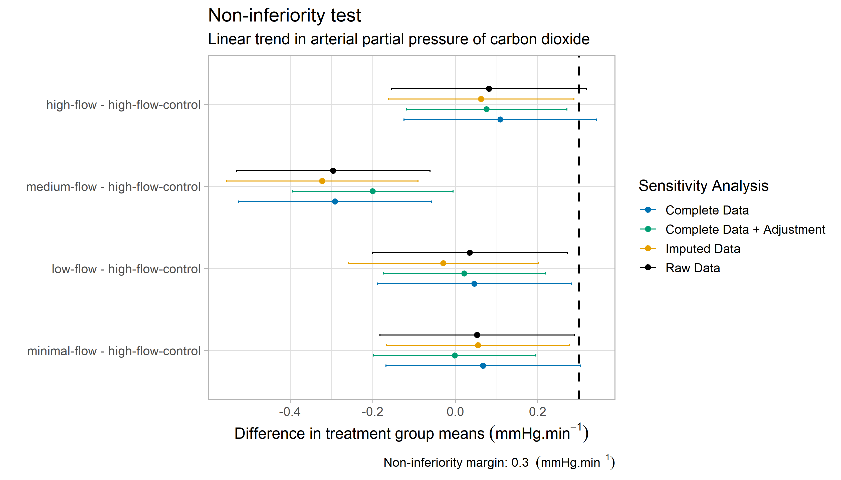
Transcutaneous carbon dioxide (tcCO₂) per minute with the TCM5-monitor: non-inferiority tests comparing four experimental groups with the control group based on a linear mixed effects model.

Supplementary Figure VI-TCM5-adjusted
Non-inferiority with adjustment for multiple comparison (TCM5)

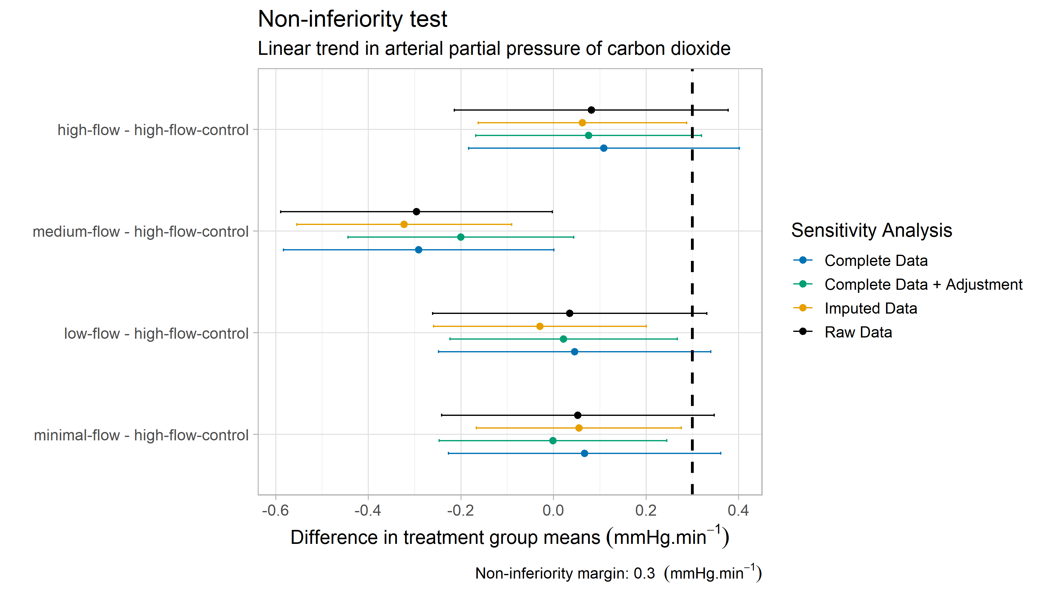
Transcutaneous carbon dioxide (tcCO₂) per minute with the TCM5-monitor: non-inferiority tests comparing four experimental groups with the control group based on a linear mixed effects model. Dunnett’s method for adjustment of multiple comparisons is used.

Supplementary Table VI to Figure V-TCM5 and Figure VI-TCM5-adjusted: TCM5: Difference in transcutaneous carbon dioxide (tcCO₂) per minute with respect to high-flow control group. Data are based on a mixed effects model with treatment group and time as fixed effects and a random intercept for each patient. Units are in mmHg.min⁻¹. P-values for non-inferiority are shown in brackets.

 | minimal-flow | low-flow | medium-flow | high-flow
Raw Data | 0.1 (P=0.040) | 0.0 (P=0.028) | -0.3 (P<0.001) | 0.1 (P=0.070)
Complete Data | 0.1 (P=0.053) | 0.1 (P=0.034) | -0.3 (P<0.001) | 0.1 (P=0.109)
Complete Data + Adjustment | 0 (P=0.003) | 0.0 (P=0.006) | -0.2 (P<0.001) | 0.1 (P=0.024)
Imputed Data | 0.1 (P=0.030) | -0.0 (P=0.005) | -0.3 (P<0.001) | 0.1 (P=0.039)
Dunnett’s method for multiple comparisons
Raw Data | 0.1 (P=0.130) | 0.0 (P=0.095) | -0.3 (P<0.001) | 0.1 (P=0.216)
Complete Data | 0.1 (P=0.167) | 0.1 (P=0.114) | -0.3 (P<0.001) | 0.1 (P=0.314)
Complete Data + Adjustment | 0 (P=0.010) | 0.0 (P=0.020) | -0.2 (P<0.001) | 0.1 (P=0.083)
Imputed Data | 0.1 (P=0.102) | -0.0 (P=0.019) | -0.3 (P=0.001) | 0.1 (P=0.127)

Linear Trends

Supplementary Table VII
Results of Table 4 of the manuscript analyzed as described in BMJopen

 | minimal-flow | low-flow | medium-flow | high-flow | high-flow (control)
Raw Data | 1.7 (1.5,1.8) | 1.7 (1.5,1.8) | 1.3 (1.2,1.5) | 1.7 (1.5,1.9) | 1.6 (1.5,1.8)
Sensitivity Tests
Complete Data | 1.7 (1.5,1.8) | 1.6 (1.5,1.8) | 1.3 (1.1,1.5) | 1.7 (1.5,1.9) | 1.6 (1.4,1.8)
Complete Data + Adjustment | 1.5 (1.3,1.6) | 1.5 (1.3,1.6) | 1.3 (1.1,1.4) | 1.5 (1.4,1.7) | 1.5 (1.3,1.6)
Imputed data | 1.7 (1.5,1.8) | 1.6 (1.4,1.8) | 1.3 (1.1,1.5) | 1.7 (1.5,1.9) | 1.6 (1.5 - 1.8)
Linear trends in increase of transcutaneous carbon dioxide (tcCO₂) per minute with the TCM5-Monitor. Data are based on a linear mixed effects model and means with corresponding 95% confidence intervals are shown. Units are in mmHg.min⁻¹. The number of patients in each group may differ across the sensitivity tests due to missing blood data measurements.

Supplementary Table VIII: Number of patients in each treatment group for each sensitivity analysis

Treatment Group | Raw Data | Complete Data | Complete + Adjustment Data | Imputed Data
High-Flow (control) | 25 | 23 | 23 | 25
Low-Flow | 25 | 24 | 24 | 25
Medium-Flow | 25 | 24 | 24 | 25
High-Flow | 25 | 24 | 24 | 25
Minimal-Flow | 25 | 25 | 25 | 25

Missing values
Supplementary Table IX: Missing values in arterial partial pressure of carbon dioxide (PaCO₂) for each patient group.

Minutes: | 0 | 1 | 3 | 5 | 7 | 9 | 11 | 13 | 15
 | N=125 | N=125 | N=124 | N=125 | N=124 | N=123 | N=121 | N=121 | N=119
control | 25 (20.0%) | 25 (20.0%) | 24 (19.4%) | 25 (20.0%) | 25 (20.2%) | 24 (19.5%) | 24 (19.8%) | 24 (19.8%) | 23 (19.3%)
treatment: low-flow | 25 (20.0%) | 25 (20.0%) | 25 (20.2%) | 25 (20.0%) | 25 (20.2%) | 25 (20.3%) | 23 (19.0%) | 23 (19.0%) | 23 (19.3%)
treatment: medium-flow | 25 (20.0%) | 25 (20.0%) | 25 (20.2%) | 25 (20.0%) | 25 (20.2%) | 25 (20.3%) | 25 (20.7%) | 25 (20.7%) | 24 (20.2%)
treatment: high-flow | 25 (20.0%) | 25 (20.0%) | 25 (20.2%) | 25 (20.0%) | 24 (19.4%) | 25 (20.3%) | 25 (20.7%) | 25 (20.7%) | 25 (21.0%)
treatment: minimal-flow | 25 (20.0%) | 25 (20.0%) | 25 (20.2%) | 25 (20.0%) | 25 (20.2%) | 24 (19.5%) | 24 (19.8%) | 24 (19.8%) | 24 (20.2%)

Supplementary Table X: Missing values in transcutaneous carbon dioxide (tcCO₂) for each patient group.

 | 0 | 1 | 2 | 3 | 4 | 5 | 6 | 7 | 8 | 9 | 10 | 11 | 12 | 13 | 14 | 15
 | N=113 | N=113 | N=113 | N=113 | N=113 | N=114 | N=113 | N=114 | N=113 | N=112 | N=111 | N=110 | N=110 | N=110 | N=109 | N=108
control | 21 (18.6%) | 21 (18.6%) | 21 (18.6%) | 21 (18.6%) | 21 (18.6%) | 21 (18.4%) | 21 (18.6%) | 22 (19.3%) | 21 (18.6%) | 21 (18.8%) | 21 (18.9%) | 21 (19.1%) | 21 (19.1%) | 21 (19.1%) | 21 (19.3%) | 20 (18.5%)
treatment: low-flow | 24 (21.2%) | 24 (21.2%) | 24 (21.2%) | 24 (21.2%) | 24 (21.2%) | 24 (21.1%) | 24 (21.2%) | 24 (21.1%) | 24 (21.2%) | 24 (21.4%) | 23 (20.7%) | 22 (20.0%) | 22 (20.0%) | 22 (20.0%) | 22 (20.2%) | 22 (20.4%)
treatment: medium-flow | 23 (20.4%) | 23 (20.4%) | 23 (20.4%) | 23 (20.4%) | 23 (20.4%) | 23 (20.2%) | 23 (20.4%) | 23 (20.2%) | 23 (20.4%) | 23 (20.5%) | 23 (20.7%) | 23 (20.9%) | 23 (20.9%) | 23 (20.9%) | 22 (20.2%) | 22 (20.4%)
treatment: high-flow | 23 (20.4%) | 23 (20.4%) | 23 (20.4%) | 23 (20.4%) | 23 (20.4%) | 23 (20.2%) | 23 (20.4%) | 23 (20.2%) | 23 (20.4%) | 23 (20.5%) | 23 (20.7%) | 23 (20.9%) | 23 (20.9%) | 23 (20.9%) | 23 (21.1%) | 23 (21.3%)
treatment: minimal-flow | 22 (19.5%) | 22 (19.5%) | 22 (19.5%) | 22 (19.5%) | 22 (19.5%) | 23 (20.2%) | 22 (19.5%) | 22 (19.3%) | 22 (19.5%) | 21 (18.8%) | 21 (18.9%) | 21 (19.1%) | 21 (19.1%) | 21 (19.1%) | 21 (19.3%) | 21 (19.4%)

Supplementary Table XI: TCM5: Missing values in transcutaneous carbon dioxide (tcCO₂) for each patient group.

 | 0 | 1 | 2 | 3 | 4 | 5 | 6 | 7 | 8 | 9 | 10 | 11 | 12 | 13 | 14 | 15
 | N=123 | N=123 | N=122 | N=123 | N=123 | N=123 | N=123 | N=123 | N=122 | N=121 | N=120 | N=119 | N=119 | N=119 | N=118 | N=117
control | 24 (19.5%) | 24 (19.5%) | 24 (19.7%) | 24 (19.5%) | 24 (19.5%) | 24 (19.5%) | 24 (19.5%) | 24 (19.5%) | 23 (18.9%) | 23 (19.0%) | 23 (19.2%) | 23 (19.3%) | 23 (19.3%) | 23 (19.3%) | 23 (19.5%) | 22 (18.8%)
treatment: low-flow | 25 (20.3%) | 25 (20.3%) | 25 (20.5%) | 25 (20.3%) | 25 (20.3%) | 25 (20.3%) | 25 (20.3%) | 25 (20.3%) | 25 (20.5%) | 25 (20.7%) | 24 (20.0%) | 23 (19.3%) | 23 (19.3%) | 23 (19.3%) | 23 (19.5%) | 23 (19.7%)
treatment: medium-flow | 25 (20.3%) | 25 (20.3%) | 25 (20.5%) | 25 (20.3%) | 25 (20.3%) | 25 (20.3%) | 25 (20.3%) | 25 (20.3%) | 25 (20.5%) | 25 (20.7%) | 25 (20.8%) | 25 (21.0%) | 25 (21.0%) | 25 (21.0%) | 24 (20.3%) | 24 (20.5%)
treatment: high-flow | 24 (19.5%) | 24 (19.5%) | 24 (19.7%) | 24 (19.5%) | 24 (19.5%) | 24 (19.5%) | 24 (19.5%) | 24 (19.5%) | 24 (19.7%) | 24 (19.8%) | 24 (20.0%) | 24 (20.2%) | 24 (20.2%) | 24 (20.2%) | 24 (20.3%) | 24 (20.5%)
treatment: minimal-flow | 25 (20.3%) | 25 (20.3%) | 24 (19.7%) | 25 (20.3%) | 25 (20.3%) | 25 (20.3%) | 25 (20.3%) | 25 (20.3%) | 25 (20.5%) | 24 (19.8%) | 24 (20.0%) | 24 (20.2%) | 24 (20.2%) | 24 (20.2%) | 24 (20.3%) | 24 (20.5%)

Supplemental Table XII: Linear rates of changes in arterial partial pressure of carbon dioxide. Data are mean ± SD. Units are in mmHg.min⁻¹. The number of patients in each group may differ across the sensitivity tests due to missing data in blood measurements. The reference case is denoted as Raw Data and includes missing blood sample measurements for some patients at varying timepoints. The Complete Data sensitivity test considers only those patients for whom blood sample measurements are available for each timepoint. The sensitivity test denoted as Imputed Data is based on imputed missing values computed with the predictive mean matching as imputation method. In order to allow for an adjustment period after the induction of apnea, the sensitivity test Complete Data + Adjustment considers only blood sample measurements from the second half of the apnea period (minutes 7 to 15).
 | Minimal flow  (n=25) | Low flow  (n=25) | Medium flow  (n=25) | High flow  (n=25) | High flow (control) (n=25)
Raw data | 2.0 ± 0.3 | 2.0 ± 0.4 | 2.0 ± 0.4 | 2.1 ± 0.5 | 2.1 ± 0.4
Sensitivity tests
Complete data | 2.0 ± 0.3 | 2.0 ± 0.4 | 1.9 ± 0.3 | 2.1 ± 0.5 | 2.1 ± 0.5
Complete data + adjustment | 1.5 ± 0.3 | 1.5 ± 0.4 | 1.5 ± 0.4 | 1.7 ± 0.5 | 1.7 ± 0.5
Imputed data | 2.0 ± 0.4 | 1.9 ± 0.4 | 1.9 ± 0.3 | 2.1 ± 0.5 | 2.1 ± 0.5

References

Dunnett, Charles W. 1955. “A Multiple Comparison Procedure for Comparing Several Treatments with a Control.” Journal of the American Statistical Association 50 (272): 1096–1121. http://www.jstor.org/stable/2281208.
R Core Team. 2020. R: A Language and Environment for Statistical Computing. Vienna, Austria: R Foundation for Statistical Computing. https://www.R-project.org/.
Theiler, Lorenz, Fabian Schneeberg, Thomas Riedel, Heiko Kaiser, Thomas Riva, and Robert Greif. 2019. “Apnoeic Oxygenation with Nasal Cannula Oxygen at Different Flow Rates in Anaesthetised Patients: A Study Protocol for a Non-Inferiority Randomised Controlled Trial.” BMJ Open 9 (7): e025442. https://doi.org/10.1136/bmjopen-2018-025442.

