Title: Temporal Transitions In Fibrinolysis After Trauma: Adverse Outcome Is Principally Related To Late Hypofibrinolysis

Authors: Andrea Rossetto, M.D.^{1,2}, Paul Vulliamy, Ph.D.^{1,2}, Kim May Lee, Ph.D.³, Karim Brohi, M.D.^{1,2}, Ross Davenport, Ph.D.^{1,2}

Affiliations: ¹Centre for Trauma Sciences, Blizard Institute, Queen Mary University of London, London, United Kingdom; ²Barts Health National Health Service Trust, London, United Kingdom; ³Institute of Psychiatry, Psychology & Neuroscience, King’s College London, United Kingdom

Corresponding Author: Ross Davenport
Trauma Research Office, Ward 12D, Royal London Hospital
London, E1 1FR, UK
Tel: +44 (0)20 7882 6175
Email: ross.davenport@qmul.ac.uk

Supplemental Digital Content:

- Page 3 - Supplemental Fig. 1. Flow diagram of the study cohort. NORMAL₀, normal maximum lysis on admission; NORMAL₂₄, normal maximum lysis at 24 hours; LOW₀, low maximum lysis on admission; LOW₂₄, low maximum lysis at 24 hours; HIGH₀, high maximum lysis on admission; HIGH₂₄, high maximum lysis at 24 hours.
- Page 4 - Supplemental Table 1. Characteristics and outcomes of the less frequent transition patterns in the non-tranexamic-acid-treated cohort
- Page 5 - Supplemental Table 2. Univariable and multivariable logistic regression analysis of fibrinolysis states and other factors associated with the development of multi-organ dysfunction syndrome
- Page 6 - Supplemental Table 3. Characteristics and outcomes according to the timing of the empiric administration of tranexamic acid in patients who required the activation of the major haemorrhage protocol

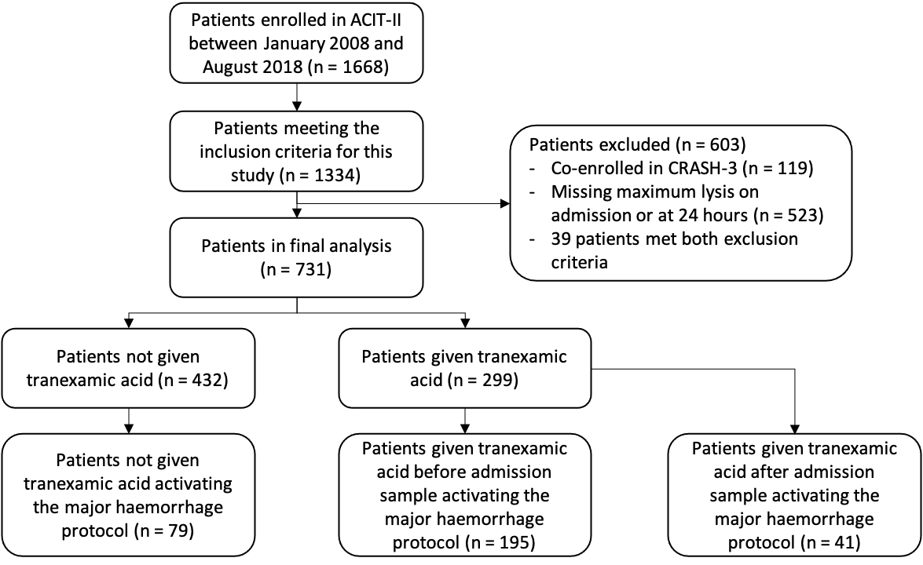
Supplemental Fig. 1. Flow diagram of the study cohort. NORMAL₀, normal maximum lysis on admission; NORMAL₂₄, normal maximum lysis at 24 hours; LOW₀, low maximum lysis on admission; LOW₂₄, low maximum lysis at 24 hours; HIGH₀, high maximum lysis on admission; HIGH₂₄, high maximum lysis at 24 hours.

Supplemental Table 1. Characteristics and outcomes of the less frequent transition patterns in the non-tranexamic-acid-treated cohort
 | LOW maximum lysis  on admission → HIGH maximum lysis at 24hr  (n = 4) |  | HIGH maximum lysis  on admission → LOW maximum lysis at 24hr  (n = 4) |  | NORMAL maximum lysis  on admission → HIGH maximum lysis at 24hr  (n = 8) |  | HIGH maximum lysis on admission → NORMAL maximum lysis at 24hr  (n = 8) |  | HIGH maximum lysis  on admission → HIGH maximum lysis at 24hr  (n = 2)
ADMISSION CHARACTERISTICS
Gender, male | 3 | (75) | 2 | (50) | 6 | (75) | 7 | (88) | 2 | (100)
Age, years | 40 | (27-51) | 32 | (23-47)) | 32 | (24-35) | 47 | (38-45) | 28 | (28-29)
Glasgow coma scale | 15 | (13-15) | 9 | (5-14) | 13 | (11-15) | 13 | (10-14) | 15 | (15-15)
SBP, mmHg | 119 | (100-138) | 82 | (72-91) | 127 | (117-139) | 134 | (89-143) | 146 | (131-160)
Base deficit, mEq·L⁻¹ | 2.0 | (2.0-6.8) | 20.5 | (18.8-26.8) | 0.6 | (-1.0-3.8) | 5.4 | (0.8-9.9) | 0.9 | (0.0-0.9)
Prothrombin time ratio > 1.2 | 0 | (0) | 2 | (100) | 0 | (0) | 2 | (33) | 0 | (0)
EXTEM amplitude at 5 minutes, mm | 36 | (28-45) | 12 | (12-25) | 42 | (40-46) | 45 | (36-46) | 46 | (46-47)
EXTEM maximum lysis, % | 4 | (4-4) | 100 | (96-100) | 10 | (8-12) | 23 | (20-28) | 24 | (20-27)
INJURY CHARACTERISTICS
Blunt | 3 | (75) | 4 | (100) | 7 | (88) | 7 | (88) | 1 | (50)
Injury severity score | 26 | (21-28) | 32 | (29-38) | 25 | (11-30) | 35 | (20-39) | 17 | (10-23)
Severe head/neck injury | 2 | (50) | 1 | (25) | 5 | (63) | 2 | (25) | 0 | (0.0)
Severe chest injury | 2 | (50) | 3 | (75) | 3 | (38) | 7 | (88) | 1 | (50)
Severe abdominal injury | 1 | (25) | 0 | (0) | 0 | (0) | 2 | (25) | 0 | (0)
Severe extremity injury | 2 | (50) | 2 | (50) | 1 | (13) | 5 | (63) | 0 | (0)
FLUID AND BLOOD PRODUCTS
24hr crystalloids, L | 4.1 | (3.6-4.3) | 5.8 | (2.9-8.3) | 2.1 | (1.3-3.9) | 4.7 | (3.3-4.9) | 2.0 | (2.0-2.0)
24hr red blood cells, units | 1 | (0-3) | 21 | (5-42) | 0 | (0) | 3 | (0-11) | 0 | (0-0)
Massive transfusion | 0 | (0) | 2 | (50) | 0 | (0) | 2 | (25) | 0 | (0)
Any other blood product† | 1 | (25) | 4 | (100) | 0 | (0) | 4 | (50) | 0 | (0)
OUTCOMES
Venous thromboembolism | 0 | (0) | 0 | (0) | 0 | (0) | 0 | (0) | 0 | (0)
Multi-organ dysfunction syndrome | 3 | (75) | 4 | (100) | 2 | (25) | 4 | (50) | 0 | (0)
Critical care length of stay, days | 5 | (2-8) | 10 | (5-18) | 3 | (2-7) | 10 | (3-15) | 0 | (0-0)
Total length of stay, days | 19 | (14-35) | 10 | (5-32) | 13 | (8-18) | 22 | (19-31) | 20 | (15-24)
Late mortality (beyond 24hr) | 1 | (25) | 3 | (75) | 1 | (13) | 0 | (0) | 0 | (0)
Data presented as median (interquartile range) or count (percentage).
†Fresh frozen plasma and/or platelets and/or cryoprecipitate.
LOW maximum lysis, EXTEM maximum lysis <5%; NORMAL maximum lysis, EXTEM maximum lysis 5-15%; HIGH maximum lysis, EXTEM maximum lysis >15%.

Supplemental Table 2. Univariable and multivariable logistic regression analysis of fibrinolysis states and other factors associated with the development of multi-organ dysfunction syndrome
 | Odds ratio |  | p value | Adjusted odds ratio |  | p value | Adjusted odds ratio |  | p value
Age | 1.04 | (1.02-1.05) | <0.001 | - | - | - | 1.04 | (1.02-1.06) | <0.001
Gender, male | 1.03 | (0.55-1.91) | 0.931 | - | - | - | 1.90 | (0.81-4.46) | 0.138
Base deficit, mEq·L⁻¹ | 1.13 | (1.06-1.20) | <0.001 | - | - | - | 1.09 | (1.00-1.18) | 0.047
Injury severity score | 1.10 | (1.07-1.12) | <0.001 | - | - | - | 1.06 | (1.03-1.09) | <0.001
Severe traumatic brain injury | 9.92 | (5.90-16.70) | <0.001 | - | - | - | 7.39 | (3.86-14.16) | <0.001
24hr crystalloids, L | 1.31 | (1.17-1.47) | <0.001 | - | - | - | 1.30 | (1.11-1.53) | 0.001
LOW maximum lysis on admission | 2.88 | (1.84-4.52) | <0.001 | 2.12 | (1.31-3.44) | 0.002 | 1.59 | (0.87-2.93) | 0.134
LOW maximum lysis at 24 hours | 5.28 | (2.82-9.79) | <0.001 | 3.89 | (2.03-7.47) | <0.001 | 3.54 | (1.55-8.06) | 0.003
Complete data available for 97% (360/372) of the patients. Cramer’s V for admission and 24hr maximum lysis = 0.34. 64.5 positive events per variable and variance inflation factor = 1.07 for the multivariable model with no confounding variables included. 16.1 positive events per variable, admission maximum lysis variance inflation factor = 1.07 and 24hr maximum lysis variance inflation factor = 1.10 for the multivariable model with confounding variables included. NORMAL maximum lysis was used as a reference category. LOW maximum lysis, EXTEM maximum lysis <5%; NORMAL maximum lysis, EXTEM maximum lysis 5-15%.

Supplemental Table 3. Characteristics and outcomes according to the timing of the empiric administration of tranexamic acid in patients who required the activation of the major haemorrhage protocol
 | No tranexamic acid  (n= 79) |  | Tranexamic acid administered before admission sample (n = 195) |  | Tranexamic acid administered after admission sample (n = 41)
ADMISSION CHARACTERISTICS
Gender, male | 58 | (73) | 140 | (72) | 34 | (83)
Age, years | 37 | (24-53) | 34 | (25-52) | 35 | (27-52)
Glasgow coma scale | 13 | (7-14) | 11 | (3-14) | 14 | (12-15)
SBP, mmHg | 107 | (83-126) | 98 | (74-123) | 87 | (69-108)*
Base deficit, mEq·L⁻¹ | 7.1 | (3.7-11.1) | 8.5 | (4.4-16.7) | 6.3 | (3.6-13.0)
Prothrombin time ratio > 1.2 | 22 | (33) | 61 | (39) | 8 | (24)
EXTEM amplitude at 5 minutes, mm | 38 | (30-46) | 36 | (30-44) | 39 | (33-43)
EXTEM maximum lysis, % | 6 | (4-13) | 3 | (1-5)*** | 5 | (3-11)
Tranexamic acid infusion | - | - | 50 | (30) | 10 | (27)
INJURY CHARACTERISTICS
Blunt | 62 | (79) | 148 | (76) | 24 | (59)
Injury severity score | 29 | (22-38) | 30 | (22-43) | 26 | (17-38)
Severe head/neck injury | 25 | (36) | 73 | (38) | 9 | (23)
Severe chest injury | 55 | (71) | 127 | (67) | 25 | (63)
Severe abdominal injury | 20 | (26) | 58 | (31) | 14 | (35)
Severe extremity injury | 41 | (53) | 99 | (52) | 14 | (35)
FLUID AND BLOOD PRODUCTS
24hr crystalloids, L | 3.3 | (1.5-5.1) | 3.3 | (1.9-4.4) | 3.0 | (2.0-4.2)
24hr red blood cells, units | 6 | (4-10) | 6 | (3-10) | 6 | (4-9)
Massive transfusion | 23 | (30) | 51 | (26) | 10 | (24)
Any other blood product† | 59 | (76) | 160 | (83) | 34 | (83)
OUTCOMES
Venous thromboembolism | 0 | (0) | 11 | (6) | 4 | (10)*
Multi-organ dysfunction syndrome | 34 | (61) | 131 | (78)* | 28 | (74)
Critical care length of stay, days | 3 | (0-11) | 6 | (2-15)** | 5 | (3-16)
Total length of stay, days | 9 | (1-24) | 20 | (6-41)** | 14 | (6-38)
Early mortality (within 24hr) | 23 | (29) | 28 | (14)* | 3 | (7)*
Late mortality (beyond 24hr) | 8 | (10) | 27 | (14) | 8 | (20)
Overall in-hospital mortality | 31 | (39) | 55 | (28) | 11 | (27)
Data presented as median (interquartile range) or count (percentage).
For 10 patients, it was not possible to clarify whether tranexamic acid had been administered before or after the baseline sample.
* p<0.05; ** p<0.01; *** p<0.001; when compared to No tranexamic acid. Bonferroni correction was applied for 2 comparisons.
†Fresh frozen plasma and/or platelets and/or cryoprecipitate.

