Supplemental Digital Content 1. Assigning Self-Reported Race Responses to Race/Ethnicity Categories
Racial Group | Self-reported Race Response
White | White
Black | Black or African-American, Barbadian, Cape Verdian, Congolese, Dominica Islander, Eritrean, Ethiopian, Gabonian, Ghanaian, Grenadian, Guinean, Haitian, Ivory Coastian, Jamaican, Kenyan, Liberian, Malian, Nigerian, Senegalese, Sierra Leonean, Somalian, St Vincentian, Sudanese, Tanzanian, Togolese, Trinidadian, Ugandan, West Indian, Zimbabwean, Other: East African, Other: North African, Other: South African, Other: West African
American Indian and Alaskan Native | Native American, American Indian Or Alaskan
Asian | Asian, Bhutanese, Burmese, Cambodian, Chinese, Taiwanese, Filipino, Hmong, Indonesian, Japanese, Korean, Laotian, Malaysian, Okinawan, Sri Lankan, Thai, Vietnamese, Iwo Jiman, Maldivian, Nepalese, Singaporean, Other Asian
Hispanic | Hispanic/Latino, Spaniard, Andalusian, Asturian, Castillian, Catalonian, Belearic Islander, Gallego, Valencian, Canarian, Spanish Basque, Mexican, Mexican American, Mexicano, Chicano, La Raza, Mexican American Indian, Central American, Costa Rican, Guatemalan, Honduran, Nicaraguan, Panamanian, Salvadoran, Central American Indian, Canal Zone, South American, Argentinean, Bolivian, Chilean, Colombian, Ecuadorian, Paraguayan, Peruvian, Uruguayan, Venezuelan, South American Indian, Criollo, Latin American, Puerto Rican, Cuban, Dominican
Indian/South Asian | Asian Indian, Bangladeshi, Pakistani
Pacific Islander | Pacific Islander, Polynesian, Native Hawaiian, Samoan, Tahitian, Tongan, Tokelauan, Micronesian, Guamanian Or Chamorro, Guamanian, Chamorro, Mariana Islander, Marshallese, Palauan, Carolinian, Kosraean, Pohnpeian, Saipanese, Kiribati, Chuukese, Yapese, Melanesian, Fijian, Papua New Guinean, Solomon Islander, New Hebrides, Other Pacific Islander
Other Race† | Other Race
†Other Race also includes patients with unknown race.

Supplemental Digital Content 2. Sensitivity Analysis of Factors Associated with Occult Hypoxemia*- Exclusion of ASA-PS 5 Patients
Perioperative Variable | OR |  | 95% Confidence Interval |  | p-value
Race/Ethnicity
White† | – |  | – |  | –
Black | 1.40 |  | 1.08 to 1.82 |  | 0.011
Asian | 0.86 |  | 0.57 to 1.29 |  | 0.454
Hispanic | 1.29 |  | 1.01 to 1.64 |  | 0.039
Other | 1.29 |  | 1.05 to 1.59 |  | 0.016
Spo₂ | 0.71 |  | 0.68 to 0.73 |  | <0.001
ASA Physical Status
1-2† | – |  | – |  | –
3 | 0.73 |  | 0.54 to 0.99 |  | 0.046
4 | 0.97 |  | 0.73 to 1.31 |  | 0.855
5 | – |  | – |  | –
Age (per 10 years)§ | 0.93 |  | 0.89 to 0.98 |  | 0.006
BMI (per 5 units)§ | 0.97 |  | 0.91 to 1.03 |  | 0.347
Sex
Female† | – |  | – |  | –
Male | 0.90 |  | 0.76 to 1.07 |  | 0.246
Fio₂ (per 10%)§ | 0.99 |  | 0.91 to 1.04 |  | 0.724
Tidal Volume (per 100 mL) § | 0.79 |  | 0.75 to 0.84 |  | <0.001
PEEP (cm H₂O) § | 1.11 |  | 1.07 to 1.15 |  | <0.001
MAP (per 10 mmHg)§ | 0.89 |  | 0.84 to 0.95 |  | <0.001
Hematocrit§ | 1.05 |  | 1.03 to 1.06 |  | <0.001
Volatile Anesthetic Use | 0.91 |  | 0.72 to 1.16 |  | 0.458
Vasoactive Infusion Use | 1.18 |  | 0.98 to 1.42 |  | 0.086
Diabetes | 0.98 |  | 0.72 1.33 |  | 0.888
Peripheral Vascular Disease | 0.93 |  | 0.59 to 1.47 |  | 0.751
Hypertension | 0.73 |  | 0.55 to 0.96 |  | 0.025
Congestive Heart Failure | 1.46 |  | 1.07 to 1.99 |  | 0.018
Chronic Pulmonary Disease | 1.16 | 0.82 to 1.64 |  | 0.396
Smoking Status
Never† | – | – |  | –
Current | 1.06 | 0.76 to 1.49 |  | 0.725
Prior | 0.86 | 0.66 to 1.12 |  | 0.270
ETco₂§ | 1.00 | 0.98 to 1.01 |  | 0.467
Renal Failure | 1.23 | 0.79 to 1.90 |  | 0.359
Year of Procedure
2008 | 1.00 | 0.66 to 1.51 |  | 0.998
2009 | 0.77 | 0.51 to 1.16 |  | 0.209
2010 | 0.48 | 0.32 to 0.73 |  | 0.001
2011† | – | – |  | –
2012 | 1.01 | 0.75 to 1.35 |  | 0.968
2013 | 0.81 | 0.59 to 1.09 |  | 0.164
2014 | 0.66 | 0.47 to 0.93 |  | 0.019
2015 | 0.53 | 0.38 to 0.76 |  | 0.001
2016 | 0.54 | 0.36 to 0.80 |  | 0.002
2017 | 0.58 | 0.40 to 0.84 |  | 0.004
2018 | 0.51 | 0.33 to 0.77 |  | 0.001
2019 | 0.45 | 0.26 to 0.77 |  | 0.004

*Occult hypoxemia defined as Sao₂% < 88 despite Spo₂ > 92%
†Reference group
§For continuous variables, the odds ratio is calculated per 1 unit increase. Scaled continuous variables were used as follows Age: per 10 years, BMI: per 5 kg/m², Fio₂: per 10%, Tidal Volume: per 100 mL, and Mean Arterial Pressure: per 10 mmHg.
ASA-PS: American Society of Anesthesiologists Physical Status
BMI: Body Mass Index
ETco₂: End-tidal Carbon Dioxide
Fio₂: Fraction of Inspired Oxygen
PEEP: Positive End-Expiratory Pressure

Supplemental Digital Content 3. Factors Associated with Occult Hypoxemia* for SpO₂ 92-96%
Perioperative Variable | OR | 95% Confidence Interval | p-value
Race/Ethnicity
White† | – | – | –
Black | 1.80 | 1.10 to 2.94 | 0.020
Asian | 0.66 | 0.31 to 1.40 | 0.276
Hispanic | 1.46 | 0.95 to 2.25 | 0.082
Other | 0.97 | 0.62 to 1.52 | 0.902
Spo₂ | 0.83 | 0.69 to 0.99 | 0.044
ASA Physical Status
1-2† | – | – | –
3 | 1.08 | 0.48 to 2.44 | 0.846
4 | 1.76 | 0.82 to 3.78 | 0.149
5 | 2.56 | 1.03 to 6.38 | 0.043
Age (per 10 years)§ | 0.96 | 0.87 to 1.04 | 0.314
BMI (per 5 unit)§ | 0.87 | 0.78 to 0.98 | 0.022
Sex
Female† | – | – | –
Male | 1.15 | 0.84 to 1.59 | 0.389
Fio₂ (per 10%)§ | 1.00 | 0.94 to 1.07 | 0.926
Tidal Volume (per 100 mL) § | 0.80 | 0.72 to 0.90 | <0.001
PEEP (cm H₂O) § | 1.11 | 1.05 to 1.17 | <0.001
MAP (per 10 mmHg)§ | 0.91 | 0.82 to 1.02 | 0.096
Hematocrit§ | 1.04 | 1.02 to 1.06 | <0.001
Volatile Anesthetic Use | 0.57 | 0.40 to 0.82 | 0.002
Vasoactive Infusion Use | 0.95 | 0.66 to 1.37 | 0.775
Diabetes | 0.73 | 0.31 to 1.70 | 0.463
Peripheral Vascular Disease | 0.92 | 0.29 to 2.90 | 0.884
Hypertension | 1.23 | 0.69 to 2.19 | 0.483
Congestive Heart Failure | 0.55 | 0.23 to 1.28 | 0.162
Chronic Pulmonary Disease | 0.96 | 0.40 to 2.29 | 0.921
Smoking Status
Never† | – | – | –
Current | 0.27 | 0.07 to 1.07 | 0.063
Prior | 0.54 | 0.27 to 1.08 | 0.081
ETco₂§ | 1.00 | 0.98 to 1.01 | 0.664
Renal Failure | 1.09 | 0.34 to 3.45 | 0.885
Year of Procedure
2008 | 0.79 | 0.32 to 1.99 | 0.622
2009 | 0.67 | 0.30 to 1.50 | 0.331
2010 | 0.08 | 0.01 to 0.60 | 0.014
2011† | – | – | –
2012 | 1.31 | 0.73 to 2.35 | 0.364
2013 | 1.24 | 0.70 to 2.20 | 0.468
2014 | 0.66 | 0.31 to 1.39 | 0.276
2015 | 0.66 | 0.33 to 1.33 | 0.245
2016 | 0.94 | 0.42 to 2.08 | 0.869
2017 | 0.76 | 0.36 to 1.59 | 0.460
2018 | 0.61 | 0.24 to 1.58 | 0.312
2019 | 0.85 | 0.32 to 2.29 | 0.750

*Occult hypoxemia defined as Sao₂% < 88 despite Spo₂ > 92%
†Reference group
§For continuous variables, the odds ratio is calculated per 1 unit increase. Scaled continuous variables were used as follows Age: per 10 years, BMI: per 5 kg/m², Fio₂: per 10%, Tidal Volume: per 100 mL, and Mean Arterial Pressure: per 10 mmHg.
ASA-PS: American Society of Anesthesiologists Physical Status
BMI: Body Mass Index
ETco₂: End-tidal CO₂
Fio₂: Fraction of Inspired Oxygen
PEEP: Positive End-Expiratory Pressure

Supplemental Digital Content 4 – F1 Score for Predicting Occult Hypoxemia Stratified by Race/Ethnicity
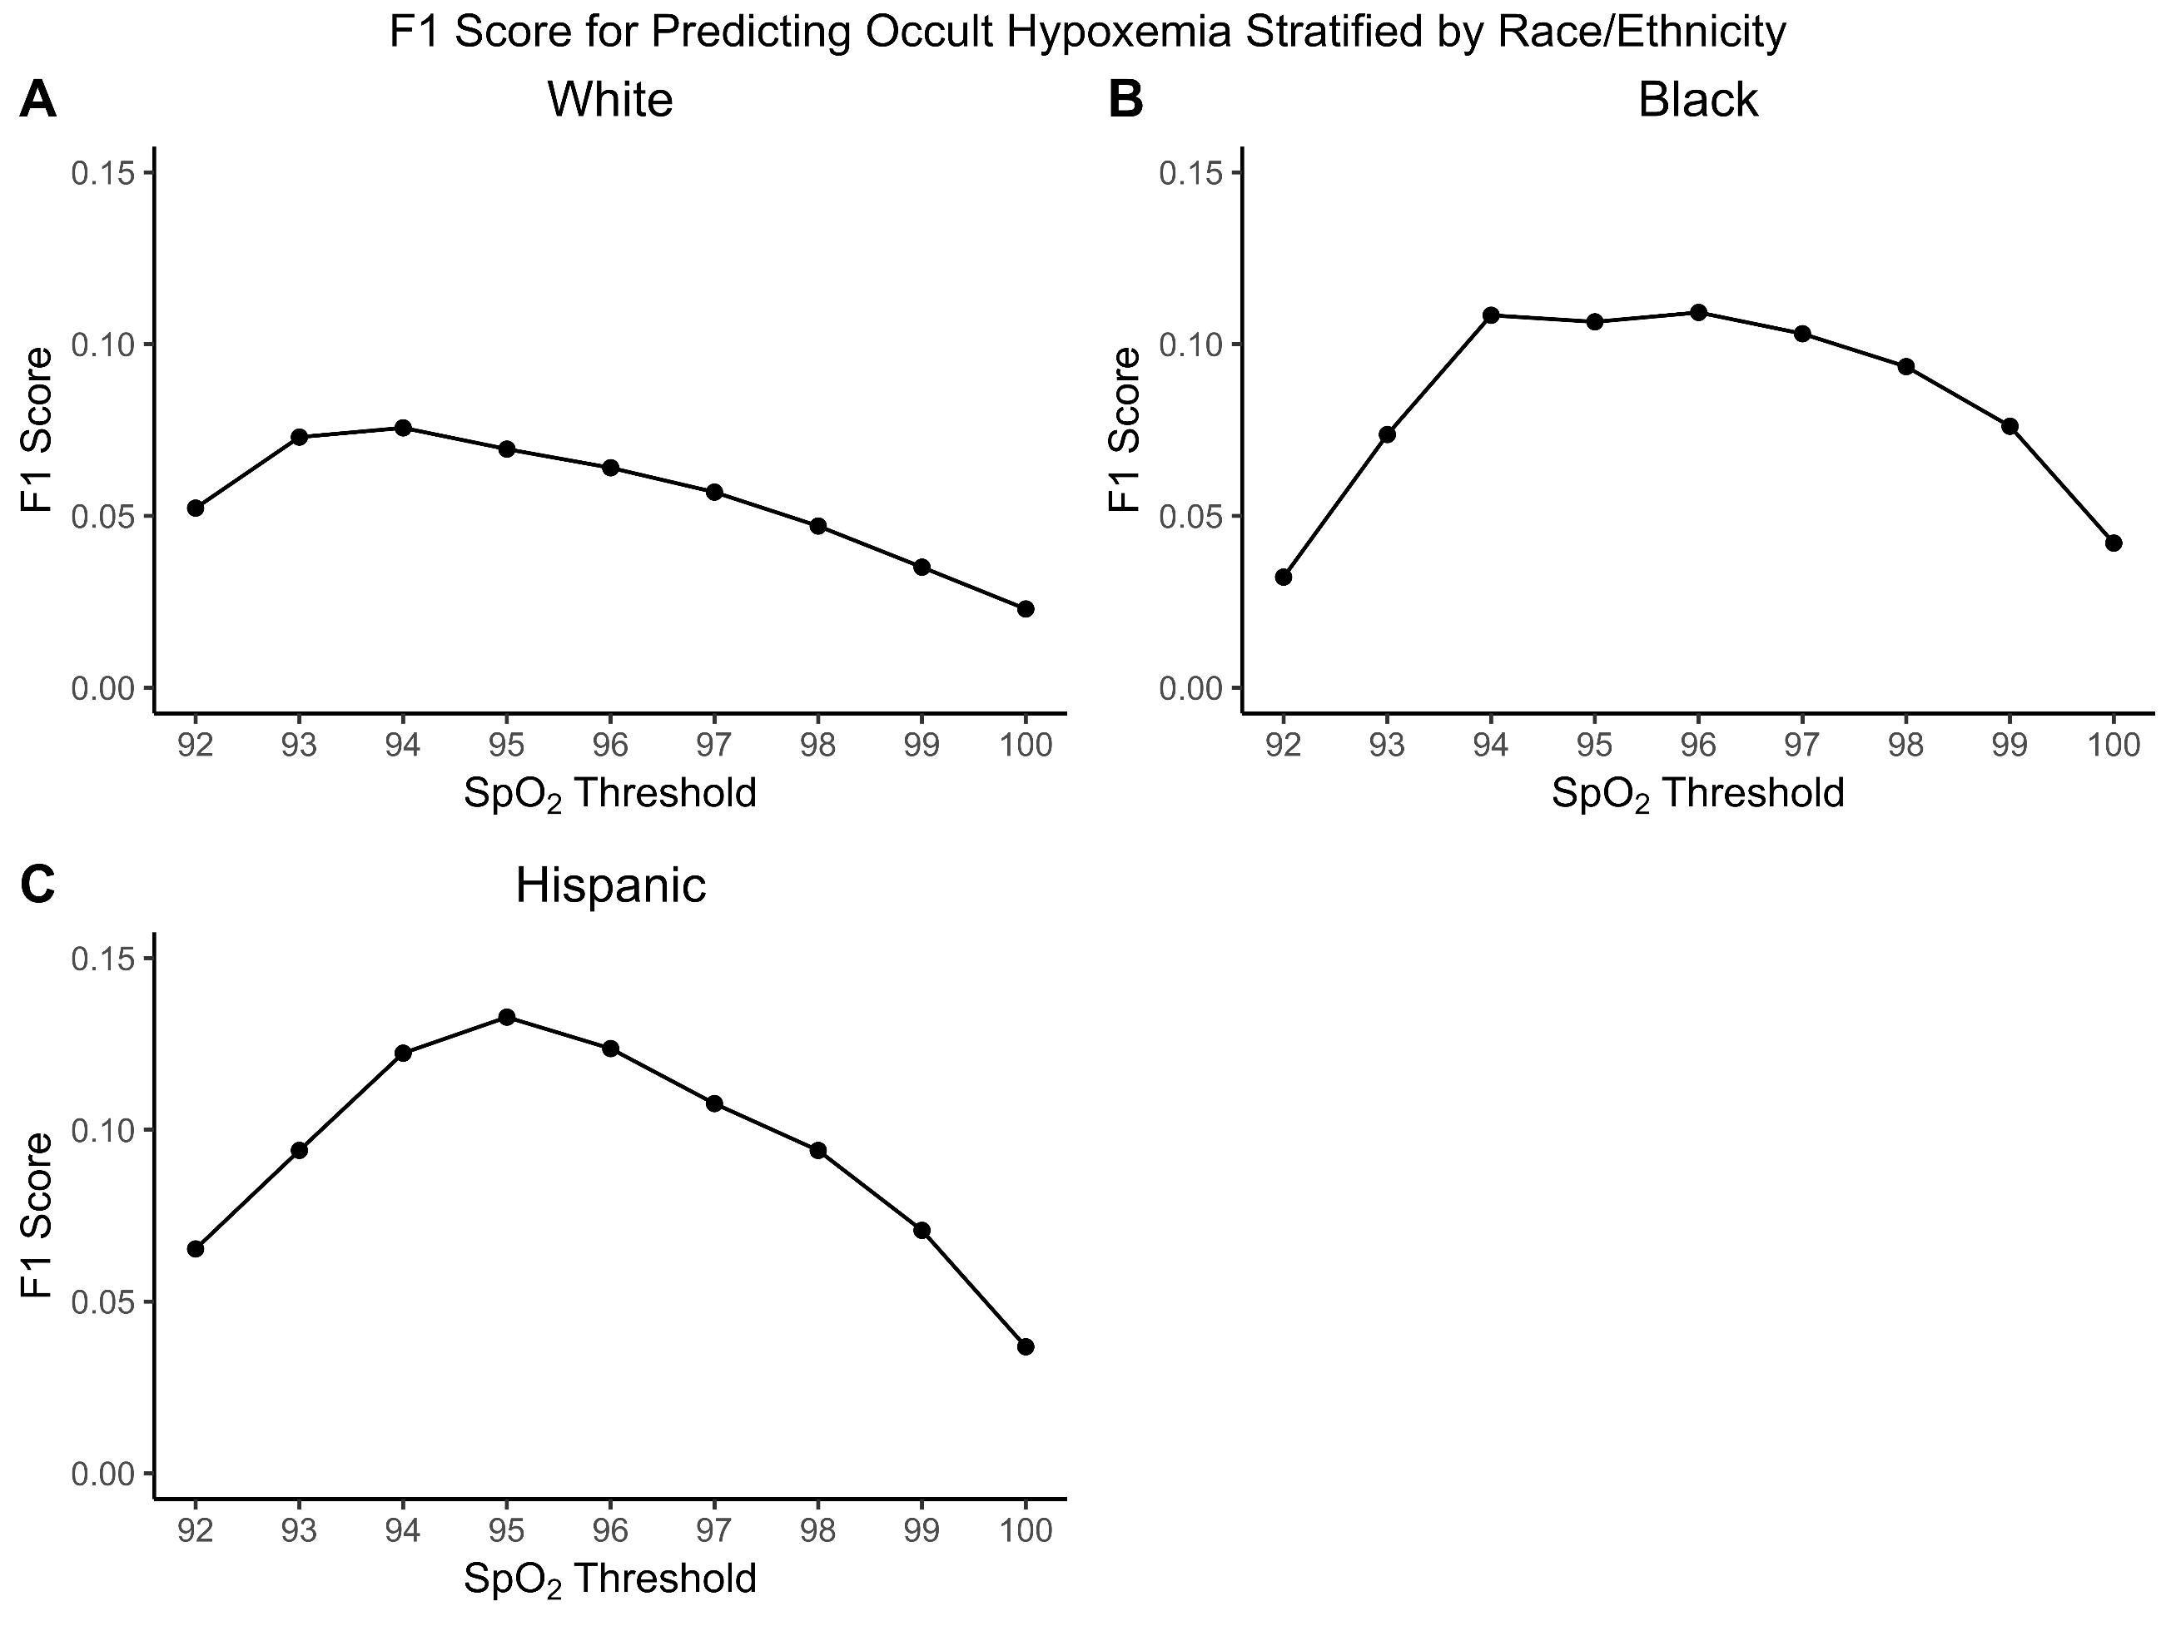
The F₁ score for occult hypoxemia (Sao₂ < 88% despite Spo₂ >92%) by self-reported White (A), Black (B), and Hispanic (C) race/ethnicity. The F₁ score can be used to determine the threshold at which a test has the best performance. The peak F₁ score for White (94%, F₁ score: 0.08), Black (96%, F₁ score: 0.11), Hispanic (95%, F₁ score: 0.13) patients are the optimal Spo₂ thresholds for predicted occult hypoxemia.

