Supplemental Digital Content
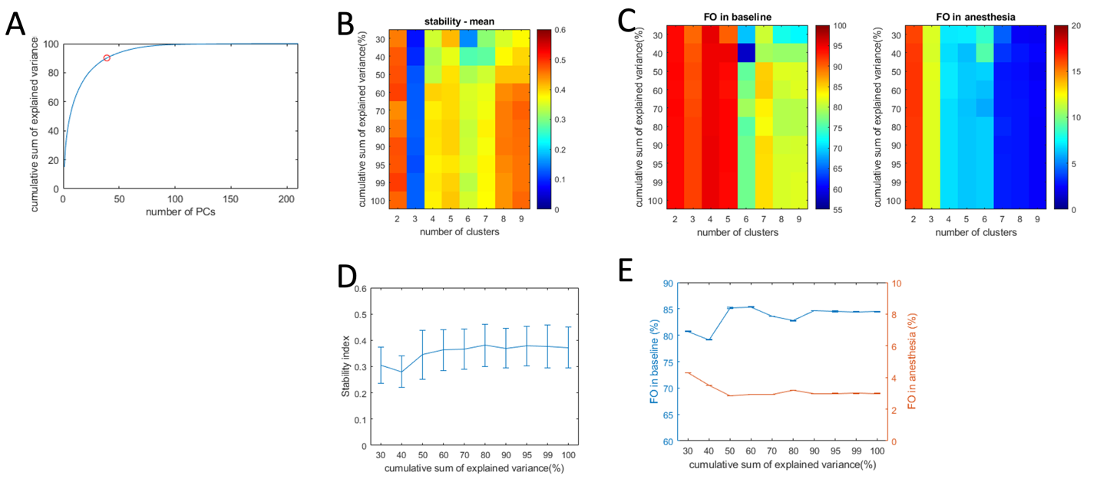
Figure 1. Parameter selection for dynamic connectivity analysis. The cumulative sum of explained variance plots as a function of the number of retained principal components (PC) is shown in (A). The stability index which quantifies the reproducibility of clustering solutions for the studied dataset (smaller value suggests a higher agreement level) and the number of clusters (mean across 100 realizations; B). Fractional occupancy (FO) of the connectivity state associated with baseline (left) and anesthetic state (right; from loss of consciousness to the discontinuation of anesthetic agent; mean across 100 realizations; C). Under the assumption that the subjects were unconscious during anesthesia, the connectivity state associated with baseline ideally should differ from those during general anesthesia (see Figure 2), thus a smaller value of FO in anesthesia suggesting a better clustering solution. Overall, a 3-cluster solution showed the best performance (B) followed by 4- to 7- cluster solutions but balancing statistical robustness with the aforementioned assumption and supported by the empirical findings the 7-cluster solution was determined to be the optimal fit. For the 7-cluster solution, the stability index (mean ± SD) and fractional occupancy in baseline (blue line) and anesthesia (red line; mean ± SD) as a function of the cumulative sum of explained variance are shown (D and E, respectively). When the retained principal components contained 30-40% of variance, the stability index demonstrated better performance, but the baseline-associated state demonstrated worse performance. When the explained variance achieved 90% or higher, both methods demonstrated stable performance; therefore, we chose the retained principal components that explained 90% of the variance.

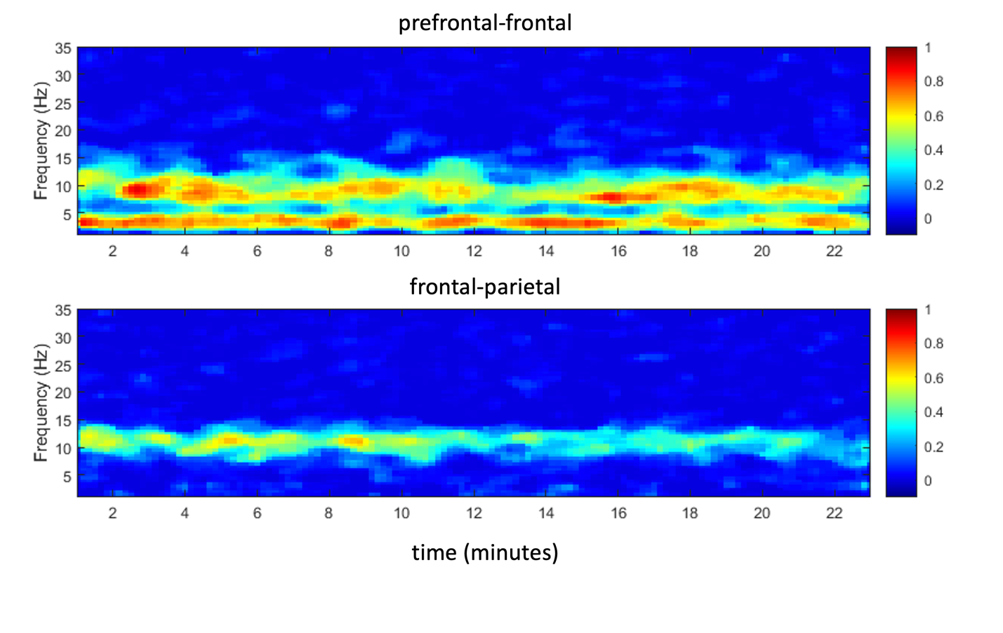Figure 2. Representative connectograms from subject E01 showing the three weighted phase lag index connectivity bands used for post hoc analysis of the temporal variation in cortical connectivity during the stable surgical anesthesia period which is shown in Figure 5. Note the prefrontal-frontal (2-6.5 Hz, and 7-13 Hz) and frontal-parietal (7-13 Hz) functional connectivity bands used for analysis.

A
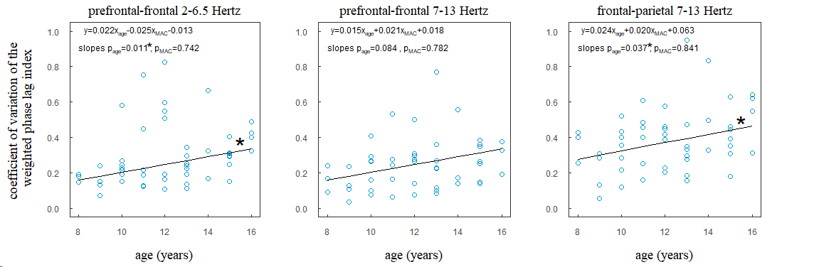
B
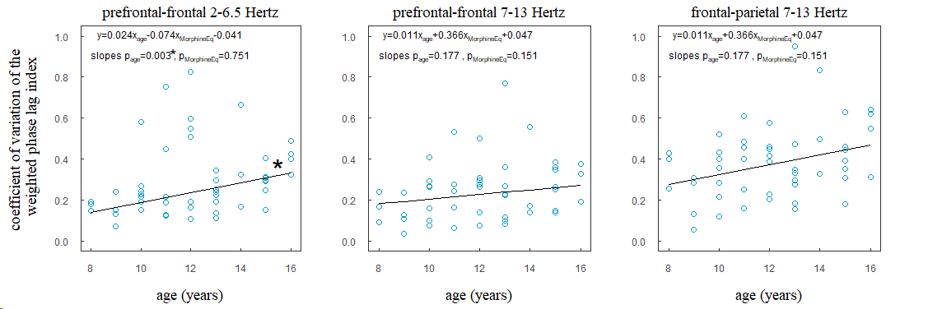
C
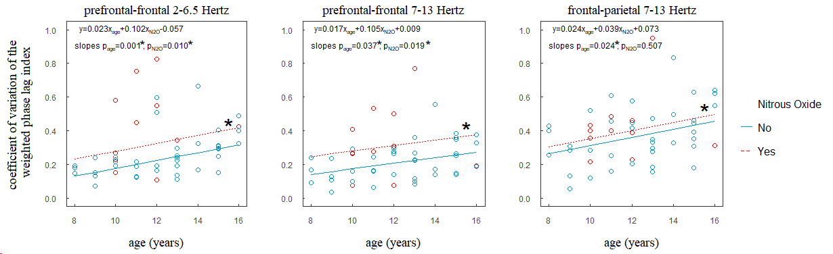

Figure 3. Association of age and temporal variations in the three dominant connectivity patterns (prefrontal-frontal 2-6.5Hz [left column], prefrontal-frontal 7-13Hz [middle column], and frontal-parietal 7-13Hz [right column] bands) during the stable surgical anesthesia period. Multivariable linear regressions showing the association of age and the coefficient of variation for the weighted phase lag index controlling for the: average minimum alveolar concentration during the stable surgical anesthesia period (n=49; panel A), intraoperative morphine equivalents (n=49; panel B), or maintenance of general anesthesia supplemented with (n=11) or without (n=38) nitrous oxide (panel C). Regression lines for panels A and B are plotted at the mean average minimum alveolar concentration (MAC) and intraoperative morphine equivalents (MorphineEq), respectively. The regression lines for panel C are plotted for both the binary outcome (yes/no) variables for supplementation with (red circle) or without (blue circle) nitrous oxide (N2O). The line equation and p-values for slopes are shown in the upper left corner of each connectivity band. *denotes statistical significance (p<0.05).

