SUPPLEMENTAL DIGITAL CONTENT 2
Mechanical power during general anaesthesia and postoperative respiratory failure: A multicentre retrospective cohort study

Peter Santer, MD, DPhil^{1,2}, Luca J. Wachtendorf, cand.med.^{1,3}, Aiman Suleiman, MD, MSc^{1,2,4}, Timothy T. Houle, PhD⁵, Philipp Fassbender, MD^{1,6}, Eduardo L. Costa, MD^{7,8}, Daniel Talmor, MD, MPH¹, Matthias Eikermann, MD, PhD^{3,9}, Elias Baedorf-Kassis, MD¹⁰, Maximilian S. Schaefer, MD, PhD^{1,2,11}

¹ Department of Anesthesia, Critical Care and Pain Medicine, Beth Israel Deaconess Medical Center, Harvard Medical School, Boston, MA, USA
² Center for Anesthesia Research Excellence (CARE), Beth Israel Deaconess Medical Center, Boston, MA, USA
³ Department of Anesthesiology, Montefiore Medical Center and Albert Einstein College of Medicine, Bronx, NY, USA
⁴ Department of Anesthesia, Intensive Care and Pain Management, Faculty of Medicine, University of Jordan, Amman, Jordan
⁵ Department of Anesthesia, Critical Care and Pain Medicine, Massachusetts General Hospital, Harvard Medical School, Boston, MA
⁶ Klinik für Anästhesiologie, operative Intensivmedizin, Schmerz- und Palliativmedizin, Marien Hospital Herne, Universitätsklinikum der Ruhr-Universität Bochum, Herne, Germany
⁷ Laboratório de Pneumologia LIM-09, Disciplina de Pneumologia, Heart Institute (Incor), Hospital das Clínicas da Faculdade de Medicina da Universidade de São Paulo, Brazil
⁸ Research and Education Institute, Hospital Sírio-Libanes, Sao Paulo, Brazil
⁹ Klinik für Anästhesiologie und Intensivmedizin, Universität Duisburg-Essen, Essen, Germany
¹⁰ Department of Medicine, Division of Pulmonary and Critical Care, Beth Israel Deaconess Medical Center, Harvard Medical School, Boston, MA, USA
¹¹ Department of Anesthesiology, Duesseldorf University Hospital, Duesseldorf, Germany

Corresponding author:
Maximilian S. Schaefer, MD, PhD
Department of Anesthesia, Critical Care and Pain Medicine, Beth Israel Deaconess Medical Center, 330 Brookline Avenue, Boston, MA, 02215
Email: msschaef@bidmc.harvard.edu

To respect space limitations of the main manuscript, we present additional information in this Supplemental Digital Content.
Table of contents
Section S1. Supplemental Methods 5
Data Sources 5
Exposure 5
Confounders 6
Outcome 6
Section S2. Sensitivity analyses 8
Categorization of the exposure variable 8
Weight-adjusted exposure variable 8
Recalculation of exposure variable 8
Exclusion of patients without available plateau pressure data 9
Exclusion of patients with laryngeal mask airway devices 9
Exclusion of patients undergoing laparoscopic procedures 10
Subgroup of patients with duration of surgery > 3 hours 10
Subgroup of patients undergoing thoracic surgery 10
Adjustment for arterial blood gas parameters 10
Exclusion of patients who received blood transfusion during surgery 11
Exclusion of patients who underwent thoracic surgery 11
Effect of anesthesia provider variability 11
Multiple imputation of missing data 12
Bootstrap analyses of the primary model 12
Inverse probability of treatment weighting 13
Section S3. Exploratory analyses 14
Absolute increase in mechanical power during surgery 14
The association of intraoperative fluid administration with temporal increases of mechanical power 15
Characteristics per year of surgery 15
Early versus late reintubation 15
Postoperative pulmonary complications 16
Effect modification analysis by the depth of neuromuscular blocking 16
Effect modification analysis by the mode of ventilation 16
Effect modification analysis by the most prominently imbalanced variables 16
Supplemental Tables 18
Table S1. Results of the primary analysis. 18
Table S2. Odds ratios per quintiles of mechanical power. 23
Table S3. Patient chracteristics per quintiles of mechanical power. 24
Table S4. Absolute increase in mechanical power during surgery 29
Table S5. Changes in ventilator parameters in cases with and without absolute increases in mechanical power 30
Table S6. Frequency of reintubation per year of surgery 31
Supplemental Figures 32
Figure S1. Calibration plot of the primary regression model 32
Figure S2. Agreement between median-based and minute-by-minute based mechanical power 32
Figure S3. Provider variability 34
Figure S4. The mean balance of the confounding variables 35
Figure S5. Changes in mechanical power and ventilator parameters over the study period 36
Figure S6. Median mechanical power per year in reintubated versus not reintubated patients 37
Figure S7. Daily distribution of reintubation after surgery 38
References 39

Section S1. Supplemental Methods

Data Sources
Data used in this study were obtained from the electronic hospital information management systems at Beth Israel Deaconess Medical Center (BIDMC) and Massachusetts General Hospital (MGH). Datasets were deidentified within the respective hospital network and subsequently combined for analyses.
Data from BIDMC was obtained from anaesthesia research data repository, which combines deidentified perioperative data from various structured query language server-based hospital databases. Perioperative anaesthesia-related data, including vital signs, ventilator settings, intraoperatively administered medications, event times and notes, were extracted from the Anaesthesia Information Management System (AIMS, Philips CompuRecord). Surgery-related data, such as surgical service or procedure times, were retrieved from the Perioperative Information Management System (PIMS). Comorbidity data (International Classification of Disease [ICD] 9/10 diagnostic codes) were extracted from the Casemix hospital billing database, and admission-related information and demographics from the Admission Discharge Transfer (ADT) database. Current Procedural Terminology (CPT) codes were obtained from the Center for Clinical Computing (CCC) anaesthesia billing database and used to define procedural severity. Data on postoperative ventilation information were retrieved from the Respiratory Therapy database.
Data at MGH was collected from the hospital’s AIMS, Enterprise Performance Systems Inc. (EPSi) as well as the Partners Research Patient Data Registry (RPDR), which is a centralised clinical data registry including billing codes and demographics.

Exposure
Power is a concept in classical physics that reflects work over time. Work stems from applying force over a specific distance and is measured in Joules. In three-dimensional structures like the lung, force and distance are reflected by pressure and volume, respectively. Work is equal to the area under the curve of the pressure-volume loop. The derivation of mechanical power equation can be simplified by explaining its individual components: (1) 0.098 is a conversion factor for units of pressure (cmH₂O and Pascal); (2) respiratory rate reflects the time component of the classical work-power derivation; (3) tidal volume represents the distance travelled per breath; (4) the pressure component of the formula is the product of the three distinct pressure-derived components of area under the curve in the pressure-volume loop, which are the static component (PEEP), the dynamic elastic component (P_{plat}−PEEP), and the dynamic resistive component (P_{peak}−P_{plat}). Median mechanical power was calculated over the duration of surgery and was used as the primary exposure in 5 J/min increments.
Mechanical power was calculated based on data from curated repositories at the two medical centers. These repositories comprise median values for each respiratory parameter for each patient case and have been calculated based on all available recordings between intubation and extubation at the time of data extraction from the respective anesthesia record. The granularity of raw recordings of each respiratory parameter is 1 per minute for both centers. To address potential bias arising from utilizing median values for mechanical power calculation, we conducted a sensitivity analysis in a subgroup of patients from one study center where we obtained raw minute-by-minute extracts, as outlined in Section S2.

Confounders
We categorized our confounding variables based on linearity assumption into quintiles (age, duration of surgery, work relative value unit as a marker for the procedural complexity based on CPT codes,^{1,2} hypotensive minutes, vasopressors, fluids, short and long acting opioids, neuromuscular blocking agents, neostigmine, age-adjusted minimal alveolar concentration [MAC], fractional inspired Oxygen [FiO₂]) or clinically relevant categories (American Society of Anesthesiologists [ASA] physical status classification, Charlson Comorbidity Index [CCI], surgical service, packed red blood cell [PRBC] units) or binary variables (sex, Score for the Prediction of Postoperative Respiratory Complications [SPORC], smoking, chronic obstructive pulmonary disease [COPD], congestive heart failure [CHF]). Sugammadex was used as a binary variable. We also adjusted for the year of surgery. Opioid doses were calculated in morphine equivalent doses and vasopressors were calculated in norepinephrine equivalent doses based on previously published calculations.^{3,4} The study site was included as a random effect in the mixed-effect logistic regression model.

Outcome
Our primary outcome was postoperative respiratory failure requiring reintubation within 7 days. The outcome was validated in previous studies^{5,6} defined based on billing data provided by respiratory therapists, and cross-validated using ICD-9/10 diagnostic codes, CPT codes and chart reviews in randomly selected patients. Results from our primary analysis model (Model 1) with all included confounders are summarized in Table S1.

Section S2. Sensitivity analyses

Categorization of the exposure variable
To address a potential non-linear relationship between the primary exposure and outcome, we redefined the exposure variable by categorising mechanical power into equally sized quintiles.
Intraoperative mechanical power ranged from a median of 3 (range 0.2–4.2) J/min in quintile 1, to 11.9 (range 9.8–38.8) J/min in quintile 5. The incidence of postoperative respiratory failure requiring reintubation within 7 days got higher from 0.4% in quintile 1 to 1.2% in quintile 5 (Table S2). After adjusting for a priori defined confounders, patients ventilated with the highest mechanical power values (quintiles 4 and 5) had higher odds of postoperative reintubation compared to patients in quintile 1 (quintile 4: adjusted OR [OR_{adj}] 1.46; 95%CI 1.19–1.78; p<0.001; quintile 5: OR_{adj} 1.66; 95%CI 1.34–2.05; p<0.001; Table S2). Patient characteristics per quintiles of mechanical power are summarized in Table S3.

Weight-adjusted exposure variable
Based on previous literature, we redefined the exposure variable by adjusting mechanical power for ideal body weight and body mass index and repeated the primary analysis.
The association between mechanical power and the outcome of postoperative respiratory failure requiring reintubation within 7 days remained significant. When adjusting mechanical power for ideal body weight, the risk of reintubation got higher by 44% with each 0.1 J/min/kg increase in mechanical power (OR_{adj} 1.44 per 0.1 J/min/kg; 95% CI 1.31–1.59; p<0.001). When adjusting mechanical power for body mass index, the risk of reintubation increased by 17% with each 0.1 J/min/kg m² increase in mechanical power (OR_{adj} 1.17 per 0.1 J/min/kg m²; 95% CI 1.11–1.22; p<0.001).

Recalculation of exposure variable
In a subgroup of patients with available highly granular, minute-by-minute ventilator data, we redefined the exposure variable by calculating mechanical power on a minute-by-minute basis: Minute-by-minute recordings of tidal volume, respiratory rate, peak inspiratory and positive end-expiratory pressures were used to calculate mechanical power. The median was subsequently derived from the minute-by-minute values of mechanical power and compared to the mechanical power values obtained using the medians of its components for the calculation.
Minute-by-minute data for ventilator parameters needed to calculate mechanical power were available in 137,507 (59.6%) cases. Using Bland Altman analysis, good agreement was shown between median-based mechanical power values and values derived from minute-by-minute data (mean difference: −0.04 J/min; 95% limits of agreement: −1.58 to 1.49 J/min; Figure S2). We repeated the primary analysis in this subgroup using the redefined exposure variable. In this cohort of 137,507 cases, 1,305 (0.95%) patients required postoperative reintubation. Intraoperative mechanical power remained significantly associated with postoperative respiratory failure requiring reintubation within 7 days (OR_{adj} 1.54 per 5 J/min increase in mechanical power; 95% CI 1.24–1.9; p<0.001).

Exclusion of patients without available plateau pressure data
To address inaccuracies arising from the approximation of plateau pressure in cases with missing data (i.e. use of peak inspiratory pressure in cases with missing plateau pressure), we repeated the primary analysis in the subgroup of patients with available plateau pressure measurements and excluded cases with missing data for this parameter.
Plateau pressure data were available in a subgroup of 89,478 cases, of whom 677 (0.76%) experienced the primary outcome of postoperative reintubation within 7 days. In this subgroup, intraoperative mechanical power remained significantly associated with the primary outcome (OR_{adj} 1.29 per 5 J/min increase; 95% CI 1.13–1.47; p<0.001).

Exclusion of patients with laryngeal mask airway devices
To account for differences in ventilation strategies when using laryngeal mask airway devices, we repeated the primary analysis in the subgroup of patients receiving endotracheal tubes.
After excluding cases receiving laryngeal mask airways, 189,980 cases undergoing endotracheal intubation remained in the cohort. Among those, 1,953 (0.95%) required postoperative reintubation within 7 days. Intraoperative mechanical power remained significantly associated with the primary outcome in this subgroup (OR_{adj} 1.31 per 5 J/min increase; 95% CI 1.2–1.42; p<0.001).

Exclusion of patients undergoing laparoscopic procedures
To address the effect of increased intraabdominal pressure during laparoscopic procedures on ventilator parameters, we repeated the primary analysis after excluding these cases.
A total of 19,271 laparoscopic cases were identified. After excluding those cases, 211,496 cases remained in the cohort. Intraoperative mechanical power remained significantly associated with postoperative respiratory failure requiring reintubation (OR_{adj} 1.35 per 5 J/min increase; 95% CI 1.24–1.47; p<0.001).

Subgroup of patients with duration of surgery > 3 hours
We re-evaluated the association between intraoperative mechanical power and postoperative respiratory failure requiring reintubation within 7 days in subgroups of patients undergoing surgeries with a duration of at least 3 hours and are inpatients.
We identified 62,448 cases, of whom 1,120 (1.8%) experienced the primary outcome of reintubation within 7 postoperative days. Mechanical power was significantly associated with the primary outcome in this subgroup (OR_{adj} 1.33 per 5 J/min increase; 95% CI 1.2–1.48; p<0.001).

Subgroup of patients undergoing thoracic surgery
The subgroup of patients undergoing thoracic surgery consisted of 13,876 cases, of whom 296 (2.13%) experienced the primary outcome. Mechanical power was significantly associated with the postoperative reintubation within 7 days in these cases (OR_{adj} 1.51 per 5 J/min increase; 95% CI 1.22–1.87; p<0.001).

Adjustment for arterial blood gas parameters
In a subgroup of patients with available blood gas analyses, we assessed the association between intraoperative mechanical power and postoperative respiratory failure after adjusting for the following variables derived from arterial blood gas analyses: (1) ratio of arterial partial pressure of oxygen to fraction of inspired oxygen (PaO₂/FiO₂ ratio), (2) arterial partial pressure of carbon dioxide (PaCO₂), and (3) PaCO₂−etCO₂ gradient as a marker of the degree of physiological dead space.
Intraoperative arterial blood gas analyses were available in 6,941 cases. Of those, 378 (5.45%) patients experienced the primary outcome of postoperative respiratory failure requiring reintubation. The adjusted odds ratios for the association between mechanical power and the postoperative respiratory failure remained comparable to the primary study cohort after adjusting for (1) PaO₂/FiO₂ ratio (OR_{adj} 1.22 per 5 J/min increase; 95%CI 1.00–1.51; p=0.059), (2) PaCO₂ (OR_{adj} 1.21 per 5 J/min increase; 95% CI 1–1.49; p=0.067), and (3) PaCO₂−etCO₂ gradient (OR_{adj} 1.23 per 5 J/min increase; 95% CI 1–1.51; p=0.054). The marginally significant levels can be attributed to the low sample size in this subgroup.

Exclusion of patients who received blood transfusion during surgery
To control for the effect of intraoperative blood transfusion on ventilator parameters, we repeated the primary analysis after excluding cases that received intraoperative blood transfusion.
We identified 225,879 patients that did not receive transfusion. Intraoperative mechanical power remained significantly associated with postoperative respiratory failure requiring reintubation (OR_{adj} 1.29 per 5 J/min increase in mechanical power; 95% CI 1.19–1.41; p<0.001).

Exclusion of patients who underwent thoracic surgery
To address the effect of thoracic surgery on ventilator parameters, we repeated the primary analysis after excluding thoracic surgery cases. We identified 216,891 patients that did not undergo thoracic surgery, of which 1,728 (0.8%) were reintubated. Intraoperative mechanical power remained significantly associated with postoperative respiratory failure requiring reintubation (OR_{adj} 1.26 per 5 J/min increase in mechanical power; 95% CI 1.15–1.37; p<0.001).

Effect of anesthesia provider variability
The intraoperative management of mechanical ventilation may depend on an individual anesthesia provider’s practice. We conducted a sensitivity analysis where we assessed provider variability in our study cohort. To define an individual provider’s likelihood of using high mechanical power, we used a multivariable mixed-effects logistic regression model to calculate the adjusted probability for the occurrence of high mechanical power (highest quintile) for each individual provider – a method we have used before.⁷ For each individual anesthesia provider, we then calculated the adjusted likelihood of using high mechanical power across all cases performed by this provider.
We observed variability in using high mechanical power across individual anaesthesia providers with a predicted probability ranging from 8.8% to 43% (Figure S3). We then added the individual anesthesia provider as a random effect to the model, then nested the anesthesia providers variables and repeated primary model as mixed-effect model⁷: our results remained robust, and high mechanical power (highest quintile) was significantly associated with postoperative respiratory failure requiring reintubation (OR_{adj} 1.31 per 5 J/min; 95% CI 1.15–1.5; p<0.001).

Multiple imputation of missing data
The primary analysis was conducted in a complete-case cohort. To address potential bias resulting from missing data of confounding varibales, we performed multiple imputation by chained equations.
A total of 9 covariates contained missing data. The variables with the most missing data points included the “Score for the prediction of postoperative respiratory complications (SPORC)” (2.5%), body mass index (1.8%), and surgical service (1.7%).
After five imputations with five iterations each, we repeated the primary analysis in the imputed cohort (n=245,229) assuming missing at random mechanism. The associations between intraoperative mechanical power and postoperative respiratory failure requiring reintubation within 7 days remained robust in this cohort (OR_{adj} 1.27 per 5 J/min increase in mechanical power; 95% CI 1.18–1.37; p<0.001).

Bootstrap analyses of the primary model
We have performed a bootstrapping analysis to check robustness of our results through resampling our data with 1,000 bootstraps. Our results remained robust: high mechanical power was associated with a 31% higher risk of reintubation per 5 J/min increase in mechanical power (OR_{adj} 1.31 per 5 J/min; 95% CI 1.21–142; p<0.001).

Inverse probability of treatment weighting
As an additional sensitivity analysis, we used propensity score estimates in an inverse probability of treatment weighting model.⁸
A logistic regression model using multinomial propensity scores was used to estimate the probability of a patient to be in any of the exposure groups (i.e., quintiles of mechanical power). Ranges of mechanical power quintiles were <4.16 J/min in the 1st quintile, 4.16 to 5.84 J/min in the 2nd quintile, 5.84 to 7.49 in the 3rd quintile, 7.49 to 9.83 in the 4th quintile, and >9.83 J/min in the highest quintile. The derived predicted probabilities of patients included in our study cohort for the individual exposure groups were then included as weights in subsequent analyses, re-evaluating the association between mechanical power and postoperative respiratory failure requiring reintubation adjusted for the treatment weights. Statistical analysis was performed using the ‘mnps’ package in R Statistical Software (Foundation for Statistical Computing, Vienna, Austria). The mean balance of all confounding variables used in our analysis is displayed in Figure S4, indicating that inverse probability of treatment weighting yielded adequate balance among all confounding variables. After inverse probability of treatment weighting with the confounders used in the primary analysis, high mechanical power (highest quintile) remained associated with an greater risk of postoperative respiratory failure requiring reintubation (ORadj 2.08; 95% CI 1.61–2.7; p<0.001).⁸

Section S3. Exploratory analyses

Absolute increase in mechanical power during surgery
In a hypothesis-generating exploratory analysis, we observed a constant linear increase in mechanical power in patients eventually experiencing postoperative respiratory failure requiring reintubation within 7 days (Figure 5B in Manuscript). To further dissect this finding, we evaluated the effect of absolute changes in mechanical power during surgery on the primary outcome.
Among a subgroup of cases with available minute-by-minute ventilator data, we identified 126,621 cases with sufficient data to calculate absolute changes in mechanical power during surgery. For each case, we defined time periods for the first and second half of the procedure based on intubation times and extubation/end-of-case times. We then calculated the mean mechanical power during the first and second halves of each procedure from minute-by-minute values of mechanical power. We defined the absolute change in mechanical power by subtracting the mean mechanical power during the first half of a procedure from the mean mechanical power during the second half of a procedure. The median (IQR) change in mechanical power across all cases was −0.28 (−1.24 to 0.63) J/min.
To evaluate the association of absolute changes in mechanical power during a procedure with the primary outcome, we compared cases with increases in mechanical power (i.e. absolute change >0 J/min) to cases without an increase in mechanical power (i.e. absolute change ≤0 J/min, reference group). Cases with increases above certain thresholds of mechanical power (i.e. absolute change >0, >1, >2, >3, >4, and >5 J/min) were compared to the reference group in separate logistic regression models.
For cases with absolute increases in mechanical power >2 J/min from start to end of surgery, higher odds of experiencing postoperative respiratory failure were observed (see Table S4). Increases in mechanical power >5 J/min showed the most pronounced increase in risk (OR_{adj} 1.56; 95% CI 0.98–2.49; p=0.060). The adjusted absolute risk to experience postoperative respiratory failure is depicted in Figure 5B in the main manuscript.
We identified a threshold increase in mechanical power >2 J/min between start and end of surgery to be significantly associated with higher risk of postoperative respiratory failure requiring reintubation. In this subgroup of 126,621 cases, 9,802 (7.74%) had absolute increases in mechanical power of >2 J/min from start to end of surgery. Of those, 1.27% (126 out of 9,802 cases) experienced postoperative respiratory failure, compared to 1% (1,215 out of 116,693 cases) of patients with increases less or equal to 2 J/min. An increase in mechanical power of >2 J/min resulted in a risk difference of 0.3% (OR_{adj} 1.28; 95% CI 1.04–1.58, p=0.02)) when adjusted for the confounders used in the primary analysis.
Supplementary Table S5 summarizes differences in ventilator parameters between cases with increases in mechanical power ≤2 J/min and >2 J/min. We also explored the association with intraoperative fluid on temporal increases with mechanical power during surgery.

The association of intraoperative fluid administration with temporal increases of mechanical power
In a subgroup of patients with temporal increases in mechanical power of > 2 J/min during surgery, the median (IQR) volume of fluid given to patients with a temporal increase in mechanical power during surgery of >2 J/min was 1.2 L (0.8–2 L), compared to 1 L (0.7–1.5 L) in the group with a temporal increase of ≤ 2 J/min. Although the median difference was statistically significant using Mann-Whitney U test (p<0.001), the difference of 0.2 L increase in fluid seems clinically irrelevant.

Characteristics per year of surgery
We investigated how reintubation and median mechanical power varied over the years of surgeries included in our cohort. Table S6 represents number of reintubated patients per year of surgery. Figure S5 represents changes in median mechanical power and ventilator parameters over the years included in our cohort. Figure S6 represents changes in median mechanical power in reintubated compared to non-reintubated patients.

Early versus late reintubation
We investigated the association between mechanical power and early (postoperative days 0-3) and late (postoperative days 4-7) reintubation after surgery. 1,569 of patients required early reintubation, while 455 required late reintubation. A higher mechanical power was associated with 39% increase in the odds of early reintubation per 5 J/min increase in mechanical power (OR_{adj} 1.39; 95% CI 1.27–1.52; p<0.001), while no significant association was found with late reintubation (OR_{adj} 1.02; 95% CI 0.85–1.22; p=0.84). Figure S7 represents the distribution of reintubation events in cases that were reintubated over 7 days following surgery.

Postoperative pulmonary complications
We investigated the commonly used composite outcome of postoperative pulmonary complications, defined as atelectasis, pneumonia, respiratory failure, and exacerbation of underlying chronic lung disease⁹ in a subgroup of patients where these data were available (n=89,478). We found that higher mechanical power was associated with greater odds of postoperative pulmonary complications with an adjusted odds ratio of 1.14 per 5 J/min increase in mechanical power (95% CI 1.08–1.21; p<0.001).

Effect modification analysis by the depth of neuromuscular blocking
We have performed effect modification analyses by the depth of NMB (defined as median intraoperative TOF and excluding baseline and post-reversal), categorized into deep (TOF ≤1) and not deep (TOF ≥2) neuromuscular blockade, as previously published.^{10,11} This analysis was done in a subgroup of patients with available data (n=55,837). We found no effect modification of the association between mechanical power and postoperative respiratory failure by deep NMB (p-for-interaction=0.59).

Effect modification analysis by the mode of ventilation
We have performed effect modification analyses by the mode of ventilation, categorized into pressure control ventilation vs other modes of ventilation. This analysis was done in a subgroup of patients with available data (n=89,445). There was no significant effect modification of mode of ventilation on the association between mechanical power and reintubation within 7 days postoperatively (p=0.82).

Effect modification analysis by the most prominently imbalanced variables
We have performed interaction term analysis of the most prominently imbalanced variables to further address the robustness of our results. None of the interactions tested showed significant effect modification on the association between mechanical power and postoperative respiratory failure requiring reintubation, these included: age (p-for-interaction=0.49), ASA physical status (p-for-interaction=0.93), duration of surgery (p-for-interaction=0.88), general surgery service (p-for-interaction=0.98), neurosurgery (p-for-interaction=0.85), Gynecological surgery (p-for-interaction=0.81), orthopaedic surgery (p-for-interaction=0.72), use of vasopressors (p-for-interaction=0.2), intraoperative fluids (p-for-interaction=0.4), use of neuromuscular blockers (p-for-interaction=0.38) and Charlson comorbidity index (p-for-interaction=0.07).

Supplemental Tables

Table S1. Results of the primary analysis.

Primary model results
Reintubation | OR | p value | 95% CI
Mechanical power in 5 J/min | 1.31 | 0.00 | 1.21 | 1.42
Age in quintiles
2 | 1.18 | 0.12 | 0.96 | 1.45
3 | 1.25 | 0.03 | 1.02 | 1.52
4 | 1.46 | 0.00 | 1.2 | 1.77
5 | 1.63 | 0.00 | 1.34 | 1.99
Sex (female) | 0.95 | 0.29 | 0.86 | 1.05
Body mass index in quintiles
2 | 0.7 | 0.02 | 0.53 | 0.94
3 | 0.67 | 0.01 | 0.5 | 0.89
4 | 0.56 | 0.00 | 0.41 | 0.76
5 | 0.54 | 0.00 | 0.39 | 0.74
ASA class (>3) | 2.16 | 0.00 | 1.91 | 2.44
Sugammadex (binary) | 0.47 | 0.00 | 0.42 | 0.54
Neostigmine in quintiles
2 | 0.65 | 0.00 | 0.55 | 0.77
3 | 0.66 | 0.00 | 0.56 | 0.78
4 | 0.79 | 0.00 | 0.67 | 0.92
5 | 0.88 | 0.1 | 0.75 | 1.02
Year of surgery
2009 | 1.28 | 0.11 | 0.95 | 1.72
2010 | 1.15 | 0.37 | 0.85 | 1.55
2011 | 1.05 | 0.7 | 0.81 | 1.38
2012 | 1.01 | 0.91 | 0.78 | 1.32
2013 | 0.91 | 0.51 | 0.7 | 1.2
2014 | 0.94 | 0.64 | 0.72 | 1.23
2015 | 0.93 | 0.6 | 0.71 | 1.22
2016 | 1 | 0.98 | 0.75 | 1.34
2017 | 1 | 1 | 0.74 | 1.34
2018 | 1.27 | 0.11 | 0.95 | 1.7
Duration of surgery in quintiles
2 | 1.27 | 0.04 | 1.01 | 1.6
3 | 1.72 | 0.00 | 1.35 | 2.19
4 | 1.74 | 0.00 | 1.34 | 2.25
5 | 1.08 | 0.00 | 1.58 | 2.76
Surgical service per type of surgery
General surgery | 0.44 | 0.00 | 0.34 | 0.56
Gynecology | 0.19 | 0.00 | 0.13 | 0.27
Neurosurgery | 0.64 | 0.00 | 0.5 | 0.82
Oral/  Maxillofacial  surgery | 1.19 | 0.55 | 0.67 | 2.11
Orthopedic  surgery | 0.73 | 0.01 | 0.58 | 0.92
Otolaryngology | 0.28 | 0.00 | 0.16 | 0.46
Plastic surgery | 0.31 | 0.00 | 0.22 | 0.45
Surgical  oncology | 0.34 | 0.00 | 0.23 | 0.46
Thoracic  surgery | 0.64 | 0.00 | 0.5 | 0.82
Transplant | 0.44 | 0.00 | 0.32 | 0.6
Urology | 0.21 | 0.00 | 0.16 | 0.29
Vascular  surgery | 0.66 | 0.00 | 0.5 | 0.85
Other | 0.59 | 0.00 | 0.45 | 0.76
Work RVU in quintiles
2 | 0.61 | 0.00 | 0.49 | 0.76
3 | 0.59 | 0.00 | 0.48 | 0.73
4 | 0.49 | 0.51 | 0.77 | 1.13
5 | 1.22 | 0.05 | 1 | 1.49
Hypotensive minutes below 55 mmHg in quintiles
2 | 1.07 | 0.31 | 0.94 | 1.22
3 | 1.22 | 0.14 | 0.96 | 1.31
4 | 1.2 | 0.01 | 1.05 | 1.38
5 | 1.16 | 0.05 | 1 | 1.33
Vasopressors in quintiles
2 | 1.14 | 0.18 | 0.94 | 1.22
3 | 1.25 | 0.01 | 1.06 | 1.48
4 | 1.45 | 0.00 | 1.24 | 1.7
5 | 1.74 | 0.00 | 1.48 | 2.04
PRBCs in units
1 | 1.98 | 0.00 | 1.62 | 2.43
2 | 1.96 | 0.00 | 1.55 | 2.46
>2 | 2.91 | 0.00 | 2.18 | 3.88
Fluids in quintiles
2 | 0.76 | 0.00 | 0.65 | 0.9
3 | 0.8 | 0.06 | 0.63 | 1.01
4 | 0.77 | 0.01 | 0.64 | 0.93
5 | 1.06 | 0.59 | 0.86 | 1.3
Opioids (long acting) in quintiles
2 | 0.91 | 0.18 | 0.79 | 1.04
3 | 0.9 | 0.15 | 0.78 | 1.04
4 | 0.83 | 0.04 | 0.7 | 1
5 | 1.61 | 0.04 | 1 | 1.34
Opioids (short acting) in quintiles
2 | 0.9 | 0.29 | 0.75 | 1.09
3 | 0.97 | 0.75 | 0.78 | 1.19
4 | 0.99 | 0.94 | 0.83 | 1.19
5 | 1.19 | 0.07 | 0.99 | 1.45
NMBA ED95 in quintiles
2 | 1.15 | 0.245 | 0.91 | 1.45
3 | 1.12 | 0.26 | 0.9 | 1.36
4 | 1.42 | 0.00 | 1.17 | 1.73
5 | 1.71 | 0.00 | 1.4 | 2.09
MAC in quintiles
2 | 0.7 | 0.00 | 0.6 | 0.8
3 | 0.63 | 0.00 | 0.54 | 0.74
4 | 0.55 | 0.00 | 0.47 | 0.64
5 | 0.65 | 0.00 | 0.56 | 0.75
FiO2 in quintiles
2 | 1.11 | 0.22 | 0.94 | 1.3
3 | 1.35 | 0.00 | 1.14 | 1.59
4 | 1.55 | 0.00 | 1.31 | 1.82
5 | 2.13 | 0.00 | 1.82 | 2.52
Charlson comorbidity index (clinically relevant categories)
1 | 1.12 | 0.09 | 0.98 | 1.29
2 | 1.33 | 0.00 | 1.11 | 1.6
3 | 1.46 | 0.00 | 1.24 | 1.73
4 | 1.69 | 0.00 | 1.43 | 1.99
SPORC (high) | 1.16 | 0.22 | 0.92 | 1.45
Smoking (binary) | 0.88 | 0.07 | 0.76 | 1.01
CHF (binary) | 1.7 | 0.00 | 1.43 | 2.03
COPD (binary) | 1.51 | 0.00 | 1.3 | 1.74
Airway (laryngeal mask airway) | 0.34 | 0.00 | 0.26 | 0.46
ASA: American Society of Anesthesiologists; RVU: relative value unit; PRBCs: Packed red blood cells; ND-NMBA: non-depolarizing neuromuscular blocking agents; MAC: minimal alveolar concentration; SPORC: Score for Prediction of Postoperative Respiratory Complications; COPD: chronic obstructive pulmonary disease; CHF: congestive heart failure. ED95 dose of neuromuscular blocking agents (NMBA): median effective dose required to achieve a 95% reduction in maximal twitch response from baseline.

Table S2. Odds ratios per quintiles of mechanical power.

No. of events (%) |  | Unadjusted analysis |  | Adjusted analysis
 |  | OR  (95% CI) | p value | Adjusted OR  (95% CI) | p value
Mechanical power quintiles
Quintile 1  (n = 46,168) | 186 (0.4%) | Reference | — | Reference | —
Quintile 2  (n = 46,157) | 381 (10.8%) | 2.06 (1.73–2.45) | <0.001 | 1.16 (0.96–1.41) | 0.124
Quintile 3  (n = 46,138) | 392 (0.5%) | 2.12 (1.78–2.52) | <0.001 | 1.1 (0.9–1.34) | 0.34
Quintile 4  (n = 46,152) | 510 (1.1%) | 2.76 (2.33–3.27) | <0.001 | 1.46 (1.19–1.78) | <0.001
Quintile 5  (n = 46,152) | 555 (1.2%) | 3.01 (2.55–3.55) | <0.001 | 1.66 (1.34–2.05) | <0.001
Data are expressed as frequency (prevalence in %). Statistical analyses were performed by using univariable and multivariable logistic regression. Results are reported as odds ratios (OR).

Table S3. Patient chracteristics per quintiles of mechanical power.

 | 1st quintile | 2nd quintile | 3rd quintile | 4th quintile | 5th quintile
 | n=46,168 | n=46,157 | n=46,138 | n=46,152 | n=46,152
Center
BIDMC | 35,170 (76.2%) | 27,198 (58.9%) | 26,089 (56.5%) | 26,367 (57.1%) | 26,465 (57.3%)
MGH | 10,998 (23.8%) | 18,959 (41.1%) | 20,049 (43.5%) | 19,785 (42.9%) | 19,687 (42.7%)
Age (years) | 53.9 ± 17.4 | 55.8 ± 17.3 | 55.3 ± 16.6 | 54.4 ± 15.5 | 52.3 ± 14.1
Sex
Male | 16,886 (36.6%) | 15,791 (34.2%) | 19,648 (42.6%) | 23,121 (50.1%) | 25,199 (54.6%)
Female | 29,282 (63.4%) | 30,366 (65.8%) | 26,490 (57.4%) | 23,031 (49.9%) | 20,953 (45.4%)
Body mass index | 25.6 ± 5.2 | 25.7 ± 4.9 | 27.3 ± 5.3 | 29.6 ± 6.0 | 34.2 ± 8.2
ASA class
1 | 8,371 (18.1%) | 5,701 (12.4%) | 4,837 (10.5%) | 3,842 (8.3%) | 2,445  (5.3%)
2 | 25,148 (54.5%) | 25,237 (54.7%) | 25,149 (54.5%) | 25,074 (54.3%) | 23,886 (51.8%)
3 | 11,856 (25.7%) | 14,255 (30.9%) | 15,184 (32.9%) | 16,210 (35.1%) | 18,846 (40.8%)
4 | 793  (1.7%) | 964  (2.1%) | 968  (2.1%) | 1,026 (2.2%) | 975  (2.1%)
Type of surgery
Acute care surgery | 603  (1.3%) | 1,061 (2.3%) | 1,359 (2.9%) | 1,772 (3.8%) | 2,009  (4.4%)
General surgery | 5,256 (11.4%) | 6,375 (13.8%) | 6,989 (15.1%) | 7,542 (16.3%) | 9,740 (21.1%)
Gynecology | 5,153 (11.2%) | 4,293 (9.3%) | 4,129 (8.9%) | 4,612 (10.0%) | 6,348 (13.8%)
Neurosurgery | 1,116 (2.4%) | 3,002 (6.5%) | 3,674 (8.0%) | 3,948 (8.6%) | 3,526  (7.6%)
Oral/Maxillofacial  surgery | 211  (0.5%) | 511  (1.1%) | 556  (1.2%) | 529  (1.1%) | 402  (0.9%)
Orthopedic surgery | 13,044 (28.3%) | 10,693 (23.2%) | 10,530 (22.8%) | 10,230 (22.2%) | 8,274 (17.9%)
Otolaryngology | 2,167 (4.7%) | 1,344 (2.9%) | 1,134 (2.5%) | 1,124 (2.4%) | 960  (2.1%)
Plastic surgery | 3,191 (6.9%) | 4,655 (10.1%) | 3,898 (8.4%) | 2,826 (6.1%) | 1,486  (3.2%)
Surgical oncology | 2,941 (6.4%) | 2,671 (5.8%) | 2,399 (5.2%) | 1,907 (4.1%) | 1,306  (2.8%)
Thoracic surgery | 4,241 (9.2%) | 2,659 (5.8%) | 2,513 (5.4%) | 2,316 (5.0%) | 2,147  (4.7%)
Transplant | 398  (0.9%) | 807  (1.7%) | 961  (2.1%) | 1,076 (2.3%) | 851  (1.8%)
Urology | 4,578 (9.9%) | 3,621 (7.8%) | 3,272 (7.1%) | 3,594 (7.8%) | 4,888 (10.6%)
Vascular surgery | 1,259 (2.7%) | 2,093 (4.5%) | 2,067 (4.5%) | 1,826 (4.0%) | 1,148  (2.5%)
Other | 2,010 (4.4%) | 2,372 (5.1%) | 2,657 (5.8%) | 2,850 (6.2%) | 3,067  (6.6%)
Year of surgery
2008 | 2,920 (6.3%) | 2,030 (4.4%) | 1,894 (4.1%) | 1,939 (4.2%) | 1,868  (4.0%)
2009 | 2,667 (5.8%) | 2,035 (4.4%) | 1,930 (4.2%) | 2,024 (4.4%) | 1,941  (4.2%)
2010 | 2,850 (6.2%) | 2,103 (4.6%) | 2,015 (4.4%) | 2,080 (4.5%) | 2,059  (4.5%)
2011 | 4,699 (10.2%) | 5,292 (11.5%) | 5,229 (11.3%) | 5,139 (11.1%) | 5,138 (11.1%)
2012 | 5,356 (11.6%) | 6,175 (13.4%) | 6,259 (13.6%) | 6,140 (13.3%) | 6,116 (13.3%)
2013 | 4,921 (10.7%) | 6,188 (13.4%) | 6,668 (14.5%) | 6,788 (14.7%) | 6,909 (15.0%)
2014 | 5,774 (12.5%) | 6,775 (14.7%) | 6,825 (14.8%) | 6,887 (14.9%) | 6,732 (14.6%)
2015 | 7,083 (15.3%) | 7,289 (15.8%) | 7,148 (15.5%) | 6,899 (14.9%) | 7,032 (15.2%)
2016 | 3,304 (7.2%) | 2,670 (5.8%) | 2,694 (5.8%) | 2,931 (6.4%) | 3,086  (6.7%)
2017 | 3,194 (6.9%) | 2,715 (5.9%) | 2,729 (5.9%) | 2,704 (5.9%) | 2,760  (6.0%)
2018 | 3,400 (7.4%) | 2,885 (6.3%) | 2,747 (6.0%) | 2,621 (5.7%) | 2,511  (5.4%)
Duration of surgery (minutes) | 81.0  (57.0 - 121.0) | 124.0  (83.0 - 186.0) | 138.0  (94.0 - 207.5) | 149.0 (102.7 - 220.6) | 174.0  (118.0 - 251.0)
Work relative value units | 7.4  (4.7 - 12.1) | 12.5  (7.1 - 18.2) | 14.4  (8.2 - 20.1) | 15.2  (9.4 - 21.8) | 17.3  (10.5 - 23.8)
Hypotension below 55 mmHg (minutes) | 0.0 (0.0 - 3.0) | 0.0 (0.0 - 3.0) | 0.0 (0.0 - 3.0) | 0.0 (0.0 - 3.0) | 0.0  (0.0 - 3.0)
Total vasopressor dose (mg) | 0.0  (0.0 - 0.0) | 0.0  (0.0 - 0.1) | 0.0  (0.0 - 0.2) | 0.0  (0.0 - 0.2) | 0.0  (0.0 - 0.2)
Packed red blood cells (units)
0 | 45,809 (99.2%) | 45,103 (97.7%) | 44,842 (97.2%) | 44,969 (97.4%) | 45,156 (97.8%)
1 | 200 (0.4%) | 503 (1.1%) | 632 (1.4%) | 575 (1.2%) | 447 (1.0%)
2 | 125 (0.3%) | 408 (0.9%) | 490 (1.1%) | 407 (0.9%) | 378 (0.8%)
>2 | 34 (0.1%) | 143 (0.3%) | 174 (0.4%) | 201 (0.4%) | 171 (0.4%)
Fluids (ml) | 800.0 (500.0 - 1000.0) | 1000.0 (700.0 - 1500.0) | 1000.0 (800.0 - 1700.0) | 1200.0 (800.0 - 1900.0) | 1400.0 (1000.0 - 2000.0)
Short acting opioids (mg) | 25.0 (12.5 - 37.5) | 37.5 (25.0 - 62.5) | 37.5 (25.0 - 62.5) | 50.0 (25.0 - 62.5) | 50.0 (25.0 - 62.5)
Long acting opioids (mg) | 0.0  (0.0 - 6.8) | 6.8  (0.0 - 17.0) | 8.5  (0.0 - 17.0) | 10.2  (0.0 - 20.4) | 13.6  (0.0 - 25.5)
ND-NMBA ED95ª dose (mg) | 0.0  (0.0 - 0.3) | 1.8  (0.0 - 2.9) | 2.1  (0.7 - 3.1) | 2.1  (1.1 - 3.2) | 2.2  (1.3 - 3.4)
MAC of volatile agents and nitrous oxide | 0.9  (0.8 - 1.1) | 0.9  (0.8 - 1.1) | 1.0  (0.8 - 1.1) | 1.0  (0.8 - 1.1) | 1.0  (0.8 - 1.1)
Neostigmine dose (mcg/kg) | 0.0  (0.0 - 0.0) | 15.9  (0.0 - 44.1) | 26.8  (0.0 - 44.3) | 27.4  (0.0 - 42.9) | 27.5  (0.0 - 40.7)
Sugammadex dose (mg) | 0.0  (0.0 - 0.0) | 0.0  (0.0 - 0.0) | 0.0  (0.0 - 0.0) | 0.0  (0.0 - 0.0) | 0.0  (0.0 - 0.0)
Charlson Comorbidity Index | 0.0  (0.0 - 2.0) | 1.0  (0.0 - 2.0) | 1.0  (0.0 - 3.0) | 1.0  (0.0 - 3.0) | 1.0  (0.0 - 2.0)
SPORC | 0.0  (0.0 - 3.0) | 2.0  (0.0 - 3.0) | 2.0  (0.0 - 3.0) | 2.0  (0.0 - 3.0) | 2.0  (0.0 - 4.0)
COPD | 1,892 (4.1%) | 2,200 (4.8%) | 2,165 (4.7%) | 2,158 (4.7%) | 2,053  (4.4%)
CHF | 1,822 (3.9%) | 2,371 (5.1%) | 2,633 (5.7%) | 2,802 (6.1%) | 2,956  (6.4%)
Smoking | 2,863 (6.2%) | 4,451 (9.6%) | 4,865 (10.5%) | 5,117 (11.1%) | 5,271 (11.4%)
Airway device
Endotracheal tube | 16,146 (35.0%) | 38,894 (84.3%) | 43,785 (94.9%) | 45,326 (98.2%) | 45,829 (99.3%)
Laryngeal mask  airway | 29,891 (64.7%) | 7,134 (15.5%) | 2,231 (4.8%) | 718  (1.6%) | 210  (0.5%)
Combined | 131 (0.3%) | 129 (0.3%) | 122 (0.3%) | 108 (0.2%) | 113 (0.2%)
Data are expressed as frequency (prevalence in %), mean ± standard deviation, or median (interquartile range [25th-75th percentile]).
BIDMC: Beth Israel Deaconess Medical Center; MGH: Massachusetts General Hospital, ASA: American Society of Anesthesiologists; ND-NMBA: non-depolarizing neuromuscular blocking agents; MAC: minimal alveolar concentration; SPORC: Score for Prediction of Postoperative Respiratory Complications; COPD: chronic obstructive pulmonary disease; CHF: congestive heart failure.
ª: ED95 dose of neuromuscular blocking agents (NMBA): median effective dose required to achieve a 95% reduction in maximal twitch response from baseline.

Table S4. Absolute increase in mechanical power during surgery

Absolute increase in mechanical power during surgery
Outcome | No. of events (%) | Adjusted OR  (95% CI) | p value
Reintubation within 7 days
Change in mechanical power ≤0 J/min  (n = 73,988) | 739 (1%) | Reference | —
Increase in mechanical power >0 J/min  (n = 52,633) | 487 (0.93%) | 0.95 (0.84–1.08) | 0.470
Increase in mechanical power >1 J/min  (n = 22,951) | 238 (1.04%) | 1.06 (0.9–1.24) | 0.499
Increase in mechanical power >2 J/min  (n = 9,928) | 126 (1.27%) | 1.28 (1.04–1.58) | 0.021
Increase in mechanical power >3 J/min  (n = 4,549) | 65 (1.43%) | 1.41 (1.07–1.87) | 0.015
Increase in mechanical power >4 J/min  (n = 2,283) | 36 (1.58%) | 1.47 (1.02–2.12) | 0.040
Increase in mechanical power >5 J/min  (n = 1,237) | 22 (1.78%) | 1.56 (0.98–2.49) | 0.060
Data are expressed as frequency (prevalence in %). Statistical analyses were performed by using multivariable logistic regression; separate regression models were used to compare cases with increases above each mechanical power threshold to the reference group (i.e. no increase in mechanical power). Results are reported as odds ratios (OR).
This analysis was performed in a subgroup of cases with available data (n =126,621).

Table S5. Changes in ventilator parameters in cases with and without absolute increases in mechanical power
Changes in ventilator parameters in cases with and without absolute increases in mechanical power
Parameter | Absolute change in mechanical power ≤2 J/min |  |  | Absolute change in mechanical power >2 J/min |  |  | p value
 | First half of procedure | Second half of procedure | Difference | First half of procedure | Second half of procedure | Difference
Mechanical power, J/min | 6.9 ± 3.3 | 6.3 ± 3.1 | −0.6 ± 1.5 | 7.5 ± 3.7 | 11 ± 4.2 | 3.4 ± 1.7 | <0.001
Tidal volume, ml | 531 ± 127 | 500 ± 116 | −30 ± 84 | 513 ± 140 | 562 ± 119 | 50 ± 108 | <0.001
Tidal volume, ml/kg IBW | 8.8 ± 2.3 | 8.2 ± 2.1 | −0.5 ± 1.4 | 8.2 ± 2.4 | 9.0 ± 2.1 | 0.8 ± 1.7 | <0.001
PIP, cmH₂O | 20.1 ± 6.5 | 18.7 ± 6.7 | −1.4 ± 2.9 | 21.6 ± 7 | 24.2 ± 7.7 | 2.6 ± 3.3 | <0.001
PEEP, cmH₂O | 3.4 (1.9, 4.9) | 3.8 (2, 4.9) | 0.1 ± 1.0 | 3.5 (1.9, 5) | 4.6 (2.8, 5.1) | 0.8 ± 1.5 | <0.001
Driving pressure, cmH₂O | 16.71 ± 6.2 | 15.2 ± 6.4 | −1.5 ± 3 | 18.1 ± 6.6 | 19.9 ± 7.5 | 1.8 ± 3.7 | <0.001
Respiratory rate, 1/min | 11.2 ± 2.8 | 11.5 ± 3.1 | 0.4 ± 2.5 | 11.5 ± 2.9 | 14.2 ± 3.5 | 2.8 ± 3.1 | <0.001
Data are expressed as mean (standard deviation) or median (interquartile range); mean differences reflect the change from the first half of a procedure to the second half. Statistical analyses were performed by unpaired two-tailed t-test comparing the difference in each parameter between cases with and without increases in mechanical power >2 J/min. IBW: ideal body weight; PEEP: positive end-expiratory pressure; PIP: peak inspiratory pressure.

Table S6. Frequency of reintubation per year of surgery

Frequency of reintubation per year of surgery
Year of surgery | No reintubation | Reintubation | Total
2008 | 10,569 | 82 | 10,651
2009 | 10,490 | 107 | 10,597
2010 | 11,006 | 101 | 11,107
2011 | 25,261 | 236 | 25,497
2012 | 29789 | 257 | 30,046
2013 | 31,221 | 253 | 31,474
2014 | 32,726 | 267 | 32,993
2015 | 35,173 | 278 | 35,451
2016 | 14,530 | 155 | 14,685
2017 | 13,967 | 135 | 14,102
2018 | 14,011 | 153 | 14,164
Total | 228,743 | 2,024 | 230,767

Supplemental Figures

Figure S1. Calibration plot of the primary regression model
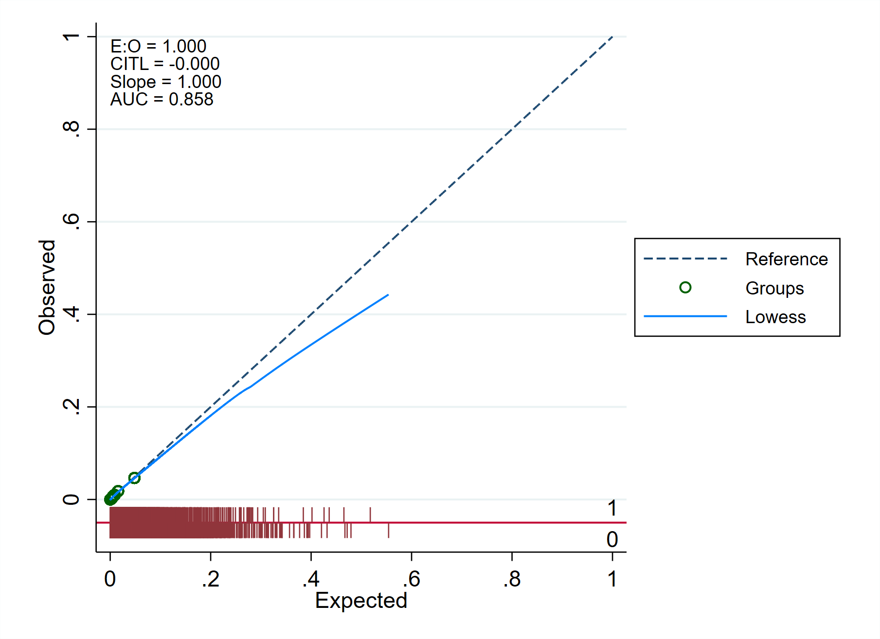
Each grey dot represents a decile of the predicted probability of postoperative respiratory failure. Abbreviations: E:O, ratio between expected and observed outcome; CITL, Calibration-In-The-Large; AUC, Area Under the Curve.

Figure S2. Agreement between median-based and minute-by-minute based mechanical power
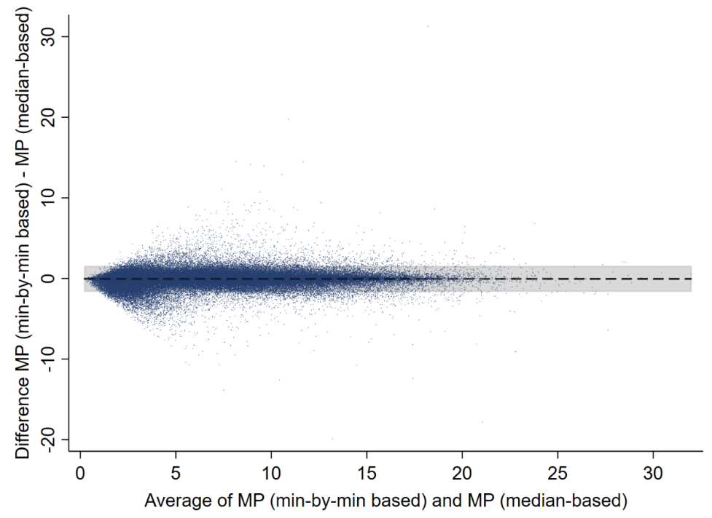
Bland Altman plot showing the agreement between median-based and minute-by-minute based mechanical power. Median-based mechanical power was derived by using the intraoperative medians of ventilator parameters to calculate mechanical power (as described in the main manuscript); minute-by-minute based mechanical power was derived from minute-by-minute ventilator data before calculating the median mechanical power. When comparing median-based and minute-by-minute based mechanical power, (mean difference: −0.04 J/min, 95% limits of agreement: −1.58 to 1.49 J/min).

Figure S3. Provider variability
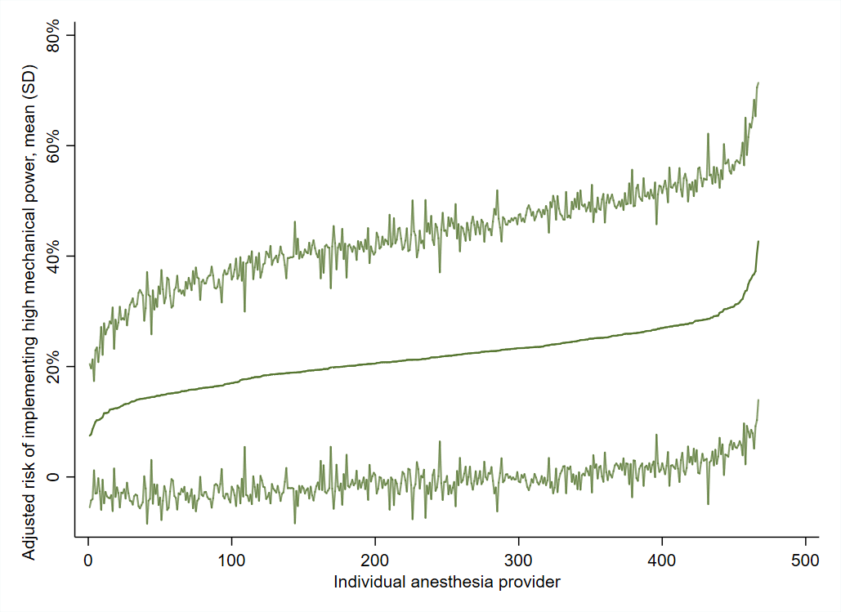
Variability in the use of high intraoperative tidal volumes across anesthesia providers with ranges from 8.8-43% in the highest quintile of mechanical power.

Figure S4. The mean balance of the confounding variables
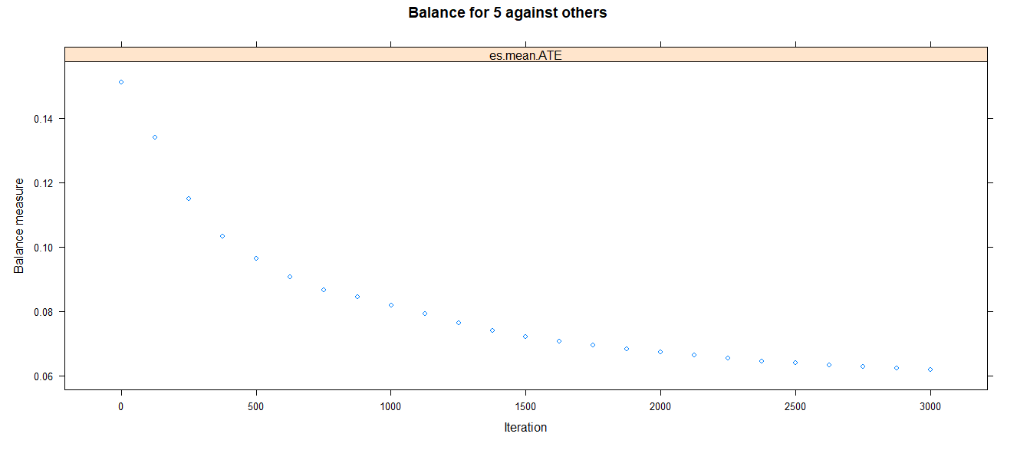
The mean balance of all confounding variables used in our analysis is displayed. Throughout all 3000 iterations used in our inverse probability of treatment weighting, the mean balance for our confounding variables decreased from 0.15 to 0.06, yielding adequate balance among all confounding variables.

Figure S5. Changes in mechanical power and ventilator parameters over the study period
Changes in mechanical power and the ventilator parameters used in its calculation (i.e. respiratory rate, tidal volume, driving pressure) are shown over the study period. Values are expressed as mean (SD).

Figure S6. Median mechanical power per year in reintubated versus not reintubated patients
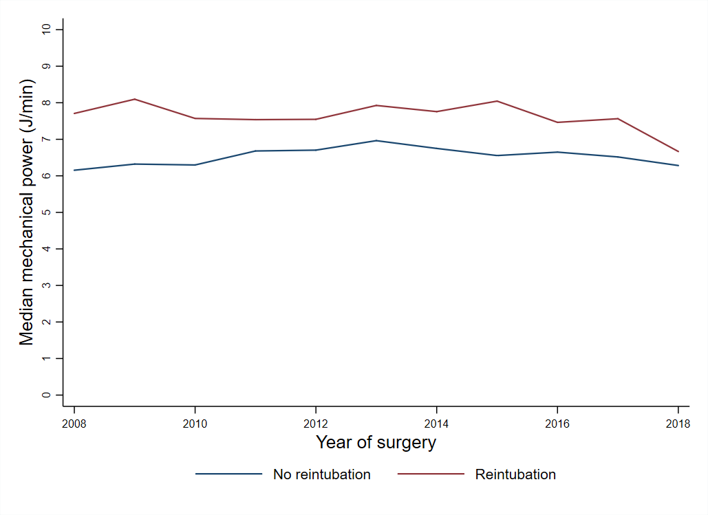
Changes in median mechanical power (J/min) per year of surgery in reintubated versus non-reintubated patients.

Figure S7. Daily distribution of reintubation after surgery
Distribution of reintubation events in cases that were reintubated over 7 days following surgery.

References
1. License For Use Of Physicians’ Current Procedural Terminology, Fourth Edition (“CPT®”) 2014:p 2014 at <https://www.cms.gov/medicare/physician-fee-schedule/search/license-agreement?destination=/medicare/physician-fee-schedule/search%3F>
2. AAPC: CPT Codes - Current Procedural Terminology - AAPC 2019 at <https://www.aapc.com/resources/medical-coding/cpt.aspx>
3. Patel BM, Chittock DR, Russell JA, Walley KR: Beneficial effects of short-term vasopressin infusion during severe septic shock. Anesthesiology 2002; 96:576–82
4. Gordon DB, Stevenson KK, Griffie J, Muchka S, Rapp C, Ford-Roberts K: Opioid equianalgesic calculations. J Palliat Med 1999; 2:209–18
5. Wachtendorf LJ, Schaefer MS, Santer P, Azimaraghi O, Obeidat SS, Friedrich S, Zucco L, Woo A, Nabel S, Sundar E, Eikermann M, Ramachandran SK: Association between preoperative administration of gabapentinoids and 30-day hospital readmission: A retrospective hospital registry study. J Clin Anesth 2021; 73
6. Santer P, Zheng S, Hammer M, Nabel S, Pannu A, Li Y, Ramachandran SK, Vidal Melo MF, Eikermann M: Ventilatory frequency during intraoperative mechanical ventilation and postoperative pulmonary complications: a hospital registry study. Br J Anaesth 2020; 125:e130–9
7. Althoff FC, Xu X, Wachtendorf LJ, Shay D, Patrocinio M, Schaefer MS, Houle TT, Fassbender P, Eikermann M, Wongtangman K: Provider variability in the intraoperative use of neuromuscular blocking agents: A retrospective multicentre cohort study. BMJ Open 2021; 11
8. Mccaffrey DF, Griffin BA, Almirall D, Slaughter ME, Ramchand R, Burgette LF: A tutorial on propensity score estimation for multiple treatments using generalized boosted models. Stat Med 2013; 32:3388–414
9. Smetana GW, Lawrence VA, Cornell JE: Preoperative pulmonary risk stratification for noncardiothoracic surgery: Systematic review for the American College of Physicians. Ann Intern Med 2006; 144:581–95
10. McLean DJ, Diaz-Gil D, Farhan HN, Ladha KS, Kurth T, Eikermann M: Dose-dependent Association between Intermediate-acting Neuromuscular-blocking Agents and Postoperative Respiratory Complications. Anesthesiology 2015; 122:1201–13
11. Scheffenbichler FT, Rudolph MI, Friedrich S, Althoff FC, Xu X, Spicer AC, Patrocínio M, Ng PY, Deng H, Anderson TA, Eikermann M: Effects of high neuromuscular blocking agent dose on post-operative respiratory complications in infants and children. Acta Anaesthesiol Scand 2020; 64:156–67

