SUPPLEMENT
Supplemental Figure 1: Histograms of (A) Baseline Concentrations of NFL (pg/mL), (B) Postoperative Day 1 Concentrations of NFL (pg/mL), and (C) Changes in Concentration of NFL (pg/mL) from Baseline to Postoperative Day 1

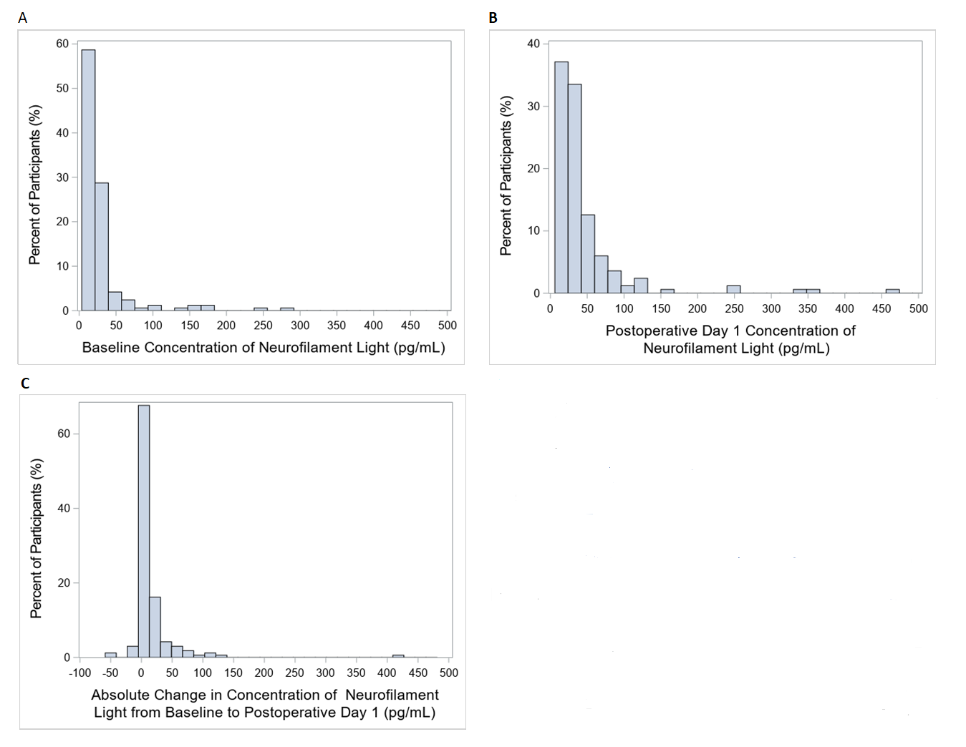
Supplement Figure 2: Patient Flow Diagram

Supplement Figure 3: Scatterplot of Baseline Log Neurofilament Concentration vs. Absolute and Relative Postoperative Change in Log Neurofilament Concentration

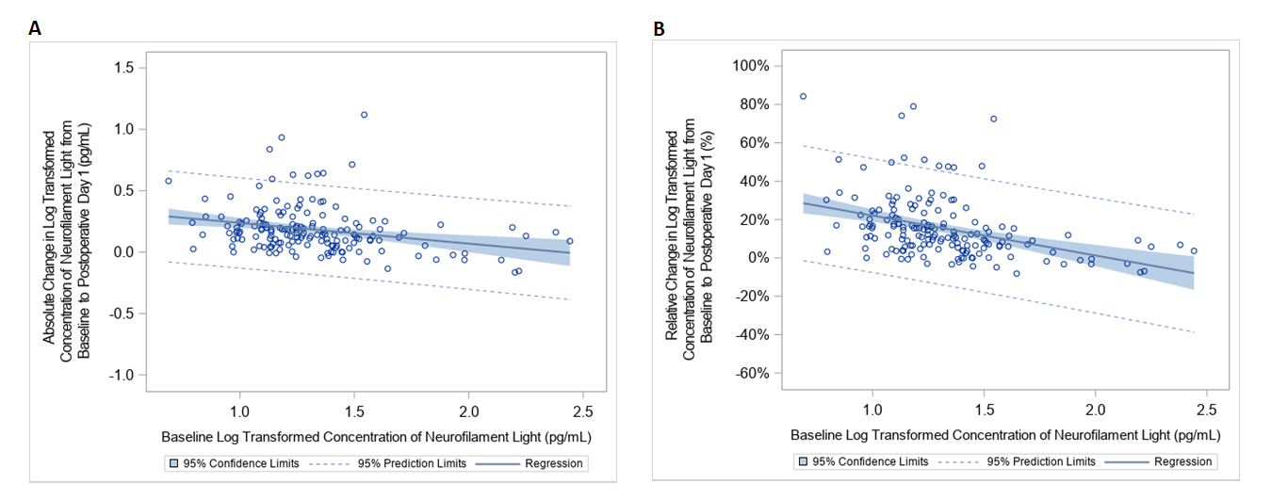
Supplemental Table 1: Association of Baseline log Neurofilament Light Concentrations with Change in Composite Cognitive Z-score from Baseline to 1-year Using a Range of Delta Estimates.

Delta ª | β-coefficient (95% CI) | p-value
0% | 0.44 (0.20,0.68) | <0.001
25% | 0.43 (0.16, 0.70) | 0.002
50% | 0.42 (0.15, 0.69) | 0.003
75% | 0.41 (0.14, 0.69) | 0.004
100% | 0.41 (0.12, 0.69) | 0.006

ª The delta represents the mean 1-year cognitive z-score among the observed patients. The delta was used to reduce the imputed 1-year cognitive z-scores by 25%, 50%, 75%, and 100% of the delta, after which adjusted linear models were fit for the association of baseline log neurofilament light concentrations with change in composite cognitive z-score from baseline to 1-year.

Supplement Table 2: Association of Baseline log Neurofilament Light Concentrations with Composite Cognitive Z-score at 1-Month and 1-Year, with Adjustment for Baseline Composite Cognitive Z-score
 | Adjusted for baseline cognition only |  | Adjustedª |  | Adjusted with Multiple Imputationª
 | β- coefficient (95% CI) | p-value | β- coefficient (95% CI) | p-value | β- coefficient (95% CI) | p-value
Outcome: cognitive z-score at 1-month
Baseline Log Neurofilament Light | 0.06  (-0.24, 0.35) | 0.710 | 0.08  (-0.23, 0.39) | 0.603 | 0.03  (-0.27, 0.34) | 0.828
Outcome: cognitive z-score at 1-year
Baseline Log Neurofilament Light | 0.32  (0.07, 0.58) | 0.013 | 0.43  (0.16, 0.69) | 0.002 | 0.34  (0.08, 0.59) | 0.009
ª Adjusted by age, gender, race, logistic European System for Cardiac Operative Risk Evaluation score and baseline cognitive Z-score.

Supplement Table 3: Patient Characteristics by Change in log Neurofilament Light Concentration ª

 | Change in Neurofilament Light from Baseline to Postoperative Day 1 < Mean Value (15.6 pg/mL)  (n=84) | Change in Neurofilament Light from Baseline to Postoperative Day 1 > Mean Value (15.6 pg/mL)  (n=83) | P-value
Age (years), mean (SD) | 70 (8) | 71 (7) | 0.125
Male, n (%) | 61 (72.6) | 62 (74.7) | 0.760
Race, n (%)  Caucasian  African-American  Other | 68 (81.0)  10 (11.9)  6 (7.1) | 64 (77.1)  12 (14.5)  7 (8.4) | 0.813
Education (years), median (IQR) | 16 (12-17) | 16(12-17) | 0.840
Comorbidities, n (%)
Prior stroke | 11 (13.8) | 13 (15.7) | 0.730
Hypertension | 78 (92.9) | 78 (94.0) | 0.771
Atrial Fibrillation | 15 (17.9) | 31 (37.4) | 0.005
Myocardial Infarction | 26 (31.0) | 21 (25.3) | 0.417
Chronic Obstructive Pulmonary Disease | 8 (9.6) | 5 (6.0) | 0.386
Obstructive Sleep Apnea | 18 (21.7) | 18 (21.7) | 1.000
Tobacco (current) | 11 (13.3) | 3 (3.6) | 0.047
Diabetes | 45 (53.6) | 35 (42.2) | 0.140
Anemia ^{b} | 41 (48.8) | 36 (43.9) | 0.537
Logistic European System for Cardiac Operative Risk Evaluation, median (IQR) | 4.8 (2.7-9.4) | 6.2 (2.8-10.8) | 0.396
Surgery, n (%)
Coronary Artery Bypass Graft | 42 (50.6) | 35 (42.7) | 0.377
Coronary Artery Bypass Graft +Valve  Valve | 15 (18.1)  24 (28.9) | 17 (20.7)  30 (36.6)
Other | 2 (2.4) | 0
Cardiopulmonary bypass duration (minutes), median (IQR) | 114 (90-143) | 125 (91-160) | 0.037
Aortic cross-clamp duration (minutes), median (IQR) | 76.5 (57.5-96) | 73 (51-97) | 0.551

ª All variables were complete except the following education (n=43 missing), prior stroke (n=4 missing), chronic obstructive pulmonary disease, obstructive sleep apnea, current tobacco, and anemia (all n=1 missing)
^{b} Anemia was defined as hemoglobin<13 g/dL in males and <12 g/dL in females
Supplemental Table 4: Association of Change in log Neurofilament Light Concentrations with Change in Composite Cognitive Z-score from Baseline to 1-year Using a Range of Delta Estimates.

Delta | Absolute or Relative Change in log Neurofilament Light from Baseline to Postoperative Day 1 | β -coefficient (95% CI) | p-value
0% | Absolute | -0.38 (-0.74, -0.03) | 0.034
 | Relative | -0.50 (-0.92, -0.09) | 0.017
25% | Absolute | -0.46 (-0.86, -0.06) | 0.025
 | Relative | -0.58 (-1.04, -0.12) | 0.015
50% | Absolute | -0.46 (-0.86, -0.05) | 0.027
 | Relative | -0.58 (-1.05, -0.11) | 0.016
75% | Absolute | -0.46 (-0.87, -0.05) | 0.029
 | Relative | -0.58 (-1.06, -0.10) | 0.018
100% | Absolute | -0.46 (-0.89, -0.04) | 0.032
 | Relative | -0.58 (-1.07, -0.09) | 0.021

ª The delta represents the mean 1-year cognitive z-score among the observed patients. The delta was used to reduce the imputed 1-year cognitive z-scores by 25%, 50%, 75%, and 100% of the delta, after which adjusted linear models were fit for the association of absolute or relative change in log neurofilament light concentrations with change in composite cognitive z-score from baseline to 1-year.

Supplemental Table 5: Association of Change in log Neurofilament Light Concentrations with Composite Cognitive Z-score at 1-Month and 1-Year, with Adjustment for Baseline Composite Cognitive Z-score

 | Adjusted for baseline cognition only |  | Adjusted ª |  | Adjusted with Multiple Imputation ª
 | β- coefficient (95% CI) | p-value | β- coefficient (95% CI) | p-value | β- coefficient (95% CI) | p-value
Outcome: cognitive z-score at 1-month
Absolute Change in log Neurofilament Light from Baseline to Postoperative Day 1 | -0.27  (-0.69, 0.15) | 0.208 | -0.25  (-0.69, 0.20) | 0.277 | -0.07  (-0.50, 0.36) | 0.762
Relative Change in log Neurofilament Light from Baseline to Postoperative Day 1 | -0.17  (-0.67, 0.32) | 0.488 | -0.16  (-0.68, 0.36) | 0.539 | 0.00  (-0.50, 0.51) | 0.992
Outcome: cognitive z-score at 1-year
Absolute Change in log Neurofilament Light from Baseline to Postoperative Day 1 | -0.47  (-0.83, -0.11) | 0.011 | -0.43  (-0.81, -0.04) | 0.031 | -0.31  (-0.65, -0.03) | 0.075
Relative Change in log Neurofilament Light from Baseline to Postoperative Day 1 | -0.55  (-0.97, -0.13) | 0.011 | -0.54  (-0.99, -0.09) | 0.019 | -0.41  (-0.81, -0.003) | 0.048

ª Adjusted by age, gender, race, logistic European System for Cardiac Operative Risk Evaluation score and baseline cognitive Z-score.

Supplemental Table 6: Age-Stratified Analyses of the Association of Baseline log Neurofilament Light Concentrations with Composite Cognitive Z-scores

 | Unadjusted |  |  | Adjusted ª |  |  | Adjusted with Multiple Imputation ^{b}
 | β- coefficient (95% CI) | p-value | p-value for interaction | β- coefficient (95% CI) | p-value | p-value for interaction | β- coefficient (95% CI) | p-value | p-value for interaction
Outcome: Baseline cognitive z-score
Baseline log Neurofilament Light (Age<70) | -0.76  (-1.12, -0.41) | <0.0001 | 0.704 | -0.58  (-0.93, -0.23) | 0.001 | 0.696 | N/A | N/A | N/A
Baseline log Neurofilament Light (Age≥70) | -0.89  (-1.44, -0.34) | 0.002 |  | -0.70  (-1.24, -0.16) | 0.012 |  | N/A | N/A | N/A
Outcome: Baseline to 1-month change in cognitive z-score
Baseline log Neurofilament Light (Age<70) | -0.14  (-0.48, 0.21) | 0.437 | 0.032 | -0.12  (-0.47, 0.24) | 0.521 | 0.030 | -0.04  (-0.37, 0.30) | 0.838 | 0.160
Baseline log Neurofilament Light (Age≥70) | 0.48  (0.03, 0.92) | 0.034 |  | 0.55  (-0.05, 1.05) | 0.301 |  | 0.39  (-0.11, 0.88) | 0.126
Outcome: Baseline to 1-year change in cognitive z-score
Baseline log Neurofilament Light (Age<70) | 0.46  (0.15, 0.77) | 0.004 | 0.784 | 0.47  (0.15, 0.80) | 0.005 | 0.663 | 0.43  (0.15, 0.71) | 0.003 | 0.979
Baseline log Neurofilament Light (Age≥70) | 0.53  (0.14, 0.91) | 0.008 |  | 0.59  (0.16, 1.02) | 0.007 |  | 0.44  (0.04, 0.83) | 0.030
ª Adjusted by age, gender, race and logistic European System for Cardiac Operative Risk Evaluation score

^{b} Among 167 subjects, 134 had available neuropsychological data at 1-month, and 99 had available neuropsychological data at 1-year. Variables used for the multiple imputation (imputation number=50) were: age, sex, race, education, logistic European System for Cardiac Operative Risk Evaluation score, duration of aortic cross-clamp, type of surgery, duration of hospitalization, neurofilament light concentration at baseline, and any available neuropsychological data (i.e. baseline and/or 1-month data, as appropriate).

Supplemental Table 7: Age-Stratified Analyses of the Association of Change in log Neurofilament Light Concentrations with Change in Composite Cognitive Z-score from Baseline to 1-month and 1-year

 | Unadjusted |  |  | Adjusted ª |  |  | Adjusted with Multiple Imputation ^{b}
 | β- coefficient (95% CI) | p-value | p-value for interaction | β- coefficient (95% CI) | p-value | p-value for interaction | β- coefficient (95% CI) | p-value | p-value for interaction
Outcome: Baseline to 1-month change in cognitive z-score
Absolute change in log Neurofilament Light from Baseline to Postoperative Day 1 (Age<70) | -0.13  (-0.91, 0.64) | 0.742 | 0.708 | -0.20  (-1.01, 0.61) | 0.630 | 0.851 | -0.15  (-0.96, 0.66) | 0.716 | 0.875
Absolute change in log Neurofilament Light from Baseline to Postoperative Day 1 Age≥70) | -0.31  (-0.82, 0.21) | 0.244 |  | -0.29  (-0.82, 0.24) | 0.278 |  | -0.08  (-0.59, 0.44) | 0.778
Outcome: Baseline to 1-month change in cognitive z-score
Percent change in log Neurofilament Light from Baseline to Postoperative Day 1 (Age<70) | 0.04  (-0.68, 0.75) | 0.913 | 0.432 | -0.02  (-0.78, 0.74) | 0.952 | 0.560 | -0.03  (-0.80, 0.73) | 0.931 | 0.471
Percent change in log Neurofilament Light from Baseline to Postoperative Day 1 (Age≥70) | -0.35  (-1.03, 0.33) | 0.304 |  | -0.33  (-1.03, 0.37) | 0.349 |  | -0.05  (-0.72, 0.63) | 0.886
Outcome: Baseline to 1-year change in cognitive z-score
Absolute change in log Neurofilament Light from Baseline to Postoperative Day 1 (Age<70) | -0.85  (-1.62, -0.08) | 0.032 | 0.323 | -0.90  (-1.75, -0.05) | 0.039 | 0.324 | -0.71  (-1.37, -0.05) | 0.035 | 0.266
Absolute change in log Neurofilament Light from Baseline to Postoperative Day 1 Age≥70) | -0.40  (-0.86, 0.06) | 0.088 |  | -0.41  (-0.89, 0.06) | 0.009 |  | -0.27  (-0.61, 0.14) | 0.201
Outcome: Baseline to 1-year change in cognitive z-score
Percent change in log Neurofilament Light from Baseline to Postoperative Day 1 (Age<70) | -0.71  (-1.37, -0.05) | 0.035 | 0.758 | -0.78  (-1.53, -0.04) | 0.040 | 0.693 | -0.75  (-1.38, - 0.12) | 0.021 | 0.968
Percent change in log Neurofilament Light from Baseline to Postoperative Day 1 (Age≥70) | -0.57  (-1.18, 0.04) | 0.065 |  | -0.59  (-1.22, 0.04) | 0.067 |  | -0.36  (-0.90, 0.18) | 0.188

ª Adjusted by age, gender, race and logistic European System for Cardiac Operative Risk Evaluation score
^{b} Among 167 subjects, 134 had available neuropsychological data at 1-month, and 99 had available neuropsychological data at 1-year. Variables used for the multiple imputation (imputation number=50) were: age, sex, race, education, logistic European System for Cardiac Operative Risk Evaluation score, duration of aortic cross-clamp, type of surgery, duration of hospitalization, neurofilament light concentration at baseline, and any available neuropsychological data (i.e. baseline and/or 1-month data, as appropriate).
Supplemental Table 8: Baseline Cognition-Stratified Analyses of the Association of Baseline log Neurofilament Light Concentrations with Composite Cognitive Z-scores

 | Unadjusted |  |  | Adjusted ª |  |  | Adjusted with Multiple Imputation ^{b}
 | β- coefficient (95% CI) | p-value | p-value for interaction | β- coefficient (95% CI) | p-value | p-value for interaction | β- coefficient (95% CI) | p-value | p-value for interaction
Outcome: Baseline to 1-month change in cognitive z-score
Baseline log Neurofilament Light (Baseline Z-score<0) | 0.10  (-0.31, 0.50) | 0.638 | 0.711 | 0.14  (-0.30, 0.58) | 0.534 | 0.717 | 0.11  (-0.28, 0.50) | 0.576 | 0.828
Baseline log Neurofilament Light (Baseline Z-score≥0) | -0.01  (-0.42, 0.40) | 0.954 |  | 0.03  (-0.40, 0.46) | 0.904 |  | -0.04  (-0.46, 0.38) | 0.841
Outcome: Baseline to 1-year change in cognitive z-score
Baseline log Neurofilament Light (Baseline Z-score<0) | 0.65  (0.29, 1.01) | <0.001 | 0.052 | 0.82  (0.43, 1.22) | <0.001 | 0.027 | 0.50  (0.17, 0.84) | 0.003 | 0.132
Baseline log Neurofilament Light (Baseline Z-score≥0) | 0.17  (-0.15, 0.49) | 0.293 |  | 0.25  (-0.09, 0.58) | 0.149 |  | 0.17  (-0.16, 0.50) | 0.307

ª Adjusted by age, gender, race and logistic European System for Cardiac Operative Risk Evaluation score

^{b} Among 167 subjects, 134 had available neuropsychological data at 1-month, and 99 had available neuropsychological data at 1-year. Variables used for the multiple imputation (imputation number=50) were: age, sex, race, education, logistic European System for Cardiac Operative Risk Evaluation score, duration of aortic cross-clamp, type of surgery, duration of hospitalization, neurofilament light concentration at baseline, and any available neuropsychological data (i.e. baseline and/or 1-month data, as appropriate).

Supplemental Table 9: Baseline Cognition-Stratified Analyses of the Association of Change in log Neurofilament Light Concentrations with Change in Composite Cognitive Z-score from Baseline to 1-month and 1-year

 | Unadjusted |  |  | Adjusted ª |  |  | Adjusted with Multiple Imputation ^{b}
 | β- coefficient (95% CI) | p-value | p-value for interaction | β- coefficient (95% CI) | p-value | p-value for interaction | β- coefficient (95% CI) | p-value | p-value for interaction
Outcome: Baseline to 1-month change in cognitive z-score
Absolute change in log Neurofilament Light from Baseline to Postoperative Day 1 (Baseline Z-score<0) | -0.46  (-1.06, 0.13) | 0.128 | 0.375 | -0.48  (-1.10, 0.14) | 0.128 | 0.309 | -0.30  (-0.87, 0.27) | 0.302 | 0.385
Absolute change in log Neurofilament Light from Baseline to Postoperative Day 1 (Baseline Z-score≥0) | -0.08  (-0.68, 0.52) | 0.787 |  | -0.02  (-0.65, 0.61) | 0.941 |  | 0.06  (-0.56, 0.67) | 0.852
Outcome: Baseline to 1-month change in cognitive z-score
Relative change in log Neurofilament Light from Baseline to Postoperative Day 1 (Baseline Z-score<0) | -0.41  (-1.20, 0.38) | 0.302 | 0.446 | -0.46  (-1.28, 0.37) | 0.275 | 0.385 | -0.29  (-1.04, 0.47) | 0.455 | 0.543
Relative change in log Neurofilament Light from Baseline to Postoperative Day 1 (Baseline Z-score≥0) | -0.02  (-0.65, 0.61) | 0.942 |  | 0.011  (-0.65, 0.67) | 0.974 |  | 0.11  (-0.55, 0.76) | 0.753
Outcome: Baseline to 1-year change in cognitive z-score
Absolute change in log Neurofilament Light from Baseline to Postoperative Day 1 (Baseline Z-score<0) | -0.97  (-1.49, -0.45) | <0.001 | 0.026 | -0.95  (-1.49, -0.41) | <0.001 | 0.032 | -0.72  (-1.18 -0.25) | 0.003 | 0.064
Absolute change in log Neurofilament Light from Baseline to Postoperative Day 1 (Baseline Z-score≥0) | -0.15  (-0.65, 0.35) | 0.556 |  | -0.12  (-0.65, 0.42) | 0.667 |  | -0.12  (-0.57, 0.33) | 0.609
Outcome: Baseline to 1-year change in cognitive z-score
Relative change in log Neurofilament Light from Baseline to Postoperative Day 1 (Baseline Z-score<0) | -1.47  (-2.14, -0.79) | <0.001 | 0.003 | -1.49  (-2.21, -0.78) | <0.001 | 0.005 | -1.05  (-1.67, -0.44) | <0.001 | 0.020
Relative change in log Neurofilament Light from Baseline to Postoperative Day 1 (Baseline Z-score≥0) | -0.19  (-0.69, 0.31) | 0.450 |  | -0.19  (-0.73, 0.35) | 0.489 |  | -0.15  (-0.63, 0.34) | 0.554
ª Adjusted by age, gender, race and logistic European System for Cardiac Operative Risk Evaluation score

^{b} Among 167 subjects, 134 had available neuropsychological data at 1-month, and 99 had available neuropsychological data at 1-year. Variables used for the multiple imputation (imputation number=50) were: age, sex, race, education, logistic European System for Cardiac Operative Risk Evaluation score, duration of aortic cross-clamp, type of surgery, duration of hospitalization, neurofilament light concentration at baseline, and any available neuropsychological data (i.e. baseline and/or 1-month data, as appropriate).

