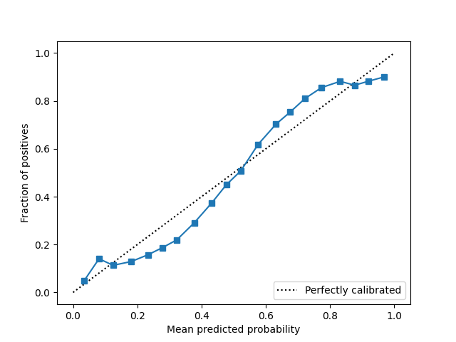
Supplemental Digital Content 9 – Calibration Plots for Best-performing Postoperative Deterioration Prediction Model (Random Forest)

2013-2017 Training/Validation Set
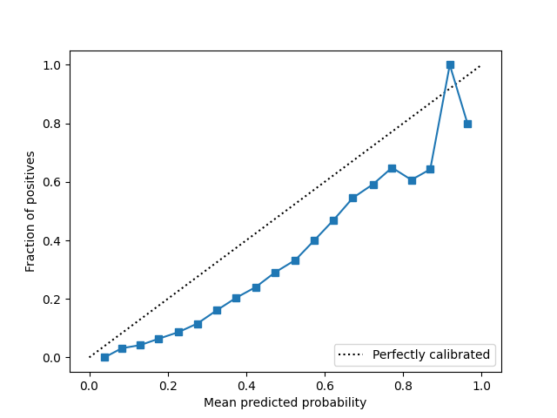
Brier Score: 0.190; Expected Calibration Error: 6.6%

2017-2020 Temporal Holdout Test Set –
Brier Score: 0.154; Expected Calibration Error: 15.7%

