Supplemental Digital Content 10 - Performance of Best-performing Postoperative Deterioration Prediction Model (Random Forest) with Varying Temporal Gap Windows, Test Set
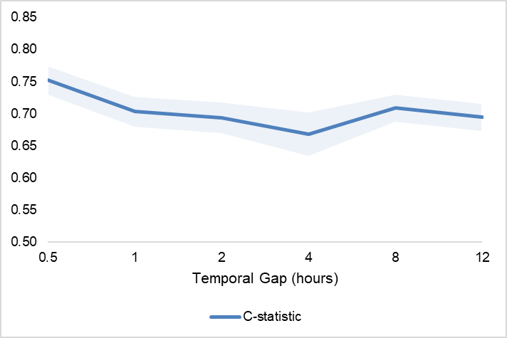
Standard deviation in the shaded region

