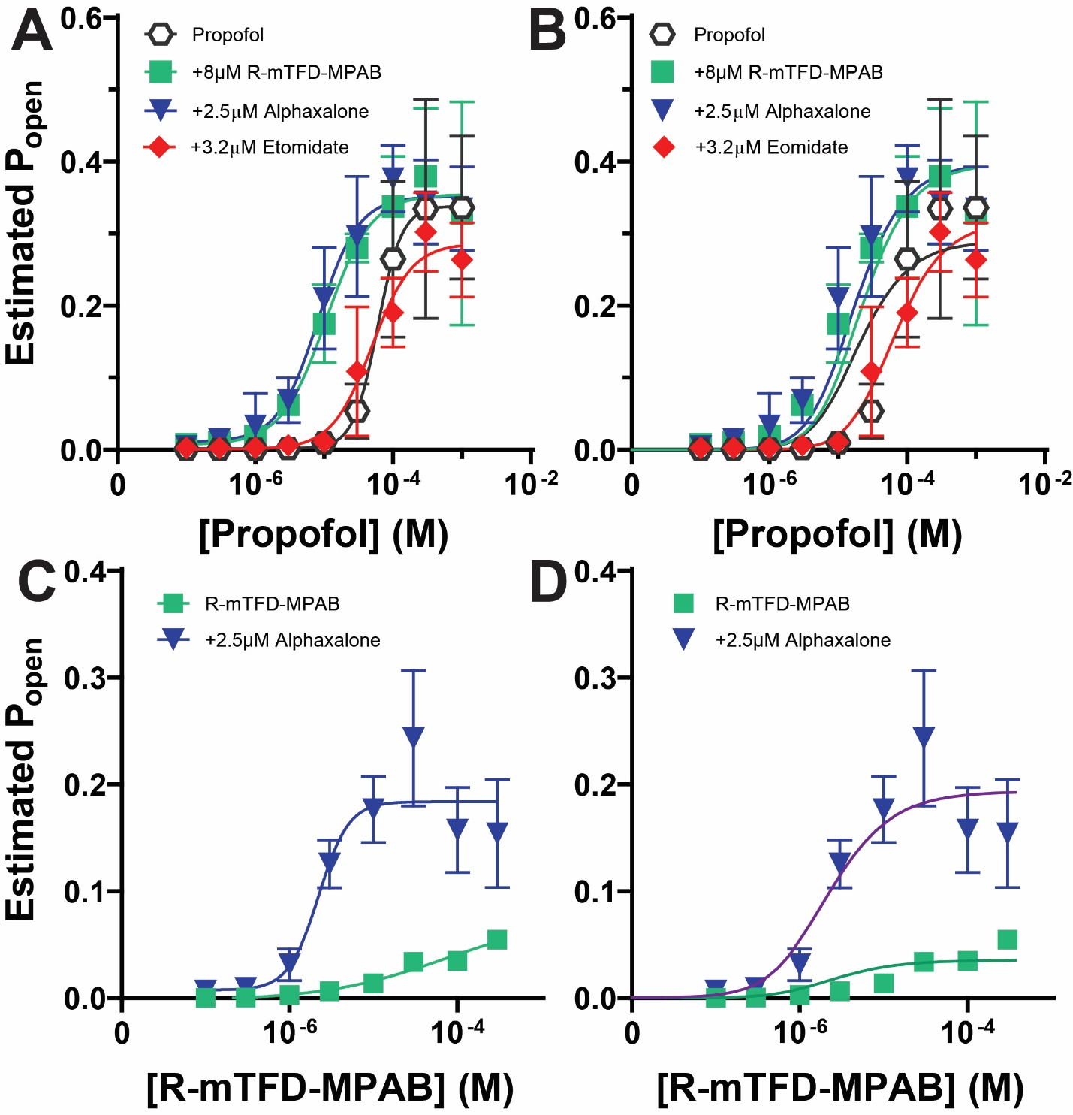

Figure S1: Anesthetic Modulation of Propofol-Activated and R-mTFD-MPAB-Activated α1β3γ2L GABA_{A} Receptors. Panel A summarizes results for propofol-activated receptors in the absence (open hexagons) or presence of 2.5 µM alphaxalone (blue triangles) 8 µM R-mTFD-MPAB (green squares), or 3.2 µM etomidate (red diamonds). Data are mean and 95% CI (n = 5 per condition) for estimated P_{open} (Eq. 3 in Methods). Lines are fits to logistic functions (Eq. 4 in Methods). Fitted parameters are reported in Table 3. Panel B shows the same data from Panel A with fitted lines representing allosteric log(d) shift models (Eq. 5 in Methods). For clarity, a single fit is shown for propofol alone. Fitted parameters are reported in Table 4. Panel C summarizes results for R-mTFD-MPAB-activated receptors in the absence and presence of alphaxalone. Data are estimated P_{open} (mean and 95% CI; n = 5) and lines represent fits to logistic functions. Fitted parameters are reported in Table 3. Panel D shows the same data from Panel C with lines representing the fitted allosteric log(d) shift model. Fitted parameters are reported in Table 4.

