Supplemental Figures

Supplemental Figure 1. Summary risk of bias assessment for clinical outcomes reported in randomized controlled trials.
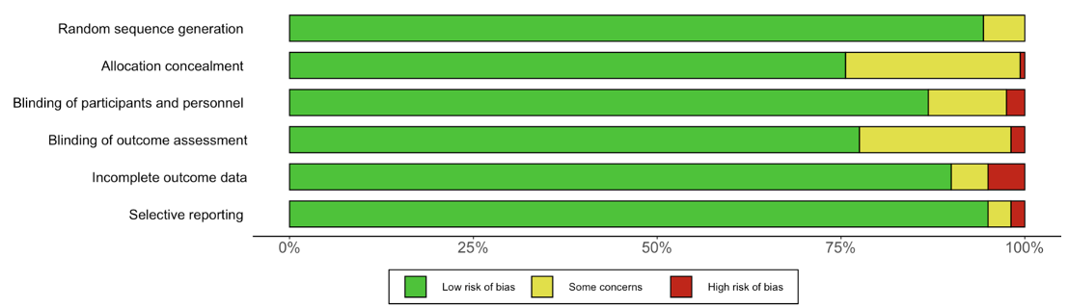

Supplemental Figure 2. Summary risk of bias assessment for clinician-assessed outcomes reported in randomized controlled trials.
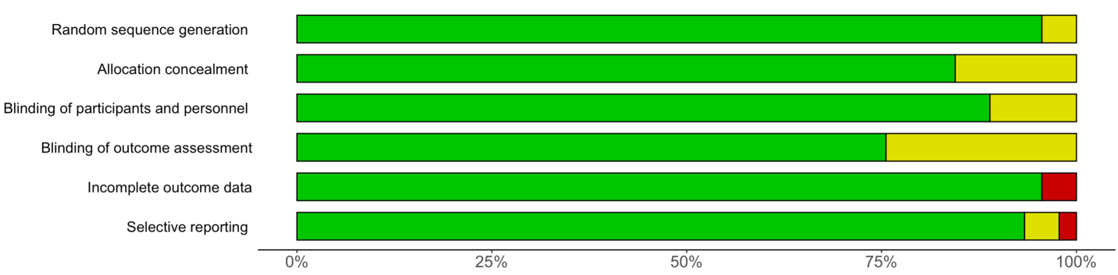

Supplemental Figure 3. Summary ROBINS-I (“Risk Of Bias In Non-randomised Studies - of Interventions”) ratings for observational studies.
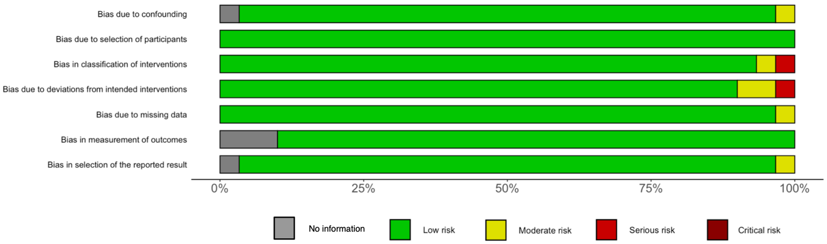

Supplemental Figure 4. Summary CLARITY risk of bias ratings for TOFR ≥ 0.9 confirmation at extubation (note applies to single arms of studies and so the low risk of bias).
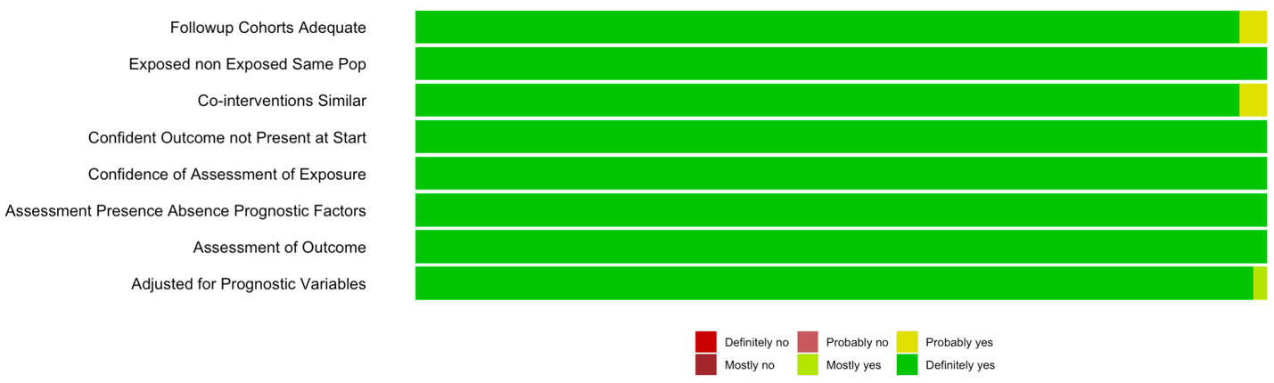

Supplemental Figure 5. Summary QUADAS-II (Quality Assessment of Diagnostic Accuracy Studies) for diagnostic studies.
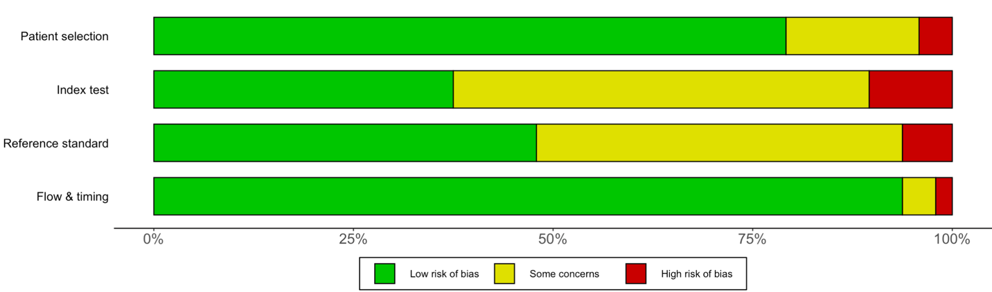

Supplemental Figure 6. Direct and indirect evidence from network meta-analysis of neuromuscular monitoring and residual neuromuscular blockade.
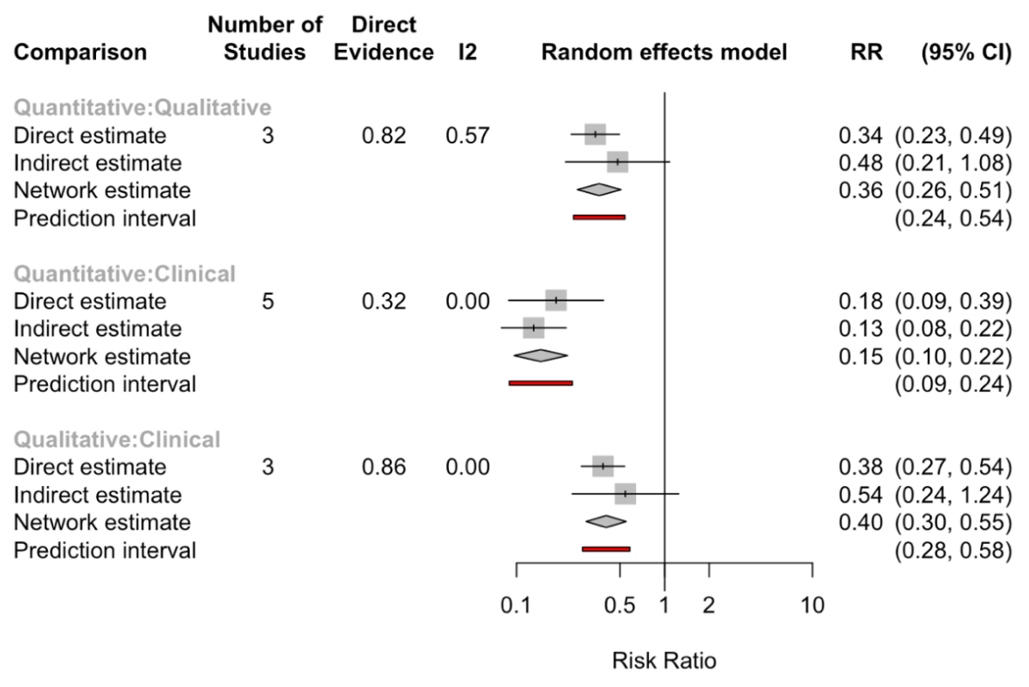

Supplemental Figure 7. Incidence proportion of residual neuromuscular blockade (train-of-four ratio < 0.9) in arms of randomized and nonrandomized studies using quantitative monitoring according to whether train-of-four ratio ≥ 0.9 was reported as confirmed prior to extubation, using qualitative or clinical assessment. From random effects meta-analyses of proportions fitted with generalized linear mixed models. Differences between confirmation and no confirmation in random effects models were P < 0.0001 for neostigmine and P = 0.24 for sugammadex; in the fixed-effects model P <0.0001 for neostigmine and P = 0.015 for sugammadex.
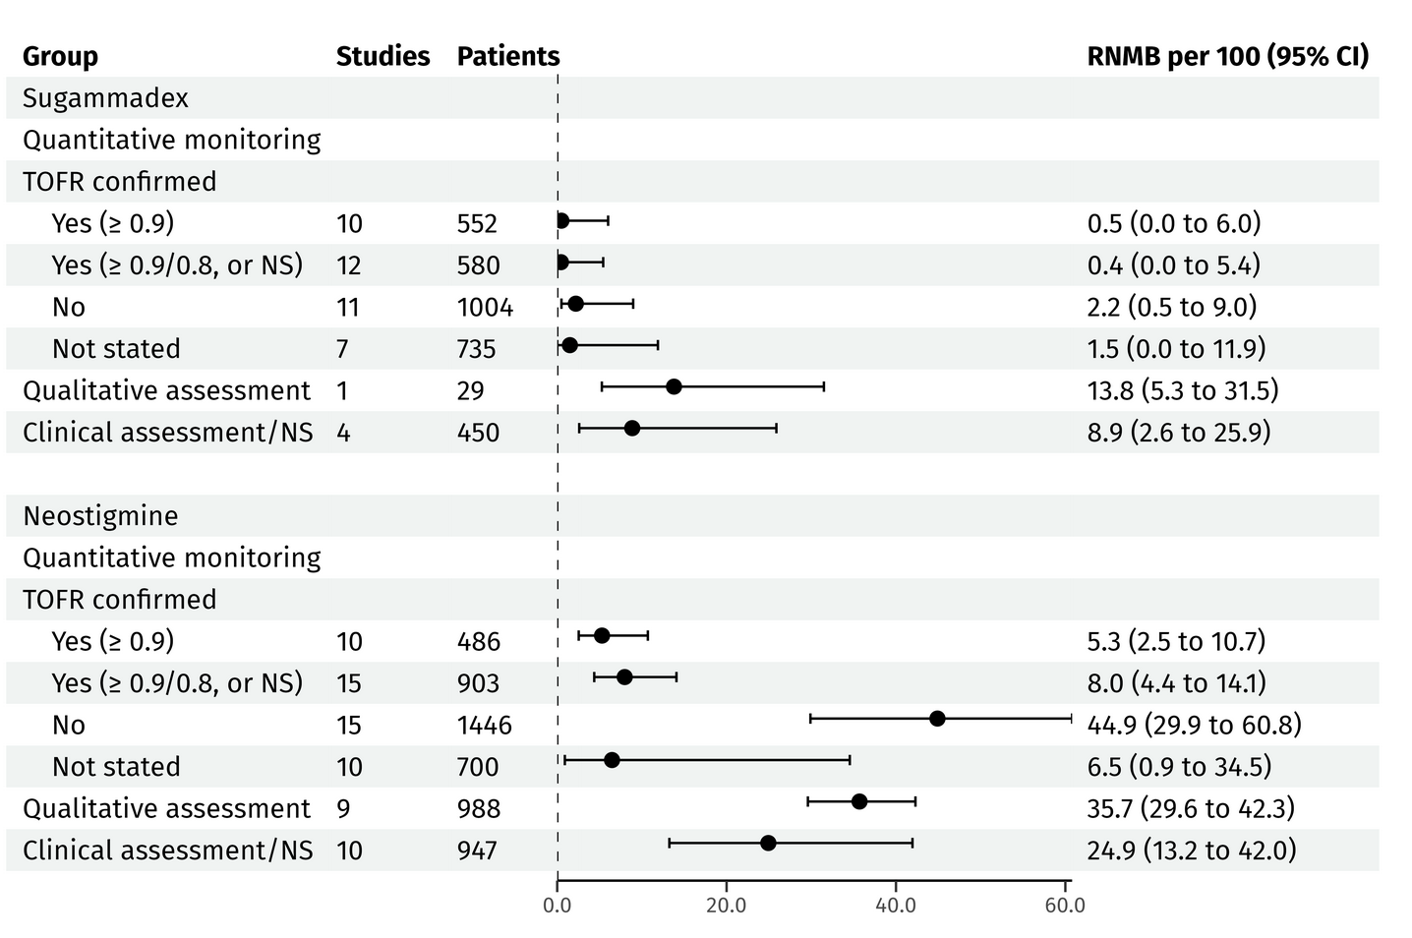

For studies stratifying randomization, arms were considered independent. In studies reporting results by subgroups, subgroups were combined to remove dependence (subgroup differences were not of interest).
RNMB: residual neuromuscular blockade (TOFR < 0.9); NS: not stated.

Supplemental Figure 8. Pooled residual neuromuscular blockade (train-of-four ratio < 0.9) from randomized trials comparing sugammadex and neostigmine by depth of blockade.
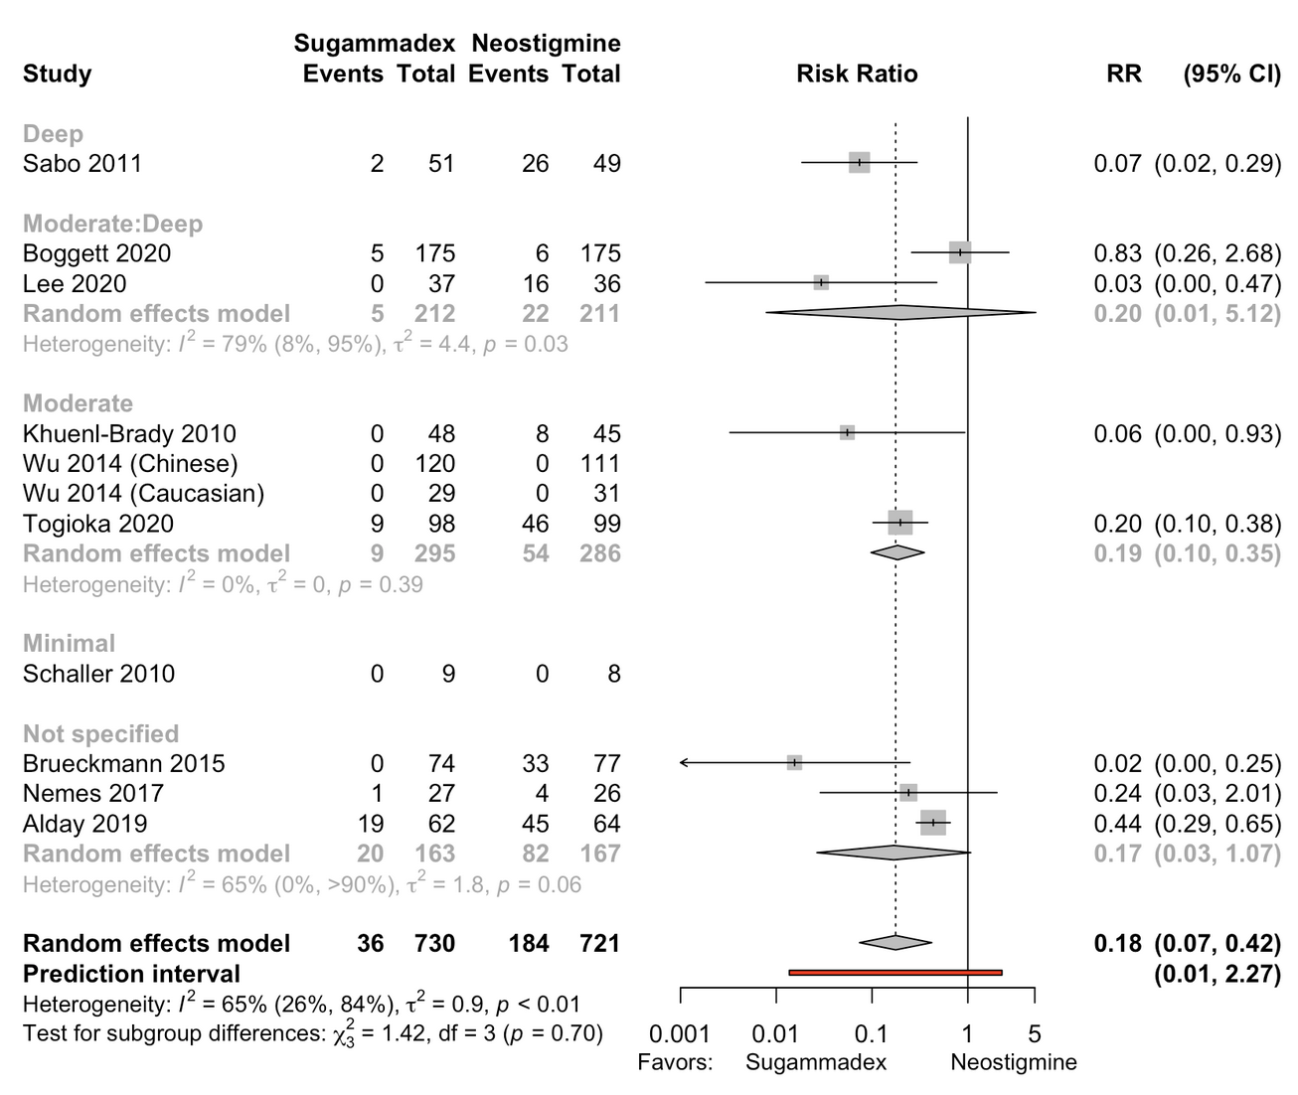
Risk difference -21.6% (95% CI, -33.8% to -9.4%); n.b., includes 10 studies (n = 1451), while RR estimate 8 studies (n = 1143). Too few studies to examine small study effects. Schaller 2010 included based on range of recovery times.

Supplemental Figure 9. Difference in time to recovery in minutes (train-of-four ratio ≥ 0.9) from deep block to antagonism in randomized controlled trials enrolling adults.
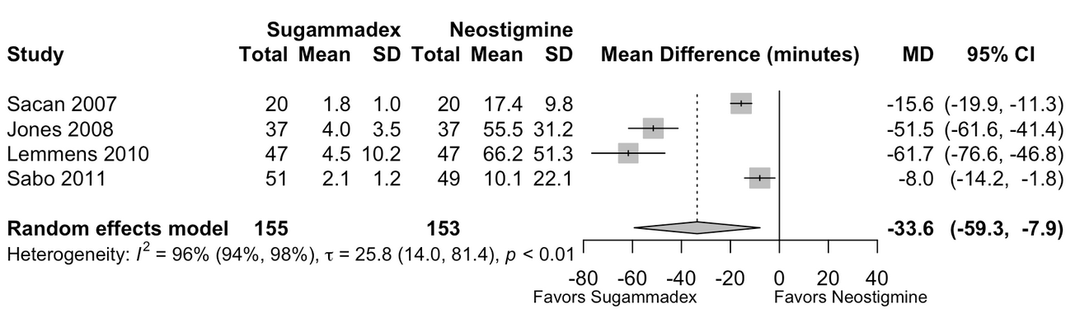
When mean and standard deviation were not available, they were estimated using the median, interquartile and overall range as reported.

Supplemental Figure 10. Difference in time to recovery in minutes (train-of-four ratio ≥ 0.9) from moderate block to antagonism in randomized controlled trials enrolling adults.
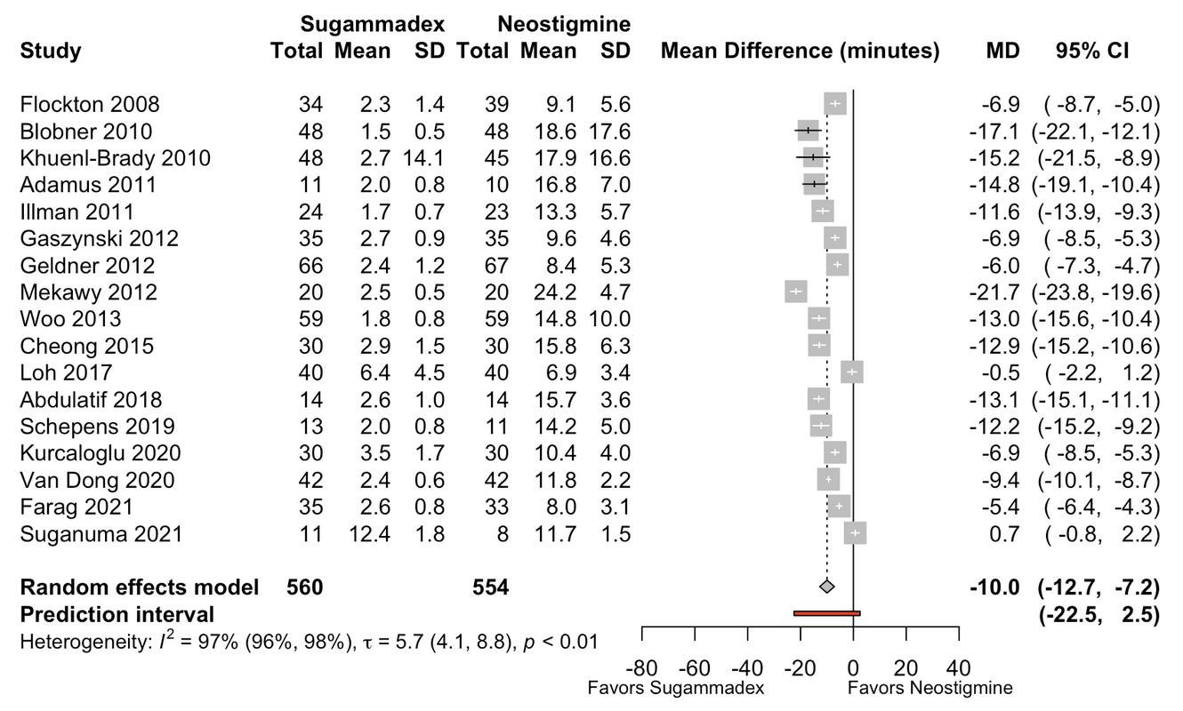
Hartung-Knapp adjustment not applied to allow comparability with other levels of block; overall result yielded the same confidence interval with or without the adjustment. No indication of potential small study effects in funnel plot or regression test. For subgroup receiving volatile anesthetics MD -11.3 (95% CI, -14.8 to -7.8), no volatiles -7.4 (95% CI, -11.7 to -3.2). When mean and standard deviation were not available, they were estimated using the median, interquartile and overall range as reported.

Supplemental Figure 11. Difference in time to recovery in minutes (train-of-four ratio ≥ 0.9) from shallow block to antagonism in randomized controlled trials enrolling adults.
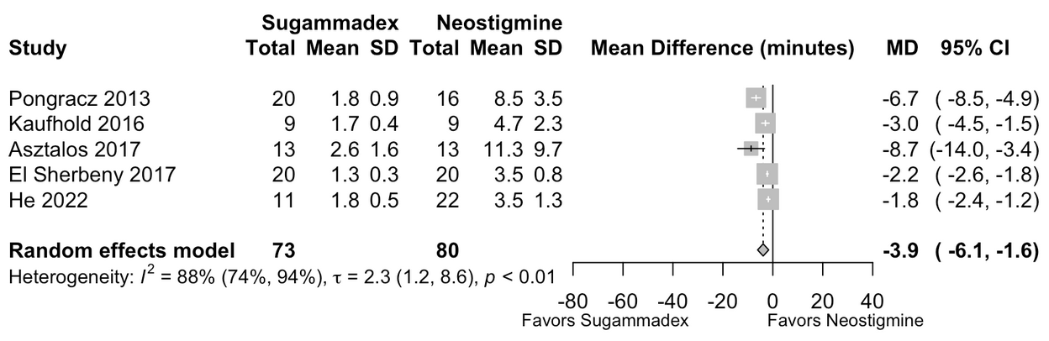
When mean and standard deviation were not available, they were estimated using the median, interquartile and overall range as reported.

Supplemental Figure 12. Difference in time to recovery in minutes (train-of-four ratio [TOFR] > 0.9) from minimal block to antagonism in randomized controlled trial enrolling adults (single dose-finding trial 40 µg/kg dose).
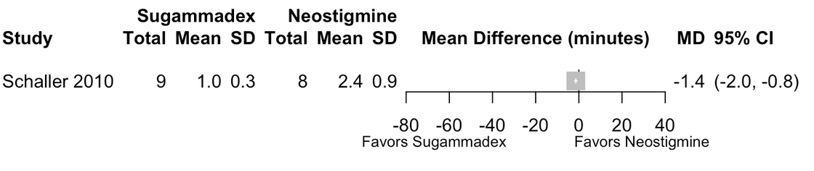
Mean and standard deviation estimated from the median and overall range.

Supplemental Figure 13. Bradycardia pooled results from randomized controlled trials.
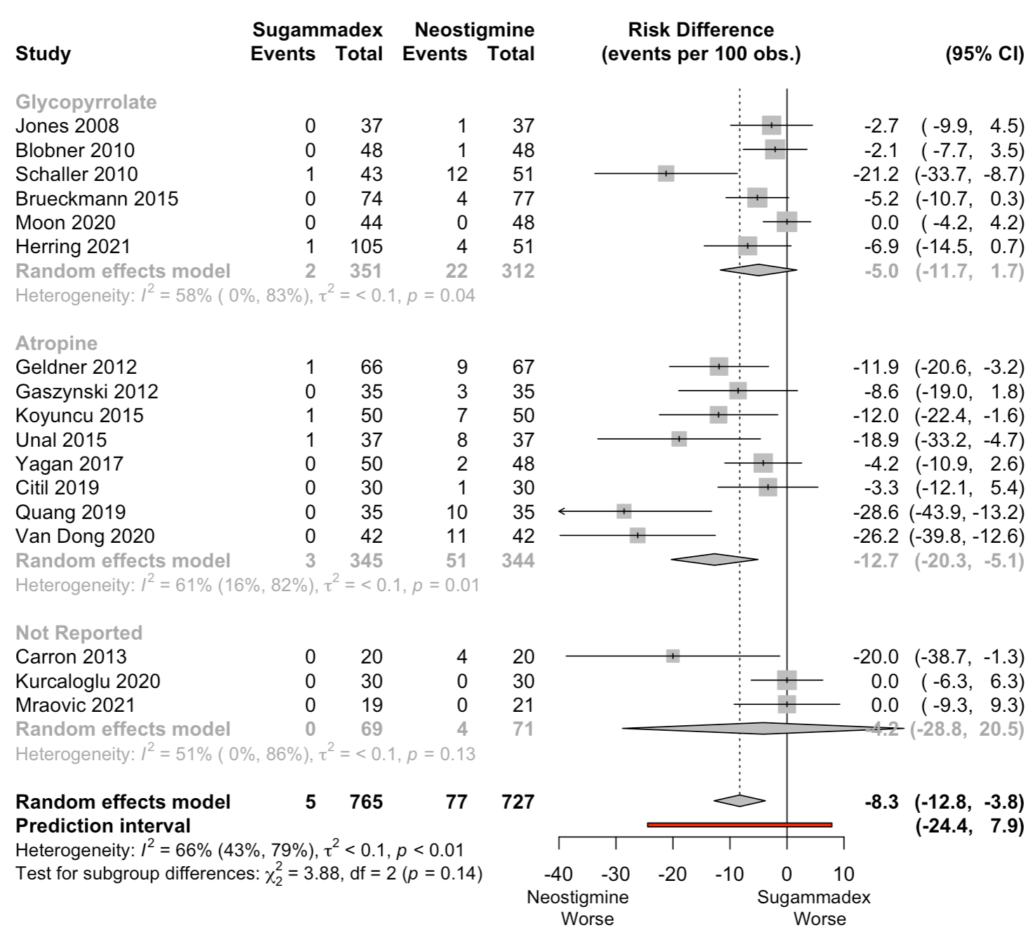
No indication of small study effects (potential publication bias) for risk ratio or odds ratio in regression tests or funnel plot.

Supplemental Figure 14. Tachycardia pooled results from randomized controlled trials.
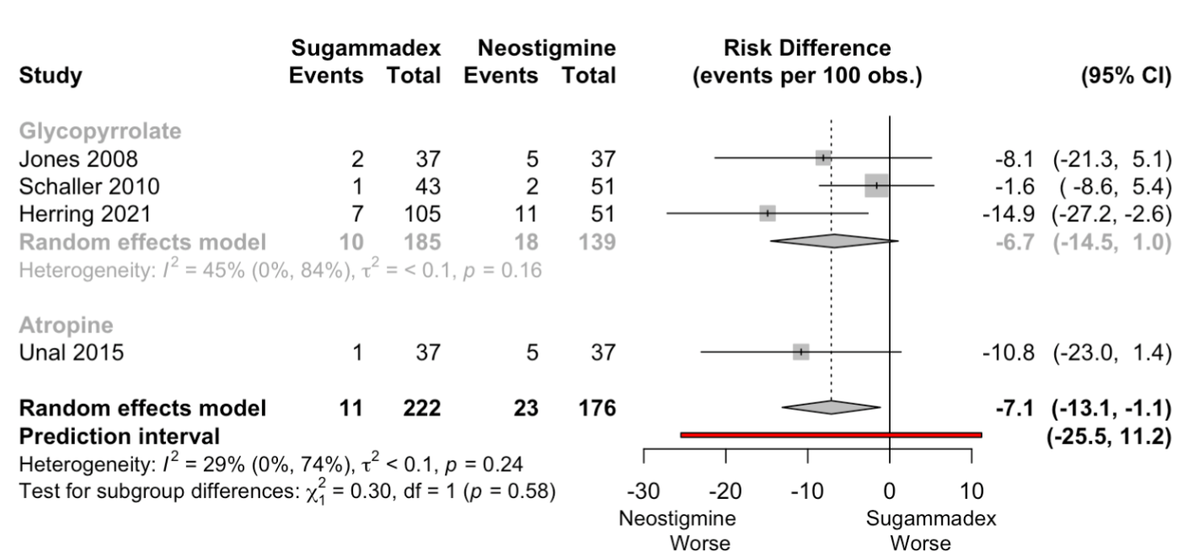

Supplemental Figure 15. Pooled incidence of postoperative pulmonary complications in randomized and nonrandomized studies, and component end points included in each study’s definition.

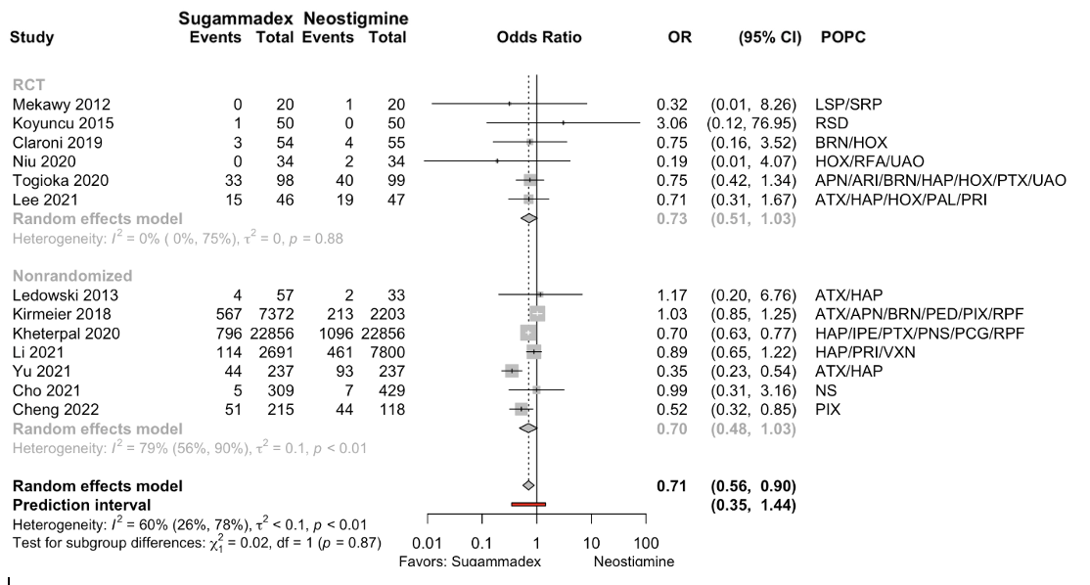
Results from 4 nonrandomized studies adjusted for potential confounding (Kirmeier 2018, multivariable regression with a likely sufficient set of deconfounders; Li 2021 and Yu 2021, propensity scores; and Kheterpal 2020, matched cohort design). Krause 2020, not included here, composite of “reintubation for respiratory failure or new noninvasive ventilation” was considered an expanded reflection of respiratory failure.
APN: aspiration pneumonitis; ARI: acute respiratory insufficiency; ATX: atelectasis; BRN: bronchospasm; HAP: pneumonia; HOX: hypoxia; IPE: iatrogenic pulmonary embolism; LSP: laryngospasm; NRSI: nonrandomized study of interventions; PAL: prolonged air leakage; PCG: pulmonary congestion; PED: pulmonary edema; PIX: pulmonary infection; PNS: pneumonitis; POPC: postoperative pulmonary complications; PRI: postoperative reintubation; PTX: pneumothorax; RFA: reflux aspiration; RPF: respiratory failure; RSD: respiratory depression; SRP: spasmodic respiratory pattern; UAO: upper airway obstruction; VXN: ventilation > 48 hrs.

Supplemental Figure 16. Pooled relative odds of postoperative pneumonia in randomized and nonrandomized studies.
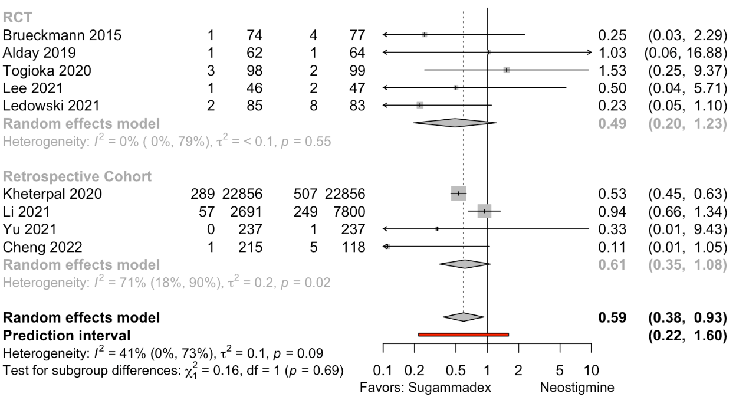
Results from 3 nonrandomized studies adjusted for potential confounding (Li 2021 and Yu 2021, propensity scores; Kheterpal 2020, matched cohort design). Pooled risk difference comparing sugammadex with neostigmine in randomized controlled trials (RCTs) -1.6% (95% CI, -4.3 to 1.1; I² = 20%, 𝜏 = 1.4%).

Supplemental Figure 17. Pooled incidence of hypoxia (determined by definition) in randomized controlled trials enrolling adults.
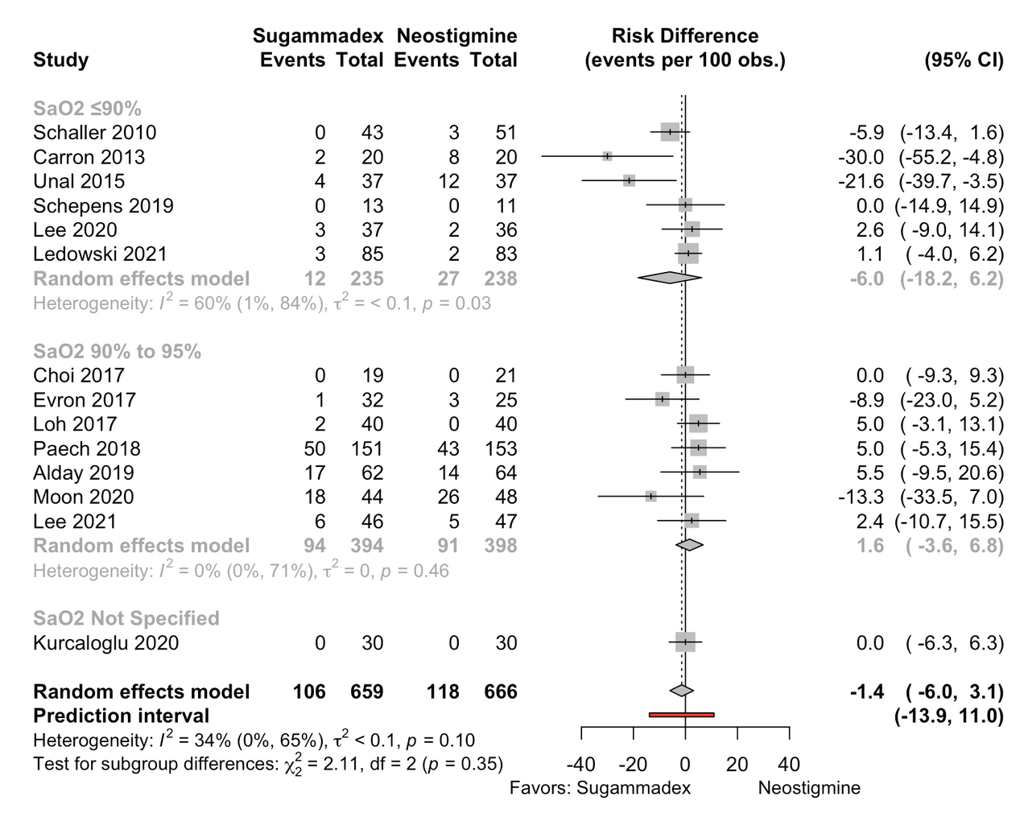
No indication of small study effects (potential publication bias) for risk ratio or odds ratio in regression tests or funnel plot.

Supplemental Figure 18. Pooled difference in risk of postoperative reintubation in randomized and nonrandomized studies.
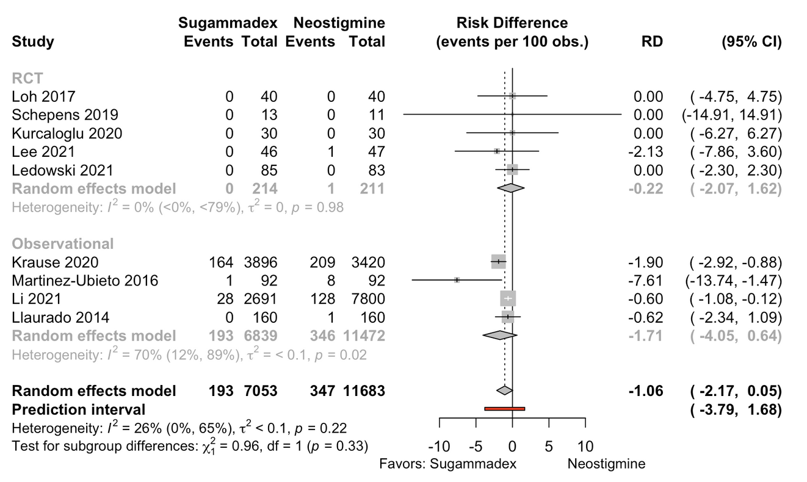

Supplemental Figure 19. Pooled risk difference for reparalysis in randomized controlled trials.

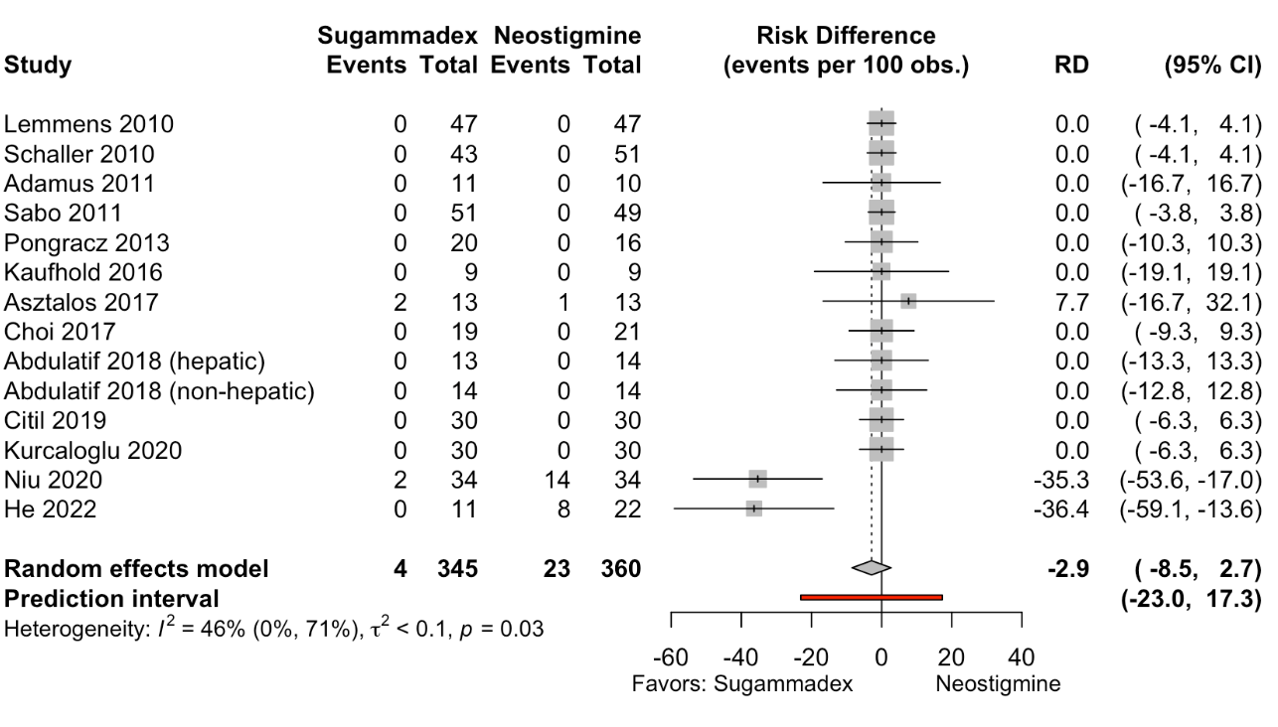

Supplemental Figure 20. Pooled risk ratios from network meta-analysis for postoperative nausea and vomiting.
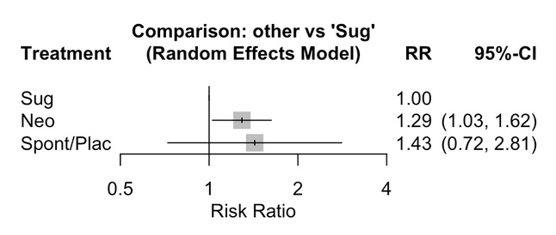

Supplemental Figure 21. Pooled risk ratios from network meta-analysis for postoperative nausea.
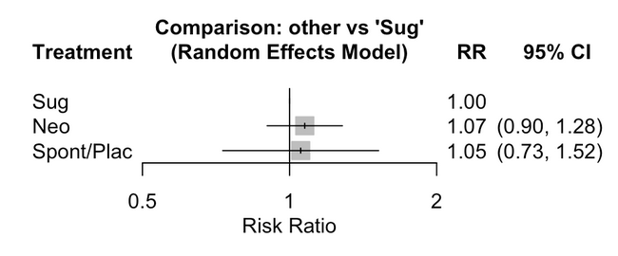

Supplemental Figure 22. Pooled risk ratios from network meta-analysis for postoperative vomiting.
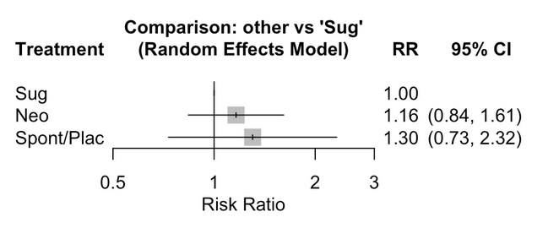

Supplemental Figure 23. Time to recovery from cisatracurium or atracurium induced neuromuscular blockade antagonized by neostigmine.
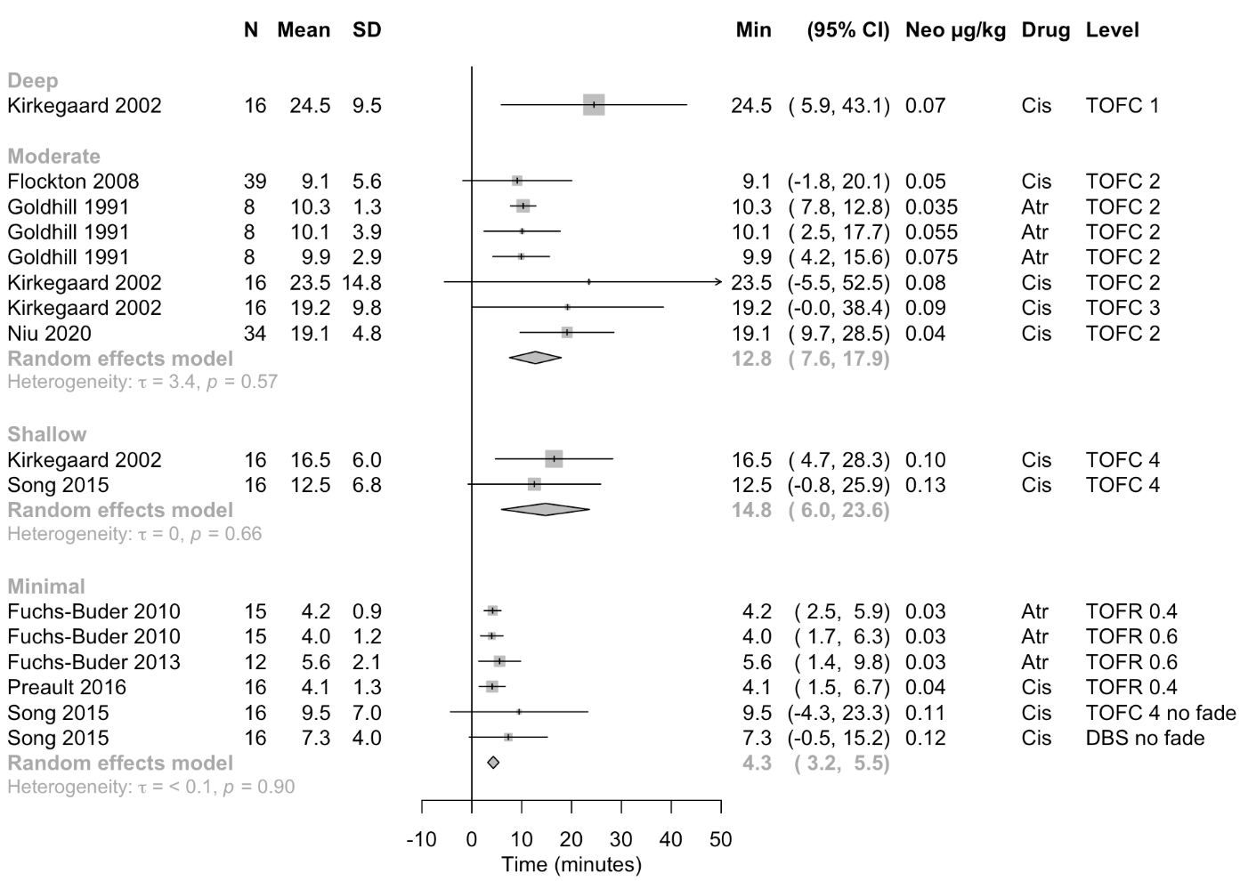
Includes study arms administering ≥ 30 mcg/kg of neostigmine. Fitted using a multilevel model to account for dependent study arms. When mean and standard deviation were not available, they were estimated using the median, interquartile and overall range as reported.

