Supplemental Tables

Supplemental Table 1. Strength of evidence for outcomes in randomized controlled trials comparing carbohydrate-containing clear liquids with fasting in adults.
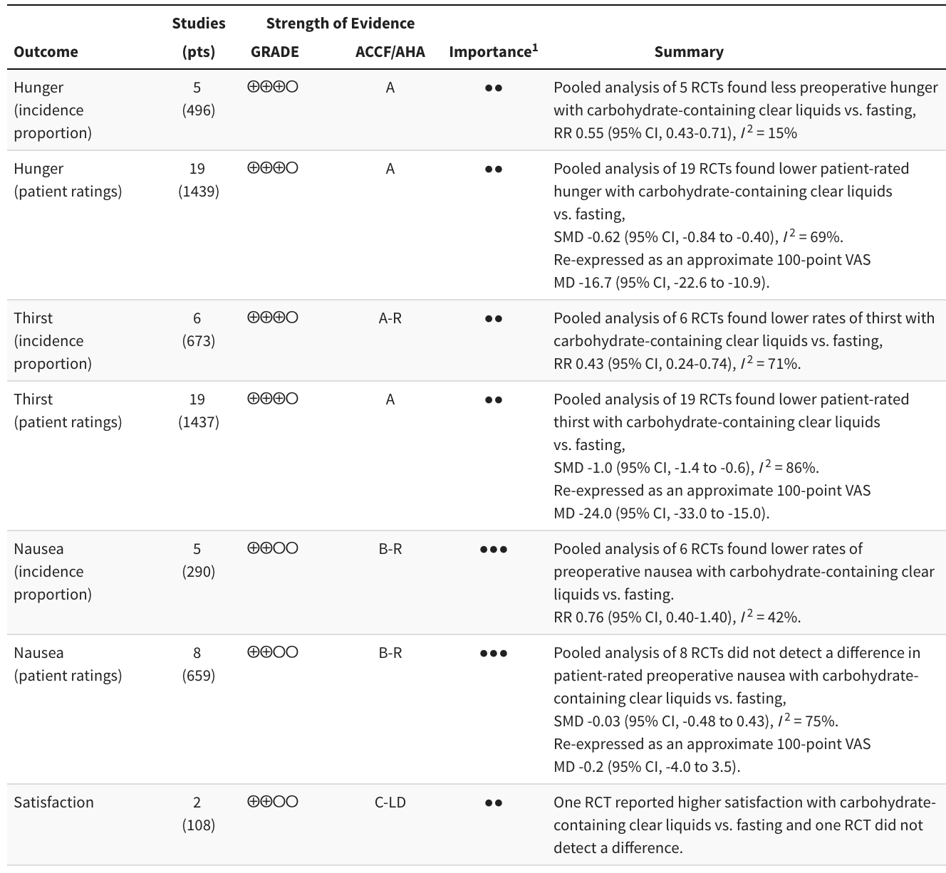
GRADE strength of evidence: ⨁⨁⨁⨁ high, ⨁⨁⨁◯ moderate, ⨁⨁◯◯ low, ⨁◯◯◯ very low.
GRADE: Grading of Recommendations Assessment, Development and Evaluation; ACCF/AHA; American College of Cardiology Foundation/American Heart Association; RR: risk ratio; SMD: standardized mean difference; MD: mean difference; RCT: randomized controlled trial; NRSI: nonrandomized studies of interventions.
ACCF/AHA ratings: A: high-quality evidence from more than 1 RCT; B-R: moderate-quality evidence from more than 1 RCT; B-NR: moderate-quality evidence from more than one observational study; C-LD: randomized or non-randomized observational or registry studies with limited data; C-EO: consensus of expert opinion.
¹ ● Limited, ●● Important, ●●● Critical.

Supplemental Table 1 (continued). Strength of evidence for outcomes in randomized controlled trials comparing carbohydrate-containing clear liquids with fasting in adults.
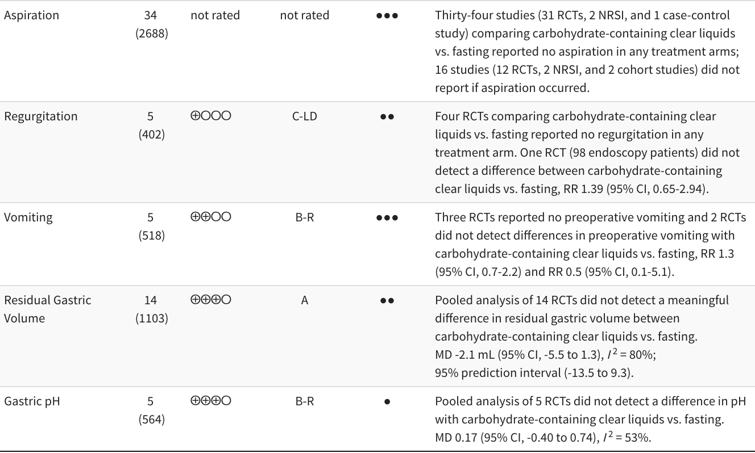
GRADE strength of evidence: ⨁⨁⨁⨁ high, ⨁⨁⨁◯ moderate, ⨁⨁◯◯ low, ⨁◯◯◯ very low.
GRADE: Grading of Recommendations Assessment, Development and Evaluation; ACCF/AHA; American College of Cardiology Foundation/American Heart Association; RR: risk ratio; SMD: standardized mean difference; MD: mean difference; RCT: randomized controlled trial; NRSI: nonrandomized studies of interventions.
ACCF/AHA ratings: A: high-quality evidence from more than 1 RCT; B-R: moderate-quality evidence from more than 1 RCT; B-NR: moderate-quality evidence from more than one observational study; C-LD: randomized or non-randomized observational or registry studies with limited data; C-EO: consensus of expert opinion.
¹ ● Limited, ●● Important, ●●● Critical.

Supplemental Table 2. GRADE domains for strength of evidence by outcome - carbohydrate-containing clear liquids compared with fasting in adults.
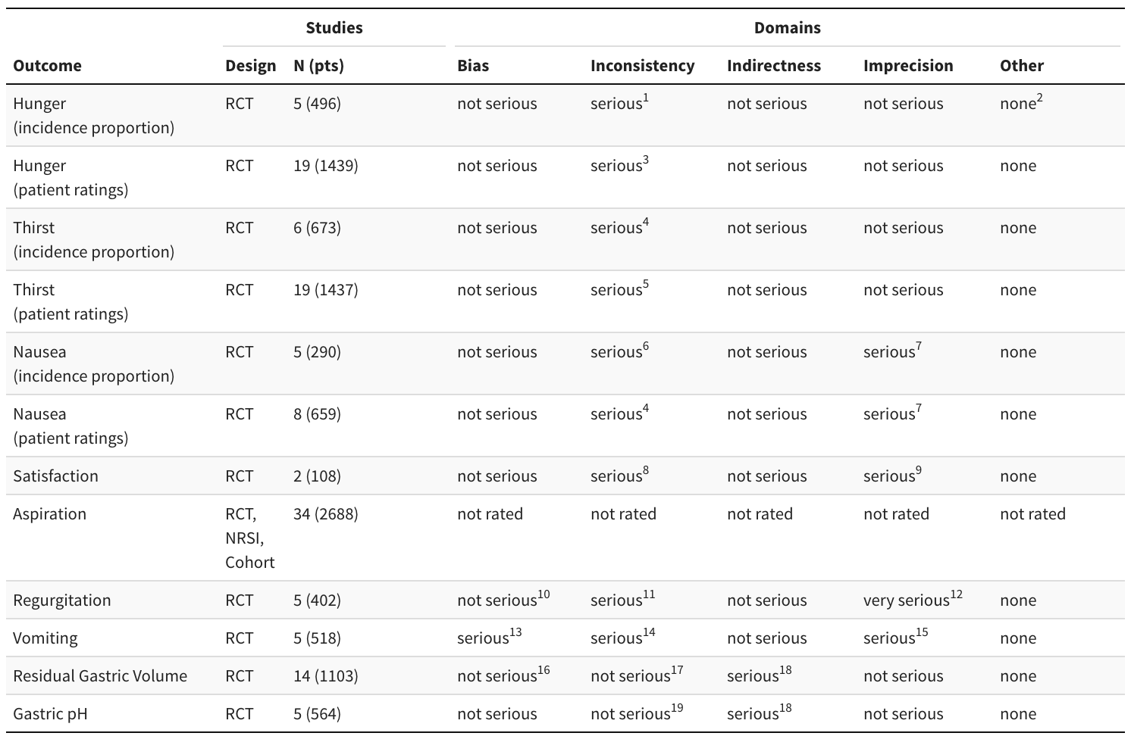
GRADE: Grading of Recommendations Assessment, Development and Evaluation; RCT: randomized controlled trial; NRSI: nonrandomized study of interventions.
¹ 95% prediction interval includes the null effect. I2 not large for pooled RR, but moderate when OR pooled (58%).
² Too few studies to examine small study effects, but smaller studies showed larger relative reductions.
³ Considerable heterogeneity (I² = 69%) and 95% prediction interval includes the null effect.
⁴ Wide 95% prediction interval.
⁵ Wide 95% prediction interval (but smaller excluding outliers, -1.74 to -0.14).
⁶ Wide 95% prediction interval accompanying heterogeneity (I² = 42%).
⁷ Wide pooled confidence interval.
⁸ Studies report inconsistent results.
⁹ Small sample sizes.
¹⁰ Unclear ascertainment accuracy except Koeppe 2013 (endoscopy).
¹¹ Only 1 study reported regurgitation.
¹² Wide confidence interval in one RCT and not events in other trials.
¹³ One study with high percentage of missing values.
¹⁴ Two studies reported events (14% vs. 17% and 0% vs. 7%) and 3 studies reported no events.
¹⁵ Wide confidence intervals for two effect estimates consistent with either CHO or fasting being accompanied by less vomiting, and remaining studies reporting no events.
¹⁶ Two of 14 studies with high percentage of missing values; remaining studies low risk of bias.
¹⁷ Considerable heterogeneity (I² = 80%) but not clinically relevant (between study mean difference 2.1 mL).
¹⁸ Strength of relationship with aspiration unclear, but for comparative purposes may be direct.
¹⁹ Heterogeneity I² = 53%.

Supplemental Table 3. Strength of evidence for outcomes in randomized controlled trials comparing carbohydrate-containing clear liquids with non-caloric clear liquids in adults.
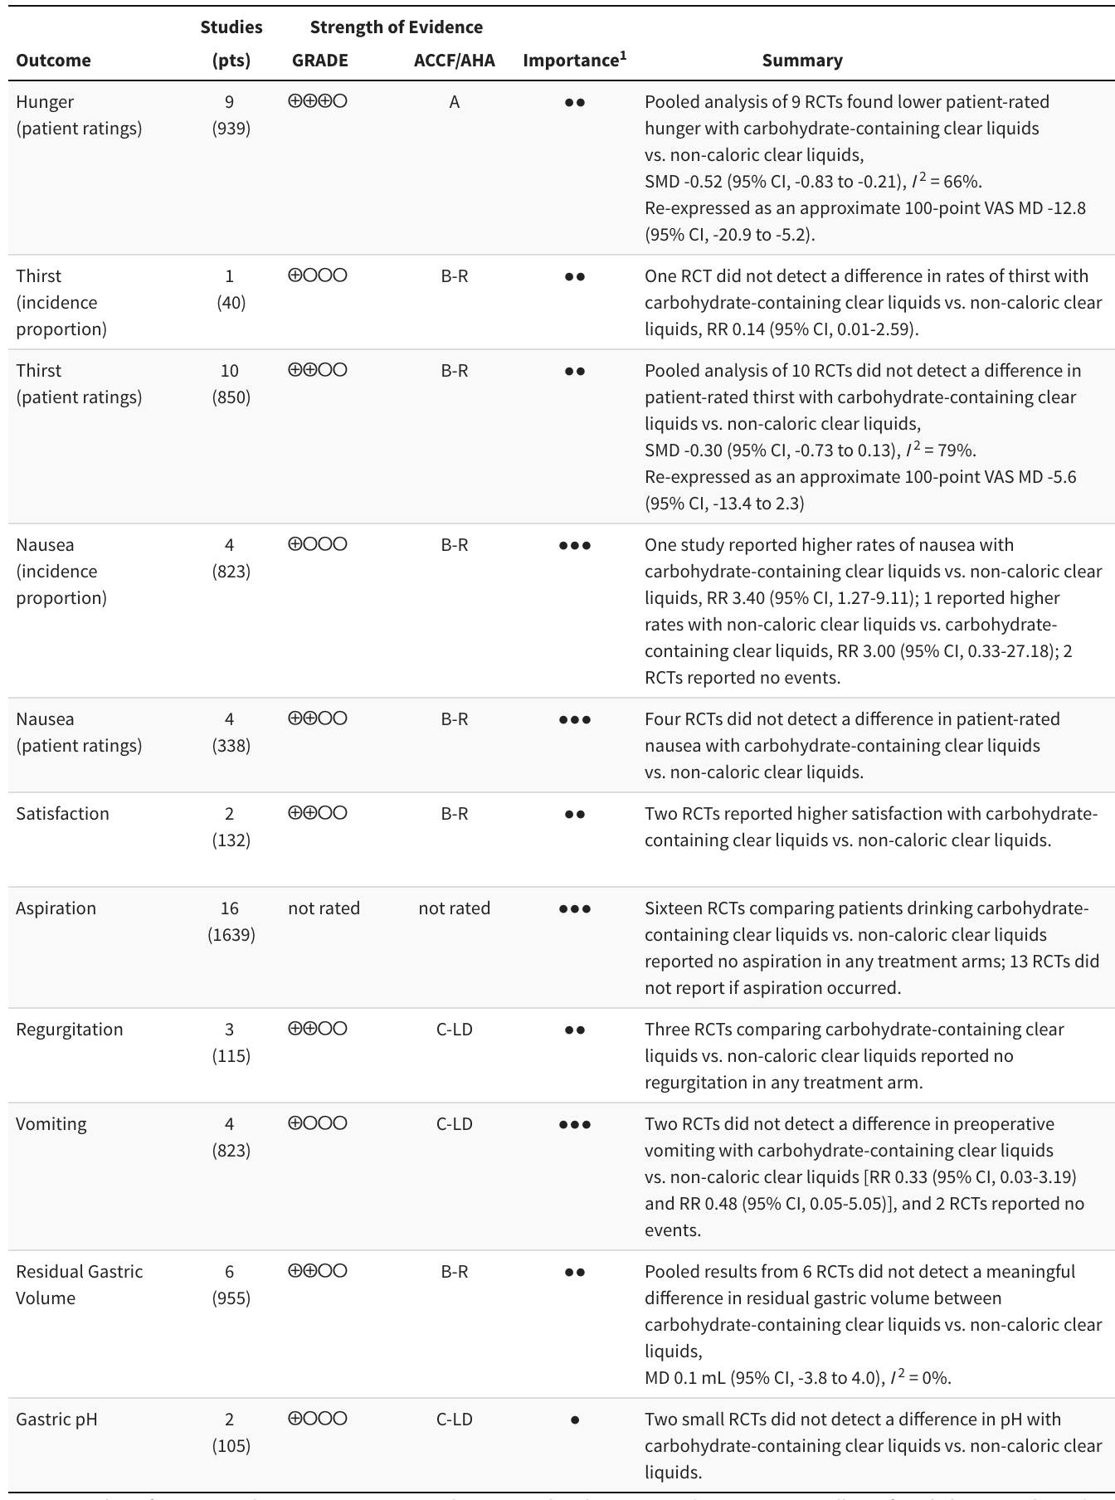
GRADE strength of evidence: ⨁⨁⨁⨁ high, ⨁⨁⨁◯ moderate, ⨁⨁◯◯ low, ⨁◯◯◯ very low.
GRADE: Grading of Recommendations Assessment, Development and Evaluation; ACCF/AHA; American College of Cardiology Foundation/American Heart Association; RR: risk ratio; SMD: standardized mean difference; MD: mean difference; RCT: randomized controlled trial.
ACCF/AHA ratings: A: high-quality evidence from more than 1 RCT; B-R: moderate-quality evidence from more than 1 RCT; B-NR: moderate-quality evidence from more than one observational study; C-LD: randomized or non-randomized observational or registry studies with limited data; C-EO: consensus of expert opinion.
¹ ● Limited, ●● Important, ●●● Critical.

Supplemental Table 4. GRADE domains for outcomes from randomized controlled trials comparing carbohydrate-containing clear liquids with non-caloric clear liquids in adults.
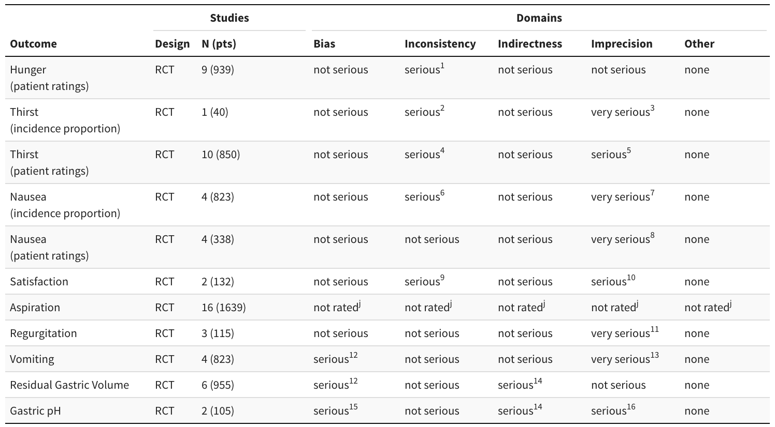
GRADE: Grading of Recommendations Assessment, Development and Evaluation; RCT: randomized controlled trial; NRSI: nonrandomized study of interventions.
¹ Substantial heterogeneity (I² =66%) yielding a 95% prediction interval consistent with lower hunger scores accompanied by either carbohydrate.
² Single study cannot assess consistency.
³ No reported thirst in carbohydrate arm.
⁴ Considerable heterogeneity (I² =79%) yielding a 95% prediction interval consistent with lower thirst scores accompanied by either carbohydrate or clear liquids.
⁵ Wide confidence intervals indicate uncertainty concerning results.
⁶ One study reported more nausea with carbohydrate drinks vs. water, 1 study did not detect a difference, and 2 studies reported no events.
⁷ Very wide confidence interval for 2 effect estimates and 2 studies with no events.
⁸ Limited by absence of nausea (1 of 4 studies reported no nausea), and small sample sizes of individual studies (2 of 4 studies with population <100).
⁹ Data limited to 2 studies.
¹⁰ One effect estimate calculated from means and confidence intervals.
¹¹ Precision cannot be determined with zero events reported.
¹² One study with high percentage of missing values.
¹³ Wide confidence interval and 7 events.
¹⁴ Strength of relationship with aspiration not clearly defined.
¹⁵ One study did not report pH on all study participants.
¹⁶ Small number of participants.

Supplemental Table 5. Mean differences in residual gastric volumes (mL) and 95% credible intervals from network meta-analysis. Comparisons are top to bottom below the diagonal (e.g., fasting versus complex carbohydrate-containing clear liquids is 1.75 mL). Note that differences were not identified between any comparators, nor were the 95% credible intervals consistent with potential clinically important differences. High confidence (CINeMA) for comparison between complex and simple carbohydrates.
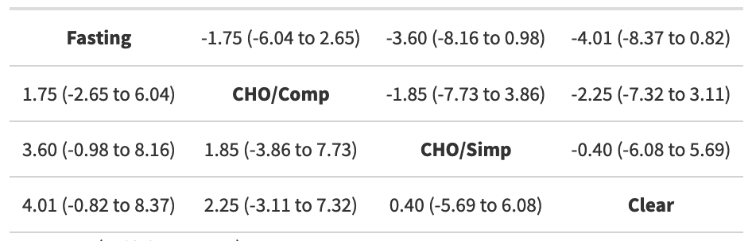
CHO: carbohydrate; Comp: complex; Simp: simple.

Supplemental Table 6. Standardized mean differences in patient-rated hunger and 95% CIs from network meta-analysis. Comparisons including direct and indirect evidence are top to bottom below the diagonal (e.g., a standardized mean difference between complex carbohydrate-containing clear liquids and simple carbohydrates of 0.27). Estimates above the diagonal include only the direct evidence for the corresponding comparison. Any differences across the diagonals reflect inconsistency between direct and indirect evidence. Despite some inconsistencies, and low confidence (CINeMA) for the comparison between complex and simple carbohydrates, the results offer no evidence to support a difference in patient rated hunger between complex and simple carbohydrate-containing clear liquids.
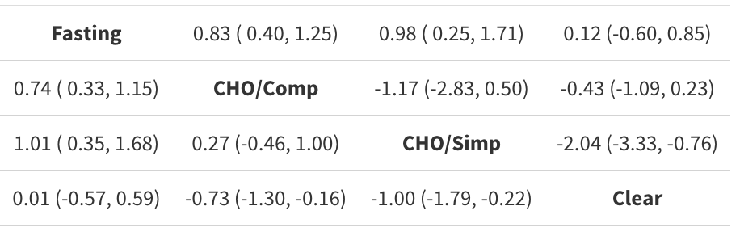
CHO: carbohydrate; Comp: complex; Simp: simple.

Supplemental Table 7. Strength of evidence for outcomes from studies comparing protein-containing clear liquids with fasting in adults (all randomized except for aspiration evidence).
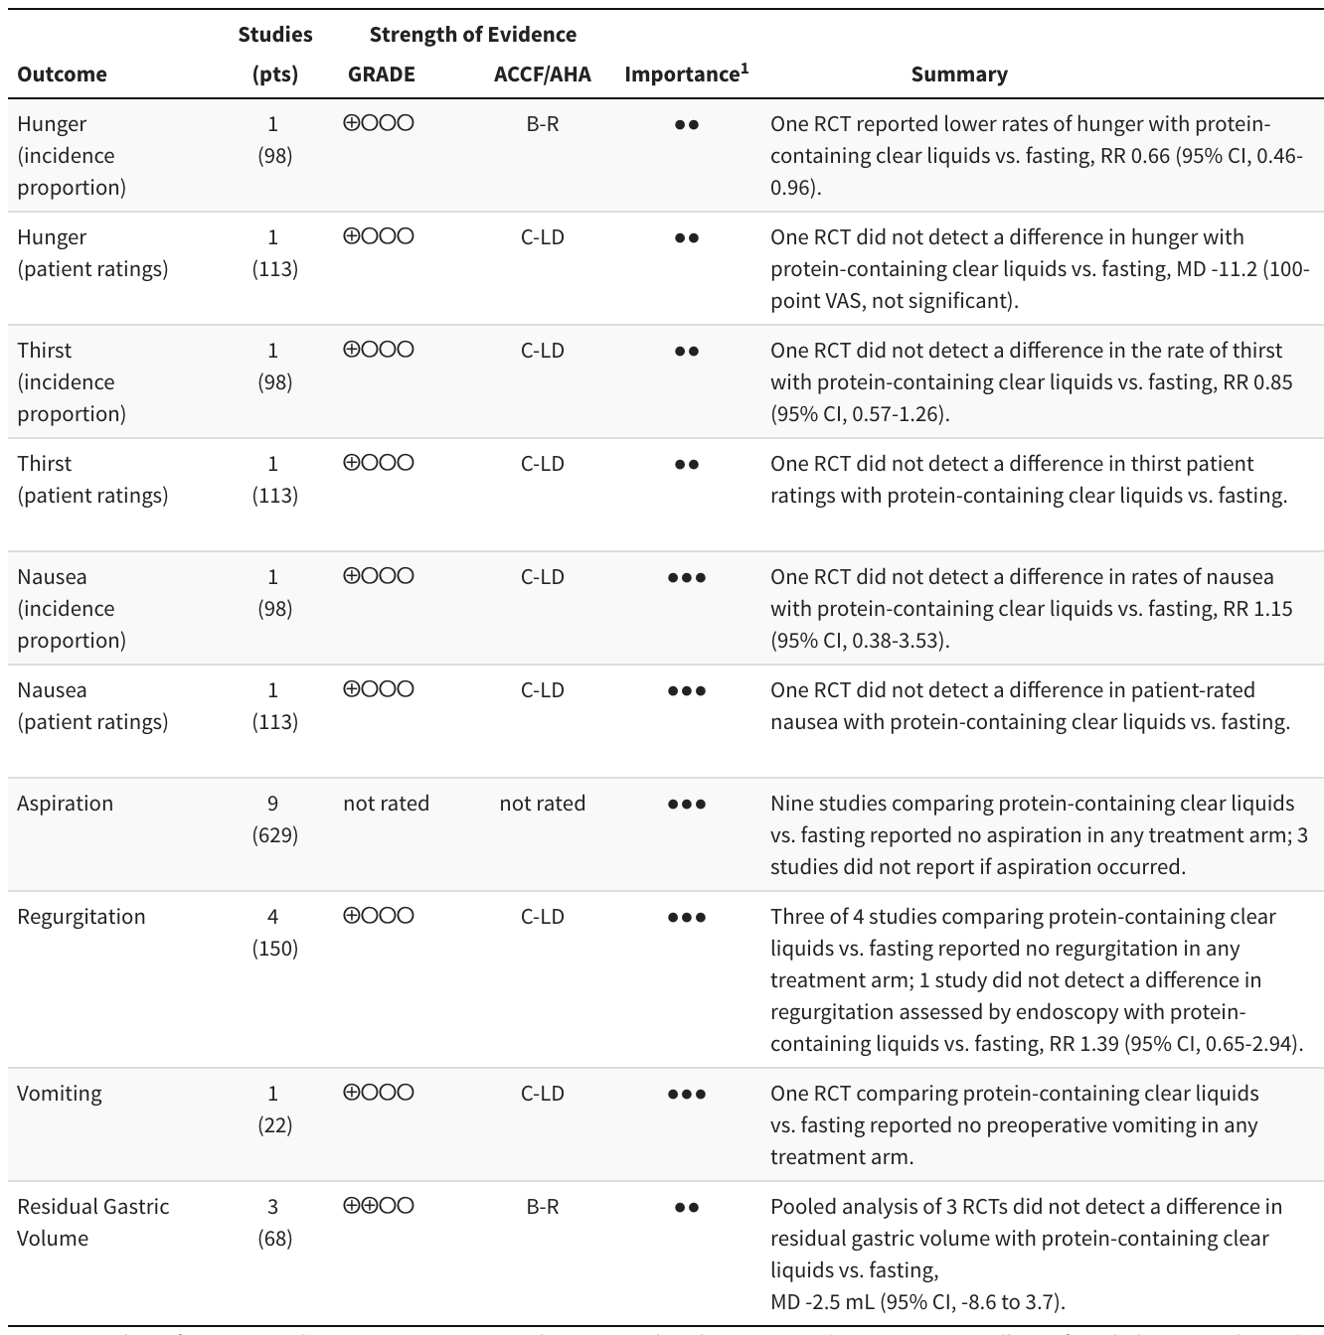
GRADE strength of evidence: ⨁⨁⨁⨁ high, ⨁⨁⨁◯ moderate, ⨁⨁◯◯ low, ⨁◯◯◯ very low.
GRADE: Grading of Recommendations Assessment, Development and Evaluation; ACCF/AHA; American College of Cardiology Foundation/American Heart Association; RCT: randomized controlled trial; RR: risk ratio; MD: mean difference.
ACCF/AHA ratings: A: high-quality evidence from more than 1 RCT; B-R: moderate-quality evidence from more than 1 RCT; B-NR: moderate-quality evidence from more than one observational study; C-LD: randomized or non-randomized observational or registry studies with limited data; C-EO: consensus of expert opinion.
¹ ● Limited, ●● Important, ●●● Critical.

Supplemental Table 8. GRADE domains for strength of evidence by outcome—protein-containing clear liquids compared with fasting in adults.
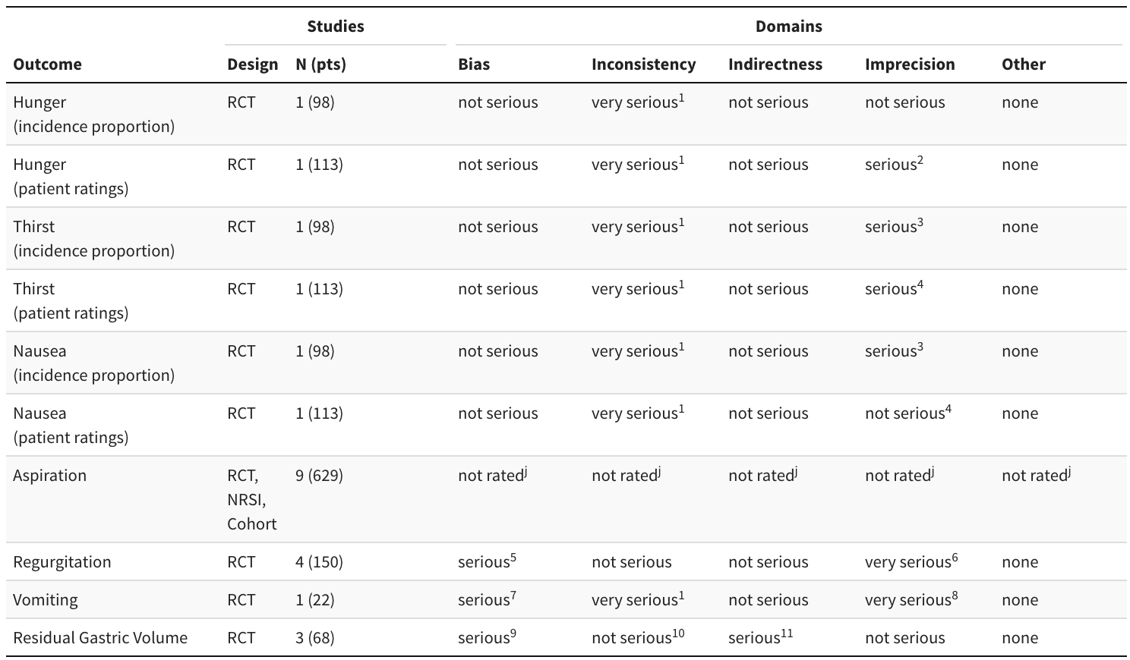
RCT: randomized controlled trial; NRSI: nonrandomized studies of interventions.
¹ Single study cannot assess consistency.
² Results estimated using reported medians, IQRs, and ranges.
³ Wide confidence intervals consistent with either carbohydrate/protein drinks or fasting being accompanied by less risk of thirst.
⁴ Small sample size.
⁵ Two studies with high percentage of missing values.
⁶ Three of 4 studies reported zero events.
⁷ High percentage of missing values.
⁸ Precision cannot be determined with zero events reported.
⁹ One study with high percentage of missing values.
¹⁰ Heterogeneity I² = 11%.
¹¹ Strength of relationship with aspiration not clearly defined.

Supplemental Table 9. Strength of evidence for outcomes in randomized controlled trials comparing protein-containing clear liquids with non-caloric clear liquids in adults.
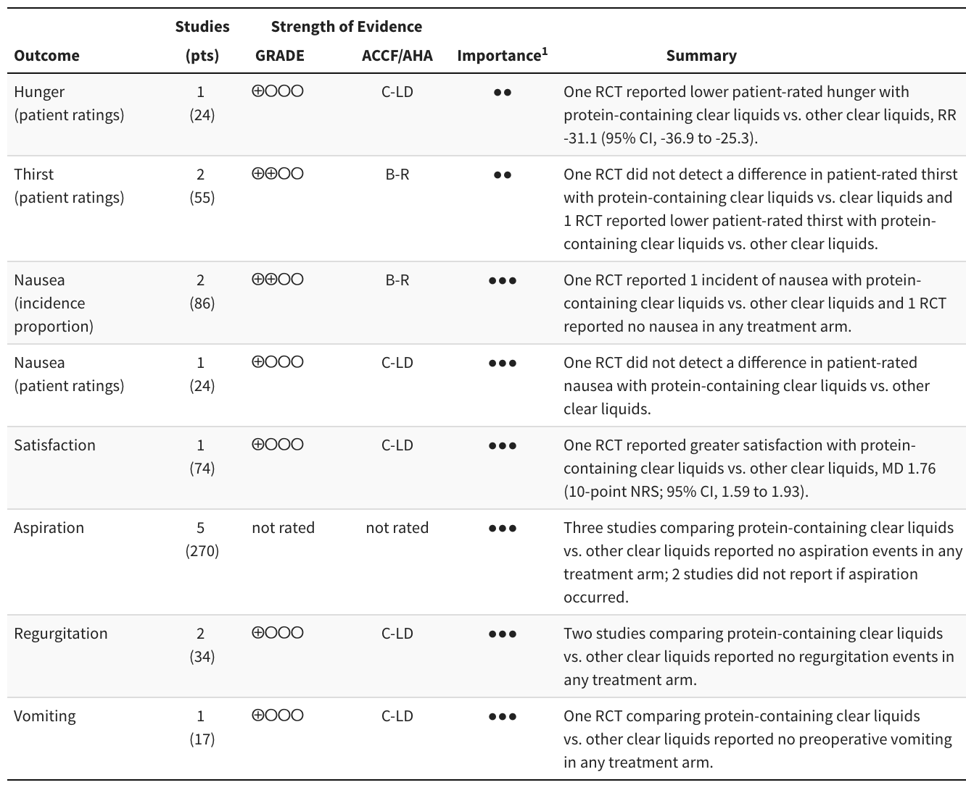
GRADE strength of evidence: ⨁⨁⨁⨁ high, ⨁⨁⨁◯ moderate, ⨁⨁◯◯ low, ⨁◯◯◯ very low.
GRADE: Grading of Recommendations Assessment, Development and Evaluation; ACCF/AHA; American College of Cardiology Foundation/American Heart Association; RCT: randomized controlled trial; RR: risk ratio; MD: mean difference.
ACCF/AHA ratings: A: high-quality evidence from more than 1 RCT; B-R: moderate-quality evidence from more than 1 RCT; B-NR: moderate-quality evidence from more than one observational study; C-LD: randomized or non-randomized observational or registry studies with limited data; C-EO: consensus of expert opinion.
¹ ● Limited, ●● Important, ●●● Critical.

Supplemental Table 10. GRADE domains for strength of evidence ratings by outcome - protein-containing clear liquids compared with non-caloric clear liquids in adults.
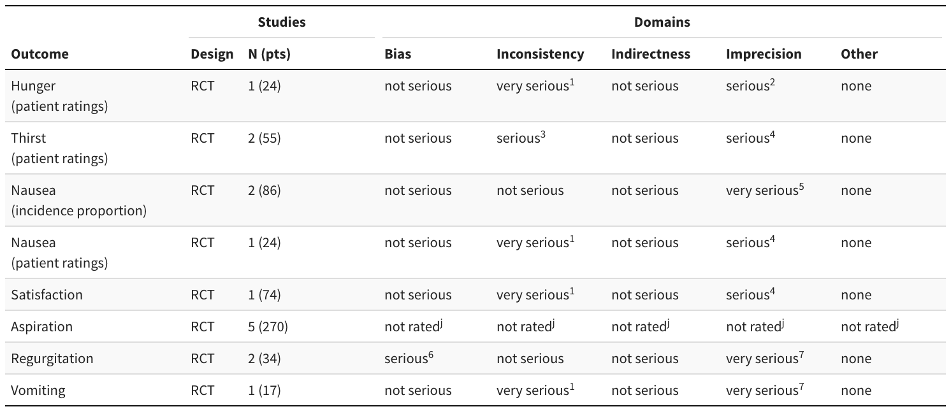
RCT: randomized controlled trial.
¹ Single study cannot assess consistency.
² Results estimated using reported medians, IQRs, and ranges.
³ Studies report inconsistent results.
⁴ Small sample size.
⁵ Precision cannot be determined with a single event reported.
⁶ One study with high percentage of missing values.
⁷ Precision cannot be determined with zero events reported.

Supplemental Table 11. Strength of evidence for residual gastric volume from crossover studies comparing protein-containing clear liquids with carbohydrate-containing clear liquids in adults.
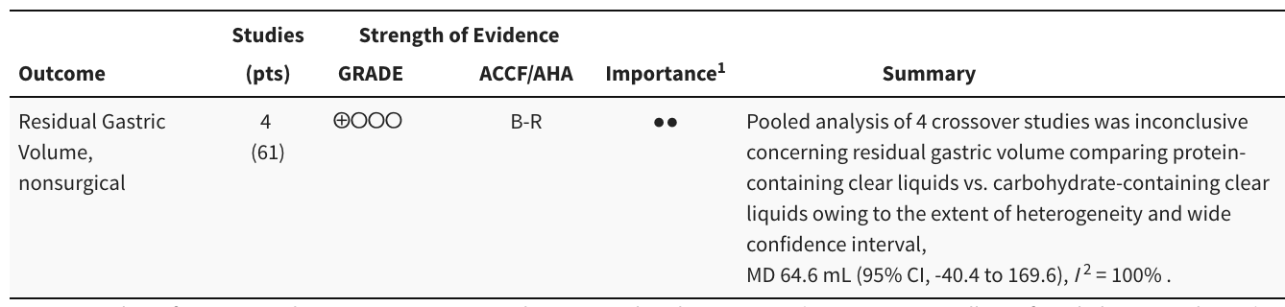
GRADE strength of evidence: ⨁⨁⨁⨁ high, ⨁⨁⨁◯ moderate, ⨁⨁◯◯ low, ⨁◯◯◯ very low.
GRADE: Grading of Recommendations Assessment, Development and Evaluation; ACCF/AHA; American College of Cardiology Foundation/American Heart Association; MD: mean difference.
ACCF/AHA ratings: A: high-quality evidence from more than 1 RCT; B-R: moderate-quality evidence from more than 1 RCT; B-NR: moderate-quality evidence from more than one observational study; C-LD: randomized or non-randomized observational or registry studies with limited data; C-EO: consensus of expert opinion.
¹ ● Limited, ●● Important, ●●● Critical.

Supplemental Table 12. GRADE domains for residual gastric volume - protein-containing clear liquids compared with carbohydrate-containing clear liquids in adults.
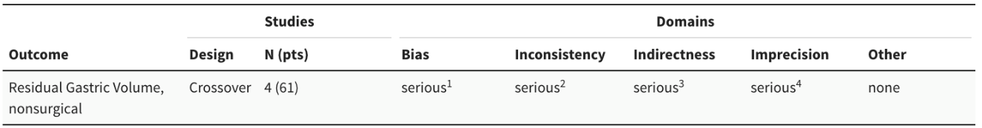
¹ Single study with high dropout rate.
² Heterogeneity I² = 100%.
³ Strength of relationship with aspiration not clearly defined.
⁴ Wide confidence intervals consistent with either protein/carbohydrate drinks or carbohydrate being accompanied by larger residual gastric volume.

Supplemental Table 13. Strength of evidence in chewing gum studies.
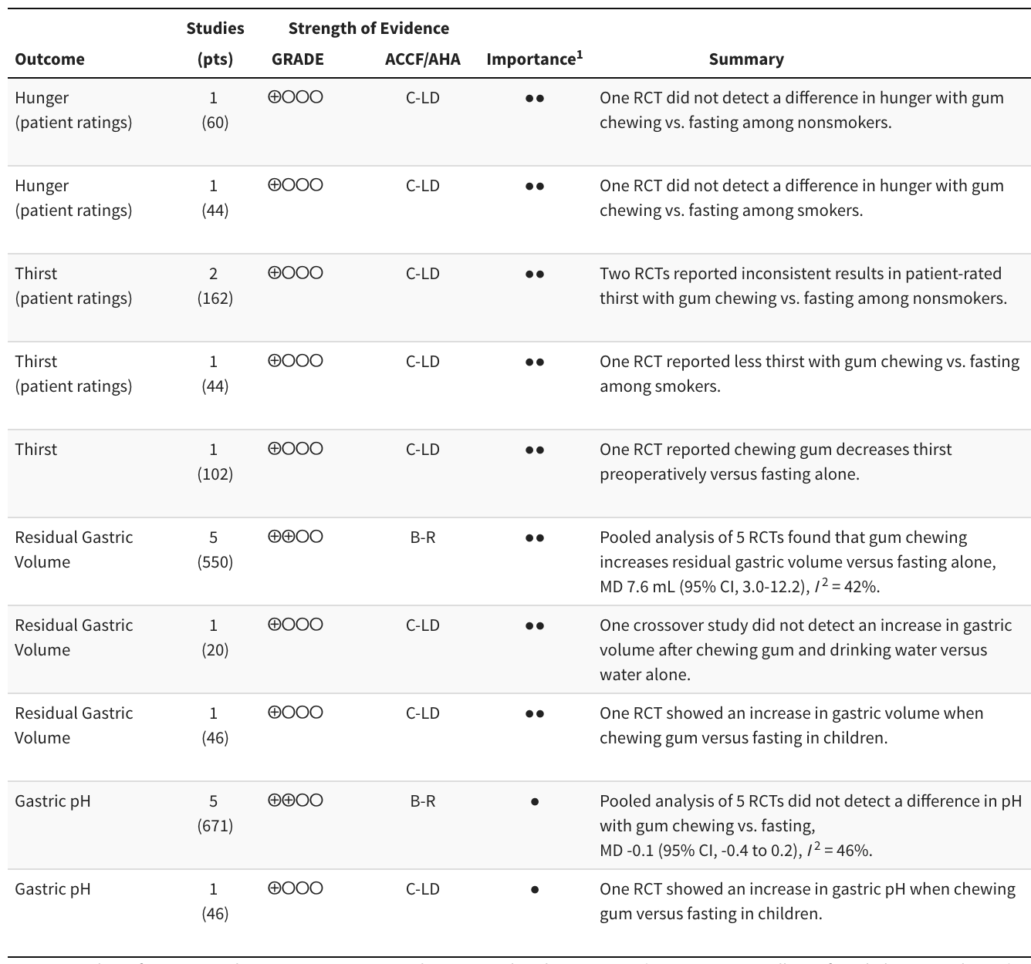
GRADE strength of evidence: ⨁⨁⨁⨁ high, ⨁⨁⨁◯ moderate, ⨁⨁◯◯ low, ⨁◯◯◯ very low.
GRADE: Grading of Recommendations Assessment, Development and Evaluation; ACCF/AHA; American College of Cardiology Foundation/American Heart Association; RCT: randomized controlled trial; MD: mean difference.
ACCF/AHA ratings: A: high-quality evidence from more than 1 RCT; B-R: moderate-quality evidence from more than 1 RCT; B-NR: moderate-quality evidence from more than one observational study; C-LD: randomized or non-randomized observational or registry studies with limited data; C-EO: consensus of expert opinion.
¹ ● Limited, ●● Important, ●●● Critical.

Supplemental Table 14. GRADE domains for strength of evidence ratings in chewing gum studies.
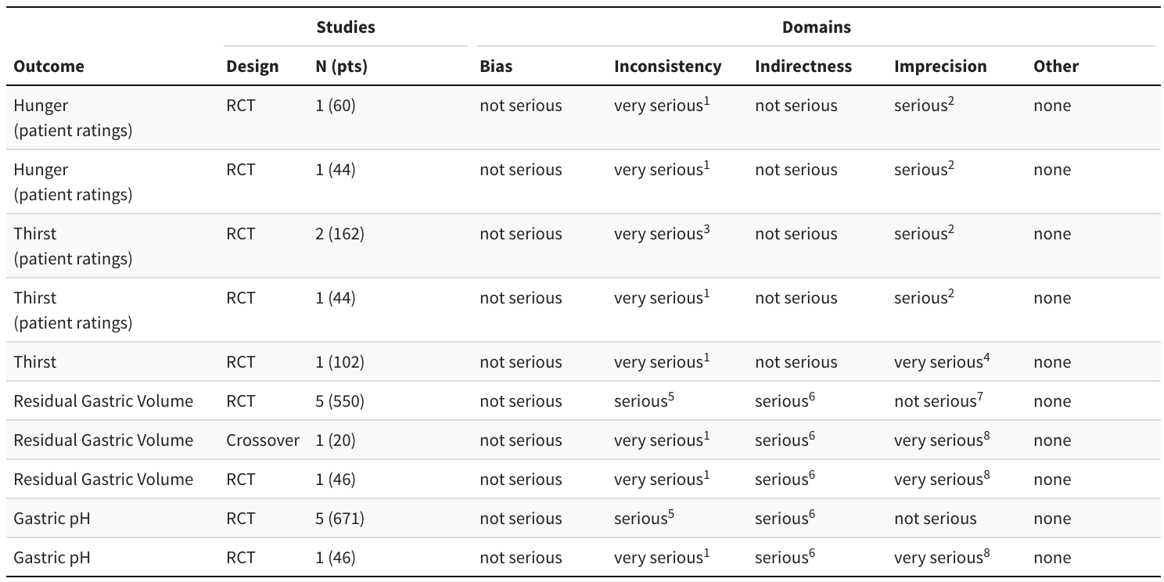
RCT: randomized controlled trials.
¹ Single study cannot assess consistency.
² Small sample size.
³ Studies report inconsistent results.
⁴ Heterogeneity of results.
⁵ Strength of relationship with aspiration not clearly defined.
⁶ Upper bound unlikely to cross the decision-making threshold.
⁷ Small sample size, single trial cannot be assessed.

Supplemental Table 15. Residual gastric volumes at induction in randomized controlled trials of adult patients undergoing surgery according to fasting and gum chewing.
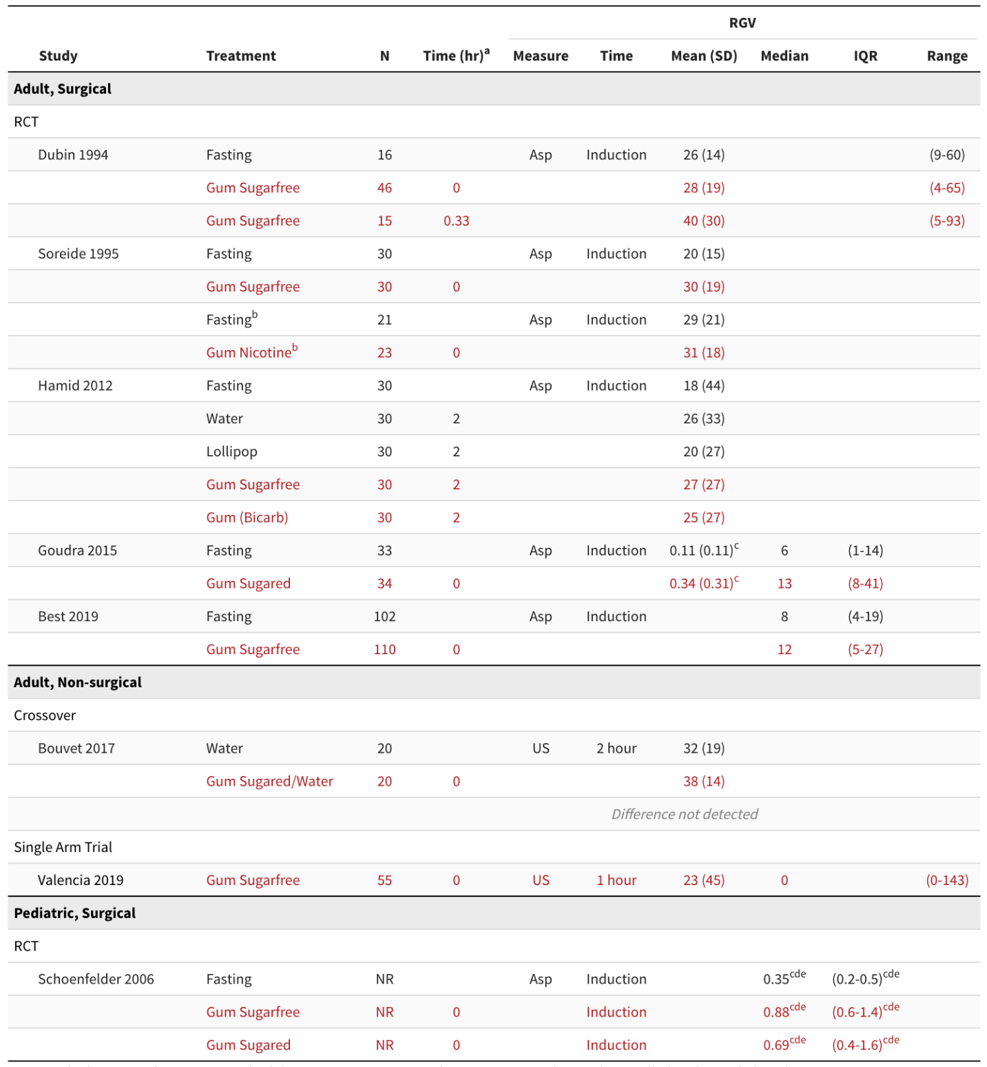
RGV: residual gastric volume; SD: standard deviation; IQR: interquartile range; RCT: randomized controlled trial; Bicarb: bicarbonate; Asp: aspiration; US: ultra- sound; NR: not reported.
ª Before induction.
^{b} Smokers.
^{c} mL/kg.
^{d} 2 hours after ingestion of 250 mL and gum chewing.
^{e} p < 0.001 for comparison with fasting.

Supplemental Table 16. Gastric pH at induction in randomized controlled trials of patients undergoing surgery according to gum chewing, fasting, and liquid.
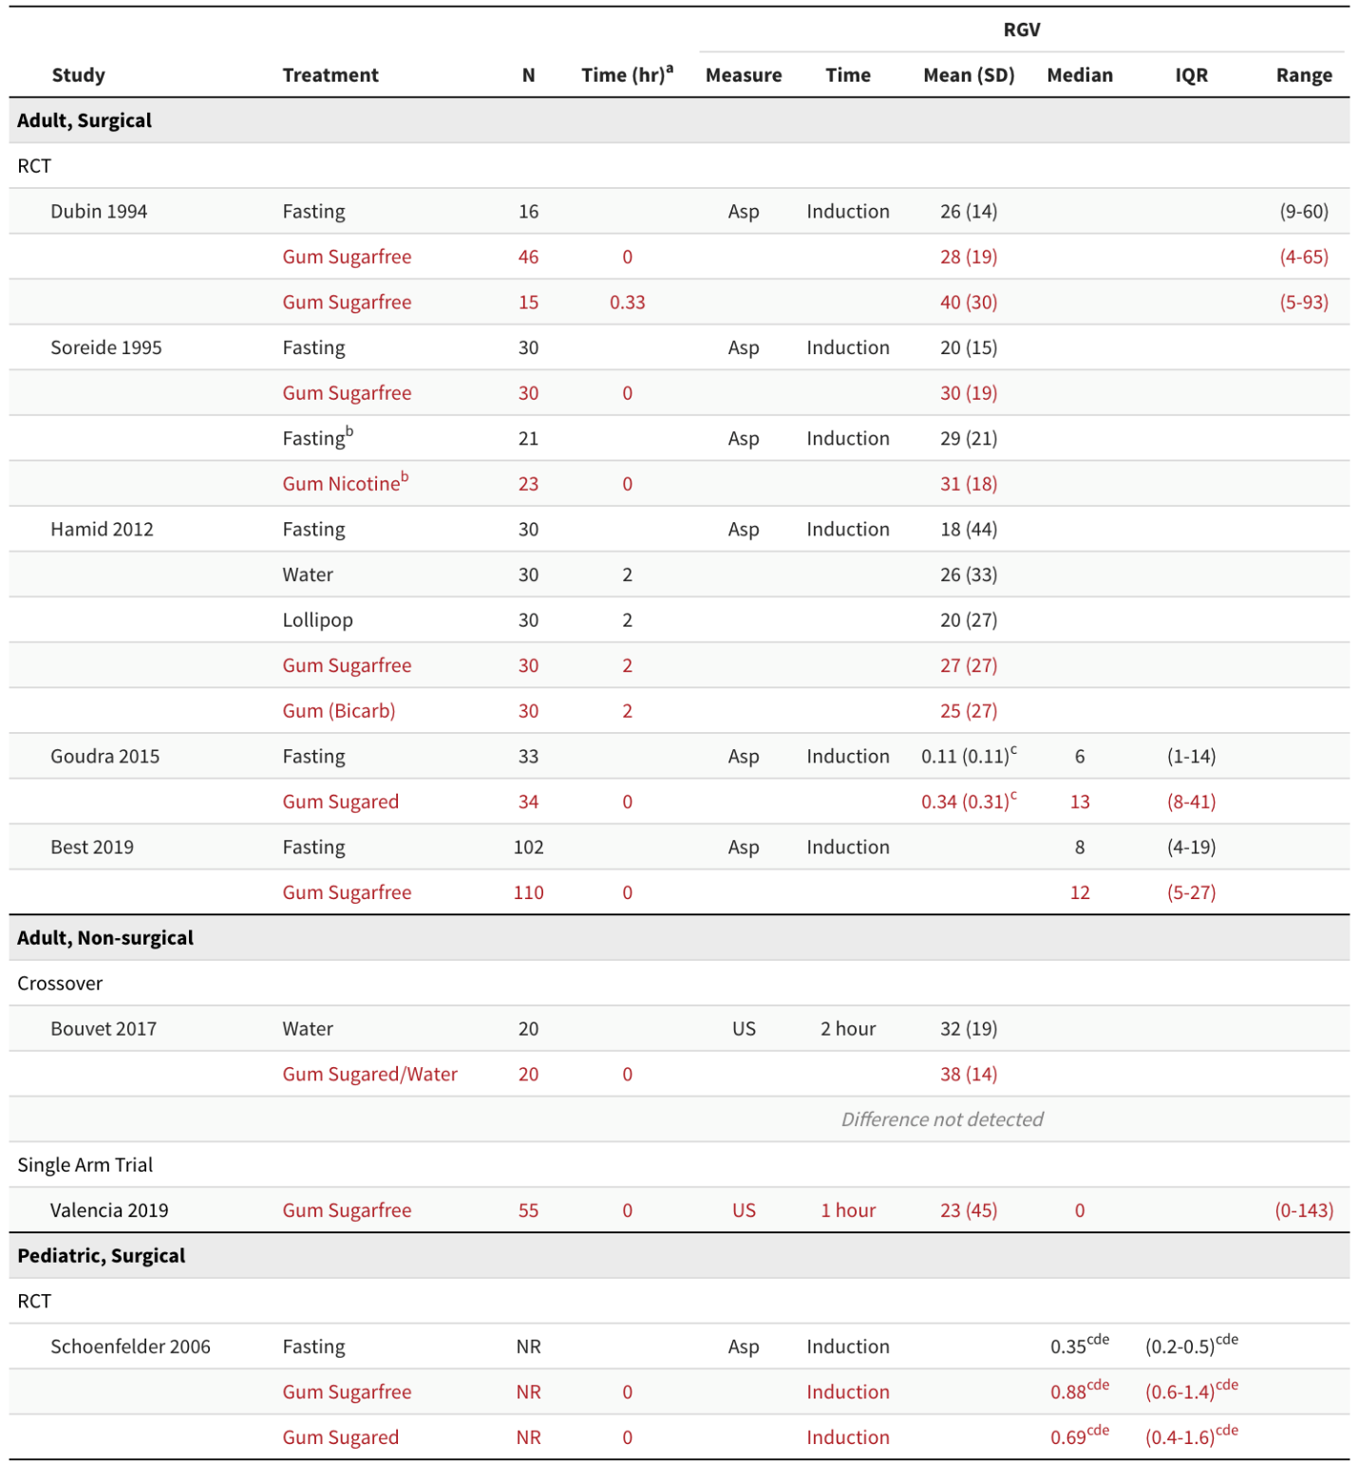
Asp: aspiration; Bicarb: bicarbonate; IQR: interquartile range; NR: not reported; RCT: randomized controlled trial; SD: standard deviation.
ª Before induction.
^{b} Smokers.

Supplemental Table 17. Strength of evidence for selected outcomes comparing 1- and 2-hour clear liquid fasting duration in pediatrics.
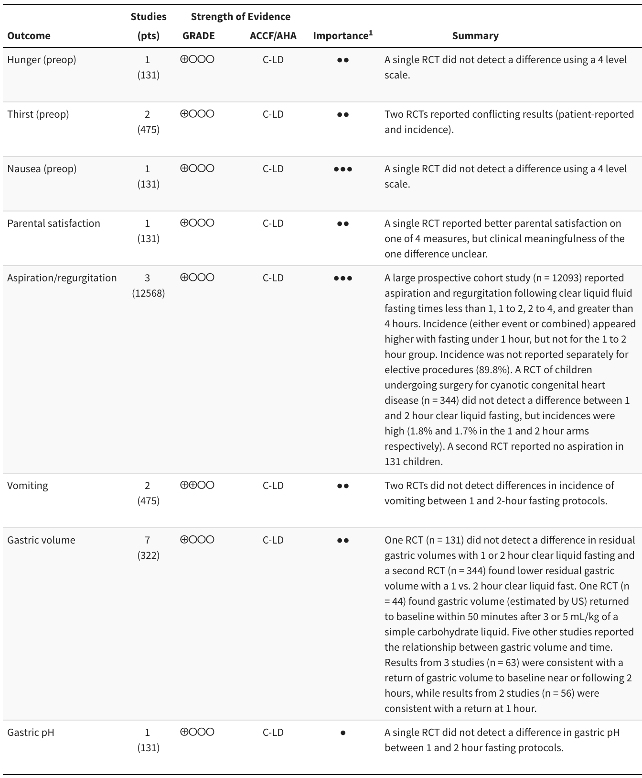
GRADE strength of evidence: ⨁⨁⨁⨁ high, ⨁⨁⨁◯ moderate, ⨁⨁◯◯ low, ⨁◯◯◯ very low.
GRADE: Grading of Recommendations Assessment, Development and Evaluation; ACCF/AHA; American College of Cardiology Foundation/American Heart Association; RCT: randomized controlled trial.
ACCF/AHA ratings: A: high-quality evidence from more than 1 RCT; B-R: moderate-quality evidence from more than 1 RCT; B-NR: moderate-quality evidence from more than one observational study; C-LD: randomized or non-randomized observational or registry studies with limited data; C-EO: consensus of expert opinion.
¹ ● Limited, ●● Important, ●●● Critical.

Supplemental Table 18. GRADE domains for strength of evidence ratings in studies comparing 1- and 2-hour clear liquid fasting duration in pediatrics.
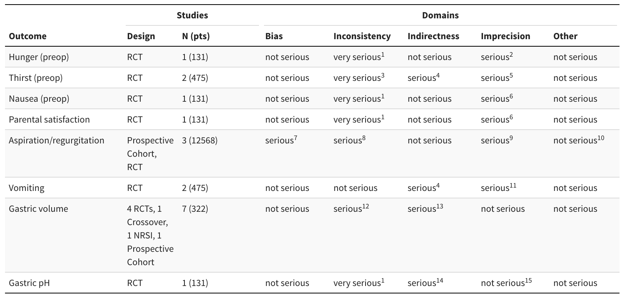
RCT: randomized controlled trial; NRSI: nonrandomized studies of interventions.
¹ Single study cannot assess consistency.
² Limited sample for ordinal scale.
³ Conflicting trial results.
⁴ One RCT conducted in children with cyanotic congenital heart disease.
⁵ Different metrics.
⁶ Limited sample for nominal scale.
⁷ Beck 2020b judged at serious risk of bias.
⁸ Single large observational study rates consistent with prior literature; RCT substantially higher.
⁹ Wide confidence interval from large observational study.
¹⁰ Publication bias unlikely, but unable to assess.
¹¹ Risk ratios included wide range of plausible effects.
¹² Inconsistent results for return to baseline gastric volume. A single RCT compared 1- and 2-hour clear liquid fasting.
¹³ Strength of relationship with aspiration not clearly defined.
¹⁴ Strength of relationship with aspiration outcomes not clearly defined.
¹⁵ Not rated down, incorporated downgrade in inconsistency domain.

Supplemental Table 19. Incidence of aspiration and regurgitation in pediatric patients according to clear liquid fasting duration.
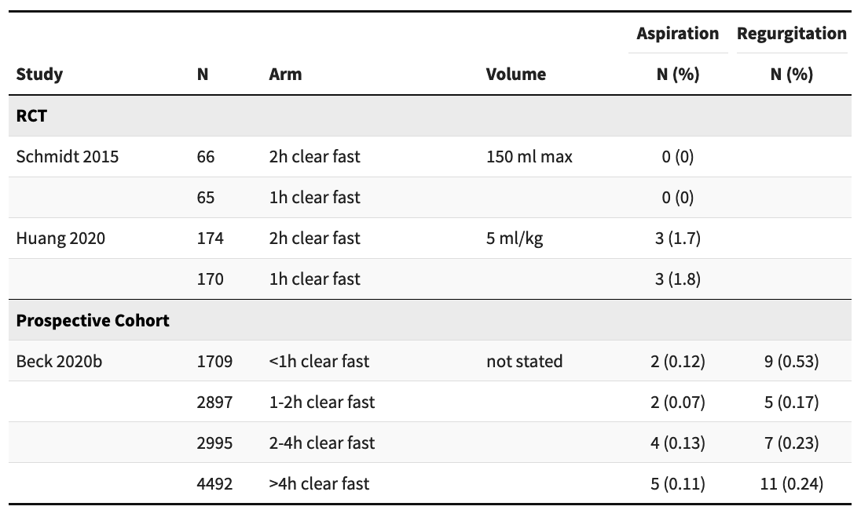
Beck2020b includes suspected and confirmed cases of aspiration; 1227 (10.2%) emergency procedures. One suspected aspiration with a recorded clear liquid fluid fasting time of 0.98 hours. One episode of suspected aspiration occurred in a child with incarcerated hernia not included (unclear if in >4-hour category).

Supplemental Table 20. Results from studies reporting gastric volumes over time in pediatric patients. Note that although studies are arranged by design from an evidence perspective, the relationship reported is independent of design.
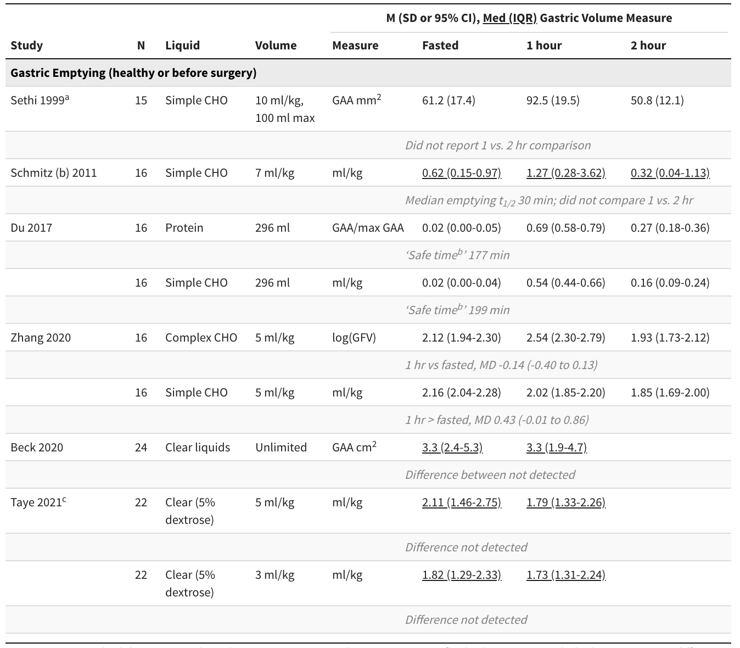
CHO: carbohydrate; GAA: gastric antral area; GFV: gastric fluid volume; M: mean; MD: mean difference; Med: median; SD: standard deviation.
ª Clear liquid arm from trial.
^{b} Time when probability of returning to baseline > 0.95.
^{c} Approximate times.

