Supplemental Content 6. Percentage of patients, stratified by procedure, filling each type of non-opioid analgesic, including (a) Acetaminophen, (b) NSAIDS, and (c) Gabapentinoids

A | B
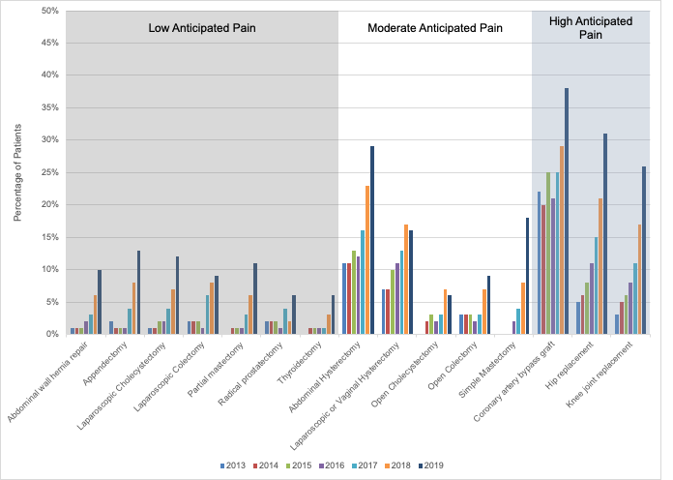 | 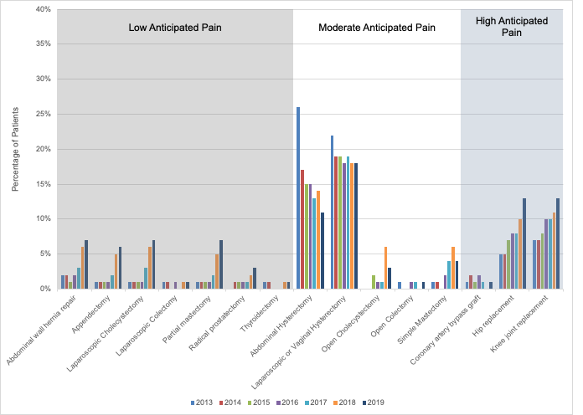
C
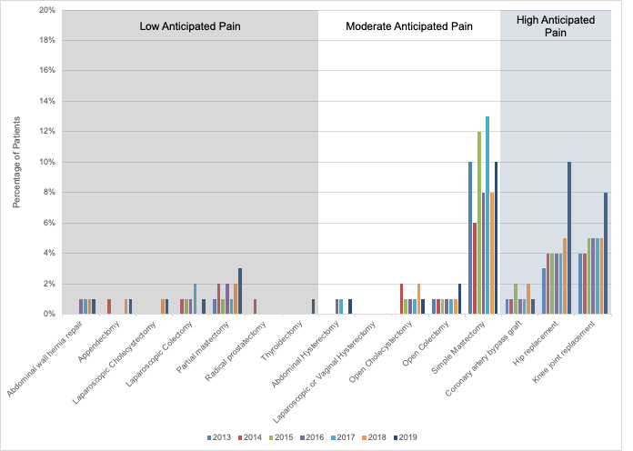
*Due to too few patients filling prescriptions for Chronic Pain Adjuncts for individual procedures, we are unable to display these data

